Part 4-C: Rangitikei/Ruapehu/Wanganui SMS

Rangitikei Ruapehu Wanganui Roads
Safety Management System

May 2005

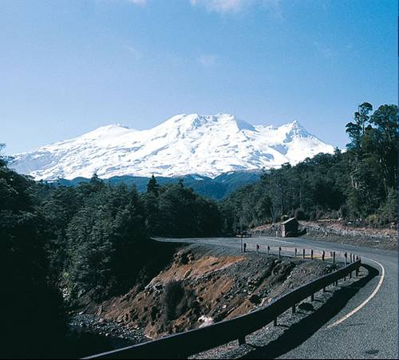

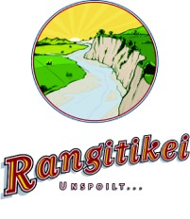
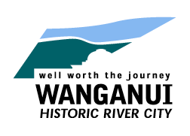
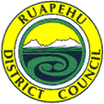

Rangitikei Ruapehu Wanganui Roads Safety Management System

Version 1

May 2005

This is an agreement between Land Transport New Zealand and the Rangitikei, Ruapehu and Wanganui District Councils to certify that this Safety Management System is endorsed by all parties as being in accordance with the LTSA Guidelines for Developing a Safety Management System.

Signed on behalf of Rangitikei District Council by: | Signed on behalf of Land Transport New Zealand by:
Leigh Halstead | Darryl Harwood
Chief Executive | Regional Manager - Safety
Date: | Date:
Signed on behalf of Ruapehu District  Council by: | Signed on behalf of Wanganui District Council by:
Chris Ryan  Chief Executive | Colin Whitlock  Chief Executive
Date: | Date:

Table of Contents

Preface i
Record of Amendments ii
Distribution List iii
Glossary of Terms iv
1.0 Introduction 1
1.1 Purpose and Philosophy 1
1.2 SMS Model for Rangitikei, Ruapehu and Wanganui Roads 3
1.3 Network Description 4
1.4 Strategic Linkages 4
1.5 Operational Linkages 5
2.0 Road Safety Strategy (RSS) 8
2.1 Introduction 8
2.2 Road Safety Vision 8
2.3 Key Road Safety Issues and Problem Analysis 9
2.4 Road Safety Goals and Targets 11
2.4.1 National and Regional Goals 11
2.4.2 RSS Goal 12
2.4.3 District Targets 12
2.5 Safety Action Programmes 15
2.6 Monitoring Road Safety Performance 15
2.6.1 Three E’s Indicators 15
2.7 Road Safety Stakeholders 16
3.0 Policies, Standards, Procedures and Guidelines 18
3.1 Introduction 18
3.2 Road Safety Activity Components 18
3.2.1 Categories 18
3.2.2 SMS Procedures 19
3.3 Safety Management Plan 20
3.4 Safety Intervention Plan 21
3.5 Safety Planning Related Activities 22
3.6 Identification of Safety Deficiencies 23
3.7 Risk Identification, Evaluation and Management 24
3.8 Crash Reporting 25
4.0 Roles and Responsibilities 27
4.1 Introduction 27
4.2 Organisational Structures 27
4.3 Safety Management Team (SMT) 28
4.4 Safety Managers / Safety Champions 29
4.5 Safety Culture, Training and Development 30
4.6 Safety Roles and Competence 30
5.0 Management System 34
5.1 Introduction 34
5.2 Management Responsibilities 34
5.3 Integration of Systems within each Organisation 35
5.4 SMS Continuous Improvement Plan 35
6.0 Audit Regime 40
6.1 Purpose of Audit 40
6.2 Responsibility 40
6.3 Audit Programme 41
6.4 Specific SMS Audit Requirements 41
6.4.1 Road Safety Strategy 41
6.4.2 Expertise 41
6.4.3 Policies, Standards, Procedures and Guidelines 42
6.4.4 Management Systems 42
6.5 External Audit Report 42

Appendix I – District Road Network Maps
Appendix II – List of Standards and Guidelines
Appendix III – Current Road Safety Issues by District
Appendix IV – SMS Procedures
Appendix V – Skid Resistance
Appendix VI – Rangitikei Resource Information
Appendix VII – Ruapehu Resource Information
Appendix VIII – Wanganui Resource Information

Preface
The 2003 LTSA Road Safety Issues reports for Rangitikei, Ruapehu and Wanganui Districts show that there were 83 fatal and 364 serious injury crashes within the three Districts over the previous five years, with 24 and 103 of these being on District road networks. The social cost of crashes on District roads was $22 million in 2003. Particular concerns in the Rangitikei, Ruapehu and Wanganui Districts include Loss of Control, Speed, Alcohol, Intersections, Vulnerable Road Users, Fatigue, and Road or Environmental factors.

Government’s 2010 Road Safety Strategy puts responsibility on individual Road Controlling Authorities to contribute to national goals for reducing fatality and hospitalisation numbers by 2010. Developing and implementing a Safety Management System (SMS) is a key component of the Strategy. An SMS should define the procedures to be used for improving the safety of the roading network, and how stakeholders can contribute to achieving safety targets.

This SMS document has been developed cooperatively by the Rangitikei, Ruapehu and Wanganui District Councils and covers the three “Local Roads” networks. It excludes State Highways, which are the responsibility of Transit New Zealand.

It’s goal is to improve the level of inherent safety on the network, with a consequential and ongoing reduction in both the road crash rate and crash severity.

The SMS is regarded as a key policy document by all three authorities. It encourages a safety culture to focus the efforts of all stakeholders on achieving road safety objectives and targets. It:
- Lists the Policies, Standards, Procedures, Guidelines and Codes of Practice used to improve the safety of the local roading networks.
- Identifies the engineering expertise and culture needed to deliver safety.
- Outlines the Management System which ensures that the necessary standards and expertise are developed and used to deliver safety outcomes
- Includes an audit regime to ensure ongoing compliance with the SMS
- Includes a review process to ensure that “best and current practice” is maintained.

The SMS is dynamic and subject to continuous improvement. It represents a partnership between the three RCA’s and Land Transport NZ. It will be updated annually by the combined Safety Management Team as a new version to reflect changing road safety priorities. Significant changes of a legislative or procedural nature will be made on an as required basis.
Record of Amendments

AMENDMENT NO. | SUBJECT | UPDATED BY | DATE

Distribution List

INDIVIDUAL | ORGANISATION | COPIES | DATE OF DISTRIBUTION
Bill Greenwood | Land Transport New Zealand | 1
David Curson | Land Transport New Zealand | 1
Barry Strichen | Rangitikei District Council | 1
Roger Coles | Rangitikei District Council - GHD | 1
Bruce Dobson | Ruapehu District Council | 1
John Jones | Wanganui District Council | 2
Charl Alberts | GHD Consultants | 1
Jim Moore | Opus Consultants | 1
vacancy | Road Safety Coordinator (MW region) | 1
Anne Redgrave | Horizons Regional Council | 1
Neil Wynne / Nick Dobson | NZ Police (Cental Districts Regional Commander) | 1
Sam Hoyle | NZ Police (Area Commander Wanganui) | 1
Dave Scott | NZ Police (Area Commander Rangitikei) | 1
Steve Mastrovich | NZ Police (Area Commander Ruapehu) | 1
Roger McLay | Transit New Zealand | 1
Mark Gordon | Maunsell | 1

Glossary of Terms

TERM | DESCRIPTION
AA | Automobile Association
ACC | Accident Compensation Corporation
AMP | Activity / Asset Management Plan
Audit | A planned or programmed check of documentation and activity that examines compliance with established standards or best practice requirements. An audit consists of Review, Monitor and Evaluation stages and generally leads to a full report on compliance with best practice and provides recommendations and/or corrective actions if necessary.
Austroads | The association of Australian and New Zealand (Transit) road transport and traffic authorities whose purpose is to contribute to the achievement of improved Australian and New Zealand transport related outcomes
CAS | Crash Analysis System
CDEM | Civil Defence and Emergency Management
COP | Code of Practice
CRS | Crash Reduction Study
Evaluation | An assessment of a RCA road safety outcome on the road against expected results to determine level of attainment and whether the RCA SMS is appropriate.
GIS | Geographic Information System
LATMS | Local Area Traffic Management Scheme
LOS | Levels of Service
Land Transport NZ | Land Transport New Zealand, formed in 2004 from the merger of the Land Transport Safety Authority (LTSA) and Transfund New Zealand.
LTCCP | Long Term Council Community Plan, a requirement under the Local Government Act 2002.
Monitoring | A formal process by which operational activity is overseen and checked. Its purpose is to increase knowledge and determine any variation or pattern, in order to identify and recommend future action.
NAASRA | National Association of Australian State Road Authorities, superseded by Austroads
Review | A reconsideration or revisiting of an SMS document or component to assess relevance and appropriateness to a requirement or a desired best practice outcome.
RAMM | Roading Assessment and Maintenance Management software system
RLTS | Regional Land Transport Strategy
RTPP | Risk Targeted Patrol Plan
RCA | Road Controlling Authority - the organisation responsible for the management of the roading network within a defined geographical area.
RLTC | Regional Land Transport Committee, a statutory committee of the regional council
RSS | Road Safety Strategy - a general framework, which provides guidance, rationale and direction for actions to be taken (and, at the same time, is shaped by the actions to be taken), based on a clear and broad understanding of the desired Road Safety goals, targets and interventions.
RSP | Road Safety Plan - an activity-based plan, which sets out the specific actions to be taken, as well as responsibilities and timelines for activity. It should be clearly linked to the Road Safety Strategy.
SIP | Safety Intervention Plan - provides guidance to maintenance contractors for prompt detection of deficiencies to allow early intervention so that a safe, efficient and “no surprises” roading network is achieved.
SMP | Safety Management Plan - defines responsibilities of network managers to document the methodology for the collection, analysis and management of safety deficiencies to achieve stated safety outcomes.
SMS | Safety Management System - a documented system that helps road controlling authorities to have consistent strategies, policies, standards and procedures in place to ensure that safety is a central consideration in every decision made about construction, maintenance and management of road networks.
SMT | Safety Management Team
SCRIM | Sideway Force Coefficient Routine Investigation Machine – measures road surface skid resistance
TLA / TA | Territorial Local Authority
TMP | Traffic Management Plan – a document recording the methods of controlling traffic and managing safety at road works sites or other events involving the temporary disruption of traffic
VPD | Vehicles per day – a measure of traffic volume

Introduction

Purpose and Philosophy
The Government has stated its commitment to reducing the impact and trauma of road crashes in New Zealand. “Road Safety to 2010” presents the Government’s direction for road safety and sets specific targets, recognising the key roles of engineering, education and enforcement.

One of the key actions that can be taken by a Road Controlling Authority is taking a systematic approach to road safety.

Safety Management Systems are designed to assist RCA’s to better manage the safety of their roading networks, and ensure that consistent strategies, policies, standards and procedures are in place. The SMS is therefore an effective way to improve the safety of road networks, and forms an integral part of the “total management system” for a road network.

Benefits of a safety management system
The systematic approach to managing the safety of a road network using an SMS helps to ensure that:

- safety is considered in decisions about construction, maintenance, planning and management of the road network
- implementation of road management procedures is consistent and efficient
- risk management is documented, providing protection from litigation
- road safety knowledge and expertise needs are documented
- methods to address any gaps are in place
- documentation provides clear guidance for all staff and can be used for training new employees
- development and auditing of the roading network are undertaken in a systematic way
- safety is improved for all road users.

Structure of a safety management system
The role of the SMS is to provide a policy document giving direction for a systems based approach to road safety on the local roads networks of the Rangitikei, Ruapehu and Wanganui Districts. The structure of this SMS is shown in Figure 0.1 below.
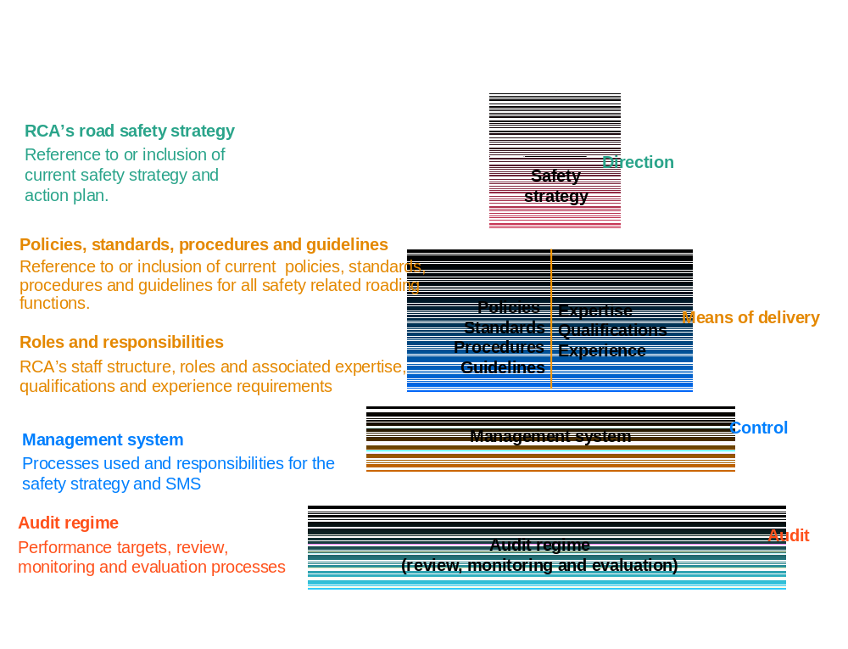
Figure 0.1: Structure of the Rangitikei Ruapehu Wanganui Safety Management System

The SMS is therefore the primary reference document for all “road safety” issues associated with the management of the three networks.

Firstly, the Safety Strategy (Direction) for the three RCA’s is outlined. This includes:
- Road Safety Vision
- Road Safety Problems and Issues
- Road Safety Goals and Targets
- Monitoring and Measuring Road Safety Performance
- Key Stakeholders and Relationships

The Safety Strategy is linked to the government’s national goals for continuous improvement in road safety.

The Safety Strategy is supported by the Means of Delivery. This includes:

- Definition of the road safety “components”, each of which has relevant policies, standards, guidelines and procedures.
- The organisational expertise needed of the RCA’s and their service suppliers.
- Reference to the Safety Management Plan and Safety Intervention Plan – these being supporting processes for network managers and maintenance contractors.

Below this is the Management System (Control) level. This section defines management responsibilities within the system to ensure that:
- The procedures and standards will deliver consistency and desired improvements in road safety.
- The SMS is used by those who have a responsibility for road safety issues on the road network, or adjacent to any road if the activity may have a safety impact on that road.
- Responsibility for key SMS functions is assigned, with a view to ensuring continuous improvement of the system and all related documents with respect to any road safety issues.
- An improvement plan is in place for safety management practices and the implementation and further development of the SMS.

The final section of the Safety Management System below this is the Audit Regime (Review). This section defines the procedures for regular review and audits of the:
- The SMS itself.
- Progress towards road safety targets.
- Use of and compliance with the requirements of the SMS.

SMS Model for Rangitikei, Ruapehu and Wanganui Roads
This SMS covers the local roading networks of the following RCA’s:
- Rangitikei District Council
- Ruapehu District Council
- Wanganui District Council

While the state highway network passes through all of these Districts, these roads are not formally part of this SMS as they are managed by Transit New Zealand. Transit is however a key stakeholder as there are many points of interaction between the networks. A close collaboration is essential in maximising potential safety benefits, and it may be possible in the future to consider a joint SMS which includes the SH’s in the area.

A single SMS has been developed for the three local road networks, referred to as the “Rangitikei Ruapehu Wanganui Roads Safety Management System”. This reflects a desire to work collaboratively in managing and improving road safety across the three networks.

Differences in levels of service between the three Districts are noted and dealt with in the various SMS components in Appendix IV.
The SMS is an important implementation tool within each RCA’s Activity (or Asset) Management Plan, as shown in Figure 0.2.

The SMS also cross-references other documents, such as Standards, Guidelines, Codes of Practice, and Contract Specifications, rather than duplicating information in them.

Network Description
Maps of each RCA network are included in Appendix I. Physical details for these networks are summarised in Table 0.1 below.

District Network | Total Length (kms) | Length Unsealed (kms) | Length Sealed (kms) | Length Urban (kms) | Length Rural (kms) | No of Bridges
Rangitikei | 1238 | 483 | 755 | 92 | 1146 | 221
Ruapehu | 1335 | 880 | 455 | 121 | 1214 | 335
Wanganui | 834 | 301 | 533 | 216 | 618 | 89
TOTAL | 3407 | 1664 | 1743 | 418 | 3051 | 645
Table 0.1: Rangitikei Ruapehu Wanganui Local Roading Networks Physical Characteristics

The main characteristic of the Rangitikei and Ruapehu networks is that over 90% of the roads are rural with speed limits greater than 70 km/h. This influences the type and nature of crashes occurring in these two districts, with those involving loss of vehicle control or excessive speed being the most common.

Much of Ruapehu’s network in particular was developed through seal extensions on unsatisfactory alignments, and this has resulted in a rural network which has a lack of prominent safety features and inadequate design standards.

Wanganui’s roading network is more urban in nature and 64% of all injury crashes in the district occur on urban roads. This is also reflected in the fact that 41% of all injury crashes occur at intersections.

Strategic Linkages
The SMS is driven by legislation and by key Plans and Strategies at the National, Regional and District level, as shown in Figure 0.2.

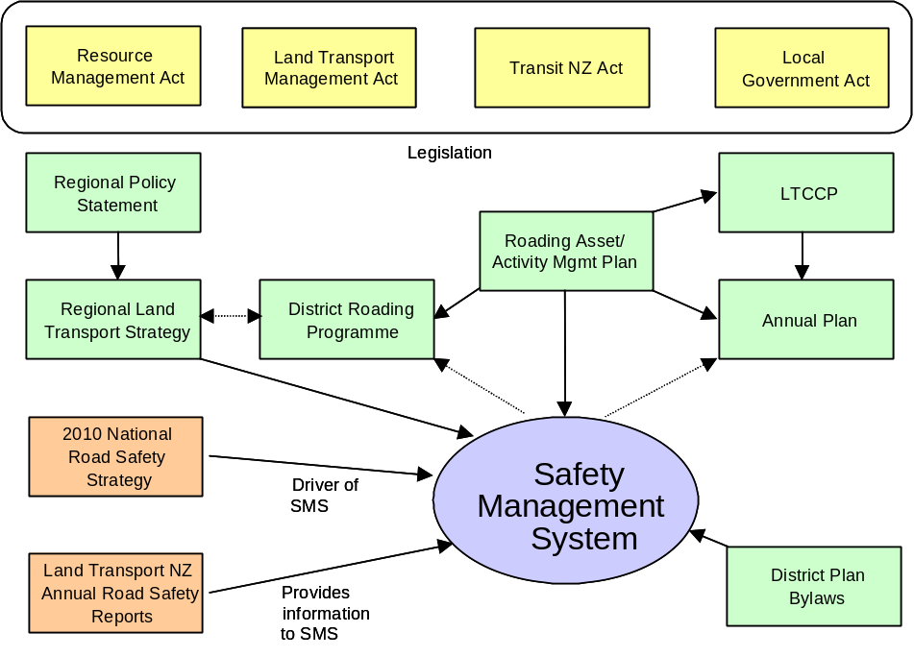

Figure 0.2: Relationship of SMS with Legislation and Other Key Planning Documents

Operational Linkages
The SMS targets a systematic approach, not only within each local authority, but also for externally contracted agencies – consultants and contractors. It is primarily focussed on Engineering operations, but is also relevant to Enforcement and Education. Figure 0.3 illustrates these linkages.

Consultants and contractors engaged in both network management and physical works activities have responsibilities under the SMS. This is important, as the system will only be successful if it is “owned and actioned” not only by Council staff but also by these parties.

District Council asset management staff have a responsibility to establish and monitor the safety performance of their local roading networks. The network manager’s role is to manage safety on a day-to-day basis, this includes management of maintenance contracts and a number of other specific activities as agreed with the client.

The roles and responsibilities of network managers and maintenance contractors is to be further developed and documented in the Safety Management Plan and Safety Intervention Plan respectively. These are further described in Section 3.

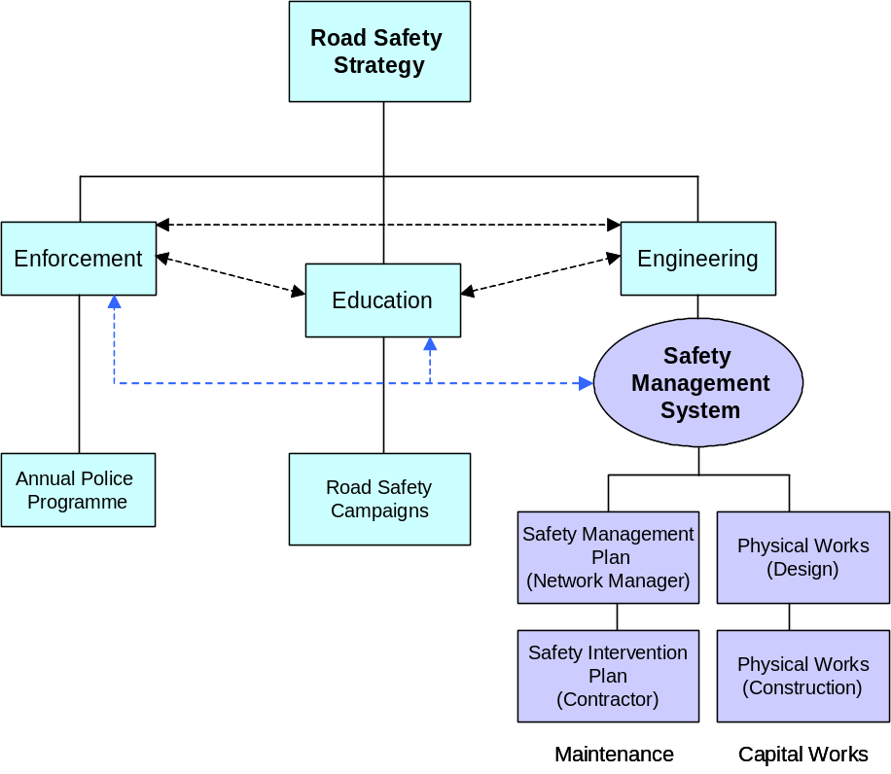
Figure 0.3 : SMS Operational Linkages

Road Safety Coordination
There are strong working relationships between roading staff and road safety coordinators in each District. Coordinators are employed by Horizons Regional Council, one for each District with the Wanganui position being senior and also responsible for regional projects. Reporting is through the Regional Land Transport Committee. Each Council is represented on the RLTC, and the regional Road Safety Committee. Each Council also participates in a local Road Safety Coordinating Committee, and this ensures an exchange of information about safety initiatives and concerns.

Activities often cross District boundaries, requiring the coordinators to work closely together.

The overall objective is to increase the combined effectiveness of the three E’s, to be achieved by continuing to develop appropriate mechanisms.

Police
Police report regularly to the District Councils with meetings being held at each of the three Councils. Achievements in relation to the S(A)P, enforcement and hours are discussed. The S(A)P is confirmed annually, with the opportunity for input by each Council.

The current status of communication and liaison on the Road Safety Action Plan within each District is summarised below:

District Council | Police Area | Communication and Road Safety Action Plan Status
Rangitikei | Wanganui | Quarterly meetings, and RSAP is discussed and agreed.
Ruapehu | Ruapehu | Informal liaison. Not specific about the RSAP.
Wanganui | Wanganui | Quarterly reporting by Police to Committee. Not specific about the RSAP.

Close working relationships between each RCA and the Police are to be developed and maintained. The Road Safety Action Plan is to be discussed and monitored at quarterly meetings of each RCA, Land Transport NZ and the Police.

Communication will include information on crash factors.

This process must be ongoing, and where it is not working well attention is to be given by the RCA and Land Transport NZ to developing a stronger working relationship with the Police. This is to include identification of enforcement priorities and hours and sharing knowledge on road safety problems and initiatives. Efforts to increase the level of communication and reporting on Police achievements within each RCA area are to be promoted.

Transit New Zealand
Transit is responsible for the State Highway network, and there are many points of interaction with the Local Roads networks and with community interests. This requires a close working relationship between each RCA and Transit, with regular communication about matters of mutual interest on the networks.

A Transit NZ representative will be invited to participate in future Safety Management Team meetings (Imp’t plan action).

Road Safety Strategy (RSS)

Introduction
Currently there is no specific road safety strategy in place for any of the three Councils. This RSS therefore provides direction for the SMS. The RSS is to be reviewed after one year in consultation with key stakeholders.

This section shows how the RSS relates to national and regional strategies, reviews historical crash trend data, defines future road safety targets for each District, and identifies key stakeholders.

Road Safety Vision
The first step in developing the RSS is to confirm a clear, achievable road safety Vision for the three networks.

National Vision
The government’s transport vision is that “by 2010 New Zealand will have an affordable, integrated, safe, responsive and sustainable transport system”.

Regional Vision
The Manawatu-Wanganui region covers all of the Districts in this SMS, and extends to Tararua and Horowhenua in the south-east. The safety component of the long-term vision is for a “land transport system in the Region which …..is the safest possible…”. This must be balanced against other competing needs, and the RLTS includes 6 objectives, one of which relates to safety.

District Outcomes
Each Council has produced a Long Term Council Community Plan and Asset Management Plan, which include desired outcomes in relation to transportation and safety:

District Council | LTCCP Outcomes relating to Road Safety | Other Goals relating to Road Safety
Rangitikei | na | AMP purpose includes – “providing a road network that meets generally accepted standards”.
Ruapehu | “Safe, reliable, efficient road, air and rail transportation” | AMP Strategic goal – “the land transport network provides for the safety of its users”.
Wanganui | “A safe and healthy community” | Rural Roads Strategy – “to provide road users with a sustainable, safe, and cost-effective roading system…”

Vision for the “Three Networks”
“The transport network is safe for all road users”

Key Road Safety Issues and Problem Analysis
From analysis of five-year crash data and trends from 1999 to 2003 for each RCA, the major road safety issues in the Rangitikei, Ruapehu and Wanganui Districts compared with national trends are summarised below:

Issue | RaDC | RuDC | WDC | National
Alcohol |  |  | ∗ | ∗
Fatigue | ∗
Intersections |  |  | ∗
Loss of Control | ∗ | ∗ | ∗
Road/ environmental factors |  | ∗
Speed | ∗ | ∗ |  | ∗
Vulnerable Road Users |  |  | ∗
Table 0.2: Rangitikei, Ruapehu and Wanganui’s Major Road Safety Issues

Note that these issues, and the Road Safety to 2010 goals and targets, include both State Highways and Local Roads. However, this SMS is only concerned with Local Road networks.

Crash rates for the three Local Roads networks are shown below, compared with national and “similar group” trends. These indicate the “relative exposure level” in relation to the total distances travelled on each network. Of particular note is the increase for urban roads in Wanganui District, while other trends are generally similar to national or “similar group” RCA’s.

The RLTS, which was last updated in June 2000, notes an overall downward trend in road crashes in the region. Forestry, tourism, freight volumes, and an increasing demand for travel are all factors likely to affect road safety in the future.

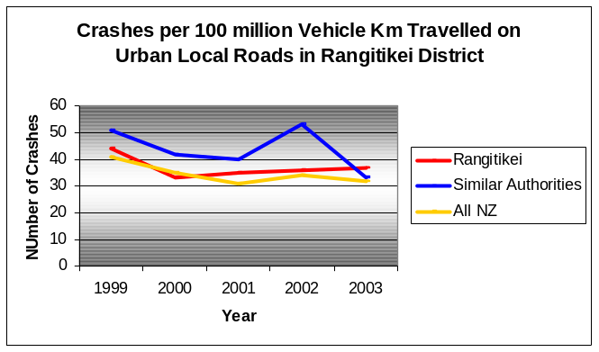
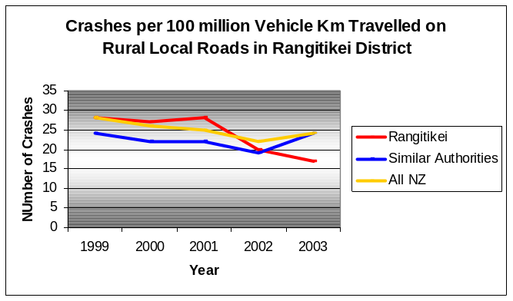

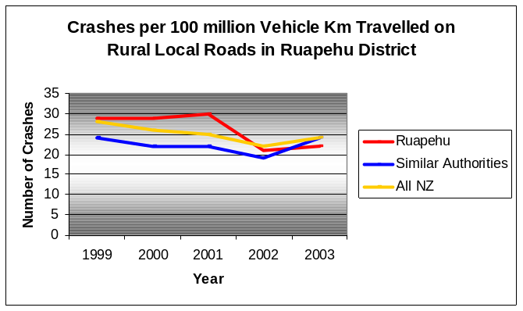
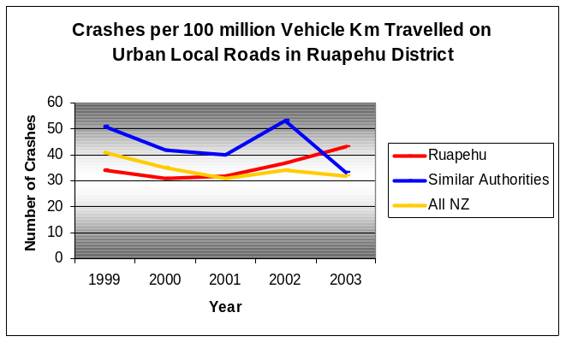

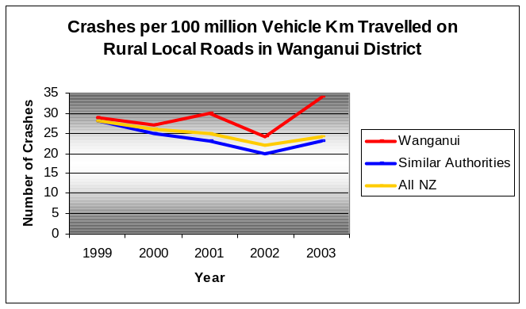
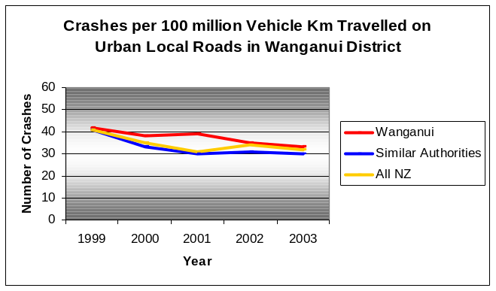

The social costs of crashes on the Local Roads networks are based on the economic costs of fatal, serious and minor urban and rural crashes, with an allowance for unreported crashes and non-injury crashes. The following graphs show quite different trends between districts, and between urban and rural roads.

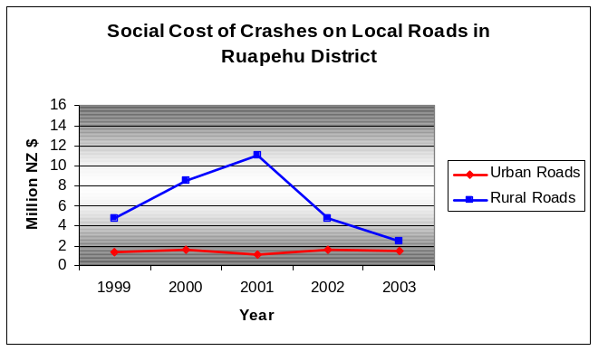
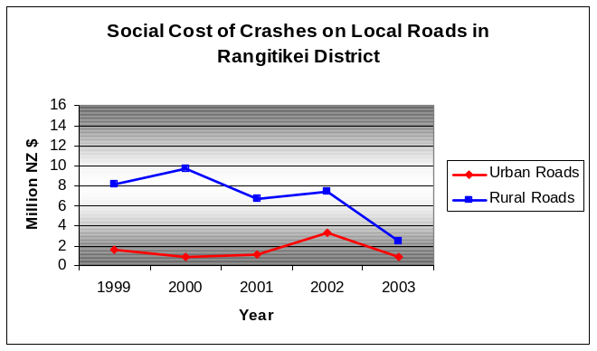

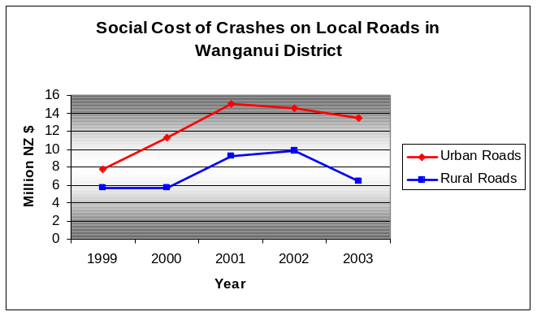
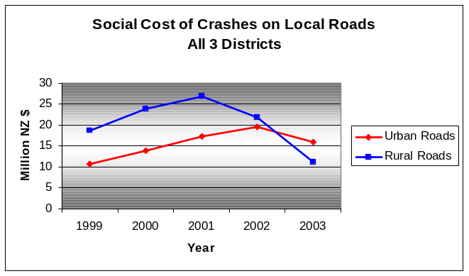

The number and dispersal of crashes throughout the rural networks in particular highlights the random nature of crash events and the need to understand the underlying causes. For example, the proximity of crashes to State Highway intersections and the extent to which these are a factor.

The major safety issues and suggested mitigation actions are further discussed for each District in Appendix III, and a number of these actions involve engineering interventions. Addressing these issues is expected to have a significant effect in achieving the safety targets.

This information has been sourced from the 2003 LTSA “Road Safety Issues” reports and most recent statistics for each RCA.

Road Safety Goals and Targets

National and Regional Goals
The national goal of the Road Safety to 2010 strategy is to reduce the number of road deaths per year to no more than 300 and hospitalisations to no more than 4,500 by 2010. This will enable the country’s road safety performance to be closer to that of countries with the best safety records.

There are no specific road safety goals in the RLTS, however safety related policies include:
- “promote a safer roading network
- encourage a coordinated approach to road safety
- promote the development of systems that improve the reporting, recording and investigation of road crashes
- improve safety for cyclists and pedestrians”.

Note that the RLTS has no specific safety targets or performance measures.

Other regional policies in the RLTS, such as the promotion of road network upgrading and provision for cyclists and pedestrians within the roading network, are also relevant to the SMS. This SMS is consistent with these policies and is a means of giving effect to them.

RSS Goal
Between 2000 and 2004 the average annual figures for fatalities and serious casualties on roads within the Rangitikei, Ruapehu and Wanganui Districts (State Highways and Local Roads) were:
- Fatalities 18
- Serious Casualties 70

The specific goal of the Road Safety Strategy for the three Districts is to:

“Annually reduce the number of fatalities and the number of serious casualties resulting from road crashes within the group of three RCA’s in line with the RLTS and Road Safety to 2010 Strategy targets”.

District Targets
Road Safety to 2010 sets regional targets for the maximum total number of deaths and hospitalisations for 2004 and 2010. Hospitalisation data is not currently available for each of the Districts, so serious casualties trends have been used instead. This Strategy has set the following target outcomes for deaths and serious casualties for each District, using on average a target reduction level of 25% from the 3 year average. The reduction in fatalities is higher, reflecting the need to reverse an increasing trend over the last few years in some Districts. As these targets include Local Roads and State Highways, they are to be regarded as guidelines pending the development of Local Roads network targets (Improvement Plan action). It is also to be noted that the SMS is only one of several initiatives influencing road safety.

The following table lists the targets for 2005 and 2010. Between 2002 and 2003 the reporting rate of serious injuries to hospital admissions was 63% for the Manawatu-Wanganui region. This is slightly lower than the 67% reporting rate for the whole of New Zealand. Hospitalisation data will need to be obtained from health agencies for future monitoring purposes.

 | 2005 Deaths | 2005 Serious Casualties | 2005 Total | 2010 Deaths | 2010 Serious Casualties | 2010 Total
Rangitikei | 7 | 18 | 25 | 4 | 13 | 17
Ruapehu | 3 | 13 | 16 | 2 | 10 | 12
Wanganui | 6 | 28 | 34 | 4 | 22 | 26
All Districts | 16 | 59 | 75 | 10 | 45 | 55
New Zealand |  |  |  | 300

Historic fatality and serious casualty trends and the above targets are shown graphically below.
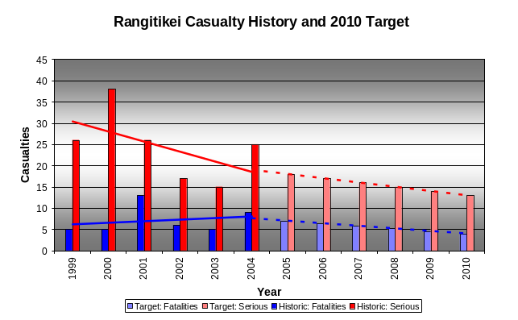
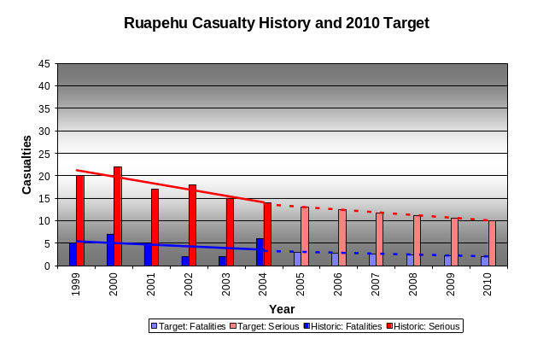

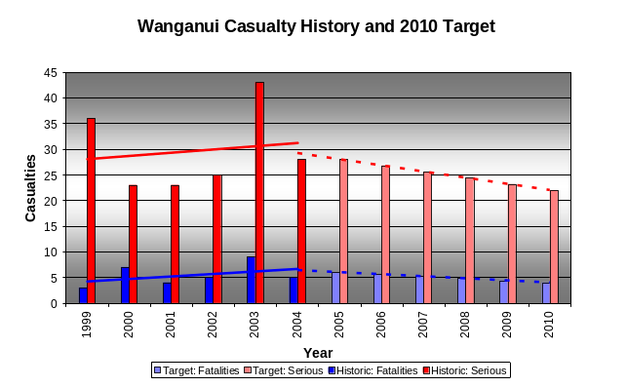

Note that these targets include crashes on both State Highways and Local Roads.

Similar targets for crash numbers on the local roads networks are shown separately below. Monitoring these will enable the impact of initiatives on the Local Roads networks to be better assessed.
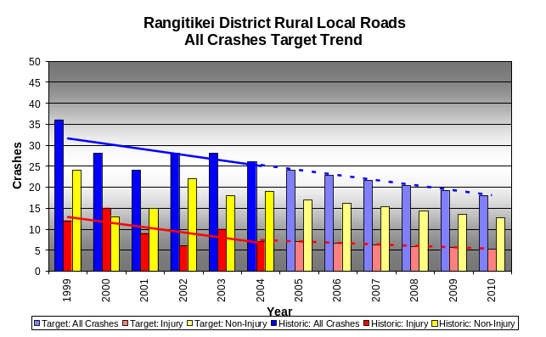
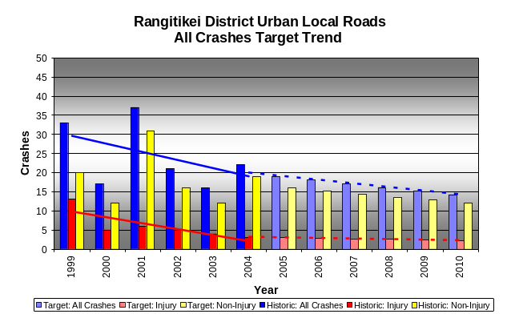

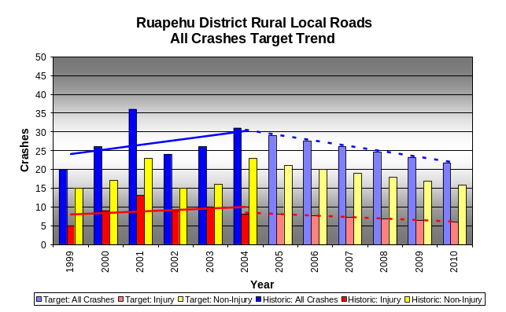
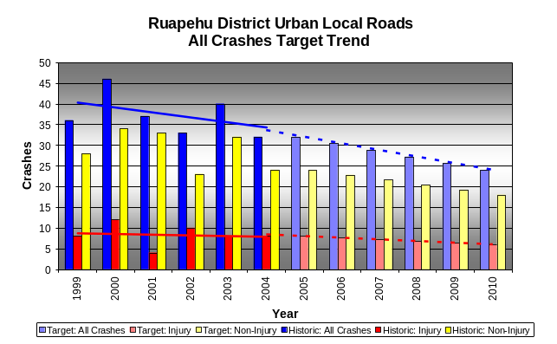

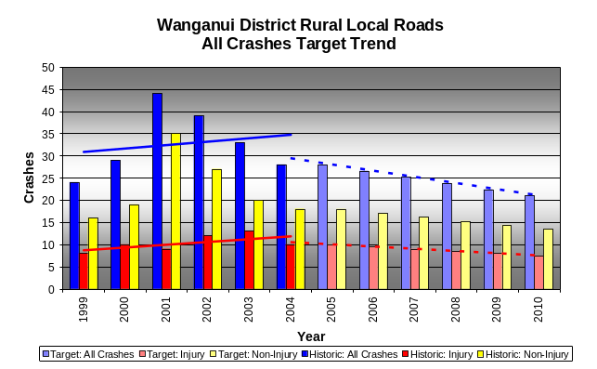
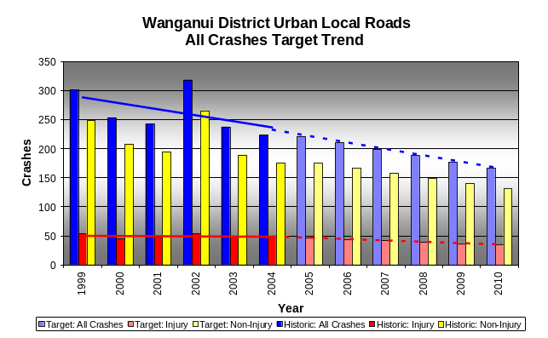

Generally, historical trends over the last 5-6 years have been downward. In the case of Wanganui, the longer term trend (ie since 1990) has been reducing, with low figures in the late 1990’s tending to mask this trend.

Note that some of the reported crashes above may occur off the local roads network, and therefore lie outside the direct control of the Council.

Safety Action Programmes
This SMS, along with the Safety (Administration) Programme, Road Safety Action Plan, and the potential actions listed in Appendix III, provides the basis for a number of activities and tasks to be programmed and implemented in a structured and coordinated manner – in order to achieve the goals and targets in the RSS.

Each RCA will therefore be actively involved in the safety planning process, identifying and monitoring the performance of programmed actions.

Monitoring Road Safety Performance
The objective of the SMS is to increase the level of safety of the Local Roads networks.

Monitoring of the target trends will be undertaken as part of the annual review of the SMS and the achievement of its goals.

In addition, RCA’s establish levels of service (LOS) and performance measures for safety in asset / activity management plans, and these are also to be reviewed in the evaluation of the effectiveness of the RSS.

All of these trends can be influenced by actions taken in engineering, education and enforcement.

Three E’s Indicators
“Engineering” is the responsibility of the individual RCA’s with the support of other organisations such as Land Transport NZ.

“Educational” programmes may be national or local. Land Transport NZ manages national campaigns. Education and promotion activities may also be delivered by local agencies, and coordinated by local road safety coordinators.

“Enforcement” is the responsibility of the NZ Police.

While responsibility for delivery differs in each of these three areas, there is significant interaction between them. Regular meetings and communication are needed to coordinate activities, such as through the Road Safety Action Plan process (this is included as part of the NZ Road Safety Programme process), along with Risk Targeted Patrol Plans – these are all important road safety planning components.

Typical measures, in addition to the target trends above, which RCA’s may select from for annual reporting are noted below.

Engineering
- Value of Minor Safety Works undertaken per year, for example as triggered through the SMS
- Actions undertaken specifically as a result of the SMS (eg with reference to the SMS Improvement Plan)
- Results of specific investigations or crash reduction studies in relation to the effectiveness of remedial measures undertaken – typically reported by Land Transport NZ
- Number of injury crashes in which a “local road” was a contributory factor.

Education
- Outcomes of campaigns on community behaviour, attitudes and culture.
- Numbers of road safety educational campaigns run per year.
- Evaluation and reporting results for specific campaigns.

Enforcement
- NZ Police under-reporting rate as defined by Land Transport NZ.
- Number of infringement notices issued for key offences, such as drink / driving, lack of restraint, speeding and failure to give way
- Time spent on key enforcement activities, such as drink driving, lack of restraint, speeding and failure to give way
- Targeted enforcement through use and deployment of RTPP’s developed through the RSAP process

Road Safety Stakeholders
A number of agencies will be involved in implementing the RSS or have an interest in it, and some have a role in implementing the SMS, as shown in Table 0.3 below. This list forms the basis for consultation on future reviews of the RSS.

Agency / Sector | Specific Organisations / Sector Groups | Key SMS User
Rangitikei, Ruapehu and Wanganui RCA’s |  | Yes
Network Managers |  | Yes
Consultants |  | Yes
Contractors – maintenance (key) |  | Yes
Contractors – projects |  | Awareness
NZ Police & Emergency services |  | Awareness
Land Transport New Zealand |  | Advisor/Sponsor
Transit New Zealand |  | Awareness
Utility Services |  | Yes
Road Safety Coordinators |  | Awareness
Regional Councils |  | Awareness
Health Authorities | Good Health Wanganui  Waikato Health | Awareness  Awareness
Accident Compensation Corporation |  | Awareness
Road User Groups | Public  Automobile Association  NZ Road Transport Association  Heavy Haulage Association | No  No  No  No
Sectors | Dairy Industry  Forestry Companies  Ski Industry  Tourism | No  No  No  No
Table 0.3: Road Safety Stakeholders

Policies, Standards, Procedures and Guidelines

Introduction
This section outlines the framework by which RCA’s manage road safety on each network. It refers to the SMS procedure components in Appendix IV, each of which incorporates reference to specific Policies, Standards and Guidelines. The list has been derived from the components in the “Guidelines for developing a Safety Management System” (LTSA).

Two tools that require further development in implementing this SMS are the Safety Management Plan and Safety Intervention Plan. These define the safety related roles and responsibilities of network consultants / managers and maintenance contractors, and provide a basis for defining future contractual requirements for managing safety. Support for developing these tools will be sought from Land Transport NZ.

Another tool is the AS/NZS 4360 risk management framework, which is to be used for the identification and rating of road safety risks on the network, and prioritisation of the SMS components. This framework is consistent with that used in Asset and Activity Management Plans.

Road Safety Activity Components
The SMS procedures described in Appendix IV cover a wide range of activities carried out within the road reserve, and are to be used by Council staff, Consultants and Contractors as is appropriate to the activity. The SMP and SIP when developed will link to these activity sheets.

It is important that judgement be used when applying standards and guidelines. Where a departure is considered to be necessary, it must be recorded and the Asset Manager notified. In situations where there is no appropriate documented standard or guideline, users should refer to and use others as contained in Appendix II with the approval of the Asset Manager.

Categories
A brief outline of the SMS activity component categories follows:

Planning
These components provide guidance with network and planning controls in relation to specific safety planning activities, and will largely be used by asset management staff and planners.

Capital Works
These components provide guidance for activities relating to the design of new assets, and will be used largely by asset managers, project designers and contractors.

Traffic Data
Provide guidance to the collection and utilisation of roading and traffic data for safety planning purposes.

Safety Operations
Provide guidance across a range of activities, including speed, network inspections / auditing, crash reduction studies, deficiencies, etc, leading to the development of safety programmes.

External Agencies
Provide guidance for temporary traffic control and relationships with other organisations which can impact on safety.

User Services
Provide guidance for dealing with applications for specific services or activities on road reserve.

Assets
These components provide guidance for activities relating to specific asset groups (which should be consistent with those in the AMP), to be used largely by network consultants / managers and maintenance contractors.

Maintenance
These components provide guidance for the development and review of maintenance contracts and emergency response procedures.

SMS Procedures
For each road safety component, procedures are typically grouped from the following headings:
- Inspection / Monitoring – inspecting or monitoring of an activity, contractor performance, asset condition or performance, or any other factor that may affect safety
- Planning Procedures – for establishing and implementing safety requirements in the District Plan
- Development Standards – definition of the standards to which the roading network is to be developed, particularly subdivisions, but also applicable to new works.
- Operational Procedures – practices and processes relating to safety planning and assessment.
- Emergency Maintenance – procedures and levels of service for urgent work, key response times, etc, impacting on safety
- Routine Maintenance – procedures and levels of service for maintenance activity which impact on safety
- Capital Works – procedures for capital projects, including design and construction standards, which impact on safety
- Audit Requirement – specific safety auditing practices, such as network, capital works, road openings and maintenance
- Review, Monitor and Evaluation Requirements – for assessing and improving a procedure / component and its impact on road safety

Safety Management Plan
From the Guidelines for Implementing a Safety Management System (LTSA), “a Safety Management Plan (SMP) is a document which provides project control for the network consultant, identifying the safety issues, concerns and deficiencies and prioritising them for investigation, improvement or mitigation with a recognition of the funding requirements. It should allow for the implementation and monitoring of improvements, and be reviewed jointly by the RCA, the network consultant and network contractors annually”.

The purpose of the SMP will therefore be to formalise and document the specific safety related responsibilities of the network manager where this role is fulfilled by an external consultant. An SMP is therefore to be developed for each of the Wanganui and Rangitikei networks by each Council and their network manager (refer Improvement Plan). It will then form part of the SMS. Ruapehu District manages its network internally, and will therefore focus on SMS based implementation activity.

The SMP will document:
- Council and Consultant responsibilities – including SMS training, intervention levels, communications, and requirements for managing contractors
- How safety issues, concerns, and deficiencies are to be identified and recorded
- Managing and reporting on the Safety Deficiency Database
- Managing and reporting on the Safety Hazard Register
- Network safety inspections (day and night) and existing road safety audits
- Network safety deficiency analysis which shall include, where relevant:
  - Crash review, analysis and reporting
  - Fatal and serious crash reporting
  - Crash reduction and prevention studies
  - Black spot studies
  - Grey spot studies
- Safety issue prioritisation, which shall be based on risk analysis / risk profiling
- Programming of the proposed safety treatments
- Development and implementation with the network maintenance contractor of the Safety Intervention Plan (SIP)

Figure 0.4 shows how these elements are to be integrated so that:
- All relevant safety information is brought together for assessment and analysis, and
- Safety management tasks can be defined and scheduled within each area
- Works programmes include prioritised safety treatments

The inputs to the process shown in this diagram are incorporated in the SMS activity sheets in Appendix IV.

Activities are linked, for example, pavement surface skid resistance is to be considered where loss of control crashes occur – initial guidance for site identification for testing / investigation is provided in Appendix V.

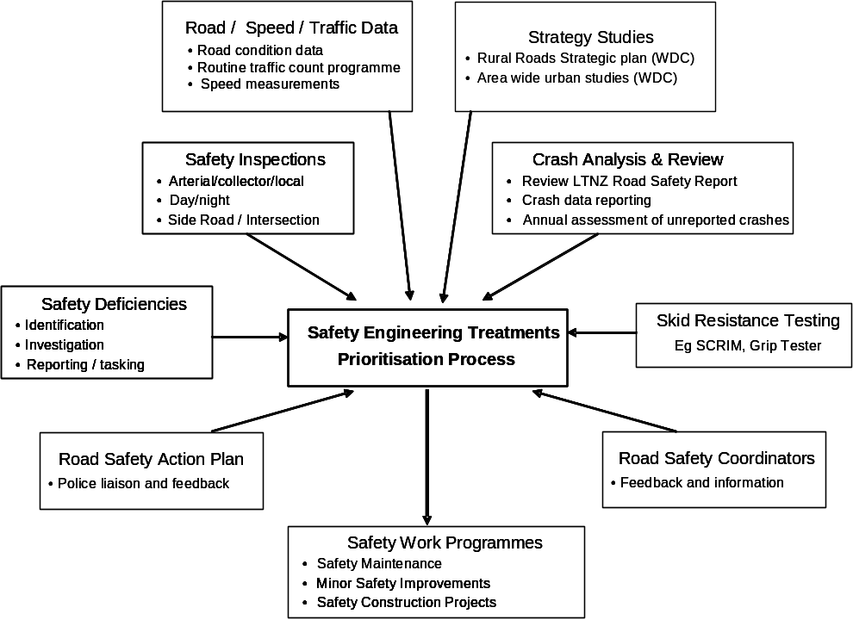
Figure 0.4: Safety Planning Integration

Safety Intervention Plan
From the Guidelines for Implementing a Safety Management System, this plan “provides the network contractor(s) with a system of works based on acceptable level specifications for road assets, including surface, drainage, marking and signage. When the condition of an asset falls below the acceptable level, intervention is usually required by way of repairs or renewal”.

The SIP therefore provides guidance to maintenance contractors to enable the prompt detection of deficiencies, allowing early intervention so that a safe, “no surprises” roading network is achieved.

The SIP is also expected to raise the level of safety consciousness of all staff involved in road maintenance.

It achieves this by:
- Providing guidance on the programming of safety related maintenance work
- Providing a basis for the development of internal systems to achieve safety related contract responsibilities
- Its coverage includes:
- Inspections
- Work prioritisation and programming
- Treatment selection
- Work execution
- Monitoring and recording
- Hazard register

For example, contract response times for different maintenance actions can have a significant safety impact.

The initial SIP will be developed jointly by the network manager / consultant and contractor, with joint reviews occurring on an annual basis (refer Improvement Plan). Reviews will target operational procedures and ensure that they capture current safety related best practice. The SIP may relate to contractual performance measures. Review outputs will provide feed-back to the SMS.

Safety Planning Related Activities

Wanganui
A Rural Roads Strategic Plan was developed in 2001 in response to concerns about future growth in forestry traffic, winding hilly roads, and the conflicts with local use.

It included a review of standards and levels of service, and defined a large number of objectives and policies relating to safety, such as:
- To undertake crash-reduction studies, safety management strategies, and safety audits to identify possible safety improvements
- To generally improve the safety of the rural roads system, in particular by addressing crash blackspots

Priorities, many of which can be implemented through the Minor Safety Works programme, include:
- alignment improvements, especially in high crash areas
- “no surprises” road environment – target speed environment anomalies,
- better visibility – eg sight distances on narrow winding roads
- improved safety and traffic management at work-sites
- more passing opportunities

The Strategy is to be reviewed every 3-5 years.

Two other studies have since been initiated, and also two route based studies.

In parallel with a 2003 Crash Reduction Study, Wanganui DC has developed an area wide investigatory approach to safety in urban areas, beginning with the Laird Park area – a part of the network characterised by a grid layout, wide streets, and a high intersection crash rate. This study identified extensive safety related issues, which require more investigation to identify appropriate solutions. Solutions could include, for example, the programmed narrowing of overly wide low volume roads to NZS 4404 standards to reinforce the roading hierarchy.

About one study is carried out each year, with the intent of eventually covering the whole city. The Police complement study findings with targeted enforcement.

Study results feed into lists of works for justification and prioritisation.

Identification of Safety Deficiencies
An important aspect in managing safety is the identification of safety deficiencies, and defining how they will be mitigated or corrected.

Figure 0.5 illustrates the general procedure for identifying, recording and treating safety deficiencies on the network. The management systems needed to implement this procedure are to be recorded in the SMP and SIP by the network manager and Contractor respectively. This will need to include clear criteria and responsibilities for deciding whether the issue is safety related or not.

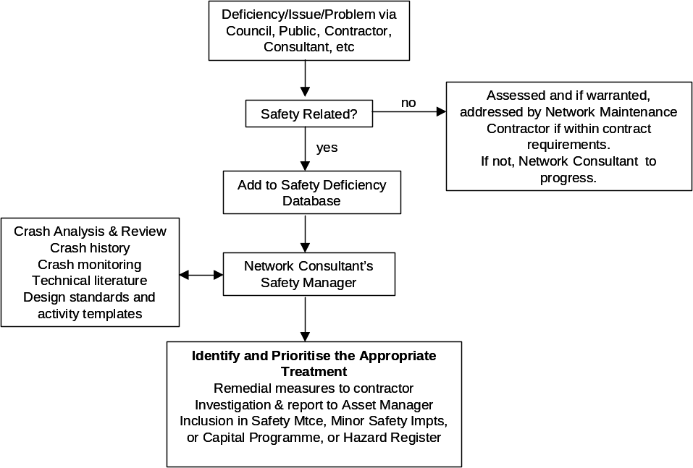
Figure 0.5 : Safety Deficiency Process
The safety deficiency database is to be developed. This will draw on national work being undertaken by Land Transport NZ, which has reviewed existing systems in use and is developing appropriate practice for different types of authority.

Risk Identification, Evaluation and Management
The following framework, which is consistent with AS/NZS 4360 and current best practice asset management planning, is included to provide a basis for:
- Prioritising specific road safety activity components to be included in the SMS
- Assessing the risk exposure of safety deficiencies / hazards identified on the network, and prioritising remedial measures

Asset management plans currently deal with risk management as follows:
- Rangitikei – includes a more detailed risk analysis process for safety, a risk register is maintained for each asset group (eg roading), and this includes safety.
- Ruapehu –
- Wanganui – risk is included in the AMP, however this is not specific to safety.

The SMS has been developed on the basis that:
- All items identified in the LTSA’s “Guidelines for the Developing a SMS for RCA’s - Version 2”, with a “Must be included” ranking have been included.
- All significant risk items identified to date have appropriate systems, procedures, policies, standards and guidelines currently in place to ensure effective safety management.
- Other components included in the activity sheets relate to a perceived High or Medium risk as defined by the following Risk Evaluation Matrix.

Risk Evaluation Matrix – Risk Exposure Level
Likelihood  Severity | Frequent | Probable | Occasional | Remote | Improbable
Catastrophic | High | High | High | High | Medium
Critical | High | High | High | Medium | Medium
Major | High | High | Medium | Medium | Low
Minor | High | Medium | Medium | Low | Low
Negligible | Medium | Medium | Low | Low | Low

Hazard Severity
Severity | Definition/Description
Catastrophic | Will cause multiple fatalities
Critical | Likely to cause a fatality
Major | Could possibly cause a fatality
Minor | Could cause serious injury
Negligible | Not likely to cause serious injury

Hazard Probability
Likelihood | Definition/Description
Frequent | Likely to occur frequently (once/year)
Probable | Likely to occur occasionally (once/5 years)
Occasional | Likely to occur at some time (once/10 years)
Remote | Will rarely occur (> 10 years)
Improbable | Unlikely that the occurrence may ever be experienced
Table 0.4: Risk Evaluation Assessment

Crash Reporting

State Highway Crashes
Many crashes in rural Districts occur on State Highways, and it is useful for each RCA to have good information on whether crashes are occurring on State Highways or Local Roads so that resources can be appropriately targeted.

In the case of Ruapehu District the Council receives many complaints from residents about crash related issues on SH’s. However, the Council does not have access to SH crash information and is often unable to assist residents. A better understanding of the SH network in the Ruapehu District is needed, and a number of measures are proposed to help achieve this, including (Improvement Plan action):
- Sharing of crash information between RCA’s
- Safety issues included as an agenda item in regular liaison meetings
- Use CAS to enquire about SH crashes
- Obtain copies of engineering reports from fatal crashes on the SH network

Unreported Crashes
Crash reporting rates vary throughout the country, depending on factors such as Police presence and remoteness.

There are likely to be many sites in remote rural areas which are crash-prone and for which there are few recorded (albeit minor or non-injury) crashes. There is merit in improving knowledge about non-reported crash sites, as any site with a non-injury crash record has the potential for a more serious crash. This however does need to be balanced with the available level of resources to enquire and investigate, and given the often very low levels of traffic it may be considered un-economic to capture unreported crash data.

Ruapehu has high numbers of unreported crashes and intends to capture better data. This will involve the development of procedures for obtaining non-reported crash data and assessing sites for potential treatment (Improvement Plan action).

Wanganui has a number of key areas that are monitored by locals, however there is a desire to improve the process (Improvement Plan action).

Roles and Responsibilities

Introduction
This Section describes the safety responsibilities, roles and desirable levels of expertise of roading personnel engaged in activities that contribute to safety on the Local Roads networks. The safety related experience of staff from Council, consultants and contractors should be reviewed annually and training records maintained to confirm their ongoing competency.

Organisational Structures
The following diagrams illustrate the organisational structures within each RCA, including the provision of network management and maintenance contract services.

Also important are the safety related interactions with other internal departments within each Council. These are recorded in the detailed SMS procedure sheets in Appendix IV.

Rangitikei District
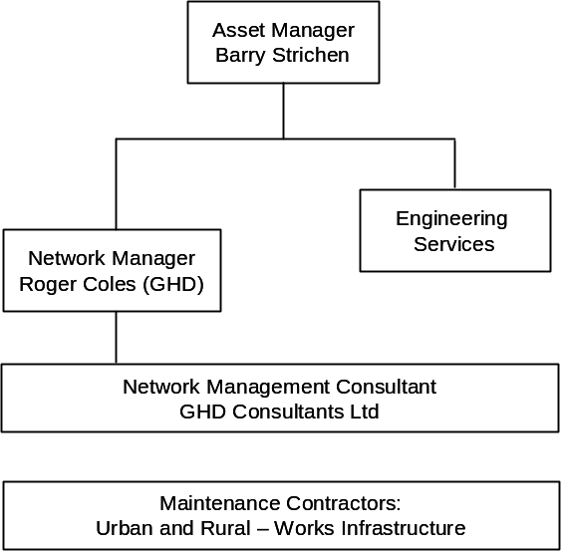

Ruapehu District
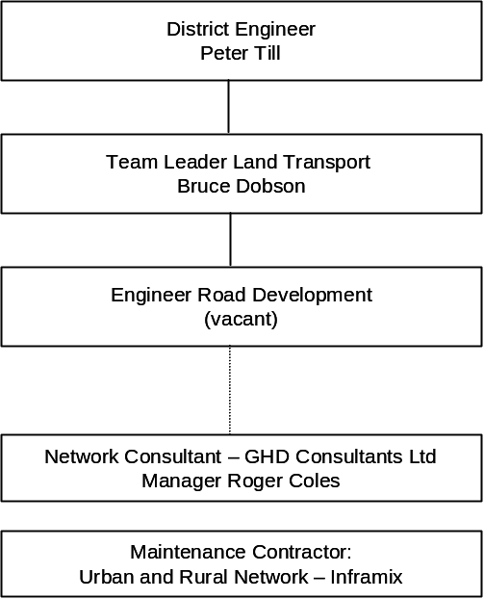

Wanganui District
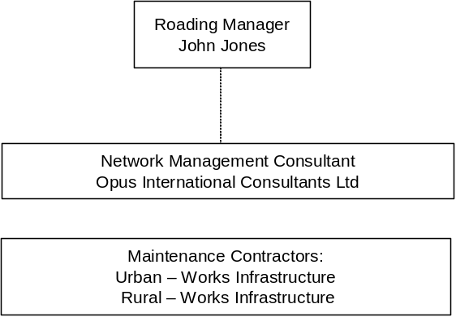

Safety Management Team (SMT)
The establishment of a Safety Management Team, involving each key participating organisation in the SMS, will encourage ownership of network safety and foster a safety culture within each organisation. An indicative team structure is shown below.

Other key agencies who are involved in the delivery of safety, and with whom close working liaison will be needed by the SMS team, are shown in this diagram.

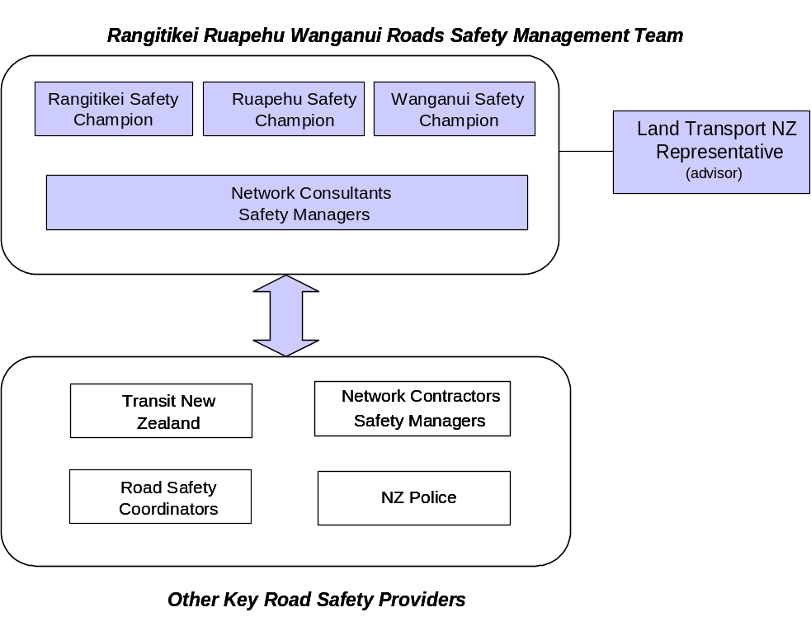
Figure 0.6: Safety Management Team Structure and Relationships

An SMS Team Leader is to be nominated by the SMT – this person will take responsibility for “championing” the SMS within the group and promoting a coordinated approach.

The present SMS Team Leader is Roger Coles of GHD Consultants.

Safety Managers / Safety Champions
This team structure identifies the need for a “safety manager / safety champion” role within each organisation. The role needs to be developed within Councils, network manager and maintenance contractor organisations – and is the key person responsible for the promotion of road safety. A key aspect is developing the road safety culture in the organisation, and ensuring buy-in and implementation of the SMS.

Network managers and contractors are expected to undertake training and development of this role within their organisations, and this is to be included in future tender proposals.

Safety Managers / Safety Champions are expected to have or gain an intimate knowledge of the safety issues within the RCA’s roading network through experience and over time.

The designated safety champions are:
- Rangitikei Barry Strichen
- Ruapehu Bruce Dobson
- Wanganui John Jones

Other staff who contribute to road safety also have a role to play in contributing to the successful outcomes of the safety teams within each organisation.

Safety Culture, Training and Development
The development of a safety culture within the SMT is critical to the effective successful implementation of the SMS. A strong safety culture should ensure that safety is a routine consideration in all day-to-day activities.

All staff contributing to safety should be trained and suitably skilled to deal with road safety issues which are expected to arise on the roading network. This will involve recruitment, and the training and development of staff.

Training levels for personnel involved in the SMS process shall be reviewed annually by the SMT. Particular safety related qualifications/training that could be considered for Council/consultant/contractor staff include:

- Training in Land Transport NZ’s Crash Analysis System (CAS).
- Transit NZ’s Temporary Traffic Management at Roadwork Sites.
- Land Transport NZ’s Safety Audits of Existing Roads.
- Road Safety Engineering Course (covering crash reduction studies, safety auditing, etc) – Land Transport NZ, NZIHT

Furthermore, encouragement will be given to service authorities and commercial road occupiers to develop a safety culture and safety champion approach.

Wide distribution of the SMS and Road Safety Strategy within SMT organisations and key stakeholders will emphasise key road safety issues and promote greater safety awareness within them.

Safety Roles and Competence
The roles of SMT member organisations are defined as follows:

District Councils – audit and control the safety management process.

Network Manager / Consultant – manage the safety process on a day-to-day basis, including the identification of safety related deficiencies and monitoring of solutions. May be an external professional services provider or an in-house business unit.

Network Maintenance Contractor – maintain and improve the network. Minimise safety deficiencies through proactive intervention.

Suggested levels of competence are defined in Table 0.5 for each position for particular safety management functions on the road network. These should be used in Job Descriptions and in recruitment and training development.

Competence Level |  | Description of expected abilities
A | Appreciation | Recognises the purpose of the activity or infrastructure element. Knows who can help and what the likely processes are in responding to requests and notifications. Can assess the need for urgency.
U | Understanding | Understands the processes and decisions involved. Appreciates the impact of options available and can identify the appropriate response within readily available guidelines
C | Competence | Develops appropriate solutions without supervision, drawing on previous experience and training. Can identify when expert or specialist assistance is necessary.
E | Expertise | Provides specialist advice, training and supervision in the relevant field. Can develop guidelines for others to determine actions, assess the implications of trends and offer options for solution.
Table 0.5: Safety Competence Levels

Specific requirements for the levels of each position are defined below. Note that some individuals may have one or more roles in this table.

SMS Function / Component Grouping | DC Senior Eng’g Manager / Director | DC Road Asset Manager | DC Safety Champion | DC Utility Assets staff | DC Planning staff | Network Manager Team Leader | Network Manager Safety Champion | Network Manager Contract Mgmt | Network Maintenance Contractor Team Leader | Design Consultants | Construction Contractors | Utility Services (external) | Utility Services Contractors
PLANNING | A | C | U | U | E | U | U | U | A | U | A | U | A
CAPITAL WORKS | A | U | U | C | U | U | U | U | A | E | E | U | C
TRAFFIC DATA | A | U | C | U | A | C | C | C | C | C | C | C | C
SAFETY OPERATIONS | A | C | E | C | C | C | E | E | C | U | A | A | A
EXTERNAL AGENCIES | A | C | C | E | A | C | E | E | U | A | A | E | C
USER SERVICES | A | C | C | A | U | C | E | E | U | A | A | A | A
ASSETS | A | E | C | A | A | C | E | E | C | C | U | A | A
MAINTENANCE | A | E | C | U | A | C | E | E | E | U | U | U | U
Safety Management Plan | A | U | C | A | A | C | E | E | E | A | A | A | A
Safety Intervention PLan | A | A | U | A | A | C | C | C | A | A | E | A | A
Table 0.6: Safety Roles and Expertise

Key positions from above within each organisation are currently as follows:

Position | Rangitikei | Ruapehu | Wanganui
Senior Manager / Director | Barry Strichen | Peter Till | John Jones
Roading Asset Manager | Barry Strichen | Bruce Dobson | John Jones
Safety Champion | Barry Strichen | Bruce Dobson | John Jones
Network Mg’mt Team Leader | Roger Coles | Ros McLachlan | John McGeorge
Network Mgm’t Safety Champion | Roger Coles | Ros McLachlan | Jim Moore
Network Mgm’t Contract Manager | tbc | Carey Morris | Simon McSweeney (U)  Graham Dhyrberg (R)
NM Contractor TL | Dave Nicholls | Brett Simpson | Glen Campbell
Design Consultants | GHD | GHD | Opus

Management System

Introduction
The Management System must ensure that all activities follow the appropriate SMS policies and procedures, and that they will contribute to the achievement of road safety goals for each District. The system is cyclic and has an annual review. This Section sets out the management responsibilities and systems necessary to achieve this objective. It also includes a continuous improvement plan.

The following diagram illustrates the overall management cycle.

Management
System
SMS Audit
Regime
SMS
Implementation
SMS
Improvement
Plan
Check
Act
Do

Management Responsibilities
The following staff have overall responsibility for implementing, auditing, and improving the Safety Management System within each Council, in line with the overall framework above. These responsibilities may be delegated as appropriate.

 | Management Responsibility
Council | Implement SMS | Monitor SMS | Develop/improve SMS
Rangitikei | Roger Coles | Jointly undertaken by the 3 RCA’s and Land Transport NZ Area Engineer | Barry Strichen
Wanganui | Jim Moore |  | John Jones
Ruapehu | Bruce Dobson |  | Bruce Dobson

All Council staff, network managers, and contractors are responsible for applying the SMS procedures to their activities. The adoption and day-to-day use of the SMS will require significant “buy in“ from all of these organisations.

Network managers are to manage the safety process in terms of identifying deficiencies and the determination, actioning and monitoring of solutions.

Network contractors are required to maintain and improve the network.

A close working relationship between these two parties is critical in maximising the benefits of the SMS.

Acceptance of the SMS by other key stakeholders such as Land Transport NZ, NZ Police and the wider community is also important. Therefore a partnership approach is proposed, involving all relevant parties involved in engineering, education, and enforcement.

As SMS requirements change, the staff responsible above will discuss the necessary amendments with the various parties and determine how best to ensure compliance.

Integration of Systems within each Organisation
The SMS needs to be integrated with the management processes of each organisation to ensure maximum buy-in and effectiveness. These include:
- Human resource development – training, recruitment, performance management
- Asset management – AMPs, data collection, data analysis
- Financial planning – budgets, programme development (eg Minor Safety Improvements and 10 Year Forward Works Programmes)
- Management reporting – achievement against budgets and targets
- Information technology – applications relating to road safety

These linkages are to be strengthened within each organisation over time. In particular, this applies to SMS training and development needs and the performance management systems within each RCA, network manager, and maintenance contractor.

Levels of safety knowledge and expertise must be incorporated in job descriptions and training requirements.

SMS Continuous Improvement Plan
The continuing development of an SMS in terms of “best practice” relies on the identification, implementation and monitoring of improvement opportunities.

To ensure continuous improvement, the SMS Team Leader will maintain an Improvement Plan for the SMS.

All participants within the SMS team and their staff, in addition to Land Transport NZ liaison staff, are responsible for making suggestions for improvements as they arise. A partnership based approach is to be promoted.

The effectiveness of the Improvement Plan will be reviewed during the annual audit of achievements and the outstanding items updated for future action.

The 3 year Improvement Plan is scheduled below. This Plan includes actions identified during the preparation of this first SMS.

It also includes specific tasks which need to be undertaken in order to comply with the SMS.

SMS IP Ref | Improvement Description | Responsible | Resource Required | Date for Action | Date Completed
SMS Main Document
S1.5 | Transit NZ representative to be invited to participate on SMT | SM Team | internal | 9/05
S2.4 | Review and update local road network targets for 2010 (fatalities and serious casualties) | SM Team | internal | annually
S3.3 | Develop Safety Management Plan (SMP) as part of SMS Implementation phase | Network managers (RangDC, WDC) | external | 12/05
S3.4 | Develop Safety Intervention Plan (SIP) as part of SMS Implementation phase | Network managers (all) | external | 6/06
S3.8 | Share information with Transit about crashes in the District | All RCA’s | internal | ongoing
S3.8 | Improve local non-reported crash data capture procedures | RuapDC | internal | 12/05
SMS Activity Components
SMS 1.1 | Review road hierarchy and standards on completion of Land Transport NZ guideline (and consider impact on District Plans) | RuapDC  WangDC | internal | 12/05
SMS 1.1 | Review consistency of application of road hierarchy development standards | WangDC | internal | ongoing
SMS 1.2 | Review District Plan and other provisions for access control relating to land-use. | RuapDC | internal | 12/05
SMS 1.2 | Ensure enforcement of non-compliant advertising signage | WangDC | internal | ongoing
SMS 2.4 | Develop, improve and document Project Safety Audits processes. | All RCA’s | internal | 9/05
SMS 3.2 | Review asset data capture and management needs (eg rationalise inventory, complete data capture) | All RCA’s | internal | ongoing
SMS 3.2 | Monitor opportunity to link CAS system with GIS &/or RAMMS, provide training | All RCA’s | internal | ongoing
SMS 4.1 | Formalise process for curve advisory speed signage, and use of 100kph vs de-restricted signage on rural roads. | RuapDc | internal  Land Tpt NZ | 12/05
SMS 4.2 | Develop LATMS implementation framework for Council approval | WangDC | internal | 6/05 | completed
SMS 4.3 | Review the approach to and timing of crash reduction studies. | All RCA’s | internal | ongoing
SMS 4.4 | Systematise and implement Network Safety Audits, and focus on key safety issues (eg delineation) | All RCA’s | internal | 12/05
SMS 4.5 | Develop / improve and implement deficiencies database inc data capture process | All RCA’s | internal | ongoing
SMS 4.7 | Review, document and implement prioritisation process for Minor Safety Improvements | All RCA’s | internal | ongoing
SMS 5.1 | Review and formalise operation of temporary traffic management site audit procedures | All RCA’s | internal | 9/05
SMS 5.2 | Coordination meetings with utilities to ensure TTM is effective | All RCA’s | internal | ongoing
SMS 5.2 | Improve and resource road opening notice management process to ensure compliance | WangDC | internal | ongoing
SMS 5.4 | Improve communication regime with TrackCo | All RCA’s  Land Tpt NZ | national | ongoing
SMS 6.1 | Tighten up the application process for over-weight vehicle permits (application lead in period needed) | RuapDC | internal | 12/05
SMS 7.2 | Review new footpath safety expenditure programme needs | RuapDC | internal | ongoing
SMS 7.4 | Implement pavement surface friction assessment process | All RCA’s | internal | 12/05
SMS 7.5 | Review response times for pavement defects in relation to safety risk | WangDC | internal | 12/05
SMS 7.7 | Develop systematic and consistent approach to delineation, including justification criteria. | All RCA’s | internal | 12/05
SMS 7.7 | Update data for Regulatory Controls. | RangDC | internal | 12/05
SMS 7.8 | Strategic review of urban lighting levels and needs, and define criteria for rural flag-lighting | WangDC | internal | 6/06
SMS 7.9 | Develop criteria for safety treatments at bridges (eg sealing of approaches, guard-rails, etc) | All RCA’s | internal | 6/06
SMS 7.10 | Review safety effects of deep road-side drains and develop management approach | WangDC | intenal | 6/06
SMS 7.11 | Review safety issues relating to urban vegetation and street trees | WangDC | intenal | 6/06
SMS 7.12 | Develop criteria for safety barriers, including compliance ratings for existing assets | All RCA’s | internal | 12/05
SMS 8.1 | Review and update safety provisions in maintenance contracts prior to re-tendering | All RCA’s | internal | ongoing
SMS 8.2 | Improve Police liaison for SH closures | RangDC | internal | 9/05
Table 0.7 : SMS Improvement Plan

Audit Regime

Purpose of Audit
The purpose of auditing is to provide assurance to each RCA and Land Transport NZ that the SMS aligns with best practice and the RCA is meeting the requirements of the SMS.

For the first two years, the audit regime for the SMS will be developed, trialled and refined.

The process will be integrated with the LTCCP audit cycle, and may involve Audit NZ review of related aspects (such as target outcomes).

The approach is based on “review, monitor and evaluate”, and is to be focussed on two processes as follows.

Technical Effectiveness (internal “audit”)
This consists of an evaluation of trends and a review of how well the SMS is working. It will include:
- Progress towards road safety targets
- Suitability of the road safety targets
- Crash trends (from Land Transport NZ reports) and the likely influence of the SMS on those trends
- Funding and human resource needs for ongoing SMS implementation
- Adequacy of the SMS itself, and any need for updating or review

System Compliance (external “audit”)
Formal processes are to be developed by the Land Transport NZ over the next 2-3 years, and a flexible approach is likely. The objective will be to monitor the:
- Currency of SMS components / items in terms of national best practice
- Adherence by the RCA to the procedures and guidelines within the SMS
- Implementation of improvement plan actions within the SMS

Responsibility
Each Roading Asset Manager will take responsibility for ensuring that the internal audit is undertaken for their RCA organisation. The overall results will be reviewed by the SMT, reported to the appropriate management level within each RCA, and actions documented.

The SMT may also, if appropriate, engage an external consultant to assist it to evaluate the effectiveness of the SMS on the road.

The external audit will be performed once agreed national guidelines are in place.

The external audit team may include:
- Land Transport NZ SMS auditor
- Land Transport NZ area engineer
- Each Council’s safety team leader / champion or representative
- Specialist consultant(s) for areas in which expertise is required.

Members of the external audit team must be suitably experienced in road safety engineering and the independent auditing of compliance with safety or quality management systems.

Audit Programme
The technical internal audit will typically be undertaken in August / September of each year.

The external audit will typically follow the internal audit, in September / October. This audit will be undertaken on a 2-3 yearly cycle, but not within the next two years.

Specific SMS Audit Requirements

Road Safety Strategy
The Road Safety Strategy will be monitored annually as part of the internal technical audit, in terms of:
- Progress towards the goals defined in Section 2.
- Adequacy of funding and resources to meet safety related levels of service in relation to recorded crashes on the network.
- Consistency with the national strategy “Road Safety Towards 2010”.
- Consistency with the current Regional Land Transport Strategy
- Consistency with each RCA’s Asset Management plan with respect to Road Safety.

Expertise
Monitor annually as part of the internal audit:
- Competency Matrix and Competency Register
- Staff competence and training development

In addition, confirm staff competence (RCA’s, Network Manager and Network Maintenance Contractor) through periodic tender evaluations and contract and performance evaluations.

Policies, Standards, Procedures and Guidelines
The procedures templates shall be individually reviewed and monitored as part of the external audit in terms of:
- Policies, procedures, standards and guidelines for consistency, currency and relevance in relation to national best practice
- Monitor the level of compliance with the specific requirements and outcomes set out in the activity sheets.

Management Systems
The external audit will specifically review the SMS for:
- Consistency with each RCA’s structure, systems, operations, delegations and responsibilities,
- Adequacy, fitness for purpose and sufficiency of resources,
- Adequacy and relevance of the SMS Improvement Plan,
- Confirmation that appropriate liaison between road safety agencies with a vested interest in the SMS is taking place.

External Audit Report
The audit team will report on:
- Review of previous audits (internal and external)
- Areas of significant non-compliance with the SMS (later)
- A summary of the actions required to address any areas of significant non-compliance (later)
- Progress towards stated road safety goals with comment on how well the SMS addresses each safety issue, noting areas for improvement.
- Recommendations for the development of new or updated policies, standards, guidelines, specifications and actions.

The report will be presented to Land Transport NZ and a summary of the results may in turn be reported to each Council.
Appendix I – District Road Network Maps

Road network maps are provided for the Rangitikei, Ruapehu and Wanganui Districts.

Appendix II – List of Standards and Guidelines

The following list of available standards and guidelines has been compiled by Land Transport NZ and is also published in the Guidelines for Developing a Safety Management System.

This list provides a secondary source of information for users of the SMS.

Appendix III – Current Road Safety Issues by District
The annual Land Transport NZ Road Safety reports prepared for each District provide an overview of the key road safety issues in each District. The issues for the 1999 to 2003 period for each of the Local Road networks are summarised below, along with suggested actions for targeting each area.

Key actions are to be considered, selected and prioritised for implementation and reporting within each District. Implementation shall be through the respective coordinator, Police plan, or SMS programme actions.

Rangitikei District

Loss of Control
This is the most common crash type, accounting for 56% of all crashes, a major road safety issue. Key factors contributing to these crashes are poor handling, poor observation, and poor judgement. Poor driving skills amongst the 15 to 24 year age group is a wider concern within the District.

Actions that are to be used to target this key safety area could include:
Education and Enforcement
- Encourage education campaigns to improve the cornering skills of younger drivers
- Support campaigns on adjusting drivers’ speed for different driving conditions
- Support strategic education and enforcement campaigns targeting speed and alcohol

SMS
- Maintain good road surfaces and drainage
- Improve delineation around curves, for example by providing edge lines and centre lines
- Ensure roadside areas are kept clear of solid objects

Speed
Excessive speed has been identified as a contributing factor in 27% of all reported injury crashes over the 5 year period. Factors include too fast for conditions and combination with alcohol.

Actions that are to be used to target this key safety area could include:
Education and Enforcement
- Support strategic enforcement campaigns targeting speed and alcohol.
- Conduct crash studies to determine whether road improvements are needed.

SMS
- Provide consistent ‘no surprises’ road environments.

Failure to Give Way
This was recorded to be a contributing factor in 37% of injury crashes over the 5 year period.

Actions that are to be used to target this key safety area will focus on intersection behaviour and visibility improvements.

Ruapehu District

Speed
Over the last five years 34% of crashes on local roads were speed related. Most speed related injury crashes in the District occur during July and August due to the popularity of winter sports in the district. Also significant overall is the representation of 15-24 year old drivers in these crashes.

Actions that are to be used to target this key safety area could include:
Education and Enforcement
- Support strategic enforcement campaigns targeting speed and alcohol.
- Conduct crash studies to determine whether road improvements are needed.

SMS
- Provide consistent ‘no surprises’ road environments.

Loss of Control
This is a major issue on Ruapehu District’s local roads, with loss of control having contributed to about 55% of all reported crashes over the 5 years. Most of these have occurred on rural roads with speed limits greater than 70 km/hr. Key factors in such crashes tend to be poor handling, too fast for conditions, and road or environmental factors.

Actions that are to be used to target this key safety area could include:
Education and Enforcement
- Encourage education campaigns to improve the cornering skills of younger drivers
- Support campaigns on adjusting drivers’ speed for different driving conditions
- Support strategic education and enforcement campaigns targeting speed and alcohol

SMS
- Maintain good road surfaces and drainage
- Improve delineation around curves, for example by providing edge lines and centre lines
- Ensure roadside areas are kept clear of solid objects

Alcohol
Over the last five years 31% of crashes on local roads were speed related.

Actions that are to be used to target this key safety area could include:

Education and Enforcement
- Continue to support drink-driving strategic enforcement campaigns.
- Continue to support the Police’s risk targeted patrol planning.
- Support the use of roving roadblocks and the booze bus in the district.
- Continue to support education campaigns aimed at drink-driving.
- Encourage campaigns aimed at rural communities.
- Support host responsibility and designated driver programmes.

Wanganui District
A concern for the Wanganui District is the increase in serious injury crashes in 2003. Of particular concern on local roads are alcohol, failure to give way and loss of control.

Alcohol
Alcohol has been a contributing factor in 19% of all injury crashes on local roads in recent years, with loss of control, speed and poor handling skills being involved in a significant number of these crashes. 15-24 year olds were involved in many of the crashes. Rural road trends are above the national and “group” averages for the District as a whole (Local Roads and SH’s).

Actions that are to be used to target this key safety area could include:
Education and Enforcement
- Continue to support drink-driving strategic enforcement campaigns.
- Continue to support the Police’s risk targeted patrol planning.
- Support the use of roving roadblocks and the booze bus in the district.
- Continue to support education campaigns aimed at drink-driving.
- Encourage campaigns aimed at rural communities.
- Support host responsibility and designated driver programmes.
- Conduct crash studies to determine whether road improvements are needed.

SMS
- Provide consistent ‘no surprises’ road environments.

Loss of Control
Loss of control accounted for 55% of all injury crashes on local roads over the 5-year period, with most of the rural crashes occurring at bends. Overall in the District, for each injury crash in 2003, there were over two additional non-injury crashes. A high proportion of crash injuries were to 15-24 year olds.

Actions that are to be used to target this key safety area could include:

Education and Enforcement
- Encourage education campaigns to improve the cornering skills of younger drivers
- Support campaigns on adjusting drivers’ speed for different driving conditions
- Support strategic education and enforcement campaigns targeting speed and alcohol

SMS
- Maintain good road surfaces and drainage
- Improve delineation around curves, for example by providing edge lines and centre lines
- Ensure roadside areas are kept clear of solid objects

Failure to Give Way
This factor makes up 66% of all injury accidents on local roads, with most occurring on urban roads. Failure to give way / stop is the most common contributory factor, followed by poor observation. This is a key improvement area for the Wanganui District.

Actions that are to be used to target this key safety area could include:
Education and Enforcement
- Support strategic enforcement campaigns aimed at T-junctions and crossroads.
- Support the risk targeted patrol planning of the New Zealand Police.
- Encourage education programmes to address key driver behaviour issues.

SMS
- Encourage crash reduction studies of known black spots.
- Ensure signs and markings are up to the appropriate standard.
- Encourage engineering staff and consultants to attend road safety workshops and conferences.
- Install appropriately designed islands at rural crossroads.

Appendix IV – Rangitikei Ruapehu Wanganui SMS Procedures

SMS Element Reference |  | Description
Planning: SMS 1.1 | Road Hierarchy
SMS 1.2 | Land use planning and regulatory controls including district plan and bylaws
Capital Works: SMS 2.1 | Road Design and Geometrics
SMS 2.2 | Structure Design
SMS 2.3 | Traffic Signal Design
SMS 2.3 | Project Safety Audits
Traffic Data: SMS 3.1 | Traffic Counting
SMS 3.2 | RAMM Data
Safety Operations: SMS 4.1 | Speed Management
SMS 4.2 | LATMS and Threshold Treatments
SMS 4.3 | Crash Reduction Studies
SMS 4.4 | Existing Road Safety Audits
SMS 4.5 | Deficiency Register and Analysis
SMS 4.6 | Road Safety Hazard Register
SMS 4.7 | Development of Minor Safety Works Programme
External Agencies: SMS 5.1 | Temporary Traffic Management (inc approval and auditing)
SMS 5.2 | Road Openings by utility and external service authorities and other departments within Council
SMS 5.3 | Cross-boundary Issues / Roads controlled by other RCA’s
SMS 5.4 | Railway Crossings
User Services: SMS 6.1 | Overdimension and Overweight routes
SMS 6.2 | Road Closures (planned)
SMS 6.3 | Vehicle Crossings and Accessways
SMS 6.4 | Stock Control, Crossings and Underpasses
SMS 6.5 | Vulnerable Road Users
SMS 6.6 | Parking
Assets: SMS 7.1 | Pedestrian Crossing Facilities
SMS 7.2 | Footpaths
SMS 7.3 | Cycle Facilities
SMS 7.4 | Pavement Surface Skid Resistance
SMS 7.5 | Pavement Condition – Sealed
SMS 7.6 | Pavement Condition – Unsealed
SMS 7.7 | Traffic Control Devices
SMS 7.8 | Streetlighting
SMS 7.9 | Bridges, Culverts and Structures
SMS 7.10 | Drainage Systems

SMS 7.11 | Landscaping and Vegetation Control
SMS 7.12 | Safety Barriers
Maintenance: SMS 8.1 | Maintenance Contracts Management
SMS 8.2 | Emergency Response

Additional lists of specific District Council standards are also to be referred to, as follows:

Ruapehu
- Standards Index (internal) (included in Appendix VII) – Roading, Vegetation Control
- TNZ Specifications (held on “Folder 1” and on RDC intranet)

Version 1.0 | RANGITIKEI RUAPEHU WANGANUI ROADS  SAFETY MANAGEMENT SYSTEM | SMS 1.1
May 2005 | RANGITIKEI RUAPEHU WANGANUI ROADS  SAFETY MANAGEMENT SYSTEM | SMS 1.1

Component Information Legislation, Policies, Standards and Guidelines
Activity Component: | Road Hierarchy |  | Legislation: | Resource Management Act  Local Government Act (2002)
Description / Purpose: | To assign functional categories to the road network to enable standards, guidelines and controls that are appropriate to road function to be applied in a consistent manner. |  | Policies: | RangDC District Plan  RuapDC AMP  WangDC District Plan
Safety Issues: | Use of roads that are inappropriate (eg through traffic using local access roads)  Achieving higher safety standards (eg through better lighting, capacity, separation, etc) on busier roads |  | Standards: | RangDC District Plan  RuapDC – na  WangDC AMP
Safety Issues: |  |  | Guidelines: | Rural Road Design: Guide to the Geometric Design of Rural Roads, Austroads, 1989  Urban Road Design: Guide to the Geometric Design of Major Urban Roads, Austroads (where applicable)  NZS 4404 : 2004 : Land Development and Subdivision Eng

SMS Procedures
 | Rangitikei District | Ruapehu District |  | Wanganui District
Planning Procedures | Hierarchy defined in District Plan, includes map form.  Hierarchy consists of 4 categories – Strategic, Arterial, Collector, Local. | Hierarchy is generally defined in the District Plan – this needs to be reviewed (Imp’t Plan, with Land Transport NZ support).  Hierarchy consists of 3 categories – Arterial, Collector, Local – based on traffic volumes. |  | Urban network in DP, rural network defined in Rural Strategic Plan, map form.  Hierarchy consists of 4 categories – State Highways, Arterial, Collector, Local
Planning Procedures | Roading staff are consulted by Planners in preparing District Plan, and provide recommendations on safety (and other) related issues that need to be addressed.
Development Standards | Standards are based on road function rather than traffic volume.  Standards, including intersections, are controlled in District Plan, S 23.2. | LOS standard based on the hierarchy levels. |  | Rural strategies define ideal rural standards which are also listed in the AMP.  Standards to be consistently applied (Imp’t Plan action)
 | General requirement to meet Austroads (rural) and NZS 4404 (urban) standards
Review, Monitor & Evaluation Requirements | Review hierarchy with District Plan review or if warranted by development, land-use change or traffic demand. Roading staff have input to this process.
Review, Monitor & Evaluation Requirements |  |  | Review road hierarchy and standards following development of national guidelines (Imp’t Plan action)

Organisation
Primary Responsibility: | District Planners / Asset Managers |  | Controlling Documents: | District Plans, Asset Management Plans

Version 1.0 | RANGITIKEI RUAPEHU WANGANUI ROADS  SAFETY MANAGEMENT SYSTEM | SMS 1.2
May 2005 | RANGITIKEI RUAPEHU WANGANUI ROADS  SAFETY MANAGEMENT SYSTEM | SMS 1.2

Component Information Legislation, Policies, Standards and Guidelines
Activity Component: | Land use planning and regulatory controls including district plan and bylaws |  | Legislation: | Local Government Act (2002)  Resource Management Act
Description / Purpose: | To establish controls on land use planning processes and changes so that impacts on traffic safety and efficiency can be minimised and / or balanced against the benefits of the change |  | Policies: | DC District Plans  RuapDC Roads Reserve Management Policy 2003 (Working Draft)  Bylaws:  - RangDC – General Bylaw, Stock Bylaw  - RuapDC – Road Reserve Management Bylaw 2003  - WangDC – General Bylaw, Transport section
Safety Issues: | Adjacent land uses can affect road safety if they are not controlled to be sympathetic to the road network. This includes access points, on street manoeuvring and parking demand and associated site specific signage, including advertising signs. (Excessive advertising can cause distraction and sign clutter detracting from important regulatory and warning signs. Other signs such as sandwich board signs on footpaths can create a hazard for pedestrians if they are inadequately controlled). |  | Standards: | DC District Plans  NZS 4404 : 2004 : Land Development and Subdivision Eng
Safety Issues: |  |  | Guidelines: | RTA Guide to Traffic Generating Developments  RTS 3 - Guidelines for Establishing Rural Selling Places, LTSA  RTS 6 - Guidelines for Visibility at Driveways, LTSA  RTS 7 – Advertising Signs and Road Safety: Design and Location Guidelines, LTSA  RTS 13 - Guidelines for Service Stations, LTSA  Manual of Traffic Signs and Markings (MOTSAM)  Guidelines for Traffic Impact Assessments, Institution of Highways and Transportation, 1994

SMS Procedures
 | Rangitikei District | Ruapehu District | Wanganui District
Planning Procedures | District Plan Issues and Objectives section requires safety to be considered.  Land use activities adjoining intersections typically permitted where intersection rules are met and sight distance and driveway / access rules complied with – referred to Network Manager for checking of sight distances and review. | District Plan controls access to and from roads.  District Plan includes Rules for Access, Parking, sight distance, etc.  . | Accessways and driveways – RTS standards over-ride District Plan provisions.
Planning Procedures | Consent applications (subdivision and resource consents) are managed through the District Plan, roading staff / Network Manager provide comment on consents where there are safety and /or transportation effects.
Planning Procedures | Advertising signage is controlled in the District Plan.
Planning Procedures | Limited Access Roads considered at discretion of Asset Manager | Limited Access Roads not used for control purposes.
Audit Procedures | Subdivisions / developments may require independent safety review / audit as determined by Asset Manager.
Review, Monitor & Evaluation Requirements |  | Bylaws under review at present, include Traffic, Parking Restrictions, Stock Droving (Imp’t Plan action).
Review, Monitor & Evaluation Requirements | Reviews of DP and Bylaws involve Roading staff advice and input.

Organisation
Primary Responsibility: | Asset Managers |  | Controlling Documents: | District Plans

Version 1.0 | RANGITIKEI RUAPEHU WANGANUI ROADS  SAFETY MANAGEMENT SYSTEM | SMS 2.1
May 2005 | RANGITIKEI RUAPEHU WANGANUI ROADS  SAFETY MANAGEMENT SYSTEM | SMS 2.1

Component Information Legislation, Policies, Standards and Guidelines
Activity Component: | Road Design and Geometrics |  | Legislation: | Resource Management Act  Local Government Act
Description / Purpose: | To provide design guidance for roading projects.  To ensure constistency in construction standards for long term safety and cost effectiveness. |  | Policies: | Asset Management Plans
Safety Issues: | Providing “no surprises” for road users through consistent design standards.  Potential for conflict between road users. |  | Standards: | NZS 4404 : 2004 : Land Development and Subdivision Eng  RuapDC AMP – Sect A2, Pavements
Safety Issues: |  |  | Guidelines: | Guide to Geometric Design Rural Roads, NRBNZ, 1985  Rural Road Design: Guide to the Geometric Design of Rural Roads, Austroads, 2003  Guide to Traffic Engineering Practice, Part 5 Intersections at Grade, Austroads, 1991  Guide to Traffic Engineering Practice, Part 6 Roundabouts, Austroads, 1993  Pavement Design: A Guide to the Structural Design of Road Pavements; Austroads, 1992 (plus NZ supplement November 1995)  Code of Practice for Design of Urban Streets, NRB, 1975.  Highway Surface Drainage – Design Guide for Highways with a Positive Collection System, National Roads Board

SMS Procedures
 | Rangitikei District | Ruapehu District | Wanganui District
Capital Works | Designs must incorporate safe pull-off areas on rural roads. | Designers to advise on standards appropriate to individual designs. | Use TNZ proforma documentation.
Capital Works | Professional services for design, supervision and contract management are undertaken by consultants.  Geometric and design standards are defined in the Guidelines above, and are to be specified in briefs.  Deviations must be discussed with and approved by the Asset Manager.
Capital Works | Project safety audits are to be conducted as outlined in SMS 2.4.
Review, Monitor & Evaluation Requirements

Organisation
Primary Responsibility: | Asset Managers |  | Controlling Documents:

Version 1.0 | RANGITIKEI RUAPEHU WANGANUI ROADS  SAFETY MANAGEMENT SYSTEM | SMS 2.2
May 2005 | RANGITIKEI RUAPEHU WANGANUI ROADS  SAFETY MANAGEMENT SYSTEM | SMS 2.2

Component Information Legislation, Policies, Standards and Guidelines
Activity Component: | Structure Design |  | Legislation: | Resource Management Act  Local Government Act
Description / Purpose: | To ensure structures are designed and constructed to provide safety for road users |  | Policies: | Asset Management Plan – Bridges, Culverts
Safety Issues: | Weight and speed restrictions.  Bridge end structures represent a potential hazard.  Narrow approaches with limited stopping sight distance.  One way structures.  Retaining structures.  Pedestrian walkways and overbridges. |  | Standards: | NZS Standards and Codes for loadings, design and materials.  NZ Building Code (2002)  TNZ M23 Specification for Design, Manufacture & Maintenance of Guardrails.  NZS 4404:2004 : Land Development and Subdivision Engineering
Safety Issues: |  |  | Guidelines: | TNZ Bridge Manual.  Waterways Design: A Guide to the Hydraulic Design of Bridges, Culverts and Floodways: Austroads 1994

SMS Procedures
 | Rangitikei District | Ruapehu District | Wanganui District
Capital Works | Professional services for design, supervision and contract management by consultants.  All new structures require specific design and building consent.  Project safety audits are to be conducted as outlined in SMS 2.4.  Design standards are defined above. Deviations must be discussed with and approved by the Asset Manager.
Review, Monitor & Evaluation Requirements

Organisation
Primary Responsibility: | Asset Managers |  | Controlling Documents:

Version 1.0 | RANGITIKEI RUAPEHU WANGANUI ROADS  SAFETY MANAGEMENT SYSTEM | SMS 2.3
May 2005 | RANGITIKEI RUAPEHU WANGANUI ROADS  SAFETY MANAGEMENT SYSTEM | SMS 2.3

Component Information Legislation, Policies, Standards and Guidelines
Activity Component: | Traffic Signal design |  | Legislation: | Resource Management Act  Local Government Act
Description / Purpose: | To ensure that the design of new traffic signals or the modification of existing signals, is within the applicable standards/guidelines. |  | Policies:
Safety Issues: | To optimise effectiveness traffic signal design needs to be consistent both with current best practice and throughout the network. |  | Standards: | AS/NZS Standards relating to traffic signals and components
Safety Issues: |  |  | Guidelines: | Guide to Traffic Engineering Practice, Austroads, Part 7 “Traffic Signals”  Guide to Traffic Engineering Practice, Austroads Part 8 “Traffic Control Devices”

SMS Procedures
 | Rangitikei District | Ruapehu District | Wanganui District
Capital Works | na | na | Professional services for design, supervision and contract management are undertaken by consultants.  Design standards are defined in the Guidelines above, and are to be specified in briefs.  Deviations must be discussed with and approved by the Asset Manager.
Review, Monitor & Evaluation Requirements

Organisation
Primary Responsibility: | Asset Managers |  | Controlling Documents:

Version 1.0 | RANGITIKEI RUAPEHU WANGANUI ROADS  SAFETY MANAGEMENT SYSTEM | SMS 2.4
May 2005 | RANGITIKEI RUAPEHU WANGANUI ROADS  SAFETY MANAGEMENT SYSTEM | SMS 2.4

Component Information Legislation, Policies, Standards and Guidelines
Activity Component: | Project Safety Audits |  | Legislation: | Transit NZ Act  Local Government Act
Description / Purpose: | To ensure safety audits are carried out as appropriate to the scale and safety risk of capital projects. |  | Policies:
Safety Issues: | Inappropriate standards applied to design  Potentially unsafe designs that could be easily remedied prior to construction  Nearby features that may affect safety (but are not within the design area).  Inconsistent design  Hazards not identified as early as possible, where remedial action could be taken to reduce risk.  The needs of all types of road users should be considered. |  | Standards: | Transfund Project Safety Audit requirements  Transit NZ Manuals and Specifications
Safety Issues: |  |  | Guidelines: | Road Safety Audit,1994, Austroads  Rural Road Design: Guide to the Geometric Design of Rural Roads, 1989, Austroads  Guide to Traffic Engineering Practice, Part 5 Intersections at Grade, Austroads, 1991  Guide to Traffic Engineering Practice, Part 6 Roundabouts, Austroads, 1993  LTSA Traffic Notes and Information Sheets

SMS Procedures
 | Rangitikei District | Ruapehu District | Wanganui District
Audit Procedures |  | Informal process at present. Contractor provides informal feedback. Need for improved process.
Audit Procedures | Audit procedures to follow Land Transport NZ Project Safety Audit requirements – this defines when pre-design, design and post construction phase audits are needed.  All new internal capital works are subject to the safety audit procedure, other projects at the discretion of the asset manager.  Minimum expectation is for a field based and desk-top review.  Asset Manager to receive safety audit reports and recommendations. Subsequent design decisions to be recorded in writing.
Audit Procedures | Subdivisions / developments may require independent safety review / audit as determined by Asset Manager. Safety audit findings and responses reported to DC Asset Manager prior to project sign-off and acceptance. Record on the appropriate file.
Audit Procedures | Requirement for project audit to be included in project brief for professional services.  All safety audits must be conducted by specifically trained safety auditors or a qualified CPEng engineer. Design certification / producer statement to be provided for all works where a safety audit is undertaken.
Review, Monitor & Evaluation Requirements | Process to be documented within each RCA (Imp’t Plan action).  Procedures for considering, responding to and acting on the findings of Project Safety Audits are to be developed. These will include a simple safety review / audit checklist for “normal” projects (including minor safety improvements), and include a post-construction audit for “major” projects. (Improvement Plan)

Organisation
Primary Responsibility: | Asset Managers |  | Controlling Documents:

Version 1.0 | RANGITIKEI RUAPEHU WANGANUI ROADS  SAFETY MANAGEMENT SYSTEM | SMS 3.1
May 2005 | RANGITIKEI RUAPEHU WANGANUI ROADS  SAFETY MANAGEMENT SYSTEM | SMS 3.1

Component Information Legislation, Policies, Standards and Guidelines
Activity Component: | Traffic Counting |  | Legislation:
Description / Purpose: | To monitor traffic flows throughout the network so that a better understanding of traffic demands and patterns can be obtained |  | Policies:
Safety Issues: | Traffic flow information assists with road design and in prioritising improvements. This data is also valuable in assessing road safety risk exposure. |  | Standards:
Safety Issues: |  |  | Guidelines: | “A Guide on Estimating AADT and Traffic Growth, and a Traffic Count Monitoring Programme Basis”, Transit New Zealand  Project Evaluation Manual, Transfund

SMS Procedures
 | Rangitikei District | Ruapehu District | Wanganui District
Operational Procedures | Annual / biannual / 3 yearly traffic counting programmes based on hierarchy and AMP needs, and include speed / axle classification counts.  Programme may also be coordinated with forward programme needs, such as for Reseals and sites requiring Project Feasibility Reports.  All traffic count data is recorded in RAMM, and may be used for setting and monitoring LOS in AMP.  CAS crash data may be accessed and used with traffic data to investigate particular safety issues.  Cycle counting not undertaken.
Review, Monitor & Evaluation Requirements

Organisation
Primary Responsibility: | Asset Managers |  | Controlling Documents:

Version 1.0 | RANGITIKEI RUAPEHU WANGANUI ROADS  SAFETY MANAGEMENT SYSTEM | SMS 3.2
May 2005 | RANGITIKEI RUAPEHU WANGANUI ROADS  SAFETY MANAGEMENT SYSTEM | SMS 3.2

Component Information Legislation, Policies, Standards and Guidelines
Activity Component: | RAMM Data |  | Legislation: | Transit NZ Act
Description / Purpose: | Collection and analysis of road asset and condition data to enable the assessment of compliance with safety related standards, and contribute to project prioritisation |  | Policies:
Safety Issues: | Asset safety deficiencies (e.g. width, skid resistance/surface condition, signs and markings etc.)  Consistency of road environment. |  | Standards: | PFM 6 - RAMM Road Condition Rating and Roughness Manual, Transfund
Safety Issues: |  |  | Guidelines: | PFM 7 - Local Authority RAMM Database Operation Manual, Transfund

SMS Procedures
 | Rangitikei District | Ruapehu District | Wanganui District
Operational Procedures | The following data are recorded in RAMM for all RCA’s:  Pavements, Footpaths, Drainage
Operational Procedures | Streetlighting – SLIM (RAMM)  Bridges – BRIMS (RAMM) | Bridges – BRIMS (RAMM) | Most signs, but excludes Markings, EMP’s and delineation.  Streetlighting – SLIM (RAMM)  Bridges – BRIMS (RAMM)
Operational Procedures | Annual RAMM road asset condition rating.  Annual capture of changes to asset data – new works, subdivisions, renewals, reseals, etc.  RAMM data is analysed as part of the AMP and used in establishing LOS and roading strategies, including safety.
Review, Monitor & Evaluation Requirements | Ongoing review of asset data capture and management needs, for example for safety planning purposes (Imp’t Plan action)  Monitor opportunities to enable integration of RAMM data and CAS data for safety planning (Imp’t Plan action)

Organisation
Primary Responsibility: | Asset Managers |  | Controlling Documents:

Version 1.0 | RANGITIKEI RUAPEHU WANGANUI ROADS  SAFETY MANAGEMENT SYSTEM | SMS 4.1
May 2005 | RANGITIKEI RUAPEHU WANGANUI ROADS  SAFETY MANAGEMENT SYSTEM | SMS 4.1

Component Information Legislation, Policies, Standards and Guidelines
Activity Component: | Speed Management |  | Legislation: | Land Transport Rule: Traffic Control Devices 2004  Land Transport Rule: Setting of Speed Limits 2003
Description / Purpose: | To ensure that the posted speed limit is appropriate for the surrounding environment and development, and to manage speed so that it is consistent and appropriate to the environment. |  | Policies: | Speed limit bylaw  - RangDC – Speed Limit Bylaw 2004  - RuapDC – Setting of Speed Limits Bylaw (consult’n, 4/05)  - WangDC – Speed Limits Bylaw 2004/1, to 2005/1
Safety Issues: | Road side development can result in speed restrictions becoming inappropriate.  Inconsistent speed limits leading to erratic driver behaviour  Excessive speeds in urban areas and on rural narrow roads.  Speed management and need for regular reviews near schools, especially rural. |  | Standards:
Safety Issues: |  |  | Guidelines: | RTS 15: Guidelines for urban-rural speed thresholds  Code of Practice for Temporary Traffic Management (COPTTM), TNZ  Guidelines for Urban Safety Management, IHT, 1990.

SMS Procedures
 | Rangitikei District | Ruapehu District | Wanganui District
Operational Procedures | Controlled by Bylaw, including applications for specific restrictions such as 40km/hr school speed zones.
Operational Procedures | Speed zones management – demand for special speed limits (eg 30km/hr), such as schools, settlements “at the end of the road”, are to be monitored, and where appropriate “voluntary slow speed zones” will be trialled.  Mandatory slow speed zones to be complemented with enforcement.  Speed surveys may be undertaken to assess potential speed control problem areas. | Speed zones anticipated in the District – 50 / 70 / 100 km/hr.  Need to formalise process for curve advisory speed signage and use of 100kph sign on poor quality rural roads (Imp’t plan action). | Speed and crash data are monitored annually, and a comprehensive review undertaken periodically.
Operational Procedures | Temporary speed restrictions are controlled by the Asset Manager or delegated to the Network Manager / Consultant.
Capital Works | Identified speed problem sites are fed into the safety planning process. This may result in the development of specific capital works or minor safety improvements.
Review, Monitor & Evaluation Requirements | Refer Setting of Speed Limits Rule 2003 – results reviewed by Land Transport NZ

Organisation
Primary Responsibility: | Asset Managers or by delegation to Network Managers |  | Controlling Documents: | Land Transport Rule:Setting of Speed Limits 2003

Version 1.0 | RANGITIKEI RUAPEHU WANGANUI ROADS  SAFETY MANAGEMENT SYSTEM | SMS 4.2
May 2005 | RANGITIKEI RUAPEHU WANGANUI ROADS  SAFETY MANAGEMENT SYSTEM | SMS 4.2

Component Information Legislation, Policies, Standards and Guidelines
Activity Component: | LATMS and Threshold Treatments |  | Legislation: | Local Government Act (2002)  Transport Act (1962)  Transit NZ Act (1989)  Land Transport Rule: Traffic Control Devices 2004
Description / Purpose: | Features built into roads to control speed or the travel path of vehicles, cyclists and pedestrians using them.  Includes raised thresholds / platforms / kerb extensions |  | Policies:
Safety Issues: | Road safety in residential areas.  Local roads used as collectors or arterials by some drivers, usually to avoid traffic signals.  Placement and visiblity of devices |  | Standards:
Safety Issues: |  |  | Guidelines: | RTS 15 – Guidelines for urban-rural speed thresholds, LTSA.  Guide to Traffic Engineering Practice, Part 10, Local Area Traffic Management, Austroads, 2004  A Land Transport NZ guideline on the use of traffic calming and speed management is currently being developed.  Guidelines for Urban Safety Management, IHT, 1990.

SMS Procedures
 | Rangitikei District | Ruapehu District | Wanganui District
Capital Works | Case-by-case basis.  Physical obstructions not typically used (eg speed humps).  Recognise specific needs for slow speed environment when designing roading projects – this may result in the addition of narrowings, raised areas, as has been achieved in the Marton CBD area.  Typically, this will be considered in close proximity to pedestrian priority areas. | The use of physical measures for controlling speed is to be considered on a case-by-case basis.  SH’s can be an issue. | Historically, the implementation of physical control devices was reactive and ad-hoc.  The process now involves area based studies and strategies (see SMS 4.5), from which specific works may be systematically identified and programmed.  Propose to develop a framework and approach, including a strategy for implementation for Council consideration (Imp’t Plan action).
Review, Monitor & Evaluation Requirements

Organisation
Primary Responsibility: | Asset Managers |  | Controlling Documents:

Version 1.0 | RANGITIKEI RUAPEHU WANGANUI ROADS  SAFETY MANAGEMENT SYSTEM | SMS 4.3
May 2005 | RANGITIKEI RUAPEHU WANGANUI ROADS  SAFETY MANAGEMENT SYSTEM | SMS 4.3

Component Information Legislation, Policies, Standards and Guidelines
Activity Component: | Crash Reduction Studies |  | Legislation:
Description / Purpose: | Detailed studies of crash site “black spots” to identify improvement options, primarily focusing on low cost solutions to remedy engineering deficiencies |  | Policies:
Safety Issues: | Potential for crash numbers to continue unabated or to increase at identified crash sites.  Hazards need to be identified as early as possible so remedial works to reduce risk exposure can be carried out.  Some sites may become future “black spots” – ie crash migration |  | Standards: | Austroads Ch 4 Treatment of Crash Locations (also refer NZ supplement by LTSA)  Accident Investigation System Manual, 1994, LTSA  Accident Investigation Procedures, 1991, TNZ, MoT  Accident Investigation Monitoring System - Coding Manual, 1994, MoT
Safety Issues: |  |  | Guidelines: | Policy Guidelines for Traffic Accident Reduction and Prevention, 1990, TNZ, MoT  Standard Operating Procedure for CRS Monitoring Final Ver.1 November 2003.

SMS Procedures
 | Rangitikei District | Ruapehu District | Wanganui District
Operational Procedures | CRS completed several years ago.  Ongoing involvement with SH CRS’s.  Crash sites are dispersed throughout the District, there are no real “black spots”, although intersections are a particular focus – there are a small number where there may be several crashes / 5 years. | CRS has not been a routine activity to date.  Study to be completed in 2005.  Review and formalise the implementation of CRS (Imp’t Plan action). | CRS completed in 2003. Ongoing, frequency 3 years. However, these studies are beginning to become less effective as issues are progressively being dealt with – need to review CRS process (Imp’t Plan action).  Decision on future CRS will be based on changes in crash trends, results from previous CRS, and outputs from other (eg area) studies.
Operational Procedures | Rural local roads CRS are to be incorporated with State Highway studies wherever possible, and in particular in close proximity to intersections with SHs.
Operational Procedures | RCA’s to identify need for, timing and base frequency of CRS - if significant increase in crash rate occurs this will prompt greater frequency.  Land Transport NZ engineering staff to be involved in all CRS’s.  Black spots, grey spots and significant changes in crash data are identified in annual Land Transport NZ Road Safety Report. This information is considered along with the outputs of the CRS in the annual SAP process, safety planning, and deficiency analysis.  Section 3 of the SMS illustrates how these processes are integrated in identifying safety treatments for prioritisation and programming.
Routine Maintenance | Actions involving maintenance activity arising from the CRS process are to be implemented through maintenance contracts.
Capital Works | Identified sites for capital expenditure treatment are fed into the safety planning process. This may result in the development of specific capital works or minor safety improvements.  Completed site treatments documented by Network Manager.
Review, Monitor & Evaluation Requirements | Monitoring system for CRS to be enhanced to allow assessment of benefits from site treatments:  - RCA to notify Land Transport NZ of sites identified in CRS’s that have been treated, who may undertake independent review of the effectiveness of the treatments.  - Land Transport NZ to undertake post-construction monitoring and reporting of the effectiveness of measures in terms of crash rates through annual Road Safety Reports.

Organisation
Primary Responsibility: | Network Managers |  | Controlling Documents:

Version 1.0 | RANGITIKEI RUAPEHU WANGANUI ROADS  SAFETY MANAGEMENT SYSTEM | SMS 4.4
May 2005 | RANGITIKEI RUAPEHU WANGANUI ROADS  SAFETY MANAGEMENT SYSTEM | SMS 4.4

Component Information Legislation, Policies, Standards and Guidelines
Activity Component: | Existing Road Safety Audits |  | Legislation:
Description / Purpose: | To ensure that existing roads are safety audited for consistency and compliance with current safety standards |  | Policies:
Safety Issues: | Inappropriate / inconsistent standards on existing roads  Potentially unsafe roads or features that can be readily remedied  Nearby features that may adversely affect safety.  Achievement of a “no surprises” environment. |  | Standards:
Safety Issues: |  |  | Guidelines: | Guidelines for Auditing Existing Roads, 2000, Transfund  Rural Road Design: Guide to the Geometric Design of Rural Roads, 1989, Austroads  Guide to Traffic Engineering Practice (various Parts), Austroads  LTSA Traffic Notes and Information Sheets

SMS Procedures
 | Rangitikei District | Ruapehu District | Wanganui District
Inspection and Audit Procedures | Network is mostly low volume roads and experience shows that there is often little change from year to year.  Audits are undertaken periodically with Land Transport NZ, and an audit was undertaken recently. Policy and practice need to be formalised.  Annual inspection of road network assets is required of the Network Manager, and this includes night-time inspections. This reviews all aspects including safety, but is to be strengthened for safety (see below).  AMP highlights a number of “risk aspects” to be focussed on, including Intersections, Alignment, Signs & Markings (eg legibility to be checked when asset register is updated).  Routine liaison ongoing with Police. | Network is mostly low volume roads.  Network Manager is required to drive over the network on an annual basis, and this includes night-time inspections – this reviews all network aspects including safety.  However, there is no structured safety inspection / network auditing process at present and the need for this has been signalled in the AMP.  (Most recent audit undertaken several years ago). | Routine inspections are carried out under various maintenance contracts, these include:  - Signs visibility – a particular concern  - Performance based LOS for pavements and lighting  - Footpaths annually  - Markings and RPM’s 6 monthly  Informal night-time inspections take place, although these are not yet formally programmed.  Need to focus in particular on delineation in rural areas (Imp’t Plan action).  New professional services contract from 1 July 2005 to include this activity.
Inspection and Audit Procedures | Land Transport NZ support for developing audit procedures may be available on request.  Note that specialist teams are available throughout NZ (eg traffic signals).
Emergency Maintenance | Immediate safety items referred to appropriate contractor for urgent response.
Routine Maintenance | Items requiring routine response are to be implemented through monthly maintenance programmes.
Capital Works | Identified needs for capital expenditure treatment are to be fed into the deficiency register and safety planning process. This may result in the development of specific capital works or minor safety improvements.
Review, Monitor & Evaluation Requirements | Systematise existing roads safety inspection and audit processes suitable for local roads networks. Use Transfund Guidelines for Auditing Existing Roads as basis for implementation. (Improvement Plan).  This will define the expertise required, standards and frequency of inspections and audits, and procedures for responding to and acting on the findings.

Organisation
Primary Responsibility: | Network Managers |  | Controlling Documents: | Land Transport NZ Guidelines

Version 1.0 | RANGITIKEI RUAPEHU WANGANUI ROADS  SAFETY MANAGEMENT SYSTEM | SMS 4.5
May 2005 | RANGITIKEI RUAPEHU WANGANUI ROADS  SAFETY MANAGEMENT SYSTEM | SMS 4.5

Component Information Legislation, Policies, Standards and Guidelines
Activity Component: | Deficiency Register and Analysis |  | Legislation:
Description / Purpose: | The RCA needs to be aware of the specific safety deficiencies within its road network, so that improvements can be programmed. Deficiencies need to be systematically recorded and ranked for remedial action. |  | Policies:
Description / Purpose: |  |  | Standards:
Safety Issues: | Development of future safety problems / crash sites. |  | Guidelines:

SMS Procedures
 | Rangitikei District | Ruapehu District | Wanganui District
Operational Practice | Deficiencies are identified in the following ways:  - Feedback from the Road Safety Coordinator  - Submissions on DLTP or Annual Plan  - Service requests which are logged, categorised and monitored – may be received by Council or Network Manager  - Contractors (eg monthly reports, advice on specific sites) – proactive approach  - Land Transport NZ annual Road Safety reports  - Routine inspections and road safety audits  - Specific studies (WangDC – see below)
Operational Practice | Actions which have been taken or are programmed, crash record, and road environment factors are to be recorded.  Specific lists maintained for:  - Sight distances  - Benching deficiencies  - Poor alignment  - Other candidates for Minor Safety Imp’ts | Forward list of potential projects maintained.  Sites inspected and fed into Minor Safety Works programme.  Evaluated and prioritised using multiple criteria. | Service request issues are monitored and reported on by Customer Service staff.  Contractor has electronic access (Comms Web) to logged deficiencies.  Strategic studies (eg Tokomaru East, T.W., and Koatanui Roads completed in Jan 04). Two further studies programmed for 04/05. Identify deficiencies such as vegetation, geometrics, and benching, from which lists of works needed for safety improvement are developed.  Safety studies (eg speed) are undertaken in urban areas with known/potential problems (eg Laird Park area which has a high crash rate).
Record all deficiencies on each DC database (to be developed - Imp’t Plan action), assess remedial priorities based on risk exposure and other appropriate criteria, programme as appropriate in Maintenance, Minor Safety Improvements, or Capital Programme.
Safety deficiencies requiring major work (eg poor alignment of rural roads) are prioritised using economic analysis. Project status is to be identified for the FWP (eg programmed, pending, not yet justified, etc).
A proactive approach is to be taken to identifying safety deficiencies where changes to the network (such as forestry) are anticipated, leading to the identification and prioritising of safety improvement works.
Review, Monitor & Evaluation Requirements

Organisation
Primary Responsibility: | Network Managers |  | Controlling Documents:

Version 1.0 | RANGITIKEI RUAPEHU WANGANUI ROADS  SAFETY MANAGEMENT SYSTEM | SMS 4.6
May 2005 | RANGITIKEI RUAPEHU WANGANUI ROADS  SAFETY MANAGEMENT SYSTEM | SMS 4.6

Component Information Legislation, Policies, Standards and Guidelines
Activity Component: | Road Safety Hazard Register |  | Legislation:
Description / Purpose: | Recurring, intermittent safety issues that may not be able to be remedied permanently – these are different to the “deficiency register”. The register enables an RCA to identify, eliminate or manage all road safety hazards in a risk prioritised manner. |  | Policies:
Safety Issues: | Any safety hazard that may occur in the road reserve has the potential to increase the number and/or severity of crashes. |  | Standards:
Safety Issues: |  |  | Guidelines: | Engineering Lifelines reports

SMS Procedures
 | Rangitikei District | Ruapehu District | Wanganui District
Inspection / Monitoring | Taihape-Napier Road is affected by snow and ice.  There are no particular sites subject to regular flooding. | List of sites recorded in “Flood Damage Report”.  Maintenance Contractor is required to observe and monitor hazards such as ice and snow.  Specific risks which are known and advised to the contractor include:  - Ohakune Mountain Road  - Steep inclines where frost is prevalent.  Sites with overhanging trees or embankments – negotiate with landowners to rectify, many of these are DOC sites. | Urban flooding. Problem sites (eg sump blockages) are listed in the Maintenance Contract. Wanganui River is also a flood risk.  Four rural roads sites identified for flooding risk.  Rural slips and washouts are the most common hazards. A list is maintained on Excel spreadsheet, and this has been used as a basis for identifying works. Feb 2004 storm has added significantly to this list.
Emergency Maintenance | Roads which are expected to be closed because of natural hazard events are listed in the Maintenance Contract. | Maintenance Contractor required to take action to control ice and snow. | Maintenance Contractor.
Routine Maintenance | Refer Maintenance contracts
Review, Monitor & Evaluation Requirements

Organisation
Primary Responsibility: | Network Managers |  | Controlling Documents:

Version 1.0 | RANGITIKEI RUAPEHU WANGANUI ROADS  SAFETY MANAGEMENT SYSTEM | SMS 4.7
May 2005 | RANGITIKEI RUAPEHU WANGANUI ROADS  SAFETY MANAGEMENT SYSTEM | SMS 4.7

Component Information Legislation, Policies, Standards and Guidelines
Activity Component: | Development of Minor Safety Works Programme |  | Legislation: | Local Government Act 2002  Transit New Zealand Act
Description / Purpose: | The preparation of an annual list of small scale projects which qualify (within a “cap”) for Transfund financial assistance, with expected road safety benefits. |  | Policies:
Safety Issues: | Any road engineering problem with a safety concern |  | Standards:
Safety Issues: | Any road engineering problem with a safety concern |  | Guidelines: | Land Transport NZ programme guidelines

SMS Procedures
 | Rangitikei District | Ruapehu District | Wanganui District
Inspection / Monitoring
Emergency Maintenance
Routine Maintenance
Capital Works | Works up to a limit of $150k can be included in the MSW programme, others must be assessed using B/C and included in FWP.  Prepare annual list of candidates from following sources – Land Transport NZ road safety report, deficiencies database, complaints, crash reduction studies, speed measurements, inspections, reviews of compliance of traffic facilities with standards (eg pedestrian crossings).  Review crash data, traffic use and composition, potential for conflicts between users (eg cyclists / motor vehicles), community concerns.  Identify projects which fit the criteria for Minor Safety Improvements (others to be actioned through maintenance contracts or CAPEX process).  Prioritise the list of candidates and include in the annual plan and budget process.
Review, Monitor & Evaluation Requirements | Transfund recommendations on prioritising Minor Safety Improvements projects to be considered following their recent survey and publication of report (Improvement Plan action).

Organisation
Primary Responsibility: | Asset Managers |  | Controlling Documents:

Version 1.0 | RANGITIKEI RUAPEHU WANGANUI ROADS  SAFETY MANAGEMENT SYSTEM | SMS 5.1
May 2005 | RANGITIKEI RUAPEHU WANGANUI ROADS  SAFETY MANAGEMENT SYSTEM | SMS 5.1

Component Information Legislation, Policies, Standards and Guidelines
Activity Component: | Temporary Traffic Management (inc approval and auditing) |  | Legislation: | Health and Safety In Employment Act 1993  Land Transport Rule: Traffic Control Devices 2004  Local Government Act
Description / Purpose: | Standards are needed to ensure the safe and efficient passage of traffic through work-sites on the road, and a safe environment is needed for those working on the road.  The process requires the approval and auditing of a specific Traffic Management Plan for the works. |  | Policies: | DC Occupational Health & Safety Policy  RangDC – no written policy  RuapDC Road Reserves Management Policy (s9, 10, 11)
Safety Issues: | The existence of a worksite on any road is a hazard which alters the normal operating condition of a road, and must be managed to eliminate, isolate or minimise it.  Traffic travelling past or through works sites is a danger to workmen, particularly if they are working outside the work zone.  Machinery operating on works sites is a danger to the travelling public.  Drivers travelling at speed over rough, uneven surfaces or loose gravel can lose control of their vehicles.  Restriction of traffic flow at a works site can cause congestion and long delays.  Signs/directions need to be clear and comply with standards.  Provision for pedestrians/cyclists. |  | Standards: | OSH documents  Contractors Health and Safety procedures  Transit New Zealand COPTTM (and Low Volume Roads supplement)  G1: 1995 Specification for Temporary Traffic Control.
Safety Issues: |  |  | Guidelines: | Transfund Guidelines for Audit of Temporary Traffic Management  TNZ handbook “Working on the Road”  SNZ HB 2002:2003 Code of Practice for Working in the Road (NZUAG Roadshare).

SMS Procedures
 | Rangitikei District | Ruapehu District | Wanganui District
Operational Procedures | COPTTM standard and Low Volume Roads supplement to be generally applied. Exceptions and specific practices for each RCA are noted below.  All TMP approvals must be given by STMS qualified staff.
Operational Procedures | Network management team (GHD) has delegated authority to receive, review and approve TMP’s, including those for utility works on road reserve.  Problems or concerns to be referred to GHD for action. | All TMP’s approved by Road Asset Manager.  STMS training required for key RuapDC and GHD staff.  Code of Practice defines local variations as agreed by Ruapehu, Waitomo and Otorohanga DC’s.  Generic utility TMP’s reviewed annually by Asset Manager, similarly for Maintenance Contracts. | Network management team (Opus) STMS qualified personnel must approve, otherwise dealt with by WDC.  Rural unsealed roads (typically with traffic volumes < 100 VPD) – Working on the Road is to be applied.  Narrow rural roads where space is limited and where cones / traffic control cannot be implemented require specific provision – warning signage. (Rural category groups 3,4,5, <100 VPD)  Promote education of the industry to improve overall compliance.  Residents advised by letterbox drop of road closures.
Events on Road Reserve | All events must have TMP and follow the Road Closure Process. Maintenance contractor may lay out sites for events.
Routine Maintenance and  Capital Works | Maintenance contracts covered by generic TMP, personnel must have appropriate STMS safety qualifications.  All capital works must have specific TMP, and STMS qualified staff on site at all times.
Audit Procedures | GHD monitors all contracts during construction phase, and maintains record of site visits on file. | Asset Manager samples and audits sites. | Opus staff monitor urban and rural contract work sites.  Also monitor sites being managed by other agencies when carrying out other duties.
Audit Procedures | Engineer to the Contract is responsible for monitoring compliance with the TMP, and undertaking audits as documented in the contract.  If there is no TMP, or compliance is unsatisfactory, or a significant potential safety issue exists, then the procedure is to request remedial action (may be immediate if warranted), issue a written notice, and if necessary issue a stop-work notice.  All site activity non-compliances to be notified and recorded along with the response actions taken by the contractor.  Compliance issues may be communicated by Council staff, consultants, contractors and the public.
Review, Monitor & Evaluation Requirements | Monitor the level of compliance with the above procedures on a regular basis, and implement process improvements where necessary.  Review and improve TTM audit procedures for work being managed by other agencies.

Organisation
Primary Responsibility: | Network Managers |  | Controlling Documents: | Transit NZ Code of Practice for Temporary Traffic Management, 2nd Edition Oct 2002 (inc low volume roads supplement)  Working on the Road.

Version 1.0 | RANGITIKEI RUAPEHU WANGANUI ROADS  SAFETY MANAGEMENT SYSTEM | SMS 5.2
May 2005 | RANGITIKEI RUAPEHU WANGANUI ROADS  SAFETY MANAGEMENT SYSTEM | SMS 5.2

Component Information Legislation, Policies, Standards and Guidelines
Activity Component: | Road Openings by utility and external service authorities and other departments within Council |  | Legislation: | Local Government Act (2002)  Transport Act (1962)  Land Transport Rule: Traffic Control Devices 2004  Electricity Act  Telecommunications Act
Description / Purpose: | RCA’s need to exhibit some control over others who work on the road. This can only be effective when the RCA knows who is working on the road, and where and when – eg using an openings register system.  Controls are needed to ensure the safety of the utility / service provider and the public, and to ensure that reinstatement complies with Engineering Standards.  These include requirements for Traffic Management Plans and appropriate temporary traffic control.  Road openings are also undertaken by internal utility units – water, sewerage, and stormwater. It is possible to improve internal controls through a “service level agreement”.  Final location of utility covers / trenches can be a safety hazard in wheel tracks  Control of smaller work sites, such as driveways, builders, etc.  Restoration in rural areas.  Not receiving Road Opening Notices in advance, particularly for maintenance and emergency works.  Possible inclusion of trees in RON process (eg Rotorua). |  | Policies: | DC District Plan  DC Street Opening Policy  RuapDC Road Reserves Management Policy (s9, 10, 11)  RuapDC Road Reserve Bylaw (Opening of the Road).
Safety Issues: | As for Temporary Traffic Control  On carriageway vs off carriageway have different levels of control requirements. |  | Standards: | DC Engineering Standards  SNZ HB 2002:2003 Code of Practice for Working in the Road (NZUAG Roadshare).  Transit NZ COPTTM
Safety Issues: |  |  | Guidelines: | Network Utilities Within the Road Corridor: The Role of the Resource Management Act: A Guide to Best Practice (NZUAG Roadshare)

SMS Procedures
 | Rangitikei District | Ruapehu District | Wanganui District
Operational Procedures | Street Opening Notice process (refer Policy Manual), which includes requirement for TMP (refer also SMS 5.1 above).  Network Manager investigates, processes and advises Council on conditions.  Final inspection undertaken by RDC.  Sealing carried out by RDC for both internal and external utility services. | Operations are controlled by the Roads Reserve Management Policy, this includes a requirement to lodge a Road Opening Notice (“Operating on the Road” form).  New utility connections (water and wastewater) are to be undertaken by United Water, private contractors are not permitted to do this work. | Road Opening Notice Procedure to follow NZUAG Roadshare standard.  System to be improved to meet NZ standard practice – to provide a formal record of all road openings, with information captured on location, timing, responsibility, etc. This will require confirmation of resource to control (Imp’t Plan action)
Audit Requirement | All Utilities to be audited and are required to comply with Street / Road Opening Notice conditions.
Review, Monitor & Evaluation Requirements | Coordination meetings with utilities to ensure TTM requirements are recognised and implemented (Imp’t Plan action).

Organisation
Primary Responsibility: | Network Managers |  | Controlling Documents:

Version 1.0 | RANGITIKEI RUAPEHU WANGANUI ROADS  SAFETY MANAGEMENT SYSTEM | SMS 5.3
May 2005 | RANGITIKEI RUAPEHU WANGANUI ROADS  SAFETY MANAGEMENT SYSTEM | SMS 5.3

Component Information Legislation, Policies, Standards and Guidelines
Activity Component: | Cross Boundary Issues/Roads controlled by other RCA’s |  | Legislation:
Description / Purpose: | To ensure that there is effective cooperation to deal with adjacent RCA’s that have common boundaries. |  | Policies:
Safety Issues: | Different standards applying on cross-boundary roads could present “surprises” to motorists |  | Standards:
Safety Issues: |  |  | Guidelines:

SMS Procedures
 | Rangitikei District | Ruapehu District | Wanganui District
Operational Procedures | Quarterly coordination meetings with neighbouring RCA’s (Ruapehu, Wanganui, Manawatu) | Interfaces with Waitomo, New Plymouth, South Taranaki, Wanganui, Taupo and Rangiteiki Districts.  DOC – The Bruce Road  Electricity generators – roads to power generation sites  Local RCA coordinating groups, including TNZ – to the south and the north. | Formal regular meetings are held with Transit and neighbouring RCA’s (South Taranaki, Stratford, New Plymouth, Ruapehu, Rangitikei).
Operational Procedures | Regular and ongoing liaison with Transit NZ on SH / Local Roads interface issues.
Routine Maintenance | Boundary agreements in place for maintenance of roads and bridges, plant / resources may be shared as appropriate.  Common standards on cross-boundary roads to be maintained.
Capital Works | Joint projects by agreement and appropriate cost sharing.
Review, Monitor & Evaluation Requirements

Organisation
Primary Responsibility: | Asset Managers |  | Controlling Documents:

Version 1.0 | RANGITIKEI RUAPEHU WANGANUI ROADS  SAFETY MANAGEMENT SYSTEM | SMS 5.4
May 2005 | RANGITIKEI RUAPEHU WANGANUI ROADS  SAFETY MANAGEMENT SYSTEM | SMS 5.4

Component Information Legislation, Policies, Standards and Guidelines
Activity Component: | Railway Crossings |  | Legislation: | Local Government Act  Transit NZ Act  Transport Act (1962)  Railway Safety and Corridor Management Act, 1992  Land Transport Rule: Traffic Control Devices 2004
Description / Purpose: | Ensuring that the rail operator maintains and upgrades rail crossings to a safe and acceptable standard for road users, and that appropriate signage is in place. |  | Policies:
Safety Issues: | Potential for serious crashes involving trains and motor vehicles.  Insufficient stacking length for truck and trailer units under certain roading / side road / railway layouts.  Poor condition of railway crossings, lack of maintenance by rail authority, and perceived lack of good understanding of safety conflicts at rail crossings.  Low level of communication between RCA, TrackCo and contractors, and low responsiveness. |  | Standards: | RTS 10: Road Signs and Markings for Railway Level Crossings
Safety Issues: |  |  | Guidelines:

SMS Procedures
 | Rangitikei District | Ruapehu District | Wanganui District
Inspection / Monitoring | RDC monitors sight distance and general quality of crossings and advises Transrail of concerns. | Currently, not a crash problem, however proximity of some local road crossings to SH’s is a potential concern and must be monitored.
Inspection / Monitoring | Communication with TrackCo is currently ad hoc, and requests for response have been poor. Protocols / formal meetings required.  Requirements are identified by TrackCo and cost sharing agreements for maintenance apply.
Inspection / Monitoring | Regular joint inspection and communication regime required between RCA’s and rail authorities (operator and infrastructure management) so that both the road and rail perspectives can be identified (minimum annual).  Communication protocol needs to be improved at national level (Imp’t Plan action). (Land Transport NZ commencing joint audits with TrackCo, and can also provide support to RCA’s).
Routine Maintenance | Maintenance needs to be identified and communicated to rail authority prior to undertaking work. Maintain contacts with local rail contractors.
Review, Monitor & Evaluation Requirements

Organisation
Primary Responsibility: | Network Managers |  | Controlling Documents:

Version 1.0 | RANGITIKEI RUAPEHU WANGANUI ROADS  SAFETY MANAGEMENT SYSTEM | SMS 6.1
May 2005 | RANGITIKEI RUAPEHU WANGANUI ROADS  SAFETY MANAGEMENT SYSTEM | SMS 6.1

Component Information Legislation, Policies, Standards and Guidelines
Activity Component: | Overdimension and Overweight Routes |  | Legislation: | Heavy Motor Vehicle Regulations 1974
Description / Purpose: | To ensure the safe passage of loads over structures and on the network, and to minimise potential damage and disruption to roading assets from overweight and overdimension vehicles. |  | Policies:
Safety Issues: | Overweight loads can damage the carriageway and major structures, eg bridges, culverts.  Permits are often not obtained for over-weight vehicles with a resulting lack of control of routes being used.  Large vehicles obstruct traffic flow and visibility.  Oversize loads can damage signs, traffic facilities and street furniture.  Information / applications not being received from the transport industry. |  | Standards: | Transit New Zealand Overweight Permit Manual  Transit New Zealand Bridge Inspection and Maintenance Manual
Safety Issues: |  |  | Guidelines:

SMS Procedures
 | Rangitikei District |  | Ruapehu District | Wanganui District
Operational Procedures | Routes identified for over-dimension and over-weight vehicles. |  | Maps of District show available over-weight routes. Maps and documented procedure available to applicants. | Daily list of overwidth and overweight permits is provided to Opus by Transit.
Operational Procedures | Network Managers manage process and issue overweight permits.
Operational Procedures | Over dimension permits are issued by the Palmerston North Land Transport NZ office, who will also provide lists of approved routes on a regular basis.
Operational Procedures | Compliance on SH’s is enforced by the Police.
Review, Monitor & Evaluation Requirements |  |  |  |  | Over-weight permit application process to be reviewed to ensure higher applications rate (Imp’t Plan action)

Organisation
Primary Responsibility: | Network Managers |  | Controlling Documents:

Version 1.0 | RANGITIKEI RUAPEHU WANGANUI ROADS  SAFETY MANAGEMENT SYSTEM | SMS 6.2
May 2005 | RANGITIKEI RUAPEHU WANGANUI ROADS  SAFETY MANAGEMENT SYSTEM | SMS 6.2

Component Information Legislation, Policies, Standards and Guidelines
Activity Component: | Road Closures (Planned) |  | Legislation: | Transport Act  Land Transport Rule: Traffic Control Devices 2004  Resource Management Act  Local Government Act
Description / Purpose: | To provide effective public consultation procedures for the temporary closure of roads.  To enable the holding of a public or sporting event.  To enable the reconstruction of a road or facility. |  | Policies: | RuapDC – Roads Reserve Management Policy 2003 (s18,19)  RuapDC – Road Reserve Bylaw (Operating on the Road)
Safety Issues: | Potential conflict and confusion to road users.  Adequacy of signage for detour route |  | Standards: | DC District Plan  MOTSAM Part I
Safety Issues: |  |  | Guidelines: | TNZ COPTTM

SMS Procedures
 | Rangitikei District | Ruapehu District | Wanganui District
Operational Procedures | Procedure documented in Network Management Contract. | Temporary Road Closure Application form documents procedures and requirements.
Operational Procedures | Follow road closure permitting process as defined in legislation – includes advertising and 42 days notice time.  All events on road reserve must be approved by RCA.  Event organisers to provide adequate TMP (refer also SMS 5.1), application must be signed off by STMS qualified personnel.  Owner of event insurance policy to be advised and copy of TMP provided.  Network Manager to provide advice where requested, Maintenance Contractor may undertake set-up on the day.
Audit Requirement | Refer SMS 5.1.  Events to be monitored for compliance with conditions.
Review, Monitor & Evaluation Requirements

Organisation
Primary Responsibility: | Network Managers / Regulatory departments |  | Controlling Documents:

Version 1.0 | RANGITIKEI RUAPEHU WANGANUI ROADS  SAFETY MANAGEMENT SYSTEM | SMS 6.3
May 2005 | RANGITIKEI RUAPEHU WANGANUI ROADS  SAFETY MANAGEMENT SYSTEM | SMS 6.3

Component Information Legislation, Policies, Standards and Guidelines
Activity Component: | Vehicle Crossings and Accessways |  | Legislation:
Description / Purpose: | To control the provision of safe, convenient and efficient property access, so that new and existing crossing places are formed to an appropriate standard and in the appropriate location. |  | Policies: | DC District Plans  RuapDC – Roads Reserve Management Policy 2003 (s12, 31)  RuapDC – Road Reserve Bylaw (Opening the Road)  WangDC – District Bylaw Part 8 Streets
Safety Issues: | Use of inadequate vehicle crossings and accessways (urban and rural) may pose safety hazards to other users.  Design to meet vehicle turning and vehicle clearance requirements.  Location/alignment at intersections.  Poor visibility.  Existing crossings can be a safety concern.  Poorly located crossings (rural in particular). |  | Standards: | NZS 4404 : 2004 : Land Development and Subdivision Engineering  DC District Plans  NZS 4121:2001 : Design for Access and Mobility: Buildings and Associated Facilities  AS/NZS 3661.2:1994 : Guide to reduction of slip hazards
Safety Issues: |  |  | Guidelines: | LTSA RTS 6 - Guidelines for Visibility at Driveways  Austroads Guide to Traffic Engineering Practice: Part 5 Intersections at Grade

SMS Procedures
 | Rangitikei District | Ruapehu District | Wanganui District
Operational Practices | Standards defined in s23.1 of District Plan.  All applications are referred to Network Manager (GHD). Process controls the location of all crossings and access points.  Standards checked following construction by contractor.  Action to be taken on illegally installed crossings, particularly if there is non-compliance with standards or location requirements (eg sight distance). | Applications must come through resource or building consent process.  Engineering standards for construction including size and layout are defined.  RRMP s 31 defines construction and maintenance responsibilities – property owner’s expense.  Design criteria defined in s12 of the RRMP.  Rural crossings to be monitored closely for non-compliance, and DP provisions enforced. | Application required (Street Opening Permit) for all installations – to Environmental Services (WDC), with input sought from Roading.  Applications may be stand-alone or part of consent application (eg for re-development).  Compliance with District Plan (eg spacings) and standard drawings checked, however need to also check for consistency with road environment (eg markings, features).  Monitoring for illegally installed crossings.
Review, Monitor & Evaluation Requirements

Organisation
Primary Responsibility: | Network Managers |  | Controlling Documents: | District Plans

Version 1.0 | RANGITIKEI RUAPEHU WANGANUI ROADS  SAFETY MANAGEMENT SYSTEM | SMS 6.4
May 2005 | RANGITIKEI RUAPEHU WANGANUI ROADS  SAFETY MANAGEMENT SYSTEM | SMS 6.4

Component Information Legislation, Policies, Standards and Guidelines
Activity Component: | Stock Control, Crossings and Underpasses |  | Legislation: | Local Government Act (2002)  Transport Act (1962)  Land Transport Rule: Traffic Control Devices 2004  Transit New Zealand Act  Building Act
Description / Purpose: | To prevent uncontrolled interaction between stock and other road users. This requires processes to manage or separate stock movements from traffic (eg stock crossing points, stock underpasses) |  | Policies: | RangDC – Stock Droving and Grazing Bylaw 2001  RuapDC – Roads Reserve Management Policy 2003 (s6, 7, 14)  RuapDC – Road Reserve Bylaw (Stock Droving)  WangDC – Bylaw
Safety Issues: | Lack of control of stock movement resulting in the potential for crashes involving stock being driven along the road or across the road. |  | Standards: | DC District Plans  NZ Building Code (2002)
Safety Issues: |  |  | Guidelines: | Transit NZ COPTTM  Transit NZ Stock Underpass Procedures Manual 2001  Transfund NZ Programme and Funding Manual: clause 7.4.20 Stock Underpasses.  Culvert Manufacturer's Guidelines for Design and Installation  Best Practice Guidelines on Stock Crossings (draft), RCA’s Forum

SMS Procedures
 | Rangitikei District | Ruapehu District | Wanganui District
Operational Procedures | Bylaw to control stock droving and at grade stock crossing points managed by Environmental Services/ regulatory department. | Requirements in Bylaw and RRM Policy for traffic management procedures and signage, visibility, cleaning, formation of stock crossing points, stock droving.  Grazing of the road verge is controlled through the RRM Policy (s 14). | Bylaw to control stock droving and at grade stock crossing points managed by Environmental Services/ regulatory department.
Operational Procedures | Formal application required for stock crossing points, conditions apply.  TMP must meet farmers’ H&S requirements under OSH.
Inspection / Monitoring | Compliance monitoring and enforcement undertaken by regulatory department. This may involve reporting of significant non-compliances to OSH.
Capital Works |  | Resource consent required for construction.
Underpasses are encouraged, particularly where there is the potential for safety conflicts with traffic.
Licence to occupy road space required prior to construction commencing.
Council engineering standards must be complied with.
Producer statements to be provided by structural designer of underpass.
Maintenance of underpasses is the responsibility of the land-owner – condition to be included on licence to occupy.
Generally follow guidelines on stock crossings being developed by the RCAs Forum.
Financial assistance from Land Transport NZ programme (eg capital / minor safety), plus Council grant where applicable (eg RangDC $5,000 grant)
Audit Requirement
Review, Monitor & Evaluation Requirements

Organisation
Primary Responsibility: | Network Managers |  | Controlling Documents: | RuapDC – Roads Reserve Management Policy  Transit NZ COP for TTM

Version 1.0 | RANGITIKEI RUAPEHU WANGANUI ROADS  SAFETY MANAGEMENT SYSTEM | SMS 6.5
May 2005 | RANGITIKEI RUAPEHU WANGANUI ROADS  SAFETY MANAGEMENT SYSTEM | SMS 6.5

Component Information Legislation, Policies, Standards and Guidelines
Activity Component: | Vulnerable Road Users |  | Legislation: | Local Government Act (2002)  Transport Act (1962)  Land Transport Rule: Traffic Control Devices 2004
Description / Purpose: | Vulnerable road users include those with special needs but whose potential presence or use of the network needs to be considered and evaluated in any project. They include children, the elderly, handicapped, or impaired people. |  | Policies:
Safety Issues: | Potential for injuries – which may or may not involve motor vehicles |  | Standards: | DC District Plan
Safety Issues: |  |  | Guidelines: | Guide to Traffic Engineering Practice, Part 13: Pedestrians; Austroads  RTS 14: Guidelines for Facilities for Blind and Vision-Impaired Pedestrians (2003), LTSA

SMS Procedures
 | Rangitikei District | Ruapehu District | Wanganui District
Operational Procedures | Formal consultation is undertaken as part of the LTCCP process.  Ongoing feedback/submissions are received from groups such as the disabled, with reactive response.  Schools, bus stops, and bus waiting areas (esp rural areas) are monitored – eg safe stopping, sight distance requirements.  Encouragement approach to passenger transport users.  Liaison with school bus companies. | Reactive, case-by-case approach. | Cycling Strategy (May 2003) in place and to be reviewed periodically.  Includes development of on-road and off-road cycle routes.  Capture safety concerns using public complaints and feedback from community groups, focus groups, elderly, disabled groups, etc.  Also receive regular feedback from Road Safety Coordinator, and participate in monthly Coordinating Committee meetings.  Input concerns into safety planning process, leading to maintenance / minor safety works programming.  Also include in Urban Strategy Studies, LATMS designs, liaison with Schools process.  Develop initiatives such as Walking School Bus.
Routine Maintenance
Capital Works | Specific needs to be considered during normal project design process.  Kerb cut-downs provided for mobility scooters / wheelchairs on a reactive basis. | There is a need for more in-depth consideration and assessment of vulnerable road users’ needs in design.  Increased emphasis to be considered during normal project design process, and briefs to designers to be specific. | Standards defined in Cycle Strategy.  Consider needs of vulnerable road users in all new designs (eg as defined in Cycle Strategy).  Undertake implementation of cycleway network development as defined in the Cycling Strategy.  Ensure new subdivisions and footpath programmes include pram crossings – implement under MSW.  Provide tactile crossing facilities for new / upgraded traffic signals, and sound for Barnes dance crossings.
Review, Monitor & Evaluation Requirements

Organisation
Primary Responsibility: | Asset Managers |  | Controlling Documents:

Version 1.0 | RANGITIKEI RUAPEHU WANGANUI ROADS  SAFETY MANAGEMENT SYSTEM | SMS 6.6
May 2005 | RANGITIKEI RUAPEHU WANGANUI ROADS  SAFETY MANAGEMENT SYSTEM | SMS 6.6

Component Information Legislation, Policies, Standards and Guidelines
Activity Component: | Parking |  | Legislation: | Land Transport Rule: Traffic Control Devices 2004  Transport Act 1962  Local Government Act 2002
Description / Purpose: | To control and manage parking facilities so that drivers can park their vehicles in safety while they let down or pick up passengers or leave their vehicles unattended. |  | Policies: | RangDC -  RuapDC – Traffic Bylaw  WangDC – District Bylaw Part 23 Traffic
Safety Issues: | Parking on street can restrict visibility, egress and the flow of traffic, eg vehicles parked at intersections restrict sight distance  Conflict between cyclists and motorists opening car doors, or reversing out of angle car-parks.  Vehicles stopping in the traffic stream cause congestion and potential for collisions.  Pedestrians stepping out from between parked vehicles are difficult for drivers to see. |  | Standards: | MOTSAM Parts I and II  District Plan  Parking Bylaw
Safety Issues: |  |  | Guidelines: | Guide to Traffic Engineering Practice Part 11 : Parking, NAASRA  NZS 4404 : 2004 : Land Development and Subdivision Eng  AS/NZS 2890.1:2004 : Parking facilities - Off-street car parking

SMS Procedures
 | Rangitikei District | Ruapehu District | Wanganui District
Operational Procedures | On-site parking controlled through District Plan.  On-street parking controlled through bylaw, enforcement by regulatory departments.  Provide education about parking safety where necessary.
Inspection / Monitoring
Review, Monitor & Evaluation Requirements

Organisation
Primary Responsibility: | Network Managers |  | Controlling Documents:

Version 1.0 | RANGITIKEI RUAPEHU WANGANUI ROADS  SAFETY MANAGEMENT SYSTEM | SMS 7.1
May 2005 | RANGITIKEI RUAPEHU WANGANUI ROADS  SAFETY MANAGEMENT SYSTEM | SMS 7.1

Component Information Legislation, Policies, Standards and Guidelines
Activity Component: | Pedestrian Crossing Facilities |  | Legislation: | Land Transport Rule: Traffic Control Devices 2004
Description / Purpose: | To provide safe and well maintained pedestrian crossing facilities where traffic flow is heavy and there is a pedestrian demand |  | Policies:
Safety Issues: | Sight distances and intervisibility between driver and pedestrian.  Location of crossing.  Adequacy of signs and markings and lighting.  Overhanging vegetation can be a visibility issue at crossings.  Material type. |  | Standards: | TR11 (MOT/LTSA specification)  MOTSAM Parts I and II  AS/NZS 1158: 1997 – Street Lighting
Safety Issues: |  |  | Guidelines: | Trafinz Pedestrian Crossing Standards  NZ Local Authority Traffic Institute: Pedestrian Crossings  RTS 14: Guidelines for Facilities for blind and vision-impaired pedestrians.  LTSA Guidelines for KEA crossings – Fact Sheet 26, 2003  Austroads Guide to Traffic Engineering Practice Part 13 – Pedestrians

SMS Procedures
 | Rangitikei District | Ruapehu District | Wanganui District
Operational Practices | Locate crossing facilities in slow vehicle areas within CBD. | Low demand for Kea crossings at schools because of low numbers. Case-by-case consideration. | Maintain Wanganui CBD crossings in current form.  3 Kea crossings in place for schools, comply with warrants, with one approved school patrol.  Flourogreen signs used for school crossings.  Urban studies will highlight further needs for schools (see “Vulnerable Road Users”).
Operational Practices | Facilities including Kea crossings for schools considered on a case-by-case basis.  New pedestrian crossings are to be considered where pedestrian and vehicle numbers meet the following MOT warrants (includes State Highways):  - School Kea Crossings: Number of vehicles per half hour x number of pedestrians per half hour exceeds 3000.  - School Pedestrian Crossing: Number of vehicles per half hour x number of pedestrians per half hour exceeds 5000, and number of vehicles exceeds 100 per half hour.  - Other unsignalised pedestrian crossings: Number of vehicles per hour x number of pedestrians per hour exceeds 45,000 and number of vehicles exceeds 300 per hour.
Capital Works |  |  | Upgrade lighting at existing pedestrian crossings.
Capital Works | Upgrading works to be completed in the time specified as required by the Traffic Control Devices 2004 Rule, including markings, signage, lighting.
Review, Monitor & Evaluation Requirements | Maintain ongoing review of existing pedestrian crossings in relation to warrants, safety, and other relevant considerations such as lighting.

Organisation
Primary Responsibility: | Network Managers |  | Controlling Documents:

Version 1.0 | RANGITIKEI RUAPEHU WANGANUI ROADS  SAFETY MANAGEMENT SYSTEM | SMS 7.2
May 2005 | RANGITIKEI RUAPEHU WANGANUI ROADS  SAFETY MANAGEMENT SYSTEM | SMS 7.2

Component Information Legislation, Policies, Standards and Guidelines
Activity Component: | Footpaths |  | Legislation: | Land Transport Rule: Traffic Control Devices 2004
Description / Purpose: | To provide safe and efficient pedestrian access |  | Policies: | DC District Plans  - RangDC – footpath required on one side of road only
Safety Issues: | Separation of pedestrian traffic from vehicular traffic.  Need for an even footpath surface conflicts with the crossfall required for vehicle crossings, or disturbance by roots of adjacent trees.  Use by bicycles, push scooters and ride-on mobility scooter.  Overhanging vegetation  Location/alignment at intersections  Design and location of crossing points  Free standing signs  Tactile indicators  Cleanliness (lichen/moss, leaf drop)  Crossfall at some wheelchair crossings excessive for wheelchairs / mobility scooters. |  | Standards: | NZS 4404:2004 : Land Development and Subdivision Engineering  AS/NZS 3661.2:1994 : Guide to the reduction of slip hazards  AS/NZS 4586:1999 : Slip resistance classification of new pedestrian surface materials  AS/NZS 4663:2002 : Slip resistance measurement of existing pedestrian surfaces
Safety Issues: |  |  | Guidelines: | RTS 14 Guideline for installing pedestrian facilities for people with visual impairment

SMS Procedures
 | Rangitikei District | Ruapehu District | Wanganui District
Inspection / Monitoring | Annual feedback from residents, followed up by consultant’s inspection. | Annual inspection by Maintenance contractor. | 3 yearly inspection of all footpaths.  100% condition rating used for ranking renewal / resurfacing.
Inspection / Monitoring | Service requests from public.  Monitor overhanging vegetation and trip hazards on footpaths for pedestrian safety.
Emergency and  Routine Maintenance | Hazard standard defined as 10mm trip height.  Vegetation clearance zones defined in maintenance contracts. |  | Reactive to user feedback and complaints – in particular tilted/uplifted footpath slabs.
Emergency and  Routine Maintenance | Service requests and safety hazards are referred to the Maintenance Contractor for action.  Safety hazards are also to be identified by the Maintenance Contractor and treated / reported.
Capital Works | Renewals based on monitoring information above.
Capital Works | New footpaths – target one side of road with footpath, implement through LTCCP process. |  | Adequate numbers of footpaths.
Review, Monitor & Evaluation Requirements |  | Review footpath capital budgets (Imp’t plan action).

Organisation
Primary Responsibility: | Network Managers |  | Controlling Documents:

Version 1.0 | RANGITIKEI RUAPEHU WANGANUI ROADS  SAFETY MANAGEMENT SYSTEM | SMS 7.3
May 2005 | RANGITIKEI RUAPEHU WANGANUI ROADS  SAFETY MANAGEMENT SYSTEM | SMS 7.3

Component Information Legislation, Policies, Standards and Guidelines
Activity Component: | Cycle Facilities |  | Legislation: | Land Transport Rule: Traffic Control Devices 2004  Local Government Act 2002
Description / Purpose: | Provide a safe network of on and off-road facilities for cyclists so as to make cycling more attractive, enhance its convenience and improve safety |  | Policies:
Safety Issues: | Surface condition and debris  Alignment  Parking  Cyclists using pedestrian faclities.  Cyclists on arterial routes.  Cycle faclities at intersections and crossing places. |  | Standards: | NZS 4404:2004 : Land Development and Subdivision Engineering
Safety Issues: |  |  | Guidelines: | Austroads Guide to Traffic Engineering Part 14 – Bicycling

SMS Procedures
 | Rangitikei District | Ruapehu District | Wanganui District
Inspection / Monitoring | No specific cycle facilities, with the exception of a combined walkway/cycleway route, linkages to High School and pools.  Low numbers of cyclists – school routes are the primary focus. | Provision of specific facilities is not an issue for RuapDC.  Developing cycle education in schools through the Road Safety Coordinator. | See Vulnerable Road Users.  Cycle Strategy reviews.  Annual meetings with cycle focus groups.
Emergency Maintenance | Inspect and remove broken glass, loose sealing chip or sand, missing service access covers or sump gratings as per Maintenance contracts.
Routine Maintenance
Capital Works | Consider cyclists’ needs during design process, especially near schools, for example adequate space provision on bridges. Case-by-case basis and requests through LTCCP.
Review, Monitor & Evaluation Requirements

Organisation
Primary Responsibility: | Network Managers |  | Controlling Documents:

Version 1.0 | RANGITIKEI RUAPEHU WANGANUI ROADS  SAFETY MANAGEMENT SYSTEM | SMS 7.4
May 2005 | RANGITIKEI RUAPEHU WANGANUI ROADS  SAFETY MANAGEMENT SYSTEM | SMS 7.4

Component Information Legislation, Policies, Standards and Guidelines
Activity Component: | Pavement Surface Skid Resistance |  | Legislation:
Description / Purpose: | To ensure that the carriageway surface is safe and has adequate skid resistance for road users during all weather conditions |  | Policies:
Safety Issues: | Texture depth and skid resistance (Micro and Macro texture).  Poor skid resistance can reduce tyre traction and contribute to loss of control crashes. |  | Standards: | PFM 6: Road Condition Rating and Roughness Manual; Transfund New Zealand, 1997
Safety Issues: |  |  | Guidelines: | Transfund New Zealand Maintenance Guidelines for Local Roads, August 2004  TNZ Standards and Specifications for Testing and Evaluation  T10: Specification for Skid Resistance Deficiency Investigation and Treatment Selection (SCRIM only)  TNZ Bituminous Sealing Manual  Austroads – Friction Related Crashes – Guidelines for Minimising Friction Related Crashes on Road Networks, 2002 Draft  Austroads – Guide to the Selection of Pavement Surfacing, 2000

SMS Procedures
 | Rangitikei District | Ruapehu District | Wanganui District
Inspection / Monitoring | No formalised skid resistance tests undertaken at present.  Surface friction assessment process to follow Transfund Maintenance guidelines above – “Method For The Identification and Programming Of Sites With Insufficient Skid Resistance”; to be developed (Imp’t Plan action).  Problem sites are recorded by maintenance contractor or from complaints.  Examine loss of control crash data to check if skid resistance was a contributory factor.  High risk sites identified and monitored proactively.
Capital Works | Routine inspections for reseals to assess safety factors such as texture, surface friction.  Case-by-case approach with more frequent resealing of known problem locations.
Capital Works |  |  | Potential improvements to skid resistance by grooving AC surfaces to be considered at time of resurfacing.
Review, Monitor & Evaluation Requirements

Organisation
Primary Responsibility: | Network Managers |  | Controlling Documents:

Version 1.0 | RANGITIKEI RUAPEHU WANGANUI ROADS  SAFETY MANAGEMENT SYSTEM | SMS 7.5
May 2005 | RANGITIKEI RUAPEHU WANGANUI ROADS  SAFETY MANAGEMENT SYSTEM | SMS 7.5

Component Information Legislation, Policies, Standards and Guidelines
Activity Component: | Pavement Condition – Sealed |  | Legislation: | Resource Management Act  Local Government Act 2002
Description / Purpose: | To ensure the pavement is sound and the carriageway surface free of defects, providing a safe, trafficable surface |  | Policies: | DC Asset Management Plans
Safety Issues: | Pavement failure can contribute to loss of control crashes.  Potholes, subsidence, pavement shape (deformation, rutting, shoving, edge breaks), low shoulder, service covers, crossfall, ponding.  Shoulder rutting – safety issues on outside of curves  Edge break – can contribute to loss of control  Rutting and shoving – particularly on curves  Surface cleanliness at intersections  Excessive chip / chip loss following on from reseals  Flushing / bleeding bitumen  Spillages (diesel, fertiliser, mud etc) |  | Standards: | PFM 6: Road Condition Rating and Roughness Manual; Transfund New Zealand, 1997
Safety Issues: |  |  | Guidelines: | Transit New Zealand Code of Practice for Temporary Traffic Management  C10: Specification for the Maintenance of Unsealed Shoulders  ARRB Sealed Roads Manual, Guidelines to Good Practice for the Construction, Maintenance and Rehabilitation of Pavements 1995

SMS Procedures
 | Rangitikei District | Ruapehu District | Wanganui District
Inspection / Monitoring |  |  | Review of response times in relation to safety objectives is required (Imp’t Plan action).
Inspection / Monitoring | Maintenance contract defines the characteristics of “defects” and response / repair times, and recording requirements.
Emergency and  Routine Maintenance | Results of regular audits advised to Contractor for action.  Refer also to Land Transport NZ KPI’s and annual level of service / performance agreements.  Reviews of Maintenance Contracts to consider and provide for LOS related to safety for each condition defect type – to maintain and improve the network.
Review, Monitor & Evaluation Requirements | Refer contract performance evaluation procedures. Deductions may apply. Network manager inspections established in contract (eg 10% formal inspection each month).

Organisation
Primary Responsibility: | Network Managers |  | Controlling Documents:

Version 1.0 | RANGITIKEI RUAPEHU WANGANUI ROADS  SAFETY MANAGEMENT SYSTEM | SMS 7.6
May 2005 | RANGITIKEI RUAPEHU WANGANUI ROADS  SAFETY MANAGEMENT SYSTEM | SMS 7.6

Component Information Legislation, Policies, Standards and Guidelines
Activity Component: | Pavement Condition – Unsealed |  | Legislation: | Resource Management Act  Local Government Act 2002
Description / Purpose: | To ensure the unsealed carriageway is free of surface defects for the provision of a safe and efficient trafficable surface |  | Policies: | DC Asset Management Plans
Safety Issues: | Potholes, crossfall, ponding, loss of metal.  Metal drift, grading shape, material type. |  | Standards:
Safety Issues: |  |  | Guidelines: | ARRB Unsealed Roads Manual, Guidelines to Good Practice, 2000  Transit New Zealand Code of Practice for Temporary Traffic Management

SMS Procedures
 | Rangitikei District | Ruapehu District | Wanganui District
Inspection / Monitoring | Maintenance contract defines the characteristics of “defects” and response / repair times, and recording requirements.
Emergency Maintenance  Routine Maintenance | Grading cycles are performance based, cycle times are influenced by inspections.  Service requests also identify response needs, eg dust, metalling. | Maintenance contract requires specific unsealed surface materials and grading regime which together provide improved vehicle control characteristics. | Performance based minimum standards.
Emergency Maintenance  Routine Maintenance | Results of regular audits advised to Contractor for action.  Refer also to Land Transport NZ KPI’s and annual level of service / performance agreements.  Reviews of Maintenance Contracts to consider and provide for LOS related to safety for each condition defect type – to maintain and improve the network.
Capital Works
Review, Monitor & Evaluation Requirements | Refer contract performance evaluation procedures. Deductions may apply. Network manager inspections established in contract (eg 10% formal inspection each month).

Organisation
Primary Responsibility: | Network Managers |  | Controlling Documents:

Version 1.0 | RANGITIKEI RUAPEHU WANGANUI ROADS  SAFETY MANAGEMENT SYSTEM | SMS 7.7
May 2005 | RANGITIKEI RUAPEHU WANGANUI ROADS  SAFETY MANAGEMENT SYSTEM | SMS 7.7

Component Information Legislation, Policies, Standards and Guidelines
Activity Component: | Traffic Control Devices |  | Legislation: | Land Transport Rule: Traffic Control Devices 2004  Local Government Act (2002)  Transit NZ Act (1989)  Transport Act (1962)
Description / Purpose: | Road markings - Highlight roadway, regulate traffic movements and provide guidance and information to road users  Traffic Signs - provide good visual guidance/control, warning, information and regulates road users  Delineation - provide guidance to drivers by defining the traffic lane, carriageway alignment and roadside hazards, to ensure the safe movement of traffic eg. Edge marker posts, RRPM’s, sight rails.  Traffic Signals - provide safe, well maintained signals |  | Policies: | RuapDC District Plan  RuapDC Roads Reserve Management Policy 2003 (s 13)  RuapDC Bylaw (Signs)
Safety Issues: | Roadmarkings - Faded/poor quality road markings  Incorrect/inappropriate road markings  Can not be seen on very wet nights  Can be slippery (eg cyclists and motorcyclists).  Re-instatement of markings following pavement maintenance repairs / resurfacing.  Traffic Signs - Signs incorrectly/poorly located could provide a hazard for certain user groups, eg disabled, cyclists.  Loss of reflectivity, cleanliness  Placement and visiblity, obstructions  Damaged or missing signs.  Signs obscured by foliage.  Inadequate signage.  Delineation - Consistency in delineation to reduce loss of control crashes  Placement and spacing  Missing or damaged items  Type of delineator  Traffic Signals - Hardware performance  Maintenance of signs and markings  Temporary traffic control during system failures or planned shut-downs |  | Standards: | LTSA and TNZ Road and Traffic Standards.  TNZ/LTSA Manual of traffic Signs and Markings Parts I and II  TNZ Standards for Design, Construction & Materials  RSMA Standards for the Manufacture and Maintenance of Traffic Signs, Posts and Fittings  NZS 5431:1973 : Specification for traffic signals
Safety Issues: |  |  | Guidelines: | RTS 1: Guidelines for the implementation of traffic controls at crossroads (1990)  RTS 2: 1990 – Guidelines for Street Name Signs  RTS 4: Guidelines for flush medians  RTS 5: Guidelines for Rural Roadmarking and Delineation  Road Signs Manufacturers Association Specification  Edge Marker Posts Guidelines  Austroads Guide to Traffic Engineering Practice, Part 7 “Traffic Signals”  Austroads Guide to Traffic Engineering Practice, Part 8 “Traffic Control Devices”

SMS Procedures
 | Rangitikei District | Ruapehu District | Wanganui District
Inspection / Monitoring | Monthly audit and reporting of the network includes all Traffic Control Devices within the maintenance contract. |  | Markings – inspect and replace faulty RPM’s 6-monthly.  Signs – inspection routine (eg for reflectivity) needs to be improved – part of network safety audit process (Imp’t Plan action)  Signals – performance monitored by Opus, reactive approach
Routine Maintenance | Markings are not defined by road type or function. Refer Austroads specs.  Marking of the inside of curves is discretionary. | Defined in maintenance contracts.  Markings – LOS based approach at present, and this is moving to an increased emphasis on reflectorisation – expect to re-mark annually, or more frequently where required for performance, eg intersections.  Signs and Markings – meet TNZ standards for reflectivity, condition and display (AMP LOS). | Markings – annual re-mark.  Reflective markings used on rural roads without RPM’s and some central city non-parking lines.  Island delineation – clean and paint as required, typically 2 yearly.  Signals – non SCATS. Cyclic routine maintenance programme in place.
Capital Works | Delineation need (eg chevrons) is assessed using “g” measurements for new designs, AWT’s and minor safety improvements. Guardrails also considered where warranted by safety risk. | Case-by-case basis for any new work.  For example, currently ad-hoc approach in place for curve speed advisory signs.  No planned approach in place for improving delineation.
Review, Monitor & Evaluation Requirements | Update project required to identify, locate and record all regulatory traffic controls (Imp’t Plan action). | Controlled through District Plan and RRM Policy. | Delineation – rural strategic studies (eg Wanganui River Rd, Whangaehu Rd) can identify issues, but there is a need for a more consistent approach to delineation.
Review, Monitor & Evaluation Requirements | Systematic and consistent approach to delineation to be developed (Imp’t Plan action).  Include criteria where appropriate – traffic volume, road function, location of sight rails, etc.

Organisation
Primary Responsibility: | Network Managers |  | Controlling Documents:

Version 1.0 | RANGITIKEI RUAPEHU WANGANUI ROADS  SAFETY MANAGEMENT SYSTEM | SMS 7.8
May 2005 | RANGITIKEI RUAPEHU WANGANUI ROADS  SAFETY MANAGEMENT SYSTEM | SMS 7.8

Component Information Legislation, Policies, Standards and Guidelines
Activity Component: | Street Lighting |  | Legislation:
Description / Purpose: | To provide a safe level of road lighting to a standard appropriate for the road hierarchy |  | Policies: | DC Asset Management Plans
Safety Issues: | Light levels, uniformity and glare  Light outages  Maintenance failures  Crash risks |  | Standards: | AS/NZS 1158 – Road Lighting  NZS 4404:2004 : Land Development and Subdivision Engineering
Safety Issues: |  |  | Guidelines: | Austroads Guide to Traffic Engineering Part 12 : Roadway Lighting

SMS Procedures
 | Rangitikei District | Ruapehu District | Wanganui District
Inspection / Monitoring | Night time and routine inspections of lighting effectiveness by lighting contractor.  Most complaints relate to too much brightness, rather than lack of lighting for safety. | Investigating efficiency of existing lighting installations and the level of conformity with AS/NZS 1158.  Results of this review to be used as an input to the Minor Safety Works Programme, capital projects, or lighting upgrade projects.  Schools and accessways a particular issue. | Light measurements not currently undertaken, although it is expected that the arterial network is up to standards.
Routine Maintenance | Separate maintenance contract for street lighting. Response times in maintenance contract.
Capital Works | Flaglighting considered on a case-by-case basis for rural intersections, but largely not warranted. | New / upgraded lighting may be installed with roading projects.  AMP LOS to meet AS/NZS 1158 by 2010.  Replacement programme based on technological upgrade.  Flaglighting on a case-by-case basis. | Demand for flaglighting and there is a need for a review of criteria.
Capital Works | AS/NZS 1158 to be used for new lighting and upgrades.
Review, Monitor & Evaluation Requirements |  |  | Strategic review planned, this will assess lighting levels, pedestrian safety (eg alleyways), residential streets and aesthetics, flag-lighting criteria (Imp’t Plan action).

Organisation
Primary Responsibility: | Network Managers |  | Controlling Documents:

Version 1.0 | RANGITIKEI RUAPEHU WANGANUI ROADS  SAFETY MANAGEMENT SYSTEM | SMS 7.9
May 2005 | RANGITIKEI RUAPEHU WANGANUI ROADS  SAFETY MANAGEMENT SYSTEM | SMS 7.9

Component Information Legislation, Policies, Standards and Guidelines
Activity Component: | Bridges, Culverts and Structures |  | Legislation: | Heavy Motor Vehicle Regulations  Resource Management Act  Health and Safety in Employment Act  Building Act
Description / Purpose: | To provide safe and effective access across waterways, gullies, high volume roads, railway lines and flood prone areas.  To protect road users from the effects of slips or collapse of the road structure. |  | Policies:
Safety Issues: | Structural integrity.  Containment (vehicles, pedestrians and other road users).  Guardrails, handrails, joint movement, loading, structure (super and sub-structure) abutments/ approaches and “end-protection”, drainage and ponding.  Bridge approaches and delineation at bridges.  One lane priority (traffic management).  Proximity to the road of retaining walls, headwalls, culverts, drains or intrusion into the clear zone which creates a traffic hazard. |  | Standards: | Asset Management Plan  NZ Building Code (2002)  Transit NZ Bridge Manual SP/M/016
Safety Issues: |  |  | Guidelines: | Transit NZ Bridge Inspection & Maintenance Manual S/M/016

SMS Procedures
 | Rangitikei District | Ruapehu District | Wanganui District
Inspection / Monitoring | Routine annual inspection, 5-6 yearly structural inspection. |  | 2 yearly inspection, includes railings, approaches. Not currently used to identify need for improvements however.
Inspection / Monitoring | Weight and speed limits on bridges notified under HMV regulations.  Width, passing and stopping provisions for one-way bridges to be regularly monitored for safety.
Routine Maintenance | Maintenance contracts to maintain all bridges, guardrails, associated structures, delineation, and keep waterways clear.
Capital Works | Currently treat sealing of approaches, guardrailing and other safety improvements on a case-by-case basis, based on road function, traffic and alignment.  Programme under Minor Safety Works, capital, etc as appropriate. | Sealing of bridge approaches on unsealed roads underway – based on 100m each side.  Realignment of bridge approaches to correct existing alignment / width deficiencies – programme under Minor Safety Works, AWT, etc as appropriate. | Currently treat sealing of approaches, guardrailing and other safety improvements on a case-by-case basis, based on road function, traffic and alignment.  Programme under Minor Safety Works, capital, etc as appropriate.
Review, Monitor & Evaluation Requirements | Safety issues and LOS associated with bridges and structures are to be reviewed when the AMP is updated or LOS are reviewed, with deficiencies logged in the deficiency database (refer SMS 4.5). This will include alignment, guardrailings, sealing of approaches (Imp’t Plan action).

Organisation
Primary Responsibility: | Asset Managers |  | Controlling Documents:

Version 1.0 | RANGITIKEI RUAPEHU WANGANUI ROADS  SAFETY MANAGEMENT SYSTEM | SMS 7.10
May 2005 | RANGITIKEI RUAPEHU WANGANUI ROADS  SAFETY MANAGEMENT SYSTEM | SMS 7.10

Component Information Legislation, Policies, Standards and Guidelines
Activity Component: | Drainage Systems |  | Legislation: | NZ Building Code  Resource Management Act  Health and Safety in Employment Act
Description / Purpose: | Deep road-side & swale drains – Ensure drainage of the road corridor to minimise the risk of flooding on the carriageway, and reduce the potential damage to loss of control vehicles from impact with water channels  Kerb & channel - Captures and transports water; defines and protects edge of traffic lane  Sumps - Efficient and safe collection of stormwater and disposal of stormwater off roadways |  | Policies: | Refer Asset Management Plans
Safety Issues: | Deep road-side & swale drains – Entrapment, crash hazard/risk.  Depth of drain / narrowness of road combination  Poor / insufficient drainage causing flooding  Water channel design can contribute to vehicle roll over (Roadside clear zone philosophy)  Head wall structures can represent hazards  Kerb & channel – Trips, flooding and height.  Sumps – Blockage: flooding (aquaplanning, spray)  Grates: missing, easy to lift, cyclist hazard  Servicing: Traffic control |  | Standards: | Rural Road Design: Guide to the Geometric Design of Rural Roads, Austroads, 2003
Safety Issues: |  |  | Guidelines: | NZS 4404:2004 : Land Development and Subdivision Engineering

SMS Procedures
 | Rangitikei District | Ruapehu District | Wanganui District
Inspection / Monitoring | Waterways and drainage systems inspections undertaken by Maintenance Contractor on a regular basis.  Watertable infill deficiencies identified and recorded in RAMM for future works programming (eg as “major drainage control”).
Routine Maintenance | Maintenance contracts include LOS for drainage systems including kerbs and channels to control risk of blockages and carriageway flooding. Includes regular cleaning programmes.
Review, Monitor & Evaluation Requirements |  |  | Review the safety implications of deep drains and hazardous swales (Imp’t Plan action)

Organisation
Primary Responsibility: | Network Managers |  | Controlling Documents:

Version 1.0 | RANGITIKEI RUAPEHU WANGANUI ROADS  SAFETY MANAGEMENT SYSTEM | SMS 7.11
May 2005 | RANGITIKEI RUAPEHU WANGANUI ROADS  SAFETY MANAGEMENT SYSTEM | SMS 7.11

Component Information Legislation, Policies, Standards and Guidelines
Activity Component: | Landscaping and Vegetation Control |  | Legislation: | Local Government Act (2002)  Transport Act (1962)  Land Transport Rule: Traffic Control Devices 2004  Electricity Act
Description / Purpose: | Maintain landscaping and vegetation on various parts of road reserve in a cost effective and visually attractive manner to ensure safety is not hindered.  Trees can also provide a visual backdrop. |  | Policies: | DC District Plans  Bylaws:  - WangDC – District Bylaw Part 8 Streets
Safety Issues: | Traffic hazards caused by visibility constraints eg at intersections, traffic signals, signs etc.  Planting in traffic islands and planters can restrict visibility if not maintained or of the appropriate type.  Vegetation encroaching onto and over footpaths an obstacle for pedestrians.  Rural vegetation envelope compromised (height and width dimensions).  Public pressure for planting of trees in road reserve compromising clear zone requirements.  Impact with non-frangible planting.  Shading of the road exacerbates ice problems in winter.  Street trees can limit the effectiveness of street lighting. |  | Standards: | NZS 4404:2004 : Land Development and Subdivision Engineering
Safety Issues: |  |  | Guidelines: | Traffic sight distance criteria – eg intersections, corners, signs  TNZ COPTTM  Guidelines for Planting for Road Safety (1991), TNZ

SMS Procedures
 | Rangitikei District | Ruapehu District | Wanganui District
Inspection / Monitoring | Urban vegetation – visibility standard defined in District Plan.  Rural trees shading controlled by 10m set-back from road boundary – District Plan.  Property owners given notice to trim vegetation when non-compliance advised to RDC or through inspections, notice period applies after which Parks contractor undertakes work and owner is invoiced the costs.  All trees on rural road reserves are defined as “non-important” under the Electricity Act, and can be removed if required. | Defined window relates to different road classes.  Length standard specified for grass height.  Inspection cycles defined in maintenance contracts. | Inside bends sight distance table for operating speed defined in maintenance contract.  Rural vegetation envelope – 4.5m clear height, extending 0.3m beyond edge of SWC – defined in maintenance contract.
Emergency Maintenance
Routine Maintenance | Rural envelope managed by Maintenance Contractor.  Urban street trees, islands, roundabouts etc maintained by Parks and Reserves contractor. | Rural – maintenance contract.  Urban – Parks and reserves contract, includes regulatory needs, vegetation envelope, signage visibility etc | Overhanging vegetation (footpaths and road carriageway) controlled by Bylaw and Environmental Services unit.  Parks unit manages urban street trees, and some safety issues are apparent.
Routine Maintenance | Sight lines and visibility requirements to be specified in all contracts
Capital Works
Review, Monitor & Evaluation Requirements |  |  | Review safety implications of urban street trees and vegetation management practices (Imp’t Plan action).

Organisation
Primary Responsibility: | Network Managers |  | Controlling Documents:

Version 1.0 | RANGITIKEI RUAPEHU WANGANUI ROADS  SAFETY MANAGEMENT SYSTEM | SMS 7.12
May 2005 | RANGITIKEI RUAPEHU WANGANUI ROADS  SAFETY MANAGEMENT SYSTEM | SMS 7.12

Component Information Legislation, Policies, Standards and Guidelines
Activity Component: | Safety Barriers |  | Legislation: | Local Government Act (2002)  Transport Act (1962)  Transit NZ Act (1989)  Land Transport Rule: Traffic Control Devices 2004
Description / Purpose: | Safety barriers provide protection for road users from potential hazards such as bridges, embankments, and high drops, and can improve delineation. |  | Policies:
Safety Issues: | Damaged or missing guardrail can present hazards to motorists.  Many different standards and types  Length for hazard protection  Correct installation and end treatment  Sight rails can be inappropriately used and present a hazard in themselves |  | Standards: | AS/NZS 3845: 1999 Road Safety Barrier Systems  TNZ standard specification M23 for design, manufacture and maintenance of guardrails
Safety Issues: |  |  | Guidelines: | Transit New Zealand Draft Geometric Design Manual  Austroads Guides – 13 and 14  RTS 8: Guidelines for safe kerbline protection (1993)  RTS 11: Guidelines for Urban Roadside Barriers and Alternative Treatments

SMS Procedures
 | Rangitikei District | Ruapehu District | Wanganui District
Inspection / Monitoring | Regular inspections. | Historical practice has resulted in many sight rails effectively functioning as (unsatisfactory) safety barriers. | Regular inspections
Emergency Maintenance
Routine Maintenance
Capital Works | Case-by-case basis. | Case-by-case at present.  Design and location criteria for safety barriers need to be established. | Case-by-case basis.
Review, Monitor & Evaluation Requirements | Criteria to be established for new safety barriers (Imp’t Plan action).  Existing barriers – review for compliance with standards (Imp’t Plan action).

Organisation
Primary Responsibility: | Asset Managers |  | Controlling Documents:

Version 1.0 | RANGITIKEI RUAPEHU WANGANUI ROADS  SAFETY MANAGEMENT SYSTEM | SMS 7.13
May 2005 | RANGITIKEI RUAPEHU WANGANUI ROADS  SAFETY MANAGEMENT SYSTEM | SMS 7.13

Component Information Legislation, Policies, Standards and Guidelines
Activity Component: | Effluent Disposal |  | Legislation:
Description / Purpose: | Disposal facilities for stock trucks and to a lesser extent tourist vehicles reduces the risk of spillages onto and contamination of the road. |  | Policies:
Safety Issues: | Spillages can be a safety hazard if they result in slippery surfaces or surprise motorists into taking evasive and potentially risky action. |  | Standards:
Safety Issues: |  |  | Guidelines:

SMS Procedures
 | Rangitikei District | Ruapehu District | Wanganui District
Inspection / Monitoring | Monitoring for future potential improvements through LTCCP process.
Emergency Maintenance
Routine Maintenance
Capital Works |  | Programme for the development of effluent disposal sites is to be continued.
Review, Monitor & Evaluation Requirements

Organisation
Primary Responsibility: | Asset Managers |  | Controlling Documents:

Version 1.0 | RANGITIKEI RUAPEHU WANGANUI ROADS  SAFETY MANAGEMENT SYSTEM | SMS 8.1
May 2005 | RANGITIKEI RUAPEHU WANGANUI ROADS  SAFETY MANAGEMENT SYSTEM | SMS 8.1

Component Information Legislation, Policies, Standards and Guidelines
Activity Component: | Maintenance Contracts Management |  | Legislation: | Local Government Act 2002  Transit NZ Act
Description / Purpose: | Regular review of all roading maintenance contracts to ensure that the levels of service, standards, and specifications are optimal in relation to network safety performance. |  | Policies:
Safety Issues: | Response times.  Safety intervention standards.  Safety Intervention Plan (SIP). |  | Standards: | Asset Management Plan  Transfund Levels of Service / Performance Agreement
Safety Issues: |  |  | Guidelines:

SMS Procedures
 | Rangitikei District | Ruapehu District | Wanganui District
Operational Procedures | Maintenance contract(s) include requirements for Site Safety Plan, Temporary Traffic Control.  SIP to be developed for principal network maintenance contract(s).
Operational Procedures |  | Maintain a “parallel” contract document with desired changes marked up – implement when re-tendering or renegotiating parts of contract based on risk and need.
Inspection / Monitoring | Network Manager must carry out routine safety inspections of the network as part of the management of the Maintenance contract.
Emergency Maintenance | Response times set out in AMP LOS.
Emergency Maintenance | Maintenance tasks classed as Priority Work where the safety of road users may be compromised.
Routine Maintenance | “Omnibus” contract in place for most maintenance activities – “performance” based.  Some activities undertaken in Parks contract.  Contracts are:  - Southern and northern maintenance contracts  - Streetlighting maintenance  - Street cleaning  Some activities managed within Parks contract. | Separate contracts in place for:  - Maintenance of all assets  - Metalling of unsealed roads  - Resealing  - Footpath renewals and new development  - Vegetation / noxious plants control | Rural maintenance contract covers rural maintenance, vegetation, minor bridge repairs, non-structural metalling, delineation (EMP’s), footpaths, K&C cleaning, signs and drainage.  Urban maintenance contract is similar and also includes, litterbin emptying, cycleways, guardrails, carriageway vegetation, sumps, street furniture, bus shelters.  Pavement markings contract – markings, RPM’s, islands.  Streetlighting contract.  Traffic signals contract.  Response times typically based on traffic volumes, and many of these do not vary across road types. Some specific standards apply to specific roads.
Capital Works
Review, Monitor & Evaluation Requirements | Monthly meetings with maintenance contractor to include “safety” LOS as a regular discussion topic. Aim to develop safety culture in meetings.  Review and standardise, where appropriate, provisions for and references to safety in maintenance contracts (Improvement Plan).  All maintenance LOS are to be reviewed regularly in relation to the safety performance of the network. Normally, this will be on a 3 to 5-yearly cycle and / or when contracts are being re-tendered. However, an earlier review may be triggered by significant change in crash trends or by the findings of other safety management processes (eg network inspections).  Consider applying penalty system for high priority / safety risk safety failures / non-compliances.

Organisation
Primary Responsibility: | Network Managers |  | Controlling Documents:

Version 1.0 | RANGITIKEI RUAPEHU WANGANUI ROADS  SAFETY MANAGEMENT SYSTEM | SMS 8.2
May 2005 | RANGITIKEI RUAPEHU WANGANUI ROADS  SAFETY MANAGEMENT SYSTEM | SMS 8.2

Component Information Legislation, Policies, Standards and Guidelines
Activity Component: | Emergency Response |  | Legislation: | Transport Act (1962)  Transit NZ Act  Land Transport Rule: Traffic Control Devices 2004  Civil Defence Emergency Management Act 2002
Description / Purpose: | Following on from emergency / significant weather or hazard events which compromise road user safety, make roads safe and trafficable (to at least one-way) in shortest possible time. Implement detour routes if required. |  | Policies: | Civil Defence and Emergency Management Group Plans
Safety Issues: | Safety of roads during adverse weather conditions.  Obstacles e.g. slips, trees, damaged road surface, surface flooding.  Alternative routes if necessary.  Safety of road users during such events  Erection of appropriate signs and barriers. |  | Standards: | Transit NZ COPTTM.
Safety Issues: |  |  | Guidelines: | Transfund NZ Programming and Funding Manual

SMS Procedures
 | Rangitikei District | Ruapehu District | Wanganui District
Operational Procedures | Emergency Procedures Manual in place.  Network Manager participates fully in CDEM activities for RDC.  Police liaison to be improved and involve maintenance contractor (Imp’t Plan action). | Incorporate requirements of contractors in Maintenance Contracts.  Complete development of roadside Disaster Recovery Plan.  Plan for SH emergency route diversions. | Incorporate requirements of contractors in Maintenance Contracts.  Emergency Response Plan in place.
Emergency Maintenance
Routine Maintenance
Capital Works | Alternative routes – destination signage to be improved, particular need is SH3 closures.
Review, Monitor & Evaluation Requirements

Organisation
Primary Responsibility: | Network Managers |  | Controlling Documents:

Appendix V – Skid Resistance
Land Transport NZ has defined a method for the identification and programming of sites with insufficient skid resistance by local authorities, this is documented in “Transfund New Zealand Maintenance Guidelines for Local Roads”, August 2004 Draft.

The procedure includes the following steps:
- Desk top study
- Site investigations
- Prioritisation and programming of remedial actions
- Monitoring the effect of the remedial actions

The process includes the collection of surface friction data where resources permit.

Lists of sites, based on factors such as wet weather crashes, can be provided from Land Transport NZ’s crash database and identify where loss of control crashes have occurred. These sites could have low skid resistance contributing to the occurrence of crashes.

The networks are typically characterised by low volume roads and polish resistant chips.

Available lists are included in this Appendix.

In addition, the following sites can be considered for skid resistance / surface friction tests:
- approaches to pedestrian crossings, railway crossings, roundabouts, Stop and Give Way controlled intersections, traffic signal controlled intersections, one lane bridges, isolated curves, etc.
- other sites as identified by engineering staff
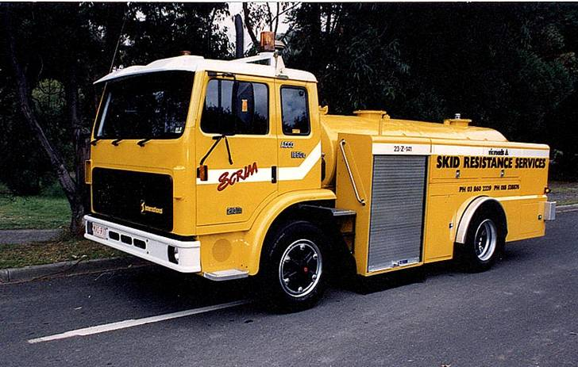
Grip Tester
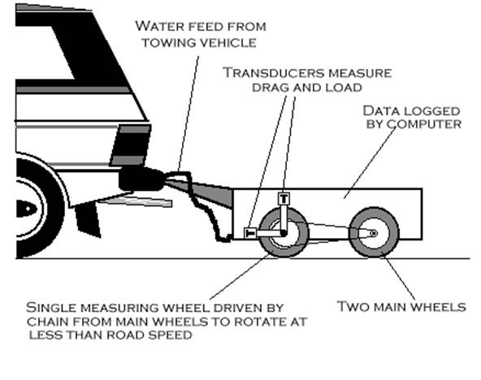
Appendix VI – Rangitikei Resource Information
Insert in this Appendix any key diagrams, lists, forms etc for ready reference in the Rangitikei District.

Appendix VII – Ruapehu Resource Information
Insert in this Appendix any key diagrams, lists, forms etc for ready reference in the Ruapehu District.

Appendix VIII – Wanganui Resource Information
Insert in this Appendix any key diagrams, lists, forms etc for ready reference in the Wanganui District.

Road Safe Central – includes representatives of 7 TLA’s, ACC, AA, Police and other key road safety agencies.
This is consistent with the national strategy
typically, these sorts of measures are reported on by Road Safety Coordinators to the RLTC, with the information being reported to the RCA’s for information.
Users within RCA’s will include engineering staff, in-house utilities, Parks and Reserves staff, and potentially front-line customer staff

