Project Name
Organisational Name

Safe System Audit Report
Safe System Audit Stage

[date]
[Version]

--

Contents
1. Safe System Auditing for Transport Projects 3
1.1. Safe System Audit Procedure 3
1.2. Safe System 4
1.3. Report Format 4
2. Safe System Audit Details 5
3. Project Description 5
3.1. Project Background and Objective 5
3.2. Existing Conditions and Context 5
3.3. Proposed Works 6
4. Assessment of Safe System Alignment 6
4.1. Project Design Safe System Assessment Summary 6
4.2. Safe System Assessment Matrix 8
5. Safety Concerns 9
5.1. Heading Concern Rating 9
5.2. Heading Concern Rating 9
5.3. Heading Concern Rating 9
5.4. Heading Concern Rating 10
6. Conclusions 11
7. Safe System Audit Statement 12

Safe System Auditing for Transport Projects
A Safe System audit is an independent review of a future transport project to identify any safety concerns that may affect the safety performance and alignment to a Safe System. The audit team considers the safety of all road users and qualitatively reports on road safety issues or opportunities for safety improvement.
A Safe System audit is therefore a formal examination of a transport project, or any type of project which affects road users (including cyclists, pedestrians, mobility impaired etc), carried out by an independent competent team who identify and document Safe System alignment and road safety concerns.
A Safe System audit is intended to help deliver a safe road system and is not a review of compliance with standards.

Safe System Audit Procedure
The primary objective of a Safe System audit is to deliver a project that achieves an outcome consistent with the Safe System approach, that is, minimisation of death and serious injury. The Safe System audit is a safety review used to identify all areas of a project that are inconsistent with a safe system and bring those concerns to the attention of the client in order that the client can make a value judgement as to appropriate action(s) based on the risk guidance provided by the safety audit team.
The key objective of a Safe System audit is summarised as:
To deliver completed projects that contribute towards a Safe System by identifying and ranking potential safety concerns for all road users and others affected by a transport project.
A Safe System audit should be undertaken at project milestones such as:
- Concept Stage (part of Business Case);
- Scheme or Preliminary Design Stage (part of Pre-Implementation);
- Detailed Design Stage (Pre-implementation / Implementation); and
- Pre-Opening / Post-Construction Stage (Implementation / Post-Implementation).
A Safe System audit is not intended as a technical or financial audit and does not substitute for a design check on standards or guidelines.
Any recommended treatment of an identified safety concern is intended to be indicative only, and to focus the design team on the type of improvements that might be appropriate. It is not intended to be prescriptive and other ways of improving the road safety or operational problems identified should also be considered.
In accordance with the procedures set down in the “Waka Kotahi NZ Transport Agency Safe System Audit Guidelines” the audit report should be submitted to the client who will instruct the design team to respond. The design team should consider the report and comment to the client on each of any concerns identified, including their cost implications where appropriate, and make a recommendation to either accept or reject the audit report recommendation.
For each audit team recommendation that is accepted, the client shall make the final decision and brief the design team to make the necessary changes and/or additions. As a result of this instruction the design team shall action the approved amendments. The client may involve a safety engineer to provide commentary to aid with the decision.
Decision tracking is an important part of the Safe System audit process. A decision tracking table is embedded into the report format at the end of each set of recommendations to be completed by the design team, safety engineer and client for each issue documenting the design team’s response, client decision and action taken.
A copy of the report including the design team’s response to the client and the client’s decision on each recommendation shall be given to the Safe System audit team leader as part of the important feedback loop. The Safe System audit team leader will disseminate this to team members.

Report Format
The potential road safety problems identified have been ranked as follows:-
The expected crash frequency is qualitatively assessed on the basis of expected exposure (how many road users will be exposed to a safety issue) and the likelihood of a crash resulting from the presence of the issue. The severity of a crash outcome is qualitatively assessed on the basis of factors such as expected speeds, type of collision, and type of vehicle involved.
Reference to historic crash rates or other research for similar elements of projects, or projects as a whole, have been drawn on where appropriate to assist in understanding the likely crash types, frequency and likely severity that may result from a particular concern.
The frequency and severity ratings are used together to develop a combined qualitative risk ranking for each safety issue using the Safety concern risk rating matrix below. The qualitative assessment requires professional judgement and a wide range of experience in projects of all sizes and locations.

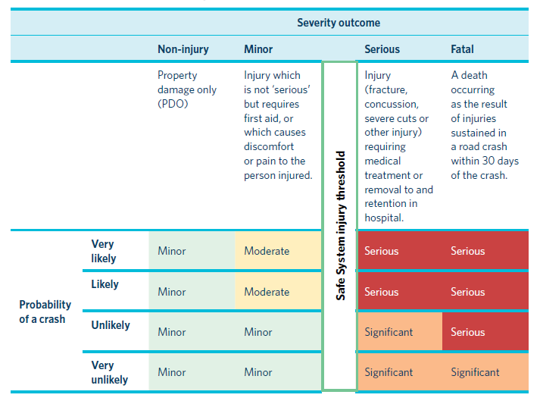
Figure 1 Safety concern risk rating matrix

Safe System Audit Details
  - Type of Audit

State what stage of audit is being carried out and reference to previous audits and exemption forms.

  - Audit Team
List the members of the SSA Team, their titles, department and organisation. Identify any members that are associated with the project being assessed and are therefore not independent.

  - Meetings and Site Inspections

List all meetings (e.g. commencement meeting), site inspections and workshops held, with dates. Include the times of site inspections.

Project Description

Project Background and Objective
Provide sufficient detail about the project background and the objectives to demonstrate an understanding of why the project is being developed.

Prompts | Comments
What is the reason for the project?
Is there specific crash type risk?
Is it addressing specific issues such as poor speed limit compliance, road access, congestion, future traffic growth, freight movement, amenity concerns from the community, maintenance/asset renewal, etc.

Existing Conditions and Context
Provide a detailed description of existing conditions. Describe the function of the road, referring to Movement and Place where possible. Is the road part of a freight route of bicycle route?. Refer to any available data on vehicle speeds and information regarding compliance with speed limits. Note if the presence of heavy vehicles increases the risk of particular crash types e.g. run-off-road, intersection and vulnerable users.
Prompts | Comments
What is the function of the road? Consider location, roadside land use, area type, speed limit, intersection type, presence of parking, public transport services and vehicle flows. What traffic features exist nearby (e.g. upstream and downstream)? What alternative routes exist?
What is the speed environment? What is the current speed limit? Has it changed recently? Is it similar to other roads of this type? How does it compare to Safe System speeds? What is the acceptability of lowering the speed limit at this location?
What road users are present? Consider the presence of elderly pedestrians, school children and cyclists. Also note what facilities are available to vulnerable road users (e.g. signalised crossings, bicycle lanes, school speed limits, etc.)
What is the vehicle composition? Consider the presence of heavy vehicles (and what type), motorcyclists and other vehicles using the roadway.

Proposed Works
Provide a description of the proposed works. Identify and describe each project design option that is being assessed – use diagrams / illustrations as necessary (either here or in an appendix). Provide a listing of the design drawings that were assessed – including drawing and issue numbers.

Assessment of Safe System Alignment

Project Design Safe System Assessment Summary
The Safe System Assessment Matrix scores for the existing conditions and the proposed design options are shown. The scores for each crash type are shown in Error! Reference source not found.. The detailed assessments are presented in Section Error! Reference source not found..
Insert scores into Table 3 and edit Figure 3. If the project has been divided into two or more segments, provide details and the SSA Matrix scores for each segment. Provide a discussion of the results and conclusions. Compare the project options with existing conditions. In particular, highlight the crash types that present the highest risk and explain why. Identify the areas where there are opportunities to improve alignment with the Safe System.

Table 1 Safe System assessment score summary table
Option | Score
Existing conditions | xx / 448
Design Option 1 | xx / 448
Design Option 2 | xx / 448

Figure 2 Safe System assessment score summary table

Safe System Assessment Matrix
Insert option e.g. “Existing Conditions”, “Design Option 1” etc. Add and complete a table for each option.

 | Run-off road | Head-on | Intersection | Other | Pedestrian | Cyclist | Motorcyclists
Exposure Comments:
Exposure Score: | /4 | /4 | /4 | /4 | /4 | /4 | /4
Likelihood Comments: | Factors that increase the likelihood include:  Factors that decrease the likelihood include: | Factors that increase the likelihood include:  Factors that decrease the likelihood include: | Factors that increase the likelihood include:  Factors that decrease the likelihood include: | Factors that increase the likelihood include:  Factors that decrease the likelihood include: | Factors that increase the likelihood include:  Factors that decrease the likelihood include: | Factors that increase the likelihood include:  Factors that decrease the likelihood include: | Factors that increase the likelihood include:  Factors that decrease the likelihood include:
Likelihood Score: | /4 | /4 | /4 | /4 | /4 | /4 | /4
Severity Comments: | Factors that increase the likelihood include:  Factors that decrease the likelihood include: | Factors that increase the likelihood include:  Factors that decrease the likelihood include: | Factors that increase the likelihood include:  Factors that decrease the likelihood include: | Factors that increase the likelihood include:  Factors that decrease the likelihood include: | Factors that increase the likelihood include:  Factors that decrease the likelihood include: | Factors that increase the likelihood include:  Factors that decrease the likelihood include: | Factors that increase the likelihood include:  Factors that decrease the likelihood include:
Severity Score: | /4 | /4 | /4 | /4 | /4 | /4 | /4
Product  (multiply scores above for crash type) | /64 | /64 | /64 | /64 | /64 | /64 | /64
TOTAL |  |  |  |  |  |  | /448

Safety Concerns

Heading Select concern rating

Subheading
Provide additional information / discussion / recommendations of specific concerns that should be highlighted for consideration by the project team.

Probability Rating:  Crashes are likely to be Choose an item. | Severity Outcome Rating:  Death or serious injury is Choose an item
Design Team Response: Click here to enter text.
Safety Engineer: Click here to enter text.
Client Decision: Click here to enter text.
Action Taken: Click here to enter text.

Heading Select concern rating

Subheading
Provide additional information / discussion / recommendations of specific concerns that should be highlighted for consideration by the project team.

Probability Rating:  Crashes are likely to be Choose an item. | Severity Outcome Rating:  Death or serious injury is Choose an item
Design Team Response: Click here to enter text.
Safety Engineer: Click here to enter text.
Client Decision: Click here to enter text.
Action Taken: Click here to enter text.

Conclusions
Outline the conclusions of the assessment. For example, are the proposals an improvement on existing conditions, what are the main crash risks, how well do each of the design options align with Safe System principles, which option is preferred and what changes could be made to the design / scope to further improve Safe System alignment.

Safe System Audit Statement
We certify that we have used the available plans, and have examined the specified roads and streets to assess the Safe System alignment and identified any safety concerns that could be changed, removed or modified in order to improve road safety outcomes. The safety concerns identified have been noted in this report.

Signed: ……………………………………………………………….. Date:
Name, Qualification
Position, Company

Signed: ……………………………………………………………… Date:
Name, Qualification
Position, Company

Signed: ………………………………………………………………. Date:
Name, Qualification
Position, Company

Design Team: Name…………………………………… Position………………………..
Signature……………………………….. Date…………………………….
Safety Engineer: Name…………………………………… Position………………………..
Signature……………………………….. Date…………………………….
Project Manager: Name…………………………………… Position………………………..
Signature……………………………….. Date…………………………….
Action Completed: Name…………………………………… Position………………………..
Signature……………………………….. Date…………………………….
Project Manager to distribute audit report incorporating decision to design team, Safety Audit Team Leader, Safety Engineer and project file.
Date: ……………………

