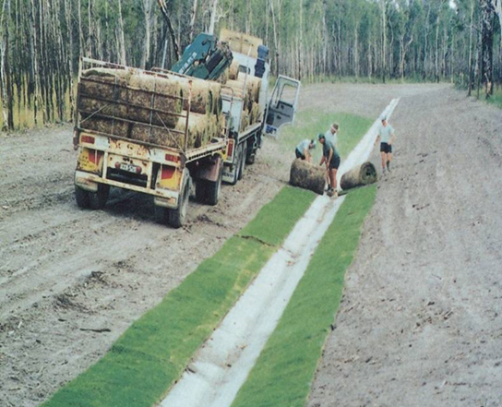

Contractor:  Inspector: | Date:  Time: |  |  | Consent #: |  |  | Site:
Site Inspection of Erosion and Sediment Control Practices
Erosion and Sediment Control Practice |  | Yes | No |  | N/A | Corrective Action
General Information
Do you know what receiving system the project drains into
Are you aware of local rainfall patterns during various times of the year
Soil types and erosion potential for site
Is a copy of the erosion and sediment control plan on site
Is temporary fencing placed in areas where no construction is to take place
Construction
Rake soil surface to break crust prior to placing turf
Irrigate lightly immediately prior to placement during periods of high temperature
Turf should be laid on the contour, never up and down the slope. Start at the bottom and work up slope
Butt joints tightly and do not stretch or overlap
Slopes steeper than 3:1, secure turf to ground with pegs or other means
Roll and tamp turf immediately to ensure solid contact with ground
Maintenance
Water daily during the first week unless there is adequate rainfall
Check to ensure that turf is firmly rooted. Do not mow until that point
Apply fertiliser in accordance with specifications
Decommissioning
Ensure good stabilisation occurs

