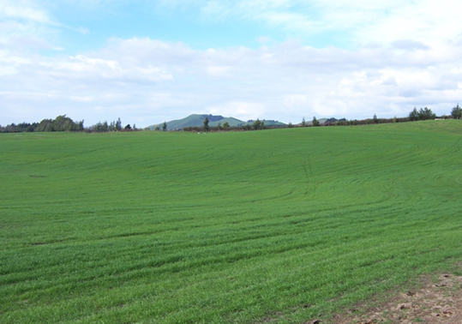

Contractor:  Inspector: | Date:  Time: |  |  | Consent #: |  |  | Site:
Site Inspection of Erosion and Sediment Control Practices
Erosion and Sediment Control Practice |  | Yes | No |  | N/A | Corrective Action
General Information
Do you know what receiving system the project drains into
Are you aware of local rainfall patterns during various times of the year
Soil types and erosion potential for site
Is a copy of the erosion and sediment control plan on site
Is temporary fencing placed in areas where no construction is to take place
Construction
Apply > 100 mm of topsoil
Apply fertiliser according to manufacturers recommendation
Apply seed uniformly at the required rate
Ensure site conditions and time of year are appropriate for germination
Ensure that site coverage > 80%
Maintenance
Check the condition of the topsoil regularly and replace where needed
Where vegetation establishment is unsatisfactory, seed will need to be reapplied.
Protect seeded areas from construction traffic or utility construction
Decommissioning
Ensure good stabilisation occurs

