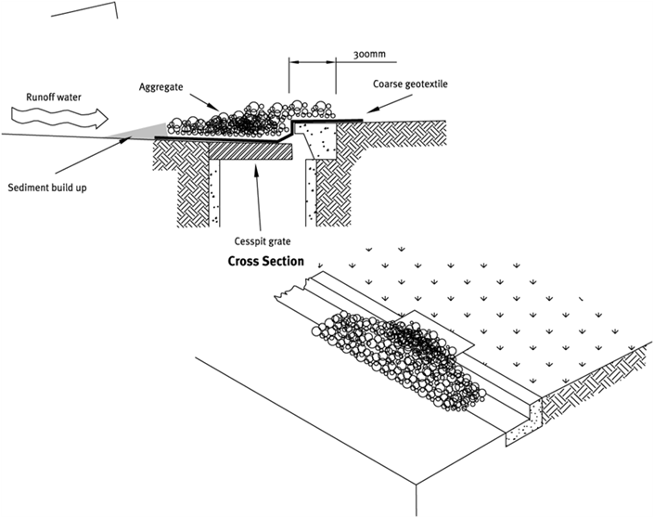

Contractor:  Inspector: | Date:  Time: |  |  | Consent #: |  |  | Site:
Site Inspection of Erosion and Sediment Control Practices
Erosion and Sediment Control Practice |  | Yes | No |  | N/A | Corrective Action
General Information
Do you know what receiving system the project drains into
Are you aware of local rainfall patterns during various times of the year
Soil types and erosion potential for site
Is a copy of the erosion and sediment control plan on site
Is temporary fencing placed in areas where no construction is to take place
Construction
Construction specifications will vary according to the type of inlet protection
Always ensure an emergency bypass is included on all devices
Ensure device does not allow water to bypass its intended flow path
Keep stockpile and loose sediment away from roadside drains
Maintenance
Inspect daily and during and after rainfall events
Beware of blockages and leaks that may affect performance
Check to see if flows have been diverted away from device and if the diversion caused any damage
Clean all sediments immediately and repair any problems
Decommissioning
Remove and dispose of all accumulated sediments
Remove control measure, reuse and recycle components

