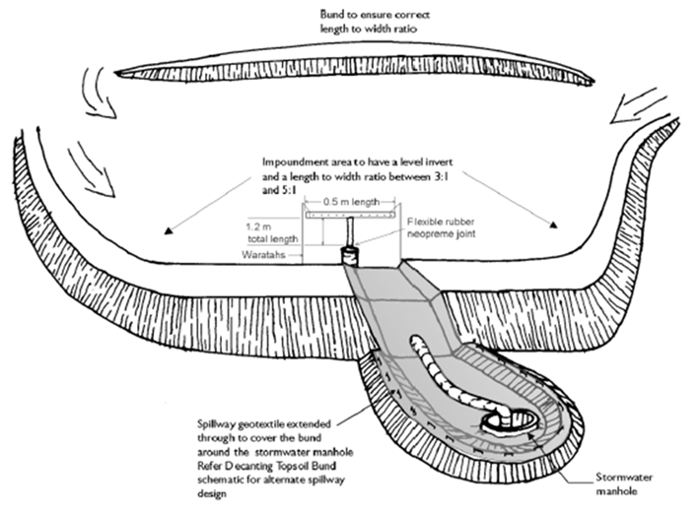

Contractor:  Inspector: | Date:  Time: |  |  | Consent #: |  |  | Site:
Site Inspection of Erosion and Sediment Control Practices
Erosion and Sediment Control Practice |  | Yes | No |  | N/A | Corrective Action
General Information
Do you know what receiving system the project drains into
Are you aware of local rainfall patterns during various times of the year
Soil types and erosion potential for site
Is a copy of the erosion and sediment control plan on site
Is temporary fencing placed in areas where no construction is to take place
Construction
Build Decanting Earth Bunds along the contour to obtain required volumes
Remove all organic/ vegetation before construction
The Decanting Earth Bund is to be keyed into the existing ground to a minimum depth of 0.3 m
The Decanting Earth Bund is to be made with a clay-silt mix of suitable moisture content to achieve a reasonable compaction standard (90%). It is considered that this can be achieved, in most instances, by track rolling at 150 - 200 mm lifts. Particular care is required to achieve good compaction around the outlet pipe that passes through the bund to avoid seepage and potential failure
Install a 150 mm diameter non-perforated outlet pipe through the bund and this is to discharge to a stable erosion proofed area or stormwater system
A T-Bar decant is attached by way of a standard 100 mm tee joint (glued and screwed). The decant is 100 mm dia. PVC pipe 0.5 metres long with 20 equally spaced holes of 10 mm diameter and fixed firmly to a waratah standard to achieve 3 litres/second/ha of contributing catchment
A sealed PVC pipe (with endcaps) is placed on top of the decant to provide buoyancy
Use a flexible thick rubber coupling to provide a connection between the decant arm and the discharge pipe. To provide sufficient flexibility (such as is required for the lower decant arm) install two couplings. Fasten the flexible coupling using strap clamps, glue and screws
The decant is fastened to two waratahs by way of a nylon cord to the correct height
Provide an emergency spillway to a stabilised outfall 150 mm above the level of the top of the decanting novacoil pipe. This can be a trapezoidal spillway with a minimum invert length of 2 m which is smooth, has no voids and is lined with a soft needle punched geotextile to the stabilised outfall. Ensure the geotextile is pinned at 0.5m centres
The emergency spillway is to have a minimum freeboard of 250 mm, i.e. between the invert of the spillway to the lowest point of the top of the bund
Undertake an As Built assessment at the completion of construction to check against design. If there are discrepancies rectify immediately
Maintenance
Inspect decanting earth bunds at least once/week and after each rainfall
Check for damage including
- Spillway
- Outlet erosion
- Decant or fitting damage
- Embankment seepage or along outlet pipe
- Blockages to holes in decants
Make any necessary repairs as soon as identified
Remove sediment when sediment accumulation reaches 20% of volume
Dispose of the sediment to an area where sediment cannot be transported downstream
Decommissioning
Do not remove Decanting Earth Bund and accumulated sediment until the catchment area has been appropriately stabilised
Dewater bund area
Remove and dispose of accumulated sediment
Remove pipes, fabric and other construction materials
Backfill, regrade and stabilise the disturbed area

