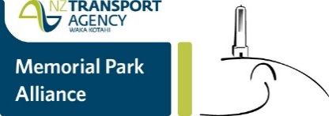
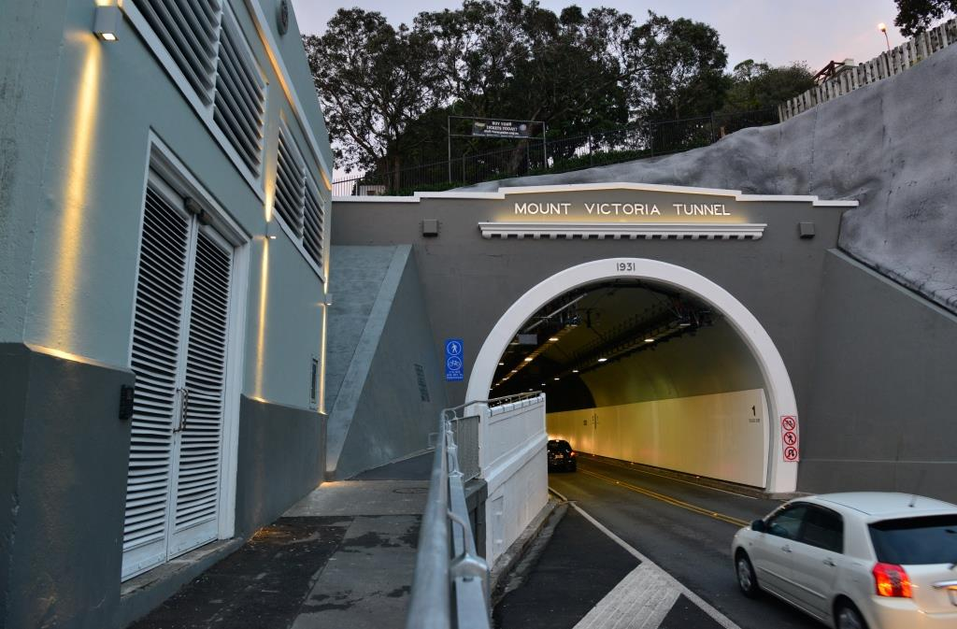
8 July 2016
Mt Victoria Tunnel radio broadcast resumes

FM radio reception has been restored for travellers’ listening pleasure through Mt Victoria Tunnel.
A temporary fix has been made until a replacement for a faulty component arrives.
Thank you for your patience.

info@memorialpark.co.nz nzta.govt.nz/mvt-upgrade2

