Accessible Streets – Overview to the Rules
9 March 2020

Copyright information
Copyright ©. This copyright work is licensed under the Creative Commons Attribution 4.0 International licence. In essence, you are free to copy, distribute and adapt the work, as long as you attribute the work to Waka Kotahi and abide by the other licence terms. To view a copy of this licence, visit http://creativecommons.org/licenses/by/4.0/.

Disclaimer
Waka Kotahi has endeavoured to ensure material in this document is technically accurate and reflects legal requirements. However, the document does not override governing legislation. Waka Kotahi does not accept liability for any consequences arising from the use of this document. If the user of this document is unsure whether the material is correct, they should refer directly to the relevant legislation and contact Waka Kotahi.

More information
Waka Kotahi NZ Transport Agency
March 2020
If you have further queries, call our contact centre on 0800 699 000 or write to us:

Accessible Streets Regulatory Package 2020
Transport System Policy Team
Free Post 65090
NZ Transport Agency
Private Bag 6995
Wellington 6141
This document is available on the Waka Kotahi website at:
www.nzta.govt.nz/accessible-streets-consultation

Contents
Copyright information 2
Disclaimer 2
More information 2
Accessible streets – overview 5
About consultation on proposed new rule and rule changes 5
Making a submission 6
Your submission is public information 7
Information you need to make a submission 7
Summary of new rule and rule changes 8
Why are the new rule and rule changes being proposed? 9
What are we seeking your feedback on? 10
Proposed timeline for implementation 10
Proposal 1: Change and re-name the types of device that used on footpaths, shared paths, cycle paths and cycle lanes 11
Proposal 1A: Pedestrians and powered wheelchairs users 16
Proposal 1B: Changing wheeled recreational devices 17
Proposal 1C: Clarifying cycles and e-bikes 23
Proposal 1D: Mobility devices 24
Alternative proposal – Keep current vehicle definitions 25
Proposal 2: Establish a national framework for the use of footpaths 26
Alternative proposal – Keep current footpath rules 30
Proposal 2A: Users on the footpath will operate vehicles in a courteous and considerate manner, travel in a way that isn’t dangerous and give right of way to pedestrians. 31
Proposal 2B: Default 15km/h speed limit for vehicles using the footpath 32
Proposal 2C: 750mm width restriction for vehicles that operate on the footpath 34
Proposal 3: Establish a national framework for the use of shared paths and cycle paths 38
Proposal 4: Enable transport devices to use cycle lanes and cycle paths 43
Proposal 5: Introduce lighting and reflector requirements for powered transport devices at night 46
Proposal 6: Remove barriers to walking, transport device use and cycling through rule changes 48
Proposal 6A: Allow cycles and transport devices to travel straight ahead from a left turn lane 48
Proposal 6B: Allow cycles and transport devices to carefully pass slow-moving vehicles on the left, unless a motor vehicle is indicating a left turn 54
Proposal 6C: Give cycles, transport devices and buses priority over turning traffic when they’re travelling through an intersection in a separated lane 58
Proposal 6D: Give priority to footpath, shared path and cycle path users over turning traffic where the necessary traffic control devices are installed 63
Proposal 7: Mandate a minimum overtaking gap for motor vehicles passing cycles, transport devices, horses, pedestrians and people using mobility devices on the road 68
Proposal 8: Clarify how road controlling authorities can restrict parking on berms 71
Proposal 9: Give buses priority when exiting bus stops 74
What are Land Transport Rules? 76
Application of rule-making criteria 76
Proposed activity or service 76
Risk to land transport safety 76
Assisting achievement of strategic objectives for transport 78
Costs of implementing our proposed changes 78
International considerations 78
How the amendment rule fits with other legislation 78
Offences and penalties 78
Access to consultation material 79
Availability of rules 79
Information about rules 79
Appendix: Regulatory impact of proposed rule amendments 79
Table 1: Summary table of costs and benefits 80

Accessible streets – overview
This overview accompanies, and provides context for, the public consultation (yellow) draft of proposed changes to:
- Land Transport Rule: Road User
- Land Transport Rule: Traffic Control Devices
- Land Transport Rule: Setting of Speed Limits, and
- proposed new Land Transport Rule: Paths and Road Margins 2020.
The proposed changes will improve safety and accessibility for all road users.

If you wish to comment on this draft Rule, please see Making a submission (page 6) for details on how to do this. The deadline for submissions is 5pm on Wednesday 22 April 2020.

About consultation on proposed new rule and rule changes
The Associate Minister of Transport (the Associate Minister) is proposing a collection of rule changes known as the Accessible Streets Regulatory Package. These rules are designed to improve safety for footpath users, encourage active modes of transport, and support the creation of more liveable and vibrant towns and cities.
This publication provides the context for consulting on our proposed new Land Transport Rule: Paths and Road Margins 2020 (the Paths Rule) and our proposed changes to:
- Land Transport Rule: Road User (the Road User Rule)
- Land Transport Rule: Traffic Control Devices (the Traffic Control Devices Rule)
- Land Transport Rule: Setting of Speed Limits (the Setting of Speed Limits Rule).
Everyone who uses the transport network will be affected by these proposed changes. We want to be sure we consider your views, and the impact that the proposed new rule and proposed rule changes could have on you.
We’re consulting on our proposed changes to ensure that:
- the rules development process takes this into account, and
- our legislation is sound and robust.
We’ll analyse the feedback we receive from you and take it into account when we finalise our proposed changes. Then the amended rules and the proposed new land transport rule will go to the Associate Minister for final decisions.

Making a submission
We want to hear what you think.
We have provided a series of questions throughout this document that seek your views. This will help us understand the impact that the proposed changes could have. These are outlined throughout this document, and in the online survey.
The questions are intended as a guide, and you do not have to answer them all. You may choose to answer only those that interest or impact you. Or, you can simply tell us what you think about the proposal in your own words.

You can make a submission in the following ways:
- Fill in the online survey: https://www.surveymonkey.com/r/MXTDZBC
or
- Fill in the submission form, which contains the range of questions.
or
- Write us a letter, email or make a video telling us what you think.

Please include the following information in your submission:
- the title – Accessible Streets Regulatory Package 2020
- your name,
- your job title and organisation’s name if applicable
- your organisation’s name if applicable
- your address or email address.

- Send your submission to us by email to accessible.streets@nzta.govt.nz

- You can post us your submission to:

Accessible Streets Regulatory Package 2020
Transport System Policy Team
Free Post 65090
Waka Kotahi NZ Transport Agency
National Office
Private Bag 6995
Wellington 6141

Please note the deadline for submissions
The deadline for submissions is 5pm on Wednesday 22 April 2020.

Your submission is public information

We will use your submission to help us make the changes to the rules.

Please note that Waka Kotahi NZ Transport Agency (the Transport Agency) will publish a summary of submissions. If you do not want your name or any identifying information to be included in anything we publish (including because you believe your comments are commercially sensitive) please indicate this clearly in your submission.

Please note that your submission is also subject to the Official Information Act 1982 (OIA). This means that other people will be able to obtain copies of submissions by making a request under the OIA. If you think there are grounds for your information to be withheld under the OIA, please note this in your submission. We will take your reasons into account and may consult with you when responding to requests under the OIA.

Information you need to make a submission
The government is committed to ensuring that legislation is sound and robust, and that our rules development process considers your views.
This publication, for your comment, has two parts:
- an overview, which sets out a proposed new rule and changes to existing rules in context

- the consultation (yellow) draft of the proposed new Paths Rule and our proposed changes to the:

- Road User Rule,
- Traffic Control Devices Rule, and
- Setting of Speed Limits Rule.
Please read these documents carefully and consider what effects these changes would have on you or your organisation (if relevant).
You’ll notice that the consultation (yellow) draft of changes to existing rules shows only the proposed rule changes and not the existing rules. Please read our Publication and Availability of Rules section (page 77) if you would like access to a copy of the:
- Road User Rule,
- Traffic Control Devices Rule, and/or
- Setting of Speed Limits Rule.

Proposed timetable for implementation
Subject to the approval of the Associate Minister, we propose that the rules take effect in the 2020 – 2021 financial year.

Making a submission
If you wish to comment on this draft rule, please see Making a submission (page 6) for how to do this. The deadline for submissions is 5pm on Wednesday 22 April 2020.

Summary of new rule and rule changes
This section outlines the changes we’re proposing under our proposed Land Transport Rule: Paths and Road Margins 2020 (the Paths Rule) and our proposed changes to:
- Land Transport Rule: Road User (the Road User Rule)
- Land Transport Rule: Traffic Control Devices (the Traffic Control Devices Rule) and
- Land Transport Rule: Setting of Speed Limits (the Setting of Speed Limits Rule).
These rule changes are collectively known as the Accessible Streets Regulatory Package (Accessible Streets). The package is designed to:
- make our footpaths, shared paths, cycle lanes, cycle paths and roads safer and more accessible for you
- accommodate the increasing use of micro-mobility devices like e-scooters on our streets and footpaths
- encourage active modes of transport and support the creation of more liveable and vibrant towns and cities
- make social and economic opportunities more accessible to you
- make public transport (buses) and active transport modes such as walking or cycling safer and more efficient.
Our proposed rules create a national framework that clarifies how and where vehicles and devices can be used. Our goal, in creating this framework, is to ensure that everyone can access a range of transport options and feel safe when they are travelling down the street.
The proposed changes also seek to clarify the powers of road controlling authorities (like local councils) in regulating users, devices and spaces like the footpath. This way, authorities can easily make changes to suit their local conditions and communities if needed.
The new and amended rules also give effect to the 2018/19-2027/28 Government Policy Statement on Land Transport (GPS 2018). This outlines a significant shift in land transport investment to prioritise:
- accessible and affordable transport,
- safety,
- liveable cities,
- regional economic development,
- protecting the environment, and
- delivering the best possible value for money.

Our proposed new and amended rules will:
- Change current vehicle and device definitions and create new categories to better regulate:
  - new and emerging devices
  - where and how they’re used.

- Change who’s allowed on footpaths and introduce conditions that users need to follow when using the footpath. For the safety of others sharing the footpath, people riding on the footpath under the new rule must:
  - behave in a courteous and considerate manner
  - travel in a way that is not dangerous for other people using the footpath
  - give right of way to pedestrians
  - travel no faster than 15km/h
  - ride a device no wider than 750mm, unless it’s a wheelchair, so multiple people can still use the footpath.

- Clarify who’s allowed on shared paths and cycle paths and introduce the conditions they need to follow. Our changes will clarify that:
  - if a path is located beside a roadway, the speed limit on the path will match the roadway. If a path is not located beside a roadway, the speed limit will be 50km/h
  - all users must give way to pedestrians on shared paths
  - road controlling authorities can declare that a path is a shared path or cycle path by resolution.
- Allow transport devices, such as skateboards and e-scooters, to use cycle lanes and cycle paths.

- Introduce lighting and reflector requirements for powered transport devices at night. Our proposed change would only permit transport devices on roads and paths at night if they are fitted with:
  - a headlamp
  - a rear facing position light, and
  - a reflector (or if the user is wearing reflective material).

- Change the priority of road users, by:
- allowing cycles and transport devices to:
  - ride straight ahead from a left turn lane
  - pass slow-moving vehicles on the left.
- clarifying that turning traffic must give way to all people using separated lanes, including buses, if those people are travelling straight through at an intersection.
- giving greater priority to people on footpaths and shared paths when they’re crossing side roads with minimum markings (two white lines).

- Mandate a minimum overtaking gap (on the road) for motor vehicles overtaking cycles, transport devices, horses, mobility devices and pedestrians of:
  - 1 metre, when the posted speed limit is 60km/h or less
  - 1.5 metres, when the posted speed limit is over 60km/h.

- Clarify what’s needed for road controlling authorities to restrict parking on berms and remove the need for signs.

- Require road users to give way to signalling buses pulling out of bus stops in urban areas, when the speed limit is 60km/h or less.

As you work through this document, we welcome your comments on all nine proposals. However, you may choose to comment on just those that interest you.
The questions provided in this document are intended as a guide, and you do not have to answer them all.
When providing feedback, it would be helpful if you would provide examples to illustrate your point.

Why are the new rule and rule changes being proposed?
The 2018/19-2027-28 Government Policy Statement on Land Transport (GPS 2018) has signalled a shift in government support to invest in and prioritise:
- safety for everyone using the road, paths and public transport, and
- access to economic and social opportunities in the land transport system.

The Accessible Streets package aims to achieve this through a collection of rule changes. These changes are designed to make our streets, paths and public transport safer and more accessible.
People should be able to feel safe and travel safely throughout our country, whether they are in vehicles or travelling as pedestrians or using other active modes. Improving the safety of our footpaths, shared paths and cycle lanes has the potential to deliver benefits in the areas of access, connectedness, health, and the environment, as well as improving the liveability of our towns and cities.
We’ve taken the following into account when writing our proposed rules:
- Recommendations from Improving Road Safety in New Zealand.
- 2014 Cycling Safety Panel’s report Safer journeys for people who cycle.
- The report from the Transport and Industrial Relations Select Committee on the petition of Joanne Clendon in May 2016 [2014/59] on children cycling on the footpath.

What are we seeking your feedback on?
As you work through this document, we welcome your comments on all nine proposals. However, you may choose to comment on just those that interest you.
We have also outlined alternative options for proposals 1 and 2. We are seeking your feedback on these alternatives, including whether you prefer these alternatives to our proposals.
The questions provided in this document are intended as a guide, and you do not have to answer them all.
When providing feedback, it would be helpful if you would provide examples to illustrate your point.

Proposed timeline for implementation
Subject to the approval of the Associate Minister of Transport, we propose that the rules take effect in the 2020- 2021 financial year.

Proposal 1: Change and re-name the types of device that are used on footpaths, shared paths, cycle paths and cycle lanes
Current state
Vehicles and devices are categorised into different groups to help you, along with councils and road controlling authorities, understand where you can use them.
We’ve outlined the current vehicle, device and user-type categories and where you can currently use them in the following tables (table 1A and 1B).

Table 1A: the current categories and their definitions
Category | Definition | Examples
Pedestrians  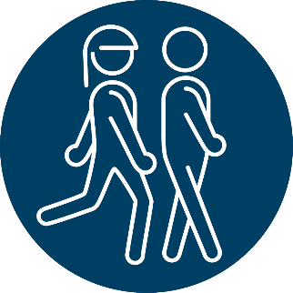 | Pedestrians include:  - people on foot  - people using unpowered wheelchairs  - everyday items such as prams and shopping trolleys when used by a person walking.  Pedestrians are the main users of the footpath. | - A person walking or running on the footpath.  - A person using an unpowered wheelchair.  - A person pushing a pram.  - A person walking their dog.
Mobility devices  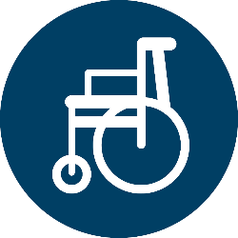  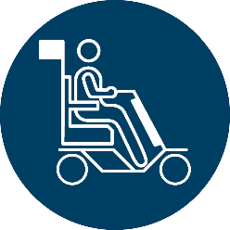 | Devices which are:  - intended for people who require mobility assistance for a physical or neurological impairment  - powered by a motor with a maximum power output of up to 1500 watts.  People using mobility devices typically use the footpath. | - Mobility scooters  - Powered wheelchairs
Wheeled recreational devices  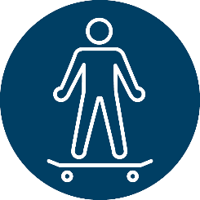 | A device with wheels, propelled by:  - human power, or  - gravity, or  - a small auxiliary motor with a maximum power output of up to 300 watts.  Currently excludes cycles with a wheel diameter over 355mm (an average six-year-old’s bike). Most adult bicycles are excluded.  Cycles with a wheel diameter of 355mm or less are wheeled recreational devices. | - Push-scooters  - Skateboards  - roller blades or skates  - Low powered motorised versions of the same devices (like e-scooters)
Cycles and e-bikes  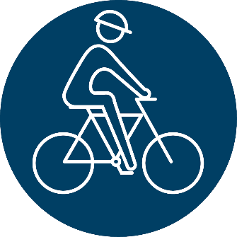 | Cycles, including adult tricycles and e- bikes, are treated as their own vehicle category.  Adult cycles are too large to be considered a wheeled recreational device. Cycles with a wheel diameter of 355mm or less, (the average size for a six-year-old), are both a WRD and a cycle. | - Bicycles  - Tricycles  - E-bikes

Table 1B: where you can currently use devices and vehicles
Where can users, devices and vehicles currently go?
User/ Device/ vehicle | All the time | If there’s no footpath available | If permitted by a road controlling authority | Never
Pedestrian | - Footpath* | - Cycle lane  - Cycle path  - Road | - Shared path*  - Cycle path
Mobility devices | - Footpath | - Cycle lane  - Cycle path  - Road | - Shared path  - Cycle path
Wheeled recreational devices (WRDs) | - Footpath  - Road |  | - Shared path  - Cycle path | - Cycle lane
Adult cycles and e-bikes | - Cycle path*  - Cycle lane*  - Road |  | - Shared path | - Footpath
Child cycles and e-bikes | - Footpath  - Cycle path*  - Cycle lane*  - Road |  | - Shared path

*This user has priority in this space
Issues with the current categories
Vehicles and devices like oversized mobility devices, e-scooters and e-skateboards are becoming more widely used. But, while these devices have many benefits, they also introduce new challenges for regulators and footpath users, including:

- greater speeds in comparison to other path users, like pedestrians
- easier access through share schemes
- greater congestion on spaces like the footpath.

It has become clear that our rules and guidelines for using footpaths, shared paths, cycle paths and cycle lanes do not deal well with these challenges. We need to update our current categories and rules to accommodate new and evolving technology.

Proposed change
We propose to change some of the current vehicle and device categories to reflect how these vehicles and devices are used on footpaths, shared paths, cycle paths and cycle lanes and clarify where they can go.
This will help road controlling authorities to:
- design current and future infrastructure for different devices on the path, and
- manage different spaces and set requirements for using them.
Broadly speaking, we’re proposing to use the following categories:
- pedestrians
- powered wheelchairs
- mobility devices
- unpowered transport devices
- powered transport devices
- cycles and e-bikes.

We’ve outlined what the proposed new categories will look like and where you’ll be able to use different devices in the following table.

Table 1C: where users, devices and vehicles will able to go under our proposed changes
Where will users, devices and vehicles be able to go under our proposed changes?
User/ Device/ vehicle | All the time | If there’s no footpath available | If permitted by a road controlling authority | Never
Pedestrian | - Footpath* | - Cycle lane  - Cycle path  - Road | - Shared path*  - Cycle path
Powered wheelchairs (new category) | - Footpath* | - Cycle lane  - Cycle path  - Road | - Shared path*  - Cycle path
Mobility devices | - Footpath | - Cycle lane  - Cycle path  - Road | - Shared path  - Cycle path
Unpowered transport devices  (new category) | - Footpath  - Cycle path  - Cycle lane  - Road |  | - Shared path
Powered transport devices  (new category) | - Footpath  - Cycle path  - Cycle lane  - Road |  | - Shared path
Cycles and e-bikes  (all sizes) | - Footpath  - Cycle path  - Cycle lane  - Road |  | - Shared path

*This user has priority in this space
Our proposals below explain the changes in more detail.

Proposal 1A: Pedestrians and powered wheelchairs users
Current state
A pedestrian currently includes:
- people on foot,
- people using unpowered wheelchairs, and
- everyday items such as prams and shopping trolleys when used by a person walking.
Pedestrians are the main people using the footpath. If there’s no footpath available, they can also use:
- cycle paths,
- cycle lanes, or
- shared paths.
A powered wheelchair is categorised as a mobility device. They can use:
- footpaths and shared paths, or
- roads, cycle lanes and cycle paths when footpaths are unavailable.
A powered wheelchair is not treated as a pedestrian, but an unpowered wheelchair is. This is inconsistent as both powered and unpowered wheelchairs:
- travel at slow speeds, typically up to 6km/h, and
- are crucial to the movement of the person using them.
A powered wheelchair differs from a mobility device, like a mobility scooter, in that:
- Mobility devices may be important for a user to travel but may not always be necessary to move from place to place.
- Mobility devices typically travel faster than a powered wheelchair.
Given the major differences between these devices and their purpose, regulators should be able to distinguish between them. The law does not currently allow for this.

Proposed change

We propose to create a new category of powered wheelchairs that will be treated as pedestrians because powered wheelchairs are crucial to the movement of the people using them. A powered wheelchair will be defined as a wheelchair:
- propelled by mechanical power, and
- operated by a joystick or other software.
This change helps to recognise the similarities in risk between powered wheelchairs, unpowered wheelchairs and pedestrians, and sets them apart from a person using a much larger, faster and higher risk mobility device, like a high-speed mobility scooter.
Where can powered wheelchairs be used?
Powered wheelchairs will be treated as pedestrians and will be allowed to use the footpath. If there’s no footpath available, they can also use:
- cycle paths,
- cycle lanes, or
- shared paths.

Rule Reference. Clauses in proposed Land Transport Rule: Paths and Road Margins 2020: Section 3 (Requirements for pedestrians, riders of mobility devices, riders of transport devices and cyclists) and Part 2 (Definitions).

Proposal 1A: Pedestrians and powered wheelchair users – Questions for your submission:

- Do you agree that powered wheelchairs should be treated as pedestrians? Why/why not?

Proposal 1B: Changing wheeled recreational devices
Current state
Wheeled recreational devices (WRDs) are defined as a device with wheels, propelled by:
- human power, or
- gravity, or
- a small auxiliary motor with a maximum power output of up to 300 watts.
The definition excludes cycles with a wheel diameter over 355mm. This means that most bicycles are excluded. But, bicycles and e-bikes with a wheel diameter of 355mm or less, are both a cycle and a wheeled recreational device.
Typical examples of wheeled recreational devices include:
- push-scooters
- skateboards
- roller blades and skates
- low powered motorised versions of the same devices (like e-scooters).
A WRD can use:
- footpaths and the road
- shared paths if permitted by road controlling authorities.

Issues with different types of wheeled recreational devices
Due to new technology, the definition of WRD now includes a range of diverse devices. Devices defined as WRDs are considered part of the same group even though they travel at different speeds and are used in different ways. For example:
- some privately-owned e-scooters can reach speeds up to 70km/h while roller blades average about 12km/h
- it’s rare to use roller blades on the road, but common for e-scooters.
As a category, WRDs pose a challenge for road controlling authorities who wish to regulate spaces like the footpath. For example, if a council wants to ban the use of devices like e-scooters and skateboards on a footpath, they must either:

- specifically list all banned devices, which may unintentionally exclude devices similar in speed and use, or

- ban all wheeled recreational devices entirely and prevent low risk devices using the footpath as well.
Powered WRDs are defined as motor vehicles unless declared otherwise
Under the current definition, a range of low-powered WRDs such as e-skateboards, powered unicycles and hoverboards, are also considered motor vehicles. Motor vehicles are not permitted on the footpath.
This can be confusing as a device that fits the definition of a wheeled recreational device is designed to use the footpath.
How are these devices also considered motor vehicles?
A motor vehicle is defined as “a vehicle drawn or propelled by a mechanical power” and may only use the road. While this definition typically applies to large vehicles like cars, it’s broad enough to include smaller, low-powered WRDs like e-skateboards, powered unicycles and hoverboards.
To use the road, motor vehicles also need to meet vehicle standards and be registered. Low-powered WRDs such as e-skateboards and powered unicycles are unlikely to meet these requirements, so they cannot be used the road.
Are any devices excluded from this shared definition?
The definition of ‘motor vehicle’ excludes vehicles or devices that have been declared by the Transport Agency not to be a motor vehicle. So far, the Transport Agency has made declarations for e-bikes, YikeBikes and e-scooters.
What definition applies to these devices? Are they permitted on the footpath, or are they excluded?
The definition of motor vehicle supersedes the definition of wheeled recreational device. This means that all low-powered devices (except for e-bikes, YikeBikes and e-scooters) are treated as motor vehicles and are not permitted on the footpath – unless the Transport Agency declares they’re not motor vehicles.
We’ve outlined the types of devices that are not motor vehicles and the types of devices that are currently considered to be both motor vehicles and wheeled recreational devices in the table below:

Table 1D: Examples of devices that are both motor vehicles and wheeled recreational devices. These are not allowed on the footpath.
Vehicle | Definition
Hover board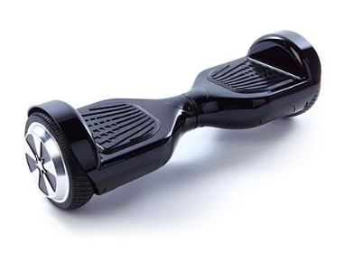 | A hoverboard is a motorised board with one wheel on either side. They are also known as self-balancing scooters.  Users ride the device facing forwards and can reach speeds up to 16km/h.
e-skateboard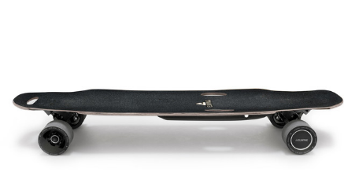 | An e-skateboard is a motorised board with two small wheels at each end of the board.  Users ride an e-skateboard facing sideways and can reach speeds up to 45km/h.
Electric unicycle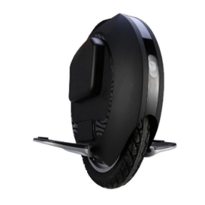 | An electric unicycle is a self-balancing, motorised wheel with foot stands on either side.  Users travel by placing their feet on the foot stands and control the speed by moving forward and backwards. Electric unicycles can reach speeds up to 40km/h.

Table 1E: Wheeled recreational devices that are NOT motor vehicles. These are allowed on the footpath.
Vehicle | Definition
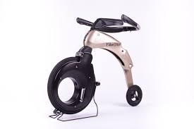  YikeBike | A YikeBike is a miniature electric bicycle with a large wheel at the front and a smaller wheel at the back. It has no pedals and is foldable, so users can carry it if they’re unable to ride it.  YikeBikes can reach speeds up to 23km/h.
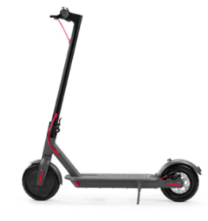  e-scooter | An e-scooter is a powered push scooter. It has a slim board with two small wheels at the front and back. The front of the board has a handle bar attached with controls to accelerate or brake.  On average, e-scooters can reach speeds up to 25km/h, but some privately-owned e-scooters can travel faster.
This situation can make it hard for people to understand where and how they can use their devices.
Proposed change
Our proposed change will replace the wheeled recreational device category with two new groups of devices:
1. Unpowered transport devices (for example push-scooters, skateboards)
2. Powered transport devices (for example e-scooters, YikeBikes)
When we are referring to unpowered and powered devices together, we’ll call them transport devices.
These new categories capture the difference between powered and unpowered wheeled recreational devices. This will help road controlling authorities assess where these devices can be used without restricting other devices unnecessarily.
Unpowered transport devices
Our proposed change will create a category that includes small unpowered devices like skateboards, push scooters and roller blades. The device must be propelled by human power or gravity. This category will be called unpowered transport devices. This will exclude cycles.
Where can unpowered transport devices be used?
Under proposal 2, unpowered transport devices could use:
- footpaths
- cycle paths
- shared paths
- cycle lanes (unless a road controlling authority excludes them)
- roads.
Powered transport devices
Our proposed change will create a category for low-powered devices (excluding cycles and mobility devices) that are:
- propelled by one or more propulsion motors, and
- declared by the Transport Agency not to be a motor vehicle.
- If the powered transport device category is introduced, under Proposal 2, these devices (like YikeBikes and e-scooters) would be permitted on
- footpaths - provided users meet speed, width and behavioural requirements.
- cycle lanes and cycle paths, unless a road controlling authority excludes them
- shared paths, if a road controlling authority permits it
- roads.
What’s not included?
All other devices, such as e-skateboards and powered unicycles, will still be regarded as motor vehicles and will not permitted on the footpath, until and unless the Transport Agency declares them not to be. Motor vehicles will still be prohibited from using the footpath. These devices will also not be permitted on roads because they do not meet vehicle standards and cannot be registered.
The Transport Agency intends to wait until the Accessible Streets framework is introduced before considering further declarations.
What if a declaration is made in the future?
The Transport Agency can declare a device is not a motor vehicle, if it meets the criteria set out the Land Transport Act 1998:
- Devices with a maximum power output of 300 watts
- Devices with a maximum power output between 300 and 600 watts.
The Transport Agency can impose conditions on devices with a maximum power output between 300 and 600 watts. For example, if an e-bike with an output of 600 watts is declared not to be a motor vehicle, the Transport Agency could impose a condition that requires all users to wear a helmet when riding. This won’t apply to transport devices with a maximum power output under 300 watts.
Segways
Segways typically have a maximum power output of 1500 watts. This means their power output is too high for the Transport Agency to declare they are not motor vehicles.
Uncertainty remains about the legal status of Segways and this will not change under our proposals. In 2011, a Segway user was prosecuted by Police for using the device on footpath on the basis that it was a motor vehicle. In 2014, the District Court ruled that the Segway was a mobility device and could use the footpath.
While this ruling clarified the legal status of the specific device in question, the judgement was also clear that it did not mean all Segways were mobility devices since the design and power output may differ. As a result, there’s still some uncertainty about the legal status of Segways.
We may need legislative change to resolve this uncertainty and will undertake a more comprehensive review of vehicle classifications to deal with this in the future.
Regulations Review Committee complaints about e-scooter declarations
On 26 March 2019, a complaint regarding the Transport Agency’s decision to declare that e-scooters are not motor vehicles was brought to the Regulations Review Committee. The complaint criticised the decision not to consult with the disability sector, or the public, and the short time it took the Transport Agency to make the declaration. The Regulatory Review Committee received two further complaints which expressed similar views.
The Transport Agency, the Ministry of Transport and the Associate Minister of Transport responded to the complaints. They noted that the decision was taken considering the existing land transport rules that applied to these devices and the extensive rule-making powers in the Land Transport Act 1998. The proposed rule changes in Accessible Streets are designed to manage the risks associated with new and emerging technologies that are, or might in the future, use the footpath.
However, the Associate Minister of Transport also acknowledged that section 168A lacks statutory guidance for exercising this delegated legislative power, and road controlling authorities are unable to impose conditions on vehicles with a power output below 300 watts. We’ve posed some questions below around these issues, which could influence future changes to the Land Transport Act.
Conditions around future Transport Agency declarations
The Transport Agency proposes to wait until the Accessible Streets framework is introduced before considering making further declarations that other devices are not motor vehicles.

The Transport Agency will need to undertake a safety investigation before deciding whether to declare a device is not a motor vehicle. A safety investigation could include but is not limited to analysing:
- crash and incident statistics
- how it will impact users and non-users
- how other countries have regulated the device.
Helmet use
We’re not proposing to change the current rules around wearing helmets as part of Accessible Streets. We’ll continue to encourage people using unpowered and powered transport devices to wear helmets, but this won’t be compulsory. Helmets on bicycles will remain compulsory.
We’re aware that there are different views about making helmets a mandatory requirement. On the one hand, helmets provide protection to individuals in crashes. On the other, there’s evidence that the mandatory requirement deters people from active travel, which is likely to reduce health and other benefits.

Rule reference: Clauses in proposed Land Transport Rule: Paths and Road Margins 2020: Section 3 (Requirements for cyclists, riders of transport devices and mobility devices and pedestrians) and Part 2 (Definitions)

Proposal 1B: Changing wheeled recreational devices – Questions for your submission
- Do you agree with the proposal to replace wheeled recreational devices with new categories for unpowered and powered transport devices? Why/why not?

- What steps should the Transport Agency take before declaring a vehicle not to be a motor vehicle?

- If the Transport Agency declares a vehicle to not be a motor vehicle, do you think it should be able to impose conditions? If yes, should such conditions be able to be applied regardless of the power output of the device?

- We propose to clarify that:
  - low powered vehicles that have not been declared not to be motor vehicles by the Transport Agency (e.g. hover boards, e-skateboards and other emerging devices) are not allowed on the footpath
  - these vehicles are also not allowed on the road under current rules, because they do not meet motor vehicle standards
  - if the Transport Agency declares any of these vehicles not to be motor vehicles in the future, they will be classified as powered transport devices and will be permitted on the footpath and the road (along with other paths and cycle lanes).

Do you agree with this proposed clarification? Why/why not?

Proposal 1C: Clarifying cycles and e-bikes
Current state
Cycles, including adult tricycles and e-bikes, are treated as their own vehicle category. Adult cycles are too large to be considered a wheeled recreational device. Cycles with a wheel diameter less than 355mm, the average size for a six-year-old, are both a WRD and a cycle.
E-bikes have a maximum power output of 300 watts. An e-bike with a greater maximum power output is not included in the cycle category.
Cycles and e-bikes are not permitted on the footpath but can use cycle paths, cycle lanes and the road. They can use shared paths if a road controlling authority permits it.
Proposed change
Cycles and e-bikes (up to 300 watts) will continue to be a separate category of vehicle known as cycles. Small-wheeled cycles and e-bikes that are propelled by cranks will now be classified as cycles. Small-wheeled cycles that do not have cranks, such as balance bikes, would be classified as unpowered transport devices.
Where can cycles and e-bikes be used?
Under our proposed changes (proposal 2), cycles can use the footpath if they:

- behave in a courteous and considerate manner
- travel in a way that is not dangerous for other people using the footpath
- give right of way to pedestrians
- travel no faster than 15km/h
- ride a cycle no wider than 750mm.

Cycles and e-bikes can use cycle paths, cycle lanes and the road.

Cycles and e-bikes can use shared paths if a road controlling authority permits it.

Maximum power output on e-bikes
Our proposed changes won’t change the maximum power output requirements (300 watts) of e-bikes.

Rule Reference: Clauses in proposed Land Transport Rule: Paths and Road Margins 2020: Section 3 (Requirements for cyclists, riders of transport devices and mobility devices and pedestrians) and Part 2 (Definitions).
Clauses in Land Transport (Road User) Rule 2004: Clause 1.6 (Interpretation)
Clauses in Land Transport Rule: Vehicle Standards Compliance 2002: Part 2, Table A (Vehicle Classes)

Proposal 1C: Clarifying cycles and e-bikes – Questions for your submission

(questions about using cycles on footpaths are in proposal 2.)

- Do you agree with the proposal that:
- Small-wheeled cycles that are propelled by cranks be defined as cycles, and
- Small-wheeled cycles that are not propelled by cranks, such as balance bikes, be defined as transport devices?

Why/why not?

Proposal 1D: Mobility devices
Current state
Mobility devices are defined as devices:

- intended for people who require mobility assistance due to a physical or neurological impairment
- powered by a motor with a maximum power output of up to 1500 watts. For example, mobility scooters and powered wheelchairs.

People using mobility devices typically have the same level of access as pedestrians and usually use the footpath. If there’s no footpath available, or if they’re permitted by a road controlling authority, they can also use:

- shared paths
- cycle paths
- cycle lanes
- roads.

Issues with the term ‘mobility device’
The definition of mobility devices is very broad. This means that devices of very different sizes and speeds can use the footpath, and this can sometimes be restrictive and dangerous for others.
Proposed change

As outlined under proposal 1B, powered wheelchairs (which are currently defined as a mobility devices) will have their own category.

We plan to review the mobility device category as part of future vehicle classification work. We welcome your suggestions on what new categories might look like.

Rule reference: Clauses in proposed Land Transport Rule: Paths and Road Margins 2020: Section 3 (Requirements for cyclists, riders of transport devices and mobility devices and pedestrians) and Part 2 (Definitions).
Clauses in Land Transport Act 1998: Section 2(1) (Interpretation).

Proposal 1D: Mobility devices – Questions for your submission
- Mobility devices have the same level of access as pedestrians but will have to give way to pedestrians and powered wheelchairs under the proposed changes. Do you agree? Why/why not?

- Do you think there will be any safety or access-related problems with mobility devices operating in different spaces? Please explain.

- We intend to review the mobility device category at a later date. What factors do you think we need to consider?

Alternative proposal – Keep current vehicle definitions
An alternative to our proposed changes is to retain the status quo. This would mean that changes to vehicle definitions would happen as part of a detailed review in the future.
We have identified multiple issues with the current vehicle definitions, but only some can be addressed by the proposals in Accessible Streets. It could be more beneficial to review vehicle definitions through legislative changes, that could include:
- changes to the Transport Agency’s declaration powers

- clarifying the definition of mobility devices, including how we regulate large covered vehicles such as “Twizys”

- clarifying the status of low-powered vehicles, such as e-skateboards, hoverboards, and Segways and any other emerging devices.
However, if we make no change to vehicle definitions through Accessible Streets, the following problems will continue:
- Devices like e-scooters and skateboards will continue to have the same definition as each other. This will make it difficult for road controlling authorities (RCAs) to regulate them as they cannot regulate them separately.

- The definition of devices such as e-skateboards, hoverboards, and powered unicycles is unclear as they can be defined as both wheeled recreational devices and motor vehicles. No change would mean that these definitions would continue to be unclear.

- Small wheeled cycles would continue to be defined as both cycles and wheeled recreational devices, leaving confusion about the rules for these vehicles.

Rule Reference: Clauses in proposed Land Transport Rule: Paths and Road Margins 2020: Section 3 (Requirements for cyclists, riders of transport devices and mobility devices and pedestrians) and Part 2 (Definitions).
Clauses in Land Transport (Road User) Rule 2004: Clause 1.6 (Interpretation)
Clauses in Land Transport Rule: Vehicle Standards Compliance 2002: Part 2, Table A (Vehicle
Classes)
Clauses in Land Transport Act 1998: Section 2(1) (Interpretation).

Alternative proposal - Question for your submission:

- We have outlined an option to not change vehicle definitions. This means we would make changes at a later date instead. Do you prefer this option to our proposal to change vehicle definitions now (see proposals 1A, 1B, 1C, 1D for more details)? Why/why not?

Proposal 2: Establish a national framework for the use of footpaths
Current state
There are three types of users currently permitted on the footpath:

- Pedestrians
- People using mobility devices
- People using wheeled recreational devices.
We’ve outlined their definitions in the table below:

Table 2A: types of user currently allowed on the footpath, with definitions and examples
Footpath user | Definition | Examples
Pedestrians  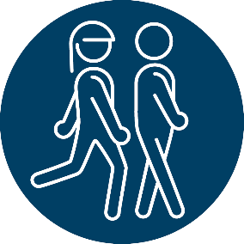 | Pedestrians include:  - people on foot  - people using unpowered wheelchairs  - everyday items such as prams and shopping trolleys when used by a person walking.  Pedestrians are the main people using the footpath. | - A person walking or running on the footpath.  - A person in an unpowered wheelchair.  - A person pushing a pram.  - A person walking their dog.
Mobility device user  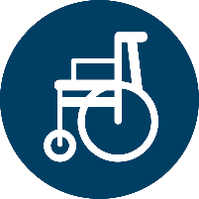  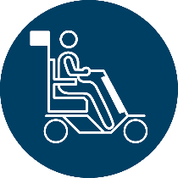 | Devices which are:  - intended for people who require mobility assistance for a physical or neurological impairment  - powered by a motor with a maximum power output of up to 1500 watts.  People using mobility devices typically use the footpath. | - Mobility scooters  - Powered wheelchairs
Wheeled recreational device user  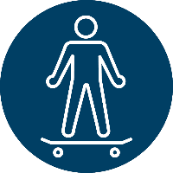 | A device with wheels, propelled by:  - human power, or  - gravity, or  - a small auxiliary motor with a maximum power output of up to 300 watts.  Currently excludes cycles with a wheel diameter over 355mm (an average six-year-old’s bike). Most adult bicycles are excluded. | - Push-scooters  - Skateboards  - roller blades or skates  - Low powered motorised versions of the same devices (like e-scooters).
Issues with the current use of the footpath
Behaviour
Currently, people using a device on the footpath must:

- behave in a courteous and considerate manner, and
- travel in a way that is not dangerous for other people using the footpath.
Users can be prosecuted for inconsiderate, careless, dangerous and reckless driving, but there are no specific restrictions on the speed they can travel or the size of their device when travelling on the footpath.
As new, fast-moving devices become more common, we need to ensure they’re operated safely and keep other users, particularly pedestrians, in mind. Our current behavioural requirements (above) don’t adequately explain:

- who people on the path should give way to when they’re travelling
- what a safe speed for footpath travel is, and
- how much space vehicles and devices should occupy on the footpath.

This gap in understanding and regulation means that people may ride on the footpath in a way that puts vulnerable footpath users at risk.

Access
The current requirements can also be unfair to particular users. For example, most children over the age of six cannot legally cycle on the footpath, but adults on e-scooters and mobility devices can.
While most children, and all adults, are currently prohibited from cycling on the footpath, in practice, younger cyclists ride on the footpath for most of their trips, unaware that this illegal. To most children and their parents, the footpath is the safest option, and the New Zealand Police and the Transport Agency recommend that children under the age of 10 only ride on the road when accompanied by a competent adult rider.
Other cyclists may use the footpath at some point in their journey in response to unsafe road environments, such as when there’s heavy, fast-moving traffic and a cycle lane is unavailable. The current settings mean that this action, taken in the interest of safety, is not allowed.
In the longer-term, changes in the design of urban spaces will reduce the risks associated with a mixture of pedestrians, devices and cycles in these spaces. In the interim, we need to make changes to the regulatory environment on the footpath for the safety of everyone using it.

Proposed change
To supplement the changes in proposal 1, we propose a new rule – the Land Transport Rule: Paths and Road Margins 2020. Our proposed new rule aims to:

- establish a national framework for devices on the footpath,
- redefine the users of the footpath, and
- enable road controlling authorities, like local councils, to vary parts of this framework if needed.
A national framework for the use of vehicles on the footpath
For the safety of others sharing the footpath, people riding on the footpath under the new rule will have to:

- behave in a courteous and considerate manner,
- travel in a way that is not dangerous for other people using the footpath,
- give right of way to pedestrians,
- travel no faster than 15km/h, and
- ride a device no wider than 750mm so multiple people can still use the footpath.

Under the new framework, everyone using the footpath, except people walking, running or using a wheelchair, must follow the above requirements. The vehicles and devices able to use the footpath will be:

- powered wheelchairs (they don’t need to follow the width limit),
- mobility devices (up to 750mm wide),
- transport devices (formerly wheeled recreational devices), and
- cycles, including e-bikes (up to 300 watts).
Our changes are meant to give as many people as possible safe spaces to travel, while maintaining and prioritising pedestrian access.
The elements of the framework are outlined in more detail in Proposals 1A-1C.

Allowing cyclists on the footpath
Our proposed change will allow cyclists to ride on the footpath if:

- they behave in a courteous and considerate manner
- travel in a way that is not dangerous for other people using the footpath
- they give way to pedestrians
- the cycle is less than 750mm wide
- they travel no faster than 15km/h.
The change would also allow people to ride on a formed path or lawn on the berm to pass or give way to a pedestrian, unless there are cultivated gardens on the berm.
The change will also mean cyclists can use pedestrian crossings to safely cross the street if they’re travelling on the footpath. They’ll still need to give right of way to pedestrians, as they do on all other parts of the footpath. This will ensure the safety of:

- children cycling at slow speeds in places where cycling on the road would put them at risk, and
- adult cyclists where cycling infrastructure is unavailable.
Cyclists travelling on the road won’t be expected to cross the road using pedestrian crossings.
We don’t expect this change to significantly increase the number of cyclists that choose to use the footpath. Research carried out for the Centre for Accident Research and Road Safety in Queensland, where cycling on the footpath is legal, found that only five percent of all cycling distance ridden occurred on footpaths. And most cyclists only did so reluctantly and for small parts of their trip. We expect cyclists in New Zealand to behave the same way, particularly due to the 15km/h speed limit proposed for the footpath.

Other options to address cyclists on the footpath
We have also considered other alternatives to the proposed change, to lessen the potential impact on other footpath users. Two options are discussed below.
Allowing cyclists up to 16 on the footpath
Allowing children up to the age of 16 to ride on the footpath would increase the safety of children when cycling on the road. In limiting this change to children, we would lessen the possible risk of incentivising all adults to ride on the footpath. While this is highly unlikely to occur in practice, it would create safety risks for other footpath users.
We note that limiting this option to children is consistent with the approach taken in some Australian states, where children under the age of 12 and their parents are allowed to cycle on the footpath. However, other Australian states and territories have rules that allow both adults and children to cycle on the footpath.
This proposal would not address the needs of adult cyclists where cycling infrastructure is unavailable, and where they see the road to be an unsafe environment. As outlined above, the experience in Queensland also suggests that most cyclists will avoid riding on the footpath, even if it is legal.
No change – status quo
Alternatively, we could make no change to the rule. This means that most cyclists will not be allowed to cycle on the footpath. This option reflects that while cycling on the footpath is illegal, in practice, most people accept that children and their parents should cycle on the footpath because it is the safest option.
However, this would mean retaining a set of rules that are confusing and could be considered unfair, particularly for children. Under the status quo most children and all adults are not legally allowed to cycle on the footpath, but they are allowed to ride other devices such as skateboards, push scooters, e-scooters, and mobility devices on the footpath.

Transport device use on the footpath
Under the proposed change, people using unpowered transport devices (for example skateboards, roller blades) and powered transport devices (for example e-scooters and YikeBikes) can use the footpath if they:

- behave in a courteous and considerate manner
- travel in a way that is not dangerous for other people using the footpath
- give right of way to pedestrians
- travel no faster than 15km/h
- ride a device no wider than 750mm.

Enabling road controlling authorities to restrict devices from using the footpath or an area of footpaths
Currently, road controlling authorities can prohibit certain devices from accessing parts, zones or specific lengths of the transport network. Signs and markings already exist for this purpose.
Our new rule aims to clarify and simplify how road controlling authorities can restrict the use of the footpath or an area of the footpaths. This means that a council, for example, could more easily restrict the use of a footpath in the centre of a town or city to only pedestrians and mobility devices. This restriction could extend over a collection of streets (referred to as an area of footpaths).
We’ll develop national guidance for road controlling authorities who are considering a restriction on certain users. This guidance will be part of the criteria for decision making. Before restricting the use of a footpath or areas of footpaths, the road controlling authority will need to consider:

- relevant guidance developed by the Transport Agency
- any alternative routes or facilities that will no longer be available to the user due to a restriction
- any other matter relevant to public safety.

The road controlling authority will need to:

- consult with any party affected by the proposed restriction
- give those parties reasonable time to respond
- take their submissions into account.

The Transport Agency will also have the power to investigate and direct road controlling authorities to comply with this rule.

Future-proofing the rule
Our proposed rules are designed to manage the possibility of new and emerging technologies. This includes small, driverless delivery vehicles which may operate on the footpath for some, or all, of their journey. The framework would limit these vehicles on the footpath if, for example, they were too large or posed a danger to other footpath users.
Use of helmets for people using the footpath
The rules around helmet use will remain the same on footpaths as for the road. Helmets remain compulsory for cyclists and are encouraged but not compulsory for users of transport devices.

Alternative proposal – Keep current footpath rules
An alternative approach is to continue relying on broad behavioural requirements. This option reflects that most people behave in a manner that is consistent with the current rules. Police can prosecute users for inconsiderate, careless, dangerous and reckless device use on the footpath. Retaining the status quo would allow users to make a judgement about what behaviour is appropriate in certain circumstances and would allow new social norms to develop within the current behavioural requirements.

The main risk with retaining the status quo is it may not address the risks posed by fundamental changes to the type of vehicles now sharing the footpath with pedestrians. The increased availability and use of powered devices on footpaths, including mobility devices and vehicles that resemble small cars, has meant a greater risk of conflict on footpaths. This conflict may be better dealt with by specific rules about the speed vehicles can travel and the width of these vehicles.

Rule reference: Clauses in the proposed Land Transport Rule: Paths and Road Margins 2020: Clause 3.1 (Use of footpaths), Clause 5.1 (Road controlling authority may restrict use of footpath or other pedestrian facility) and Clause 5.2 (Criteria for restricting use of the footpath, shared path, or cycle path).

Proposal 2: Establish a national framework for the use of footpaths – Questions for your submission:

- Our proposed changes will allow mobility devices, transport devices, and cycles on the footpath - provided users meet speed, width and behavioural requirements. Do you support this? Why/why not? Should there be any other requirements?

- We have outlined two alternative options to address cycling on the footpath. These are:
  - allow cyclists up to 16 years of age to use the footpath; or
  - Continue the status quo, where most cyclists are not allowed to use the footpath.
Do you prefer either of these options instead of allowing cyclists on the footpath?
- Would you support an age limit for cycling on the footpath? What age would you prefer?
- Our proposal allows road controlling authorities to restrict cycle or device use on certain footpaths or areas of footpaths to suit local communities and conditions. Do you agree with this proposal? Why/why not? Do you have any comments on the proposed process?

- We envisage that local authorities will make decisions to regulate the use of paths by resolution, rather than by making a bylaw. Should this be specified in the Land Transport Rule: Paths and Road Margins 2020 to provide certainty? Why/why not?

- We’re proposing that road controlling authorities consider and follow criteria in addition to their usual resolution processes if they want to restrict devices from using the footpath. Do you agree with this proposal and the proposed criteria? Why/why not?
- We have also outlined an option to maintain current footpath rules. Would you prefer this option instead of the proposed framework with speed and width requirements? Why/why not?

Proposal 2A: Users on the footpath will operate vehicles in a courteous and considerate manner, travel in a way that isn’t dangerous and give right of way to pedestrians.
Current state
Currently, people using a device on the footpath must:

- behave in a courteous and considerate manner, and
- travel in a way that is not dangerous for other people using the footpath.
People using wheeled recreational devices are also expected to give way to and prioritise pedestrians when they’re using the footpath.
Proposed change
Our proposed change will preserve these requirements but will require all footpath users to give way and prioritise the passage of pedestrians. This means that cyclists and any new and emerging devices must give way to pedestrians on the footpath. This recognises that we need to protect pedestrian use of footpaths as new and emerging transport devices like e-scooters become more widely used.
Enforcement
Footpath users who don’t prioritise, or give way to, pedestrians on the footpath can be penalised for inconsiderate, careless, dangerous and reckless driving.
Risks
Because enforcement on the footpath is typically low, there’s a risk that users won’t give way to pedestrians on the footpath, particularly if policing is not visible. This could put vulnerable pedestrians at risk.
We plan to reduce this risk through a public information campaign.

Rule reference: Clauses in proposed Land Transport Rule: Paths and Road Margins 2020: Clause 3.1 (Use of footpaths).

Proposal 2A: Users on the footpath will operate vehicles in a courteous and considerate manner, travel in a way that isn’t dangerous and give right of way to pedestrians – Questions for your submission:
- We propose that pedestrians should always have right of way on the footpath. Do you agree with this proposal? Why/why not?

- This proposal sets out three behavioural requirements; that footpath users will:
- operate vehicles in a courteous and considerate manner,
- travel in a way that isn’t dangerous, and
- give right of way to pedestrians.

Do you agree with these three requirements? Are there any others we should consider?

Proposal 2B: Default 15km/h speed limit for vehicles using the footpath
Current state
Although there is a requirement that vehicles are used at a speed that is not dangerous to other people on the footpath, currently, there’s no prescribed speed limit on the footpath. People using a transport device must behave in a courteous and considerate manner, travelling in a way that is not dangerous for other people using the footpath. If they don’t, they can be prosecuted for inconsiderate, careless, dangerous and reckless driving.
To ensure the safety of both riders and pedestrians, we propose to define an appropriate safe speed limit on the footpath to ensure safe travel speeds for all devices.
Proposed change
Our proposed change will set a default speed limit of 15km/h for travelling on the footpath. This speed limit will apply to:

- people using mobility devices
- cyclists, and
- people using transport devices.

It won’t apply to pedestrians on the footpath.

We chose 15km/h because it’s a safe compromise between different users. 15km/h is:

- around three times the speed of walking
- slightly faster than the average speed that children currently cycle (10.2km/h) and scooter (10.9km/h)

Enforcement
People using vehicles and devices may be penalised for travelling above 15km/h on the footpath. However, there could be practical challenges with enforcing the speed limit since existing speed detection devices are known to be less accurate at lower speeds.
Despite the enforcement limitations, we recognise that a maximum speed limit is more enforceable than current requirements around maximum power output and wheel diameter, which can be difficult to assess.
Accessible Streets is intended to support new behavioural norms on our roads and paths. While enforcement will be part of achieving this, the associated offences and penalties will primarily be for minor infringements. For more serious offences there are existing penalties to support enforcement.

Road controlling authority powers to vary the speed limit
Under this proposal all footpaths would have a default speed limit of 15km/h. To meet the needs of different communities, road controlling authorities will be able to lower the default footpath speed to either:

- 5km/h, or
- 10km/h.
Road controlling authorities would be able to set this speed by registering the limit on a National Speed Limit Register. This speed limit could apply to a singular footpath or an area of footpaths. This means if a council, for example, wants to limit the speed on the footpaths surrounding a school, they could do so.
Before setting this speed, road controlling authorities would need to:

- consider any relevant guidance developed by the Transport Agency
- consider any other matter relevant to public safety
- consult with any parties affected by the proposed speed limit
- allow reasonable time for parties to make a submission and take their submissions into account.
It would not be possible to set higher speed limits on the footpath
The rule won’t allow road controlling authorities to set a speed limit higher than 15km/h on the footpath. Footpaths are often narrow and largely intended for the passage of pedestrians. While people using transport devices should have access, speeds on the footpath should remain relatively low to limit risk to pedestrians and other users.
If road controlling authorities want to allow other users to travel at higher speeds, they can do so on wider paths like a shared path. This is because we want to encourage the creation of separate infrastructure that:

- provides for higher speeds and space for users like e-scooters, and
- does not endanger pedestrians or limit their access to the footpath.

Signs and markings
We propose that footpath markings showing 5km/h, 10km/h and 15km/h be made available in the Land Transport: Traffic Control Devices Rule 2004.

A road controlling authority may install markings stating a speed limit or restriction, but the speed limit or restriction will be valid whether markings are installed or not. This is similar to the approach taken for liquor ban areas.
Road controlling authorities will also need to follow the requirements in the Land Transport: Traffic Control Devices Rule 2004.

Risks
There is a risk that people will use their transport devices over 15km/h, particularly when:

- enforcement activity is low on the footpath
- device use on the footpath becomes more common
- policing is not visible
- a transport device or a cycle does not have a speedometer attached.

This may cause safety issues, especially for slower or more vulnerable footpath users.

Rule reference: Clauses in proposed Land Transport Rule: Paths and Road Margins 2020: Clauses 4.3 (Default speed limit on footpaths), Clause 4.4 (Variations from default speed limit on footpath), Clause 4.7 (Criteria for setting speed limits on paths), Clause 4.8 (Consultation requirements for speed limits on paths), Clause 4.9 (Setting speed limits on paths) and Clause 4.10 (Markings for speed limits on paths).
Clauses in proposed Land Transport Rule: Traffic Control Devices Change 2020: Clause 2.2 (Change to clause 5.2 – Provision of markings)

Proposal 2B: Default 15km/h speed limit for vehicles using the footpath – Questions for your submission:

- Do you agree with the proposed default speed limit of 15km/h for footpaths? Why/why not? Do you think the proposed speed limit should be higher/lower?

- Do you agree with the proposal that road controlling authorities will be able to lower the default speed limit for a footpath or areas of footpaths? Why/why not?

- Are there other ways, that you can think of, to improve footpath safety? Please explain.

Proposal 2C: 750mm width restriction for vehicles that operate on the footpath
Current state
Devices and vehicles that are allowed on the footpath don’t have a width restriction. However, cycles with a wheel diameter over 355mm cannot be used on the footpath. This is a wheel size that typically fits a cycle ridden by a five or six-year-old. Cycles with a wheel diameter of 355mm or less are allowed on the footpath.
There are also devices, currently in use, that take up the entire footpath when they travel. This can impact another user’s access to the footpath as they must walk or travel behind the large device, or walk on the road, which can be dangerous.
Proposed change
Our proposed change would create a general width restriction of 750mm for all vehicles (except wheelchairs) on the footpath. This means that people will be able to ride a cycle or other device on the footpath, if that device or cycle is no more than 750mm wide. 750mm is half the clear width of a narrow footpath, which will ensure that multiple people can still access the footpath.
Powered and unpowered wheelchairs don’t need to follow the width limit and can still use the footpath if they’re wider than 750mm.
We understand most cycles are less than 750mm wide. However, some cycles with particularly wide handlebars may be wider than this. People using these cycles won’t be permitted on the footpath.
Devices for medical or mobility purposes that exceed 750mm
Devices used for medical or mobility purposes won’t be permitted on the footpath if the device is wider than 750mm. Mobility scooters, which have an average width of around 660mm, won’t be affected by this change. Wheelchairs, both powered and unpowered, don’t need to follow this limit.
However, there are already mobility devices for sale in New Zealand that exceed 750mm. For example, cabin mobility scooters (fully enclosed mobility scooters) have an average width of 800mm. There are also enclosed four-wheeled electric devices, known as mini electric cars or ‘Twizys’, which are 1190mm wide on average. ‘Twizys’ are not considered mobility devices by the Transport Agency.
We currently have limited information about how many people use devices over 750mm wide for mobility purposes on the footpath. While the 750mm limit is intended to provide plenty of space to all footpath users, the proposed width limit may not be suitable for a range of users who already ride and depend on a wider device. If you use or supply a mobility device that is wider than 750mm, we’re interested in your feedback on the type of device you own, the size and width of this device and where it’s used.
Exemptions for devices that exceed 750mm
If the proposed width restriction is introduced, people who already own these types of devices and use them for medical or mobility purposes may be able to apply for an exemption from the Transport Agency to continue using their device on the footpath. Applications currently cost $27.80.
To be granted an exemption, you’ll need to show that the risk to safety won’t be significantly increased by permitting your device on the footpath. You’ll also need to show that one or more of the following is true:

- You’ve complied with the requirements and further compliance is unnecessary.
- granting an exemption will not affect wider compliance with width requirements.
- The prescribed requirements are unreasonable for you.
- Events have occurred that make the width limit inappropriate for you.
These criteria are set in legislation and the Transport Agency will need to consider them whenever they receive an application for exemption. This means that even if you purchased a wide mobility device before the width limit was introduced, you’ll still need to meet the above criteria to be granted an exemption. Likewise, if we grant an exemption for a device, this does not guarantee we’ll grant an exemption for a similar device. The Transport Agency grants exemptions on a case by case basis and may consider its own guidance on mobility devices before deciding to grant an exemption. Existing guidance for importing mobility devices suggests that mobility devices shouldn’t exceed 850mm.
It is currently unclear how many people rely on devices over 750mm wide. If it’s a large number, many people may be disadvantaged by the proposed change.
Requiring people to apply for an exemption could also put an unnecessary financial burden on people who need these devices for medical reasons. It’s unlikely that the Transport Agency will grant exemptions for electric mini cars or ‘Twizys’ as these devices shouldn’t be treated as a mobility device or used on the footpath.
Alternative approaches to reduce the impact on existing device owners
In addition to the existing exemption process, we’re interested in your feedback on whether other steps should be taken to reduce the impact of the proposed width limit on people who already own mobility devices over 750mm wide.
For example, mobility devices purchased before the rule changes could be automatically exempt from the width limit. However, we recognise this could be difficult to enforce, as it would be challenging for enforcement authorities to prove whether a mobility device was purchased before the changes were introduced.

Alternatively, or in addition, wider devices could be excluded from the width requirements if:

- they are over 750mm wide, and
- declared to be mobility devices under section 168A of the Land Transport Act.
Once declared to be a mobility device, devices over 750mm could be used on the footpath. This would provide greater certainty for those purchasing mobility devices before they buy them. It could also reduce the risks associated with vehicles such as mini cars or ‘Twizys’, which are sold as mobility devices. It is important to note, however, that the Transport Agency has never declared a device to be a mobility device.
Given we know there are existing mobility devices that are over 750mm wide, we could also apply a separate width limit to mobility devices. However, we recognise allowing wide vehicles on the footpath reduces safety for other users and could make sharing some footpaths more difficult.

We’re seeking specific feedback on these options in the question prompts listed below.
Existing exemption powers would be maintained
Accessible Streets will not change existing exemption powers that allow the Transport Agency to exempt vehicles from specific legislative requirements. For example, NZ Post’s Paxster small electric delivery vehicles currently operate under a provision that allows mail delivery services to operate motor vehicles on the footpath. They’re expected to be exempt from the 750mm width limit but will still need to comply with the proposed speed limit of 15km/h on the footpath.

Enforcement
A width limit is likely to be more enforceable than current requirements around power output and wheel diameter. People on devices wider than 750mm could be penalised.
Risks
Imposing a width limit of 750mm may exclude some devices such as mountain bikes with wide handlebars and some mobility devices.
People who have purchased devices wider than 750mm may not be able to continue to use them and could suffer financial and/or physical hardship.

Rule reference: Clauses in proposed Land Transport Rule: Paths and Road Margins 2020: Clause 3.1(1) (Use of footpaths)

Proposal 2C: 750mm width restriction for vehicles that operate on the footpath – Questions for your submission
- Do you agree with the proposed maximum width measurement of 750mm (except for wheelchairs) for devices on the footpath? Should this maximum width limit be wider/narrower?

- Do you use a mobility device? If yes, what is the width of your device? Would the proposed width restriction impact you?

- Should the maximum width limit apply to mobility devices? Why/why not?

- We propose that people who already own a device wider than 750mm could apply for an exemption. This document also considers three alternative approaches to mitigate the impact on existing device owners:
  - mobility devices purchased before the rule changes could be automatically exempt from the width limit.
  - The Transport Agency could declare certain wider devices to be mobility devices under section 168A of the Land Transport Act, and exclude them from width requirements, or
  - Apply a separate width limit to mobility devices.

Which is your preferred option? Do you have any comments on these alternatives?

Proposal 3: Establish a national framework for the use of shared paths and cycle paths
Current state: Shared Paths
A shared path (figure 3A) is a path that may be used by:

- pedestrians
- cycles
- mobility devices
- wheeled recreational devices.

A sign or marking can be used to:

- prioritise particular users like pedestrians or cycles, or to
- exclude some users.
Current state: Cycle paths
A cycle path (figure 3B) is a part of the road that is physically separated from motor vehicle traffic. They’re generally located next to the roadway. Cycle paths are intended for cycles, but pedestrians and mobility devices can use them if a footpath is unavailable. Cycle lanes, by comparison, are painted lanes within the roadway, not separated from the rest of traffic.

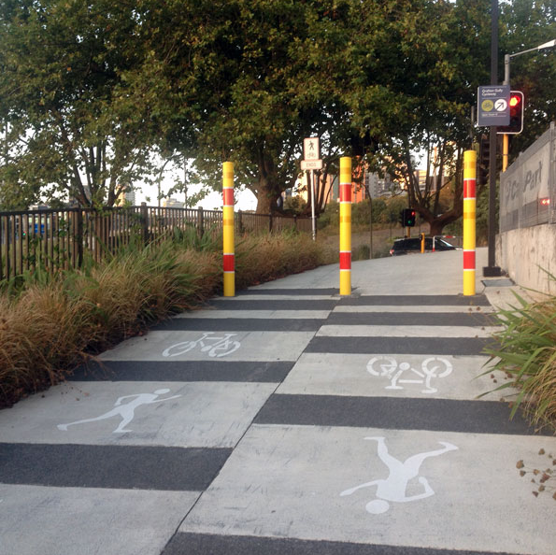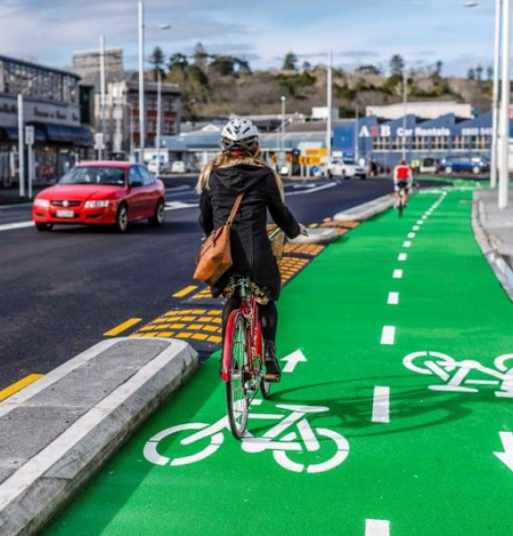
Figure 3A: A shared path Figure 3B: A cycle path

Issues with the use shared paths and cycle paths
Like the footpath, we’re seeing a greater number and variety of different devices using shared paths and cycle paths. Current rules don’t adequately explain who has priority on a shared path or cycle path, or what speeds they should travel at to ensure the safety of others on the path.
Shared paths and cycle paths have no prescribed speed limit. Usually, the speed limit on these paths matches the adjacent roadway, but if there’s no adjacent roadway, the speed limit is unclear. Likewise, while cycle paths are typically used by cycles, when there are many different devices on a shared path it’s unclear who has right of way.

Issues for road controlling authorities to make shared paths and cycle paths
The requirements for creating shared paths and cycle paths are also complex and unclear.
To create a shared path, road controlling authorities need to create a bylaw and install signs or markings to tell people who can use the path. There are no specific enabling provisions for the creation of shared paths, except for those related to signs and markings.
To create a cycle path, it’s unclear whether road controlling authorities should follow the requirements outlined in the Local Government Act 2002 or the requirements in the Land Transport Act 1998.
In the longer-term, changes in the design of urban spaces will reduce the risks associated with a greater variety of people and devices in those spaces. In the interim, we need to make changes to the regulatory environment on shared paths and cycle paths. These regulatory changes need to be in one, easy-to-find place to help road controlling authorities create more of these spaces.
Proposed change

We’re proposing a new rule – the Land Transport Rule: Paths and Road Margins 2020. The new rule aims to:

- clarify, in one place, how these spaces are created, redefine who can use them and how they’re used, and
- provide a mechanism for road controlling authorities to vary parts of this framework.

This proposal will focus on what this means for shared path and cycle path use.

Road controlling authorities can declare a path to be a shared path or cycle path
Under our proposed changes, road controlling authorities can declare a path to be a shared path or a cycle path by making a resolution.
Clarifying how users must behave on shared paths and cycle paths
Under our proposed changes, a person using a shared path or cycle path must travel:

- in a careful and considerate manner
- at a speed that is not dangerous to other people on the path
- in a way that doesn’t interfere with other people using the path.
Unlike using the footpath, there will be no width requirements for people using shared paths or cycle paths.
Clarifying priority users in shared paths
Our proposed changes will also specify which user has priority when travelling on shared paths unless a sign or marking says otherwise. We’ve outlined these proposed priorities in the following table:

User | Priority in shared path
Pedestrians | Pedestrians have greatest priority. Everyone must give way to pedestrians if they’re travelling in a shared path.
Mobility devices | People using mobility devices must give way to pedestrians. Everyone else must give way to people using mobility devices.
Transport devices | People using transport devices must give way to mobility devices and pedestrians. Cyclists must give way to transport devices.
Cycles | Cyclists must give way to all other users in a shared path.

Speed limits for shared paths and cycle paths
Under our proposed changes, if a shared path or cycle path is adjacent to a roadway, the speed limit will be the same as the roadway – which is currently the case. This means it’s possible for a shared path or cycle path to have a speed limit of 100km/h if the adjacent roadway has a speed limit of 100km/h.
If a shared path or cycle path is not located beside or adjacent to a roadway, then our proposed change clarifies that the path has a maximum default speed limit of 50km/h.
It will be an offence to travel faster than the default speed limit.
Enabling road controlling authorities to change the speed limit on a shared path or cycle path
Under our proposed changes, road controlling authorities can change the speed limit on shared paths and cycle paths if:

- the default speed limit is inappropriate or unsafe for users, and
- the new speed limit is between 10km/h and 50km/h.
The 50km/h limit can be an option for local areas that need it, like a cycle path largely used by e-bikes, which typically reach 45km/h on the flat. However, most devices or cycles only reach speeds 30km/h on the flat, so we expect that many road controlling authorities will set limits lower than 50km/h.
The lower 10km/h limit is for paths used by pedestrians, mobility devices or vulnerable users. We’ve chosen 10km/h as a minimum speed limit to ensure people using transport devices still have access but travel at a safe speed for pedestrians.
If road controlling authorities want to change the speed limit on a shared path or cycle path, they’ll need to consider:

- relevant guidance developed by the Transport Agency
- any alternative routes or facilities available to someone excluded from a path through a restriction
- any other matter relevant to public safety.
The road controlling authority will also need to:

- consult with those affected by the proposed restriction
- give those parties time to respond, and
- take their submissions into account.
The road controlling authority will need to register the speed limit restriction on the National Speed Limit Register maintained by the Transport Agency.
The Transport Agency will also have the power to investigate and direct road controlling authorities to comply with this rule.
Enabling road controlling authorities to restrict devices from using a shared path or cycle path

Our proposed change will allow road controlling authorities to restrict certain devices from using shared paths and cycle paths if it is unsafe for them or others.
This means if it’s unsafe to use a transport device in certain spaces, a road controlling authority can restrict them from those spaces.
We’ll develop national guidance to help road controlling authorities when they’re considering restrictions on certain users in these spaces. Consideration of this guidance will be part of the criteria.
Under this proposal road controlling authorities will be able to:

- restrict the use of the shared path, cycle path or an area of these paths to certain devices, and
- if needed, specify times at which these restrictions apply.
Road controlling authorities won’t be able to restrict pedestrians and mobility devices from shared paths and cycle paths if there’s no footpath available.
If road controlling authorities want to restrict the use of a shared path or cycle path, they’ll need to consider:

- relevant guidance developed by the Transport Agency
- any alternative routes or facilities available to someone excluded from a path through a restriction
- any other matter relevant to public safety.
The road controlling authority will also need to:

- consult with any party affected by the proposed restriction
- give those parties time to respond, and
- take their submissions into account.
The Transport Agency will also have the power to investigate and direct road controlling authorities to comply with this rule.
The road controlling authority will need to register the restriction on the Transport Agency’s National Speed Limit Register.

Signs and markings

A road controlling authority may install markings stating a speed limit or restriction. But the speed limit or restriction will be valid whether markings are installed or not. This is similar to the approach taken for liquor ban areas.
Road controlling authorities will also need to follow the requirements in the Land Transport: Traffic Control Devices Rule 2004.

Use of helmets on shared paths and cycle paths

We’re not addressing the current rules around wearing helmets as part of Accessible Streets.

The rules around helmet use will remain the same on shared paths and cycle paths. Helmets remain compulsory for cyclists and are encouraged although not compulsory for transport device users.

Rule reference: Clauses in proposed Land Transport Rule: Paths and Road Margins 2020: Section 2 (Creation of shared paths and cycle paths), clause 3.2 (Use of shared paths and cycle paths), clause 3.3 (Priority on shared paths), Section 4 (Speed limits on paths), Section 5 (Restrictions on use of footpath, shared path or cycle path) and Part 2 (Definitions).

Proposal 3: Establish a national framework for the use of shared paths and cycle paths – Questions for your submission
- Do you agree that road controlling authorities should be able to declare a path a shared path or a cycle path? What factors should be considered when making this decision?

- Do you agree with the behavioural requirements we are proposing? Should there be other requirements or rules to use a shared path or cycle path?

- Do you agree that all users be required to give way to pedestrians when using a shared path? Why/why not?

- Do you agree with the proposed speed limits for shared paths and cycle paths and the ability of road controlling authorities to change these limits? Please explain.

- Do you think that the Transport Agency should be able to investigate and direct road controlling authorities to comply with the required criteria? Why/why not?

Proposal 4: Enable transport devices to use cycle lanes and cycle paths
Current state
Currently, transport devices like e-scooters and skateboards can use:

- footpaths
- shared paths
- some cycle paths, and
- the road.
You can’t use transport devices in on-road cycle lanes, or some cycle paths if this is specified by council bylaw. This means that people using these devices are supposed to use the road or the footpath, even if a cycle lane or cycle path is available.
People on transport devices may be at risk travelling on the road alongside fast-moving motor vehicle traffic. However, using transport devices at higher speeds on the footpath can endanger other people on the path, particularly pedestrians.
Crash statistics in New Zealand show that as a result of vehicle crashes between 2012 and 2018:

- 130 skateboarders were injured
- 232 wheeled pedestrians, including people using wheelchairs, mobility devices and push scooters, were injured
- one skateboarder and 11 wheeled pedestrians were killed.
While limited data is available about where and how different transport devices are currently used, a survey conducted as part of the Lime e-scooter trial in Christchurch found that, of the 2298 people surveyed who used the devices, 28 percent preferred using on-road cycle lanes.
Proposed change
We propose to allow transport devices (such as e-scooters and skateboards) to use cycle lanes and cycle paths. Allowing people to use transport devices in cycle lanes and cycle paths would help to:

- encourage people using these devices to move off the footpath, and onto a defined strip within a roadway
- reduce the risks associated with travelling on the road with fast-moving motor vehicles
- reduce risks for pedestrians
- provide a safer place for transport devices to travel at higher speeds.
Some safety risk could transfer to people who already using cycle lanes by introducing additional users into this space.
All powered and unpowered transport devices can still use footpaths and shared paths. They can still use the road if they stay as far to the left as practicable.

This rule change aligns with the government’s goals of:

- Lowering transport emissions
- Creating more liveable cities
- Minimising disruption to other travellers.
Pedestrians and mobility devices may use cycle lanes and cycle paths when a footpath is unavailable or if it’s impractical to use the footpath. If a cycle lane or cycle path is available, these users won’t be forced onto the roadway when they can’t use the footpath.
All pedestrians and mobility devices using cycle lanes must keep as far to the left as is practicable.
Use of helmets in cycle lanes
We’re not addressing the current rules around wearing helmets as part of Accessible Streets. This means cyclists must still wear helmets on cycle paths, cycle lanes and the road. We encourage people using unpowered and powered transport devices to wear helmets, but this won’t be compulsory.
Restrictions by road controlling authorities
These changes would allow transport devices to use cycle lanes and cycle paths alongside cycles. However, if road controlling authorities have location-specific reasons to exclude them, they can restrict those devices.
To restrict the use of transport devices in cycle lanes and cycle paths, road controlling authorities will need to consider:

- relevant guidance developed by the Transport Agency
- any alternative routes or facilities that people will no longer be able to use because of the restriction
- any other matter relevant to public safety.
The road controlling authority will also need to:

- consult with any party affected by the proposed restriction
- give those parties time to respond, and
- take their submissions into account.
The road controlling authority will need to register the restriction on the Transport Agency’s National Speed Limit Register.
The Transport Agency will also have the power to investigate and direct road controlling authorities to comply with this rule.
The creation of a cycle-only lane won’t prevent pedestrians or mobility devices from using a cycle lane or cycle path if a footpath is unavailable.
Risks

Though cycles already manage different speeds and overtake when needed, there could be conflict between cycles and transport devices in cycle lanes, particularly if people using these devices are:

- travelling slowly
- moving erratically
- moving differently to the straight-ahead movement of cycles, such as the side to side movement of people using roller blades or skateboards going downhill.
There may also be increased conflict between cycles and drivers, for example, if a cycle needs to enter the live traffic lane in order to overtake someone on a transport device.
If they perceive cycle lanes to be a slower environment, more cyclists may choose to ride in general traffic lanes instead of in cycle lanes. This could also cause more interaction between cycles and cars.
We will provide guidance recommending that slow-moving transport devices use footpaths and shared paths instead of cycle lanes or roads.
Rule reference: Clauses in the proposed Land Transport (Road User) Amendment Rule (No2) 2020. Clause 7(4) (Cycle lane), Clauses in the proposed Land Transport: Paths and Road Margins Rule 2020. Part 2 (Definitions).

Proposal 4: Enable transport devices to use cycle lanes and cycle paths – Questions for your submission:
- Do you agree that devices other than cycles should be allowed to use cycle lanes and/or cycle paths? Why/why not?

- Do you agree that road controlling authorities should be able to exclude powered transport devices or unpowered transport devices from cycle lanes and/or cycle paths? Why/why not?

Proposal 5: Introduce lighting and reflector requirements for powered transport devices at night

Current state
Cyclists must use a headlamp, a rear-facing position light and reflectors when riding on the road at night. Powered transport devices, while also permitted on the road (and most paths), aren’t legally required to have lights or reflectors at night. This inconsistency can be dangerous as it means powered transport devices can travel at night without being visible to others. The risk is higher if they’re on the road with fast-moving traffic, travelling through intersections or riding past driveways with low lighting.

Proposed change
Our proposed change would only permit powered transport devices on the road and on paths at night, provided the device is fitted with:

- a headlamp
- a rear-facing position light, and
- a reflector (or the person is wearing reflective material)

If proposals 4 and 6C are introduced, powered transport devices would need to follow the same lighting and reflector requirements if they’re riding in a cycle lane or cycle path.

Enforcement
Police and road controlling authorities currently work together to ensure that cyclists follow lighting requirements when travelling at night. We expect they’ll apply the same process to users of powered transport devices.
People using powered transport devices could potentially be fined for not following these requirements at night.

Risks

Some powered transport devices may not have fitted reflectors and many people don’t own or use headlamps, position lights or reflective clothing. Under our proposed change, these people may need to purchase some, or all, this equipment themselves. This may be impractical or expensive and could discourage them from using their device at night.
However, the safety benefits of our proposed change are likely to outweigh this cost.

Rule reference: Clauses in proposed Land Transport (Road User) Amendment Rule (No 2) 2020: Clause 11.12 (Lighting and reflector requirements for cyclists).

Proposal 5: Introduce lighting and reflector requirements for powered transport devices at night – Questions for your submission
- Do you agree with the proposal that powered transport devices must be fitted with a headlamp, rear facing position light, and be fitted with a reflector (unless the user is wearing reflective material) if they are used at night? Why/why not?

- Do you think these requirements are practical? For example, if you own a powered transport device, will you be able to purchase and attach a reflector or lights to your device or yourself?

- Do you think unpowered transport device users should be required to meet the same lighting and reflector requirements as powered transport device users at night time? Why/why not?

Proposal 6: Remove barriers to walking, transport device use and cycling through rule changes
People walking, cycling, riding a device, or taking public transport are often given lower priority on the road than motor vehicles. There are also situations where the law prevents pedestrians, cycles and transport devices from engaging in safe behaviours that would:

- improve their visibility, and
- reduce conflicts with motor vehicles.

We aim to make our streets safer and more active mode friendly. We also want to reduce delays and make active transport modes more efficient. The following four proposals will achieve these goals, by:

- improving the visibility of people
- legitimising some beneficial road user behaviours
- prioritising pedestrian, transport device user, cyclist and bus movements.
The four proposals are:

- Allow cycles and transport devices to travel straight ahead from a left turn lane.

- Allow cycles and transport devices to carefully pass slow-moving vehicles on the left, unless a motor vehicle is indicating a left turn.

- Give cycles and buses priority over turning traffic when they’re travelling through an intersection in a separated lane.

- Give priority to footpath, shared path and cycle path users over turning traffic where the necessary traffic control devices are installed.

We’ve included question prompts at the end of each proposal.

Proposal 6A: Allow cycles and transport devices to travel straight ahead from a left turn lane
Current state
Cycles and other transport devices need to keep as far to the left as practicable when on the road. But, once they reach an intersection, they’re legally required to cross from a left turn lane into the straight-through lane to travel straight ahead (figure 1A).
Often, it can be difficult to find a gap to move safely into the straight-through lane during heavy traffic (figure 1B).
Travelling through heavier, faster-moving traffic also increases the possibility and severity of a crash.
Currently, 80 percent of cycles choose to ignore the rule, and use left turn lanes to travel straight ahead. The law is inconsistent with both common behaviour and what’s generally considered safe practice. The Official New Zealand Code for Cyclists, for example, explains that when there are heavy flows of traffic, it’s safest to ride “just to the left of this lane.”

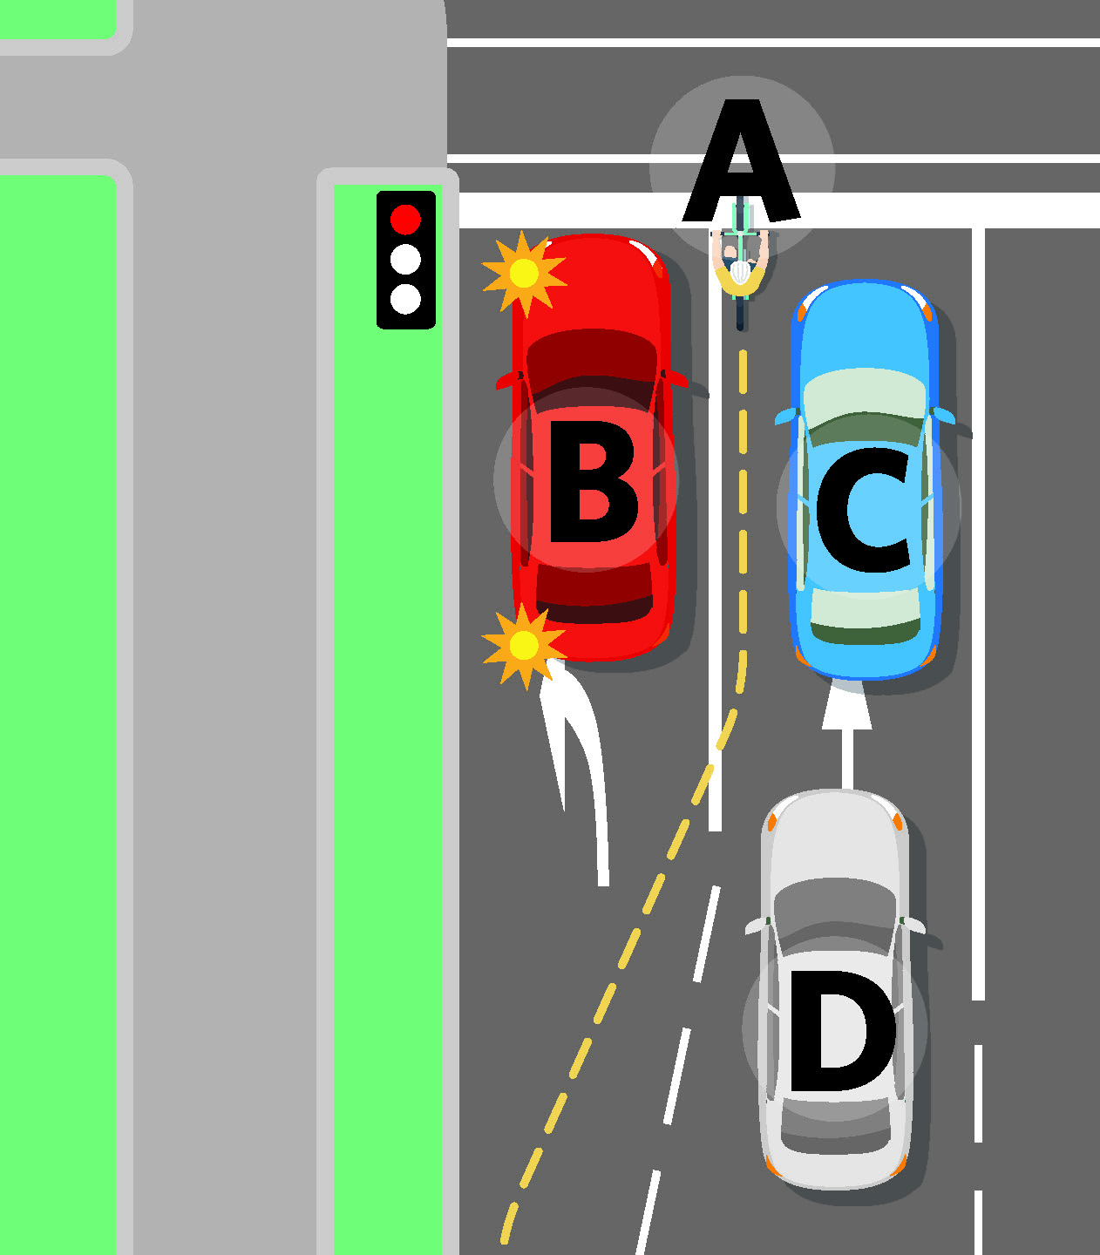
Figure 1A. Under the current state, cyclists and transport devices must legally cross from the left turn lane to travel straight ahead.

The cyclist pictured (labelled A) must travel between multiple cars (labelled B, C and D) to move from the left lane to the straight-ahead lane.

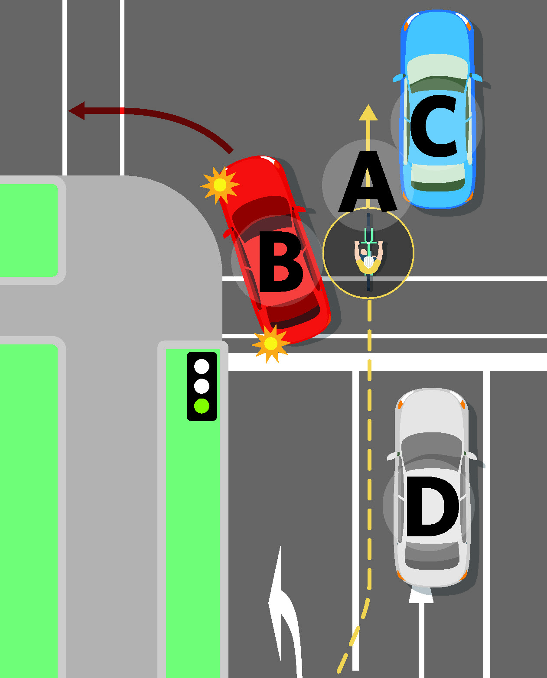
Figure 1B. Under the current state, it can be difficult to find a gap to move safely into the straight-through lane in heavy traffic.
The cyclist pictured (labelled A) must travel between multiple cars (labelled B, C and D) to move from the left lane to the straight-ahead lane and this can be dangerous for the rider.

Proposed change
The change will allow cycles and other transport devices to ride straight ahead from left turn lanes, unless:
- it’s dangerous to do so, or
- doing so would significantly delay left turning traffic, for example, if a left turn lane can proceed but the straight-ahead lane has a red light.
When cycle lanes are unavailable, the left turn lane is the safest option, as this lane has less traffic and slower travel speeds.
The change is expected to legitimise existing safe behaviour. As it would no longer be illegal, cycle skills trainers can teach people to how to use the left turn lane as the safest way to travel straight ahead.
If this proposal is introduced, we’ll introduce an education campaign to help you understand these changes.

Risks
Because cyclists already use left turn lanes to travel straight ahead, the existing risks will remain largely the same.
For example, a driver could collide with a cyclist at an intersection (without traffic signals), if:

- the cyclist is using a left turn lane to go straight along a main road, and
- the driver is coming out of a side-road, and
- the driver misreads the cyclist’s intentions and drives into the road.
A conflict could also occur at traffic lights if a left turning vehicle mistakenly assumes a cyclist in the left turn lane is also going to turn left. For example, a driver could collide with a cyclist if:

- the green light signals the car can turn left, and
- the red light signals the cyclist cannot continue straight ahead, and
- the driver begins their left turn without realising the cyclist has not moved.
In this scenario, the driver of the turning car could also brake suddenly, causing harm to the driver or passengers, or hit another vehicle while attempting to avoid the cyclist.
There are similar risks for transport devices. Transport devices can travel at a range of different speeds and may not travel at the same speed as motor traffic.

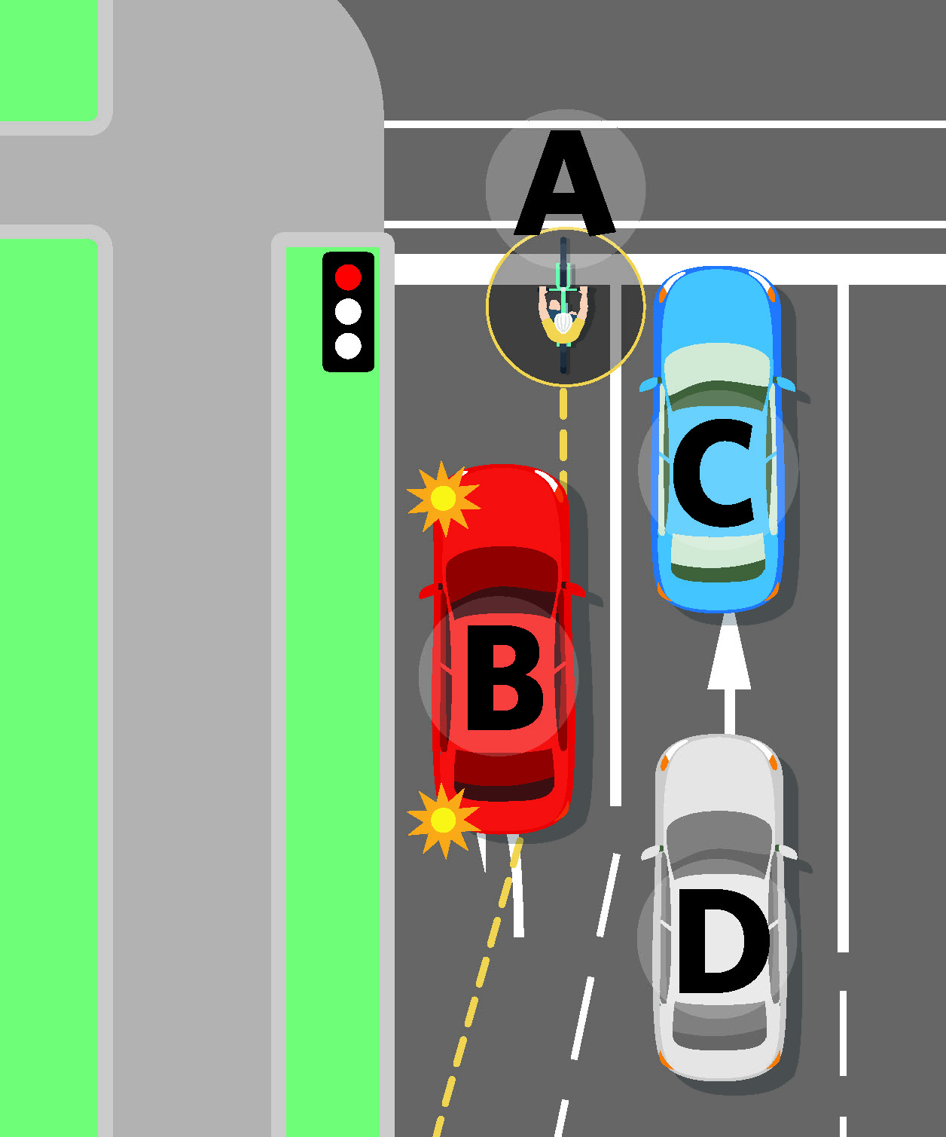
Figure 1C. We propose that cyclists and transport device users will be allowed to travel straight ahead from a left turn lane, unless excluded from doing so for safety.
This means the cyclist pictured (labelled A) will be able to travel straight ahead from the left turn lane with one left turning car (labelled B) instead of in the lane with two cars (labelled C and D).

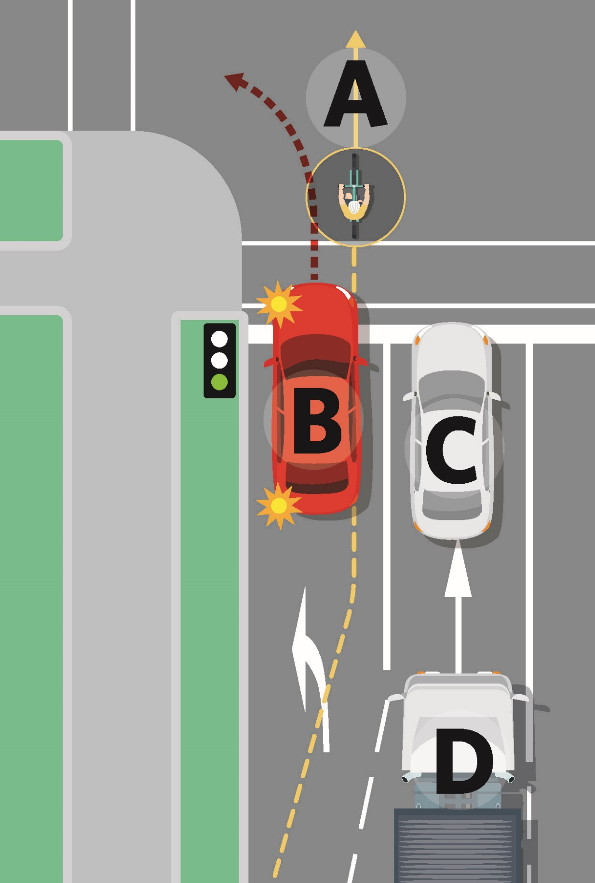
Figure 1D. Under the proposal, cyclists (labelled A) will be able to travel straight ahead in a lane that usually has less traffic and moves at a slower pace. The car in the left turn lane (labelled B) is slowing down to turn left, whereas the car (labelled C) and the truck (labelled D) in the other lane are travelling straight at a faster speed. By being in the left turn lane, the cyclist can maintain a safe distance from these faster vehicles.

Cycles and transport devices will need to exercise caution and limit their speed when riding straight ahead from a left turn lane. Our education campaign will need to include the importance of riding defensively at intersections.

Rule reference: Clauses in proposed Land Transport (Road User) Amendment Rule (No 2) 2020: Clause 2.4 (Specific manoeuvres only from marked or signed lanes at intersections).

Proposal 6A: Allow cycles and transport devices to travel straight ahead from a left turn lane – Questions for your submission:

- Do you agree that cyclists and transport device users should be able to ride straight ahead from a left turn lane at an intersection, when it is safe to do so? Why/why not?

Proposal 6B: Allow cycles and transport devices to carefully pass slow-moving vehicles on the left, unless a motor vehicle is indicating a left turn
Current state
When cycles and transport devices are on the road, they’re not allowed to overtake a vehicle on the left (sometimes referred to ‘undertaking’), unless that vehicle has stopped.
However, it’s common for riders outside of cycle lanes to ‘undertake’ slow-moving vehicles when they believe it’s safe to do so. Moving to the left means other users spend less time waiting for cycles or devices to merge into traffic to overtake other vehicles, and reduces the risks associated with moving between lanes of fast-moving traffic.
The current rule is inconsistent with both common behaviour and what’s generally considered safe practice. It also differs from other countries. Australia, for example, allows cycles to pass a vehicle on the left unless it’s indicating a left turn.
The rule should be updated to:

- reflect current behaviour and safe practice, and
- help cities to best accommodate their cycles and transport devices.

Proposed change
The proposed change would allow cycles and transport devices to undertake slow-moving traffic if a motor vehicle is not indicating a left turn.
This means cycles and transport devices can maintain a safe, steady speed past slow-moving and stop-start traffic, and ride as far to the left as practicable.
Extending this change to transport devices allows these users to move more safely and efficiently on the road.

Our proposed change will:

- make cycling a more efficient transport mode
- help cycles access advanced stop boxes
- lower the risks for cyclists moving between lanes of faster traffic
- legitimise common practice.
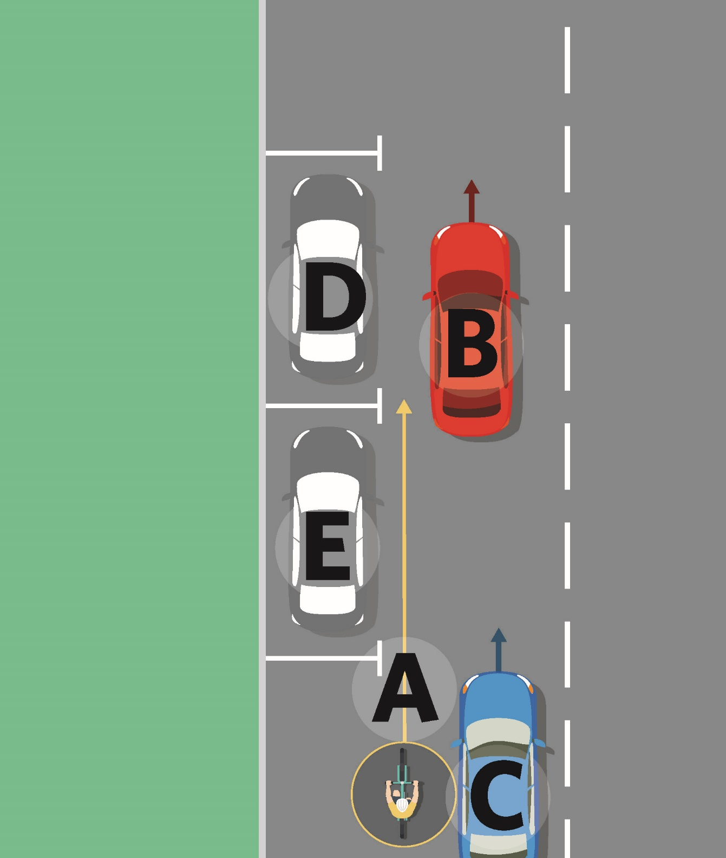
Figure 2A. We propose that cyclists and transport device users be allowed to pass slow-moving traffic on the left. Passing on the left is known as ‘undertaking.’
This means that the cyclist pictured (labelled A) can undertake the slow-moving cars (labelled B and C) on the left. If the cyclist is passing slow-moving vehicles on the left and parked cars on the right (labelled D and E), the cyclist will need to pass carefully.

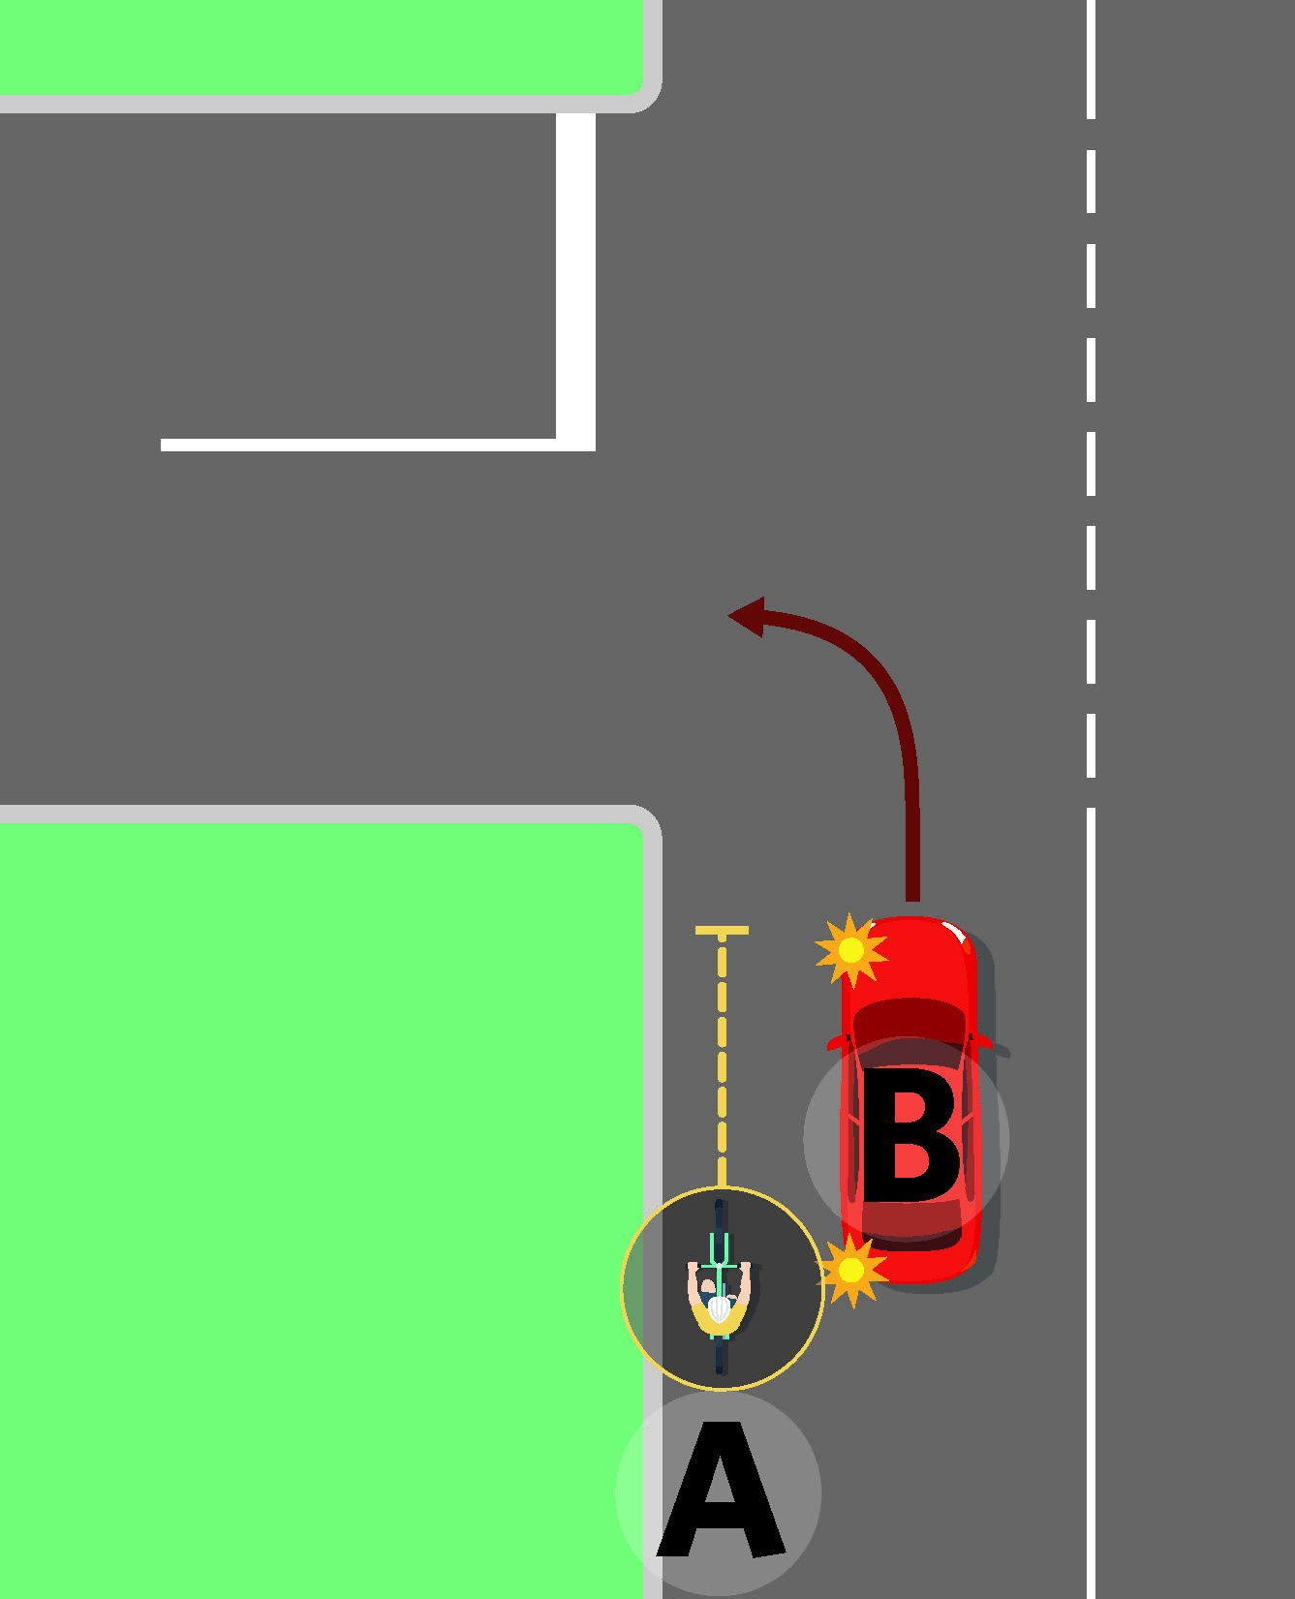
Figure 2B. We propose that cyclists and transport device users will not be able to undertake slow-moving traffic when a motor vehicle is indicating a left turn. This means that the cyclist (labelled A) in the picture above, must not undertake the car (labelled B) because it is indicating a left turn.

Risks
While ‘undertaking’ is already common practice, there are existing risks.
Conflicts could occur between a driver slowing to turn left and a cyclist mistakenly undertaking them. This is particularly likely in the case of large trucks, because:

- cyclists may not see a turn signal before beginning the undertaking manoeuvre, and
- truck drivers may not see the cyclist due to blind spots.

Conflicts could also occur between a driver turning right into what looks like a gap in traffic and an oncoming cyclist undertaking that line of slow-moving traffic (figure 2C). Currently it’s legal for the cyclist to undertake this traffic but only if the traffic has stopped moving.
People using transport devices could be at greater risk on the road when making similar manoeuvres, because unlike cyclists, they’re not required to wear a helmet.
We would introduce this rule change alongside a public information and education campaign to:

- encourage drivers to be mindful of cycles and transport devices on the road, and
- instruct riders to undertake in a safe and careful manner.

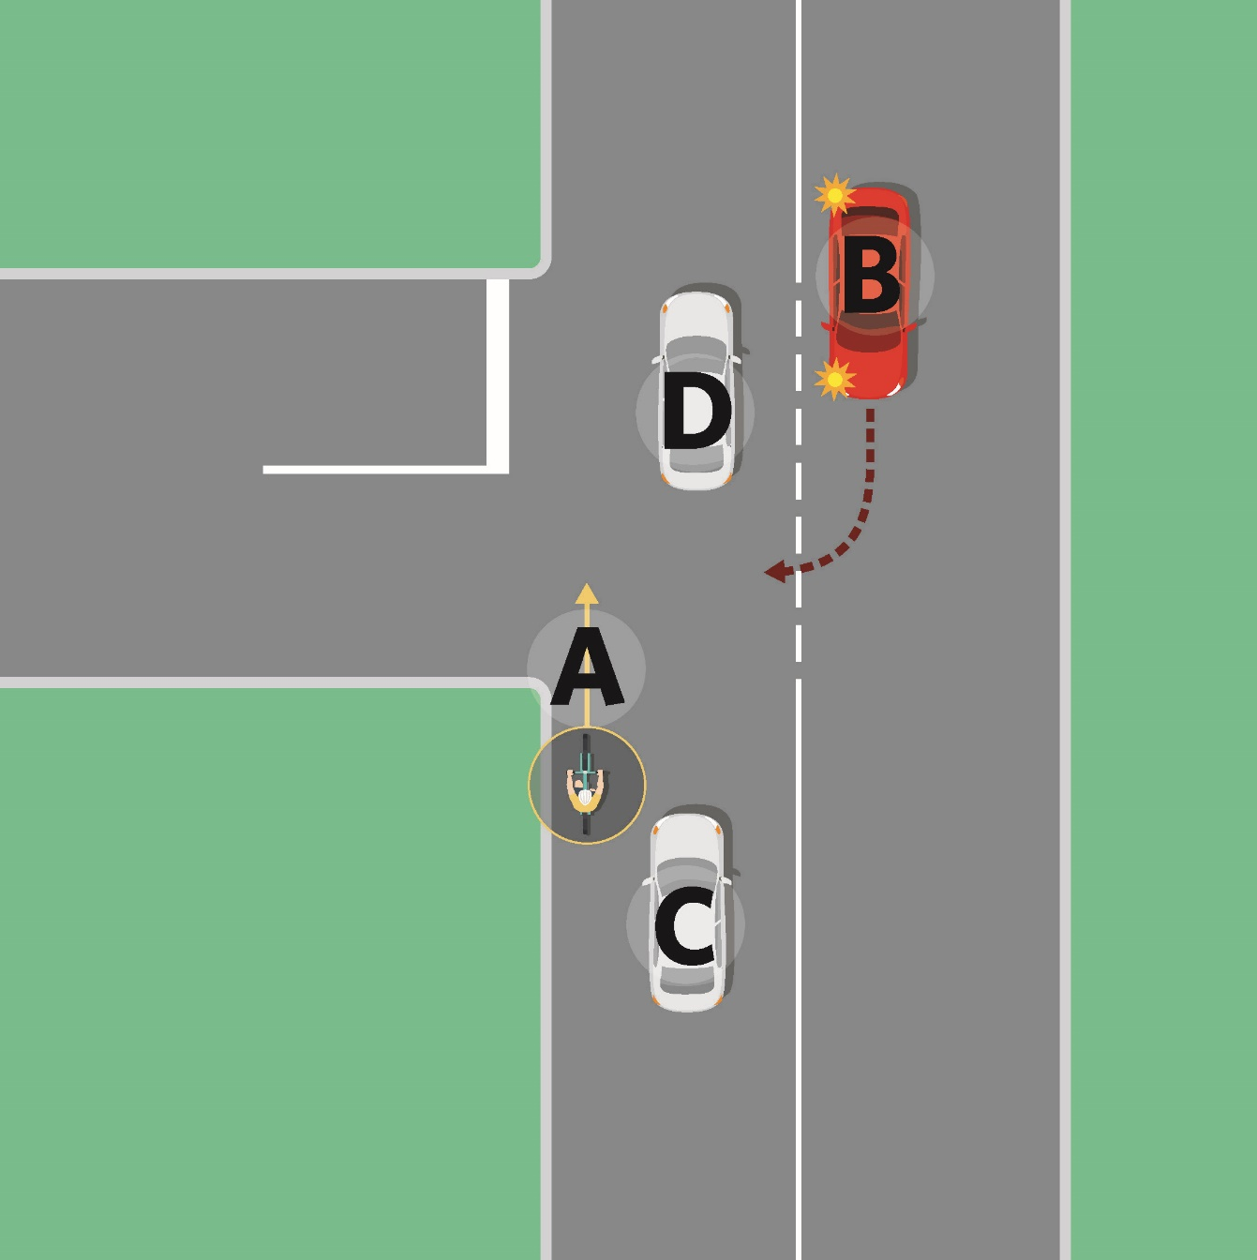
Figure 2C. Under the proposed changes, there is a risk that a conflict could occur between a motorist (the car labelled B) turning left into what they perceive to be a gap in traffic (cars labelled C and D) and an oncoming cyclist or transport device user (the cyclist labelled A) coming up to the intersection, undertaking that line of traffic.
Rule reference: Clauses in proposed Land Transport (Road User) Amendment Rule (No 2) 2020: Section 11 (Passing on left).

Proposal 6B: Allow cycles and transport devices to carefully pass slow-moving vehicles on the left, unless a motor vehicle is indicating a left turn – Questions for your submission:

- Do you agree that cyclists and transport devices should be allowed to carefully ‘undertake’ slow-moving traffic? Why/why not?

Proposal 6C: Give cycles, transport devices and buses priority over turning traffic when they’re travelling through an intersection in a separated lane
Current state
A separated lane is a lane physically separated from the adjacent roadway by a traffic control device. Traffic control devices include, but are not limited to:

- Small concrete barriers or blocks
- Posts (or bollards)
- Planters
Figures 3A, 3B and 3C show common examples of traffic control devices.

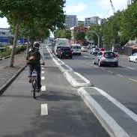  Figure 3A. A separated lane with small concrete barriers. | 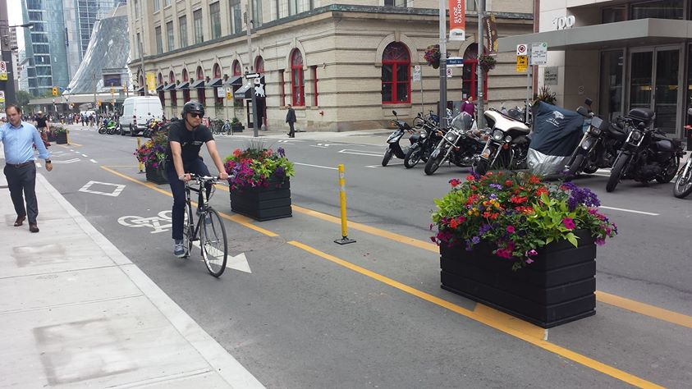  Figure 3B. A separated lane with planters.

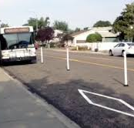
Figure 3C. A separated lane with posts (also known as bollards)

A separated lane is used to provide safe passage for particular users, such as cycles or buses. For example, cycle paths are often separated from traffic lanes with small concrete blocks.

Currently, turning traffic must give way to people using special vehicle lanes before crossing the lane. However, if that lane is separated (for example, with bollards or concrete barriers) and passes through an intersection, it’s less clear who needs to give way. For example, the cyclist pictured in figure 3D is intending to travel past a side road in a separated lane. But it’s unclear if the red and blue cars need to give way to the cyclist before turning into the side road.

This can create confusion for drivers, especially if they’re new to New Zealand roads. Drivers are also less likely to be aware of separate lane users or to slow down when turning if:

- they believe they have right of way, or
- they are not thinking to look for cycles.
If there’s heavy traffic, this can also cause major travel delays for cycles, buses and transport device users. As a result, some cycles choose to use the road instead, which can create further risks. To give these users clear right of way over turning traffic, road controlling authorities sometimes make separated lanes end well before the intersection. While this can clarify who has right of way, taking these steps can often reduce the level of separation between lane users and drivers, increasing the chances of a collision.

Between 2011 and 2015, 78 crashes involved a turning driver and a cyclist crossing an intersection from a separated lane. We intend to reduce crashes and increase safety by clarifying these rules.

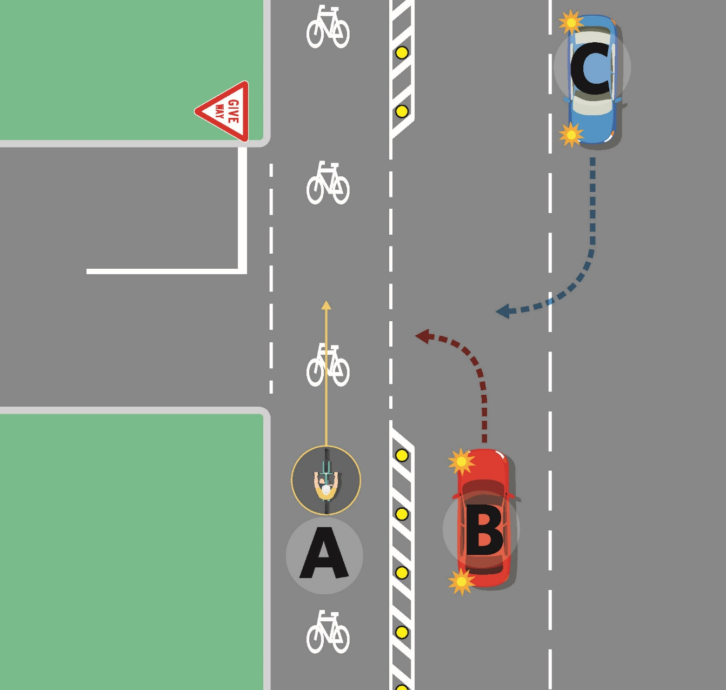
Figure 3D. Under the current state, it’s unclear if the cyclist (labelled A) in the separated lane needs to give way to turning traffic (the cars labelled B and C) before riding through an intersection.

Proposed change
Our proposed change will clarify that turning traffic must give way to people travelling straight through an intersection in a separated lane (figure 3E).
This will apply to separated lanes adjacent to the road. It will exclude lanes separated by larger barriers, for example, a plot of grass on a kerb (figure 3F).
The change will:

- reduce uncertainty for people using separated lanes, as they don’t have to wait for turning traffic
- legitimise common practice, as turning drivers usually give way to people using cycle and bus lanes whether the lane is separated or not
- allow road controlling authorities to build separated cycle lanes all the way up to intersections, making roads safer for cycles, transport devices and buses.

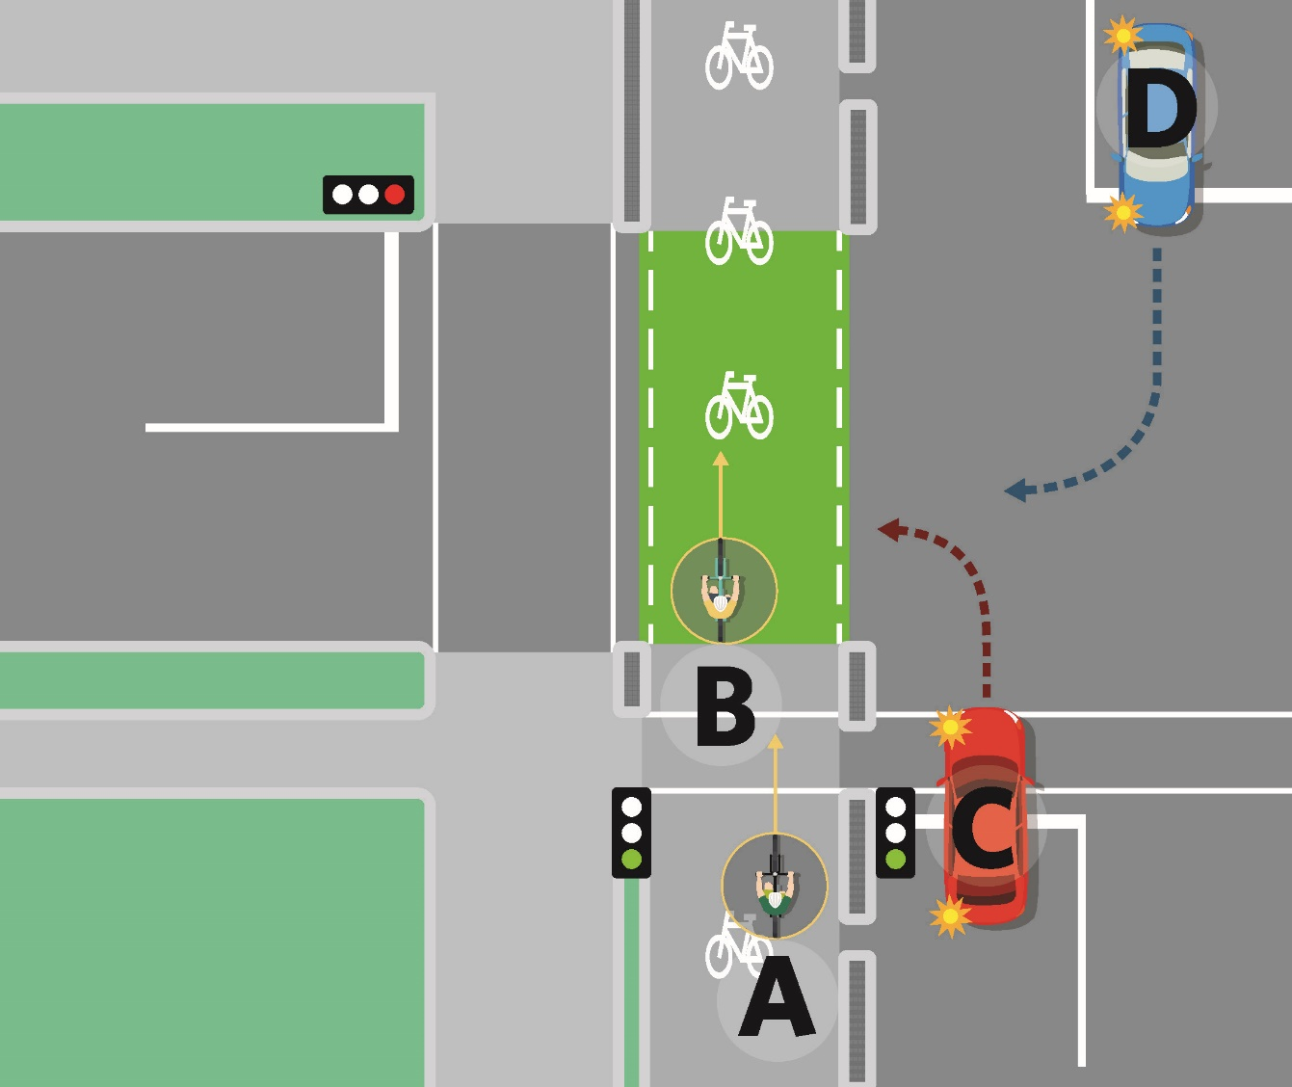
Figure 3E. We propose to clarify that road users travelling straight through an intersection in a separated lane will have right of way over turning traffic.
This means the cars pictured (labelled C and D) would need to give way to the cyclists travelling through the intersection (labelled A and B) before turning into the side road.
A and B are cyclists travelling through an intersection in a separated lane. We propose to clarify that these cyclists would have right of way over turning traffic. This means the cars (labelled as C and D) would need to give way to the cyclists or any other separated lane user before turning into the side road street if a vehicle is turning at an intersection with a separated lane.

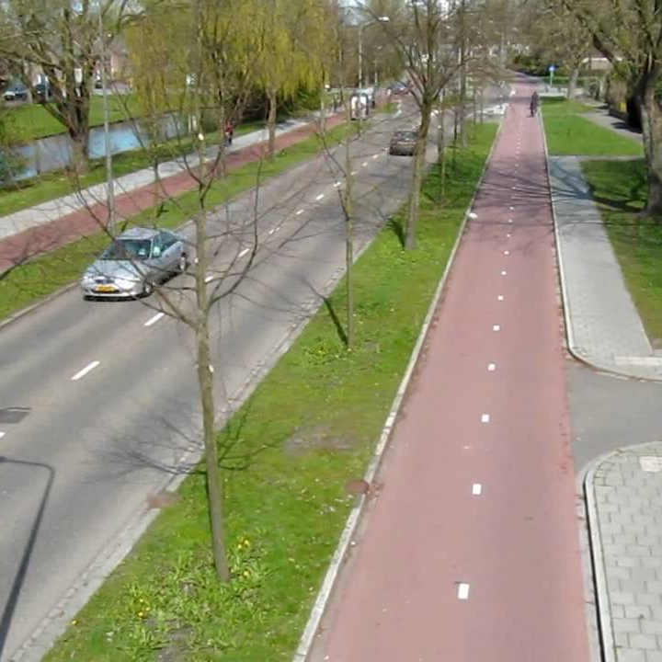
Figure 3F. Under our proposed changes, separated lanes like the one pictured would be excluded from this change due to the large level of separation from other traffic lanes.
Clarifying separated special vehicle lanes
We’ll add a new schedule to the Road Transport Traffic Control Devices Rule 2004 to clarify when turning traffic must give way to users in separated lanes. This schedule will:

- list different devices that can be used to create a separated lane
- help users understand what a separated lane is and what’s excluded.
The list is not intended to be exhaustive but will provide examples of what road users should expect.
Enforcement and effectiveness
The change would be enforceable by the NZ Police. We’ll also introduce an education campaign to help drivers and lane users to understand the changes.

Other devices in separated lanes
If proposal 4 is adopted, transport devices using separated lanes, like skateboards and e-scooters, will also have priority when travelling through an intersection.

Risks
The risks are expected to be minimal as turning drivers generally give way to people travelling straight through in cycle and bus lanes already. However, conflicts could occur between people traveling straight in a separated lane and drivers:

- turning left, or
- turning right through a gap in traffic.
Having an exhaustive list of devices may be difficult for users to understand. We could prevent confusion by outlining different requirements, such as introducing a maximum distance between the separated lane and a traffic lane.

Rule reference: Changes will be in the Land Transport (Road User) Amendment Rule (No 2) 2020 and the Land Transport Traffic Control Devices Amendment Rule 2020. Rule reference to be confirmed.

Proposal 6C: Give cycles, transport devices and buses priority over turning traffic when they’re travelling through an intersection in a separated lane – Questions for your submission:
- Do you agree that turning traffic should give way to users travelling straight through at an intersection from a separated lane? Why/why not?

- Our proposed change will introduce a list of traffic control devices used to separate lanes from the roadway to help you understand what a separated lane is and if the user has right of way at an intersection. Is such a list necessary? Why/why not?

- Should the definition of a separated lane include the distance between the lane and the road? Why/why not?

Proposal 6D: Give priority to footpath, shared path and cycle path users over turning traffic where the necessary traffic control devices are installed
Current state
In New Zealand, footpath (and other path) users crossing a side street without traffic signals must give way to turning traffic (figure 4A). Path users only have priority over turning traffic:

- at a pedestrian (zebra) crossing
- at signalised intersections.
In contrast, many countries prioritise path users when they’re travelling along the main road and crossing a side street with no traffic signals.

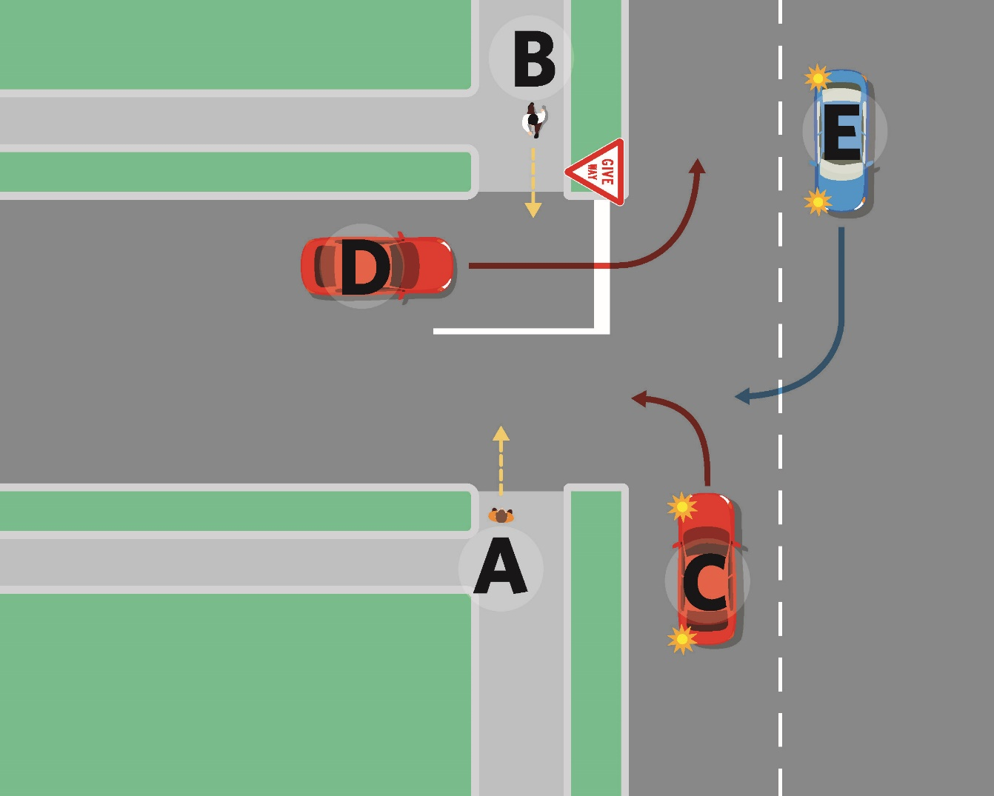
Figure 4A. Currently, path users crossing side roads must give way to turning traffic. A and B are two pedestrians that need to wait for cars (C, D, and E) which are turning into and leaving the side street before crossing.

Proposed Change
Our change will mean people on the path have priority over turning traffic when they’re crossing a side road, anywhere that minimum markings are installed.
We propose the minimum markings are two white lines (figure 4B).
This means road controlling authorities can give priority to path users crossing side roads, without resorting to the expense of a signalised crossing or other treatments associated with a pedestrian crossing (like a zebra crossing).

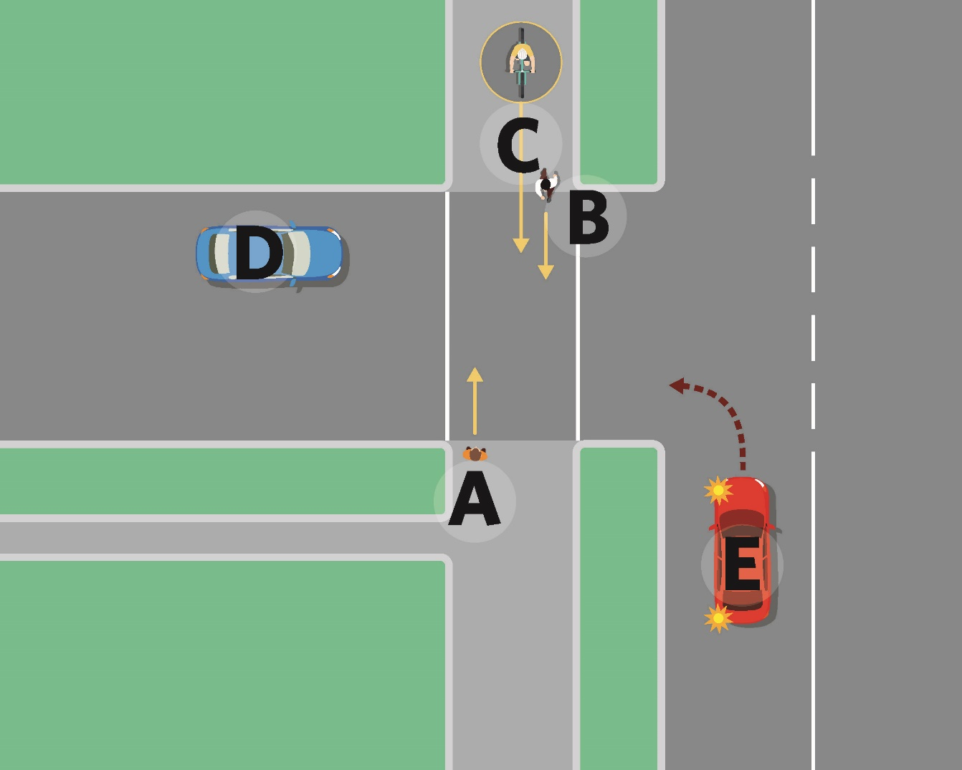
Figure 4B. A and B are pedestrians crossing the side road. We propose that these pedestrians would have right of way when crossing a side road with white lines over the crossing.
The cyclist (labelled as C) would also have right of way over turning traffic but would need to give way to the pedestrians also crossing the road.
The cars on the road (labelled D and E) will need to give way to the pedestrians and the cyclist crossing the road if there are white lines across the side road.

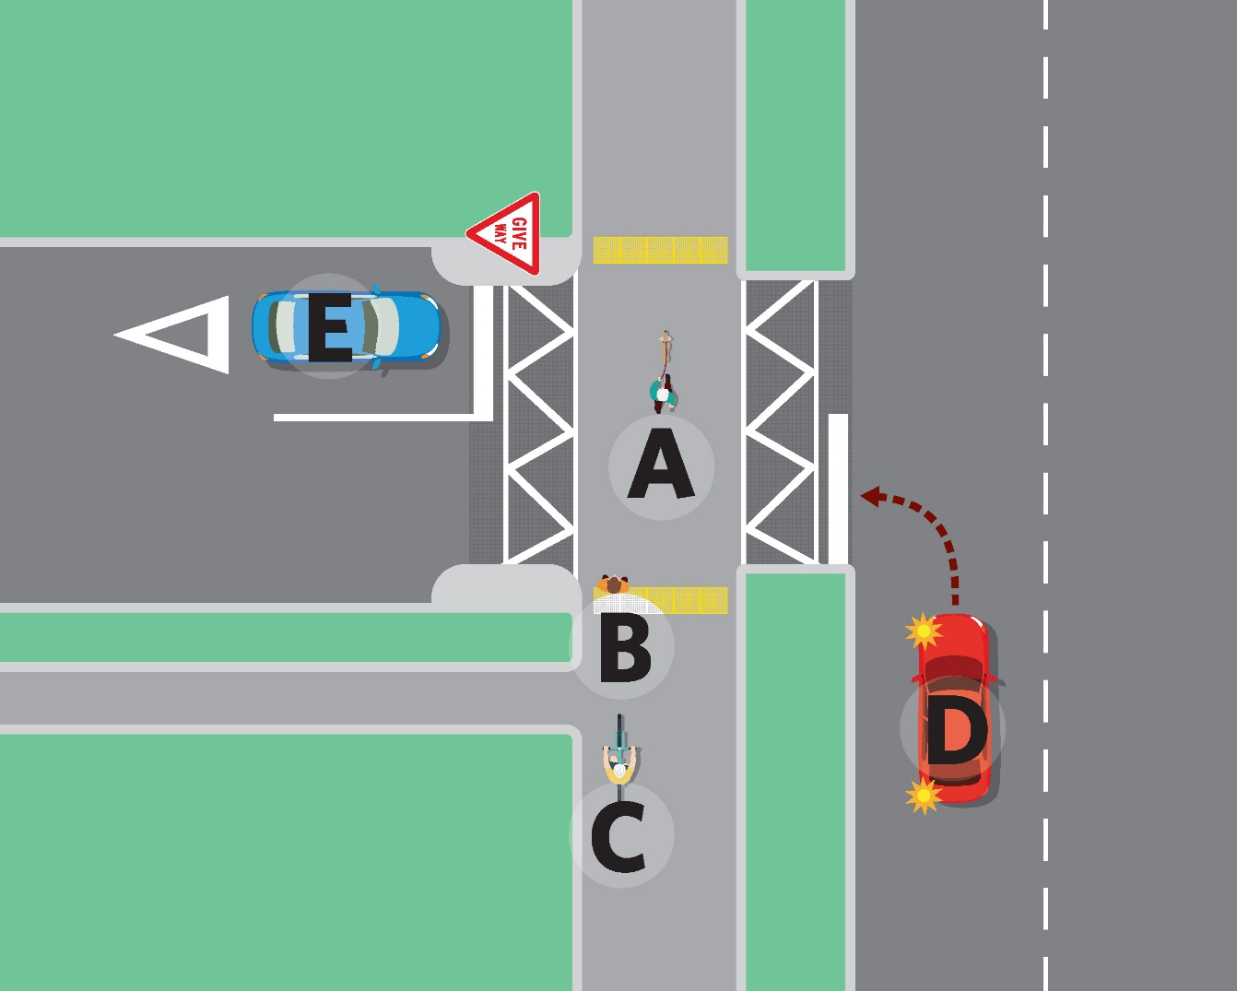
Figure 4C. Under the proposal, the Transport Agency will provide guidance to help road controlling authorities install additional treatments in busier or more risk prone side streets. This could include, for example, the addition of a raised platform crossings.
A and B are pedestrians crossing the side road. We propose that these pedestrians would have right of way when crossing a side road with these additional treatments.
C is a cyclist about to cross the side road. The cyclist has right of way over turning traffic but will need to give way to pedestrians.
D and E are cars which will need to give way to the pedestrians and cyclist crossing the road if there are additional treatments across the side road.

We’ll provide guidance for road controlling authorities about additional treatments needed in busier areas, such as:

- raised platform crossings
- markings and signs to indicate that path users have priority.
The change will:

- increase the number of places to cross where people on paths have priority
- recognise paths as part of the thoroughfare and crossings as a continuation of that thoroughfare
- reduce delays for path users, who won’t have to wait for turning traffic when crossing at these marked side roads
- make active transport a more attractive option.
Cycles will be able to cross the street at these crossings if they’re travelling on the footpath. They’ll still need to give way to pedestrians, as they do on all other parts of the footpath. This will:

- accommodate children cycling at slow speeds in places where cycling on the road would put them at risk
- keep adult cyclists safe when cycling infrastructure is unavailable.
In the long term, we expect turning drivers to take greater care and adopt slower speeds. This will make roads safer for people walking and cycling.

Risks
If either the driver or pedestrian is not paying attention, a conflict could occur between a driver turning off the main road into a side street and pedestrians crossing their path.
Potentially, a significant conflict could occur with long-haul trucks with long bonnets. With these trucks, people are hidden from view up to 4.5m away from the front and sides of the truck. Most other long-haul trucks have a 3m blind spot. This means truck drivers may not see people crossing the road – even with traffic control devices in place. This occurs already at pedestrian crossings. Our proposed changes may exacerbate the problem because these crossing points are likely to be located right at the intersection.
However, road controlling authorities will be able to reduce this risk by deciding:
- on which side roads it’s appropriate to prioritise people on the path, and
- what treatments to use to make that path safer. For example, raised platform crossings could be introduced to encourage vehicles to slow down before turning onto a side road.

Rule reference: Clauses in proposed Land Transport (Road User) Amendment Rule (No 2) 2020. Clause 4.2 (Giving way where path crosses a roadway).

Proposal 6D: Give priority to footpath, shared path and cycle path users over turning traffic where the necessary traffic control devices are installed – Questions for your submission:
- Do you agree that turning traffic should give way to path users crossing a side road with the proposed markings? Why/why not?

- Do you think that the proposed minimum markings are appropriate?

- We are proposing future guidance for additional treatments. Is there any guidance that you would like to see or recommend?

Proposal 7: Mandate a minimum overtaking gap for motor vehicles passing cycles, transport devices, horses, pedestrians and people using mobility devices on the road
Current state
Currently, we have only broad guidelines and rules for how motor vehicles should safely overtake cycles, transport devices, horses, mobility devices and pedestrians on the road. Passing these types of users too closely increases the risk of serious injury or death if there’s a crash.
Existing offences and penalties for careless driving causing injury may be used to prosecute a driver following a serious incident involving a close pass. However, there’s nothing in law that sets a minimum overtaking gap for passing them.
The existing Road User Rule states that drivers can only pass other road users when it’s safe to do so. Likewise, the Official New Zealand Road Code recommends that drivers should:

- allow for a space of at least 1.5m when passing a cyclist, and
- slow down, pass carefully, and give plenty of room when passing a horse.
Unfortunately, this doesn’t prevent drivers from passing too closely. Between 2008 and 2018, vehicles overtaking cycles contributed to:

- 174 cyclist crashes resulting in serious injury, and
- 20 percent of fatal cyclist crashes in New Zealand.

Vehicles overtaking pedestrians too closely contributed to 13 crashes, and only three of those crashes were non-injury crashes..
Incidents between horse riders and vehicles passing too closely are also common.
Research in New Zealand shows that the perceived risk of cycling on the road is one of the biggest reasons people don’t take up cycling. It’s challenging to change this perception because there are limited enforceable rules related to safe passing.
Proposed change
Our proposed change will ensure drivers of motor vehicles pass at a safe distance when overtaking cycles, transport devices, horses, and pedestrians and people using mobility devices on the road.
The minimum overtaking gap will be a lateral distance of:

- 1m when the posted speed limit is 60km/h or less
- 1.5m when the posted speed limit is over 60km/h.
The minimum overtaking gap (figure 5A) will apply if:

- a vehicle is in the same lane as the cyclist, transport device, horse rider, mobility device or pedestrian.
- a vehicle in a left lane is passing a user who’s walking or riding in a road shoulder.
If a cyclist or pedestrian is in a cycle lane or footpath next to the road way, drivers must maintain a safe and considerate distance, but the minimum overtaking gap won’t apply.

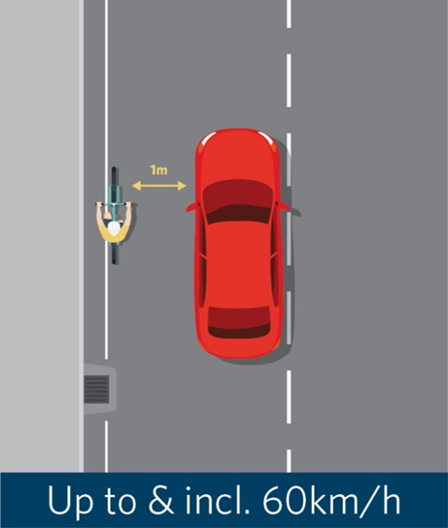 | 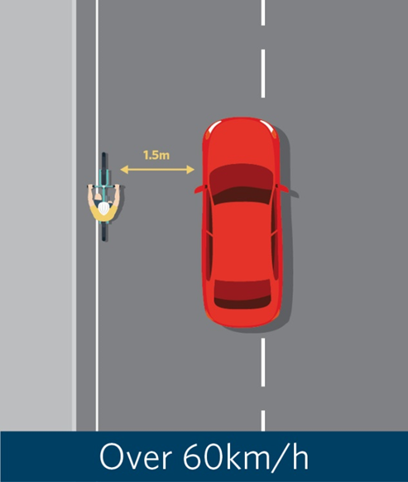
Figure 5A: The minimum overtaking gap for motor vehicles passing cycles, transport devices, horses, pedestrians and people using mobility devices will be 1m when the speed limit is 60km/h or less, or 1.5m when the speed limit is above 60km/h. Drivers must be safe and considerate when driving past road users in different lanes (such as cycle lanes).

A mandatory minimum overtaking gap will:

- set a clear expectation about what a safe minimum passing distance is
- raise awareness of this practice
- respond to recommendations from the 2014 Cycling Safety Panel report Safer journeys for people who cycle, which calls for a minimum overtaking gap to be trialled
- clarify the current legal situation around incidents with overtaking motor vehicles and provide an explicit offence for passing too closely.
We’ll implement this change alongside an information and education campaign. We expect this change to make cycles, transport devices, mobility devices, horses and pedestrians feel safer using the road.
Minimum overtaking gap and horses
The minimum overtaking gap will apply to vehicles overtaking horses on the road. This means there will be an offence for passing a horse too closely.
However, the change won’t replace existing guidance from the official road code. Vehicles passing horses must still:

- slow down,
- pass carefully, and
- give the horse and rider plenty of room.
Under our proposed change, drivers will ideally need to overtake horse riders with a gap larger than either 1m or 1.5m depending on the road’s speed limit.

Minimum overtaking gap and solid yellow centrelines
Drivers can legally cross a solid yellow centreline (or a flush median) in order to give the minimum overtaking gap when passing. Drivers must not pass other motor vehicles where a solid yellow ‘no passing’ line is installed. Drivers must still only pass when they can do so safely and with due consideration for other people using the road.
Our proposed change won’t apply to

- motor vehicles overtaking other motor vehicles. For example, if a driver is moving into the lane of oncoming traffic to pass another motor vehicle, they need to make this movement safely and with due consideration for other people using the road. They don’t need to maintain a minimum overtaking gap.
- cycles and transport devices overtaking other road users. For example, if an e-bike overtakes a pushbike, the overtaking rider must overtake safely and with due consideration of other users on the road. They’re not required to maintain a minimum overtaking gap.

Rule reference: Clauses in the proposed Land Transport (Road User) Amendment Rule (No 2) 2020: Clause 2.11A (Passing cyclists, horse riders, and users of other devices on the road).

Proposal 7: Mandate a minimum overtaking gap for motor vehicles passing cycles, transport devices, horses, pedestrians and people using mobility devices on the road – Questions for your submission:
- Do you agree with the proposal for a mandatory minimum overtaking gap for motor vehicles of 1 metre (when the speed limit is 60km/h or less), and 1.5 metres (when the speed limit is over 60km/h) when passing pedestrians, cyclists, horse riders, and users of other devices? Why/why not?

Proposal 8: Clarify how road controlling authorities can restrict parking on berms
Current state
A berm is a plot of grass, dirt, or garden located beside the roadway. They’re usually on raised kerbs but may also be beside a roadway without a kerb.
Vehicles often park on berms when there’s no parking available on the road. In many cases, parking on berms is a practicable parking solution to improve access for traffic on narrow suburban streets. In other cases, parking on the berm can block the footpath for pedestrians and devices or reduce visibility for vehicles when exiting driveways (especially in areas with fast-moving traffic). Parking on berms can also damage underground infrastructure.

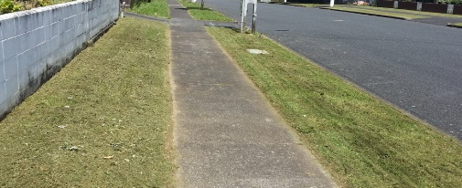
Figure 4A: A berm is a plot of grass, dirt, or garden located beside the roadway.

Road controlling authorities disagree about how they can restrict berm parking and whether they need signage. For example, both Auckland Transport and Christchurch City Council have bylaws which prohibit parking on berms. However, Auckland Transport considers it unenforceable unless signs are erected every 100m, while Christchurch City Council considers it enforceable without the use of signs.
This is because Christchurch City Council made their bylaw under the Land Transport (Road User) Rule 2004, which doesn’t require signs for a berm parking restriction through the making of a bylaw.
In contrast, Auckland Transport made its bylaw under the Land Transport Act 1998, which (combined with the Land Transport Traffic Control Devices Rule) requires signs. Auckland Transport installed signs across approximately 48 locations across the Auckland region between October 2016 and February 2018, costing approximately $50,000.
As well as being costly, signs may also be visually unappealing and make the street appear cluttered.
This suggests we need greater clarity on whether signs are required for berm parking restrictions or are not required. We’re also aware that some road controlling authorities would like the explicit ability to impose a general prohibition on berm parking, through a bylaw, without the use of a sign or other markings to notify people of the restriction.
Proposed change
Our proposed change would remove the need for signage and clarify what’s needed for road controlling authorities to restrict parking on berms. Road controlling authorities will be able to restrict parking on a berm or an area of berms by:

- passing a resolution, and
- registering the restriction with the Transport Agency.

All restrictions registered with the Transport Agency will be publicly available via an online register. A register is currently in development.

Sign and marking requirements
If a road controlling authority has passed a resolution and registered a berm restriction with the Transport Agency, they may install a sign to inform the public that parking on the berm is not allowed. However, a restriction is valid and enforceable whether or not signs are installed. This is similar to the approach taken for liquor ban areas.
Enforcement by the Transport Agency
The Transport Agency would have the power to direct road controlling authorities to install, modify, or remove signs. The Transport Agency will also be able to investigate any authority misusing these powers.
Future proofing
We need to consider how road controlling authorities would advise residents and drivers of berm parking restrictions if signs are not made available. We’re proposing that all information about berm restrictions be available on an online register. If people are unable to access the website, we may need to provide this information at a physical location such as the local library, town i-SITE or at the local council.
Risks
If there’s no requirement to put up signs or markings, a vehicle could unknowingly be parked on a restricted berm and receive an infringement fee. This could be particularly problematic for people unaware of the berm parking restrictions in the area they’re visiting.

Rule reference: Clauses in proposed Land Transport Rule: Paths and Road Margins 2020: Section 6 (Restrictions on motor vehicles parking on berms), clause 7.4 (Agency may direct road controlling authority to review restrictions on motor vehicles parking on berms) and Part 2 (Definitions)

Proposal 8: Clarify how road controlling authorities can restrict parking on berms – Questions for your submission:
- Do you agree with the proposal that road controlling authorities should be able to restrict berm parking without the use of signs and instead rely on an online register? Why/why not?

- Would it be helpful if information on berm parking restrictions was available in other places, like at a local library, i-SITE, or a local council?

Proposal 9: Give buses priority when exiting bus stops
Current state
In New Zealand, it’s considered a courtesy to give way to buses pulling out of a bus stop, but it’s not a legal requirement. However, when drivers don’t extend this courtesy it can:

- delay buses as they must wait for a suitable break in traffic to merge back into the traffic flow
- cause passengers to experience numerous delays across their journey and arrive at their destinations later than expected
- cause network planning problems for bus service operators.
In 2017, research undertaken on our behalf calculated a network-wide delay of 29.51 hours per day for buses in the Auckland region. This delay was caused solely by vehicles failing to give way to buses leaving bus stops.
This means there’s a significant loss of time, productivity and operational cost because buses have to wait to pull out of bus stops. This reduces the reliability of public transport and creates a poor perception of it.

Proposed change
Under our proposed change, road users must give way when an urban bus on a scheduled public transport service:

- is leaving a bus stop, and
- has indicated for three seconds.
Our proposed change will apply on roads with a speed limit of 60km/h or less. This will signal that public transport has priority in urban areas, as buses usually carry more people than cars.
This rule change will come at a cost to other drivers in terms of vehicle operating costs and time lost. However, reducing travel delays for buses will make public transport more appealing as a mode of travel. The large number of people that buses carry will improve access to social and economic opportunities for travellers.
The proposed change won’t give buses priority when leaving an area that is not marked or signed as a bus stop, such as:

- if a bus is merging into traffic at the end of a bus lane, or
- if cars are parked in a bus lane and the bus must move into a regular traffic lane.
In these situations, vehicles won’t have to give way to buses.
The proposed change won’t give priority to unscheduled bus services, such as tour buses or on-demand shared mobility services.
Enforcement and effectiveness
This change would be enforceable by the NZ Police. We’ll measure how effective this change is using data available from regional councils related to bus reliability and punctuality, average trip times and patronage.
We’ll use an education campaign to raise awareness about the new changes.

Rule reference: Clauses in the proposed Land Transport (Road User) Amendment Rule (No 2) 2020: Clause 1.6 (Interpretation), Clause 4.4A (Giving way to buses leaving bus stops).

Proposal 9: Give buses priority when exiting bus stops – Questions for your submission
- Do you agree that traffic should give way to indicating buses leaving a bus stop on a road with a speed limit of 60km/h or less? Why/why not?

- Should traffic give way to buses in other situations? For example, when a bus is exiting a bus lane and merging back into traffic lanes? Why/why not?

What are Land Transport Rules?
Land Transport Rules (rules) are legislation made by the Minister of Transport or his/her delegate (‘the Minister’) under the Land Transport Act 1998 (the Act).
The Act sets out:
- principles and the legal framework
- main offences and the obligations of particular road users.
Rules contain detailed requirements, including standards and processes, for putting those principles and policies into operation. Rules cover a range of land transport issues. Among the outcomes that rules aim to achieve are:

- safeguarding and improving land transport safety and security
- improving access and mobility
- assisting economic development
- protecting and promoting public health
- ensuring environmental sustainability.
Rules form part of New Zealand law and compliance is required. The specific offences and penalties that apply to each rule are set out in the Act or in regulations.
The Act provides the legal framework for making Land Transport Rules. Section 161 states the procedures by which the Minister makes ordinary rules.
Most rules are drafted by the Transport Agency, by an arrangement with the Secretary for Transport, working closely with the Ministry of Transport’s policy and legal advisors.
Rules are drafted in plain language to be understood by a wide audience and to help ensure compliance with requirements. The Transport Agency is responsible for ensuring we undertake appropriate consultation on proposed rules. We may change a draft rule in response to submissions we receive.

Application of rule-making criteria

Proposed activity or service
Section 164(2)(b) of the Act requires that appropriate weight be given to the nature of the proposed activity or service for which the rule is being established.
The Accessible Streets Regulatory Package directly addresses the focus of the 2018/19 -2027/28 Government Policy Statement on Land Transport (GPS 2018) on improving New Zealanders' access to economic and social opportunities. It supports a shift from single occupancy vehicles to more energy efficient, healthier, low cost modes like walking, cycling and transport devices for short trips in urban centres. It will also assist with our goal of reducing harmful transport emissions. It recognises the importance of creating liveable cities that value public space, enhance safety outcomes and improve access. The package also supports the current safe system approach to road safety in New Zealand.

Risk to land transport safety
Section 164(2)(a), (b), (c) and (d) requires the Minister to take into account:

- the level of risk to land transport safety in each proposed activity or service,
- the level of risk existing to land transport safety in general in New Zealand, and
- the need to maintain and improve land transport safety and security.

The regulatory package has been designed to increase safety and accessibility for people. It supports the safe system approach to road safety in New Zealand.
It seeks to increase people’s accessibility and safety when using the transport system in the following way:

- Changing current vehicle and device definitions and creating new categories to better regulate:
  - new and emerging devices
  - where and how they’re used.

- Changing who’s allowed on footpaths and introduce conditions that users need to follow when using the footpath. For the safety of others sharing the footpath, people riding on the footpath under the new rule must:
  - behave in a courteous and considerate manner
  - travel in a way that is not dangerous for other people using the footpath
  - give right of way to pedestrians
  - travel no faster than 15km/h
  - ride a device no wider than 750mm, unless it’s a wheelchair, so multiple people can still use the footpath.
- Clarifying who’s allowed on shared paths and cycle paths and introduce the conditions they need to follow. Our changes will clarify that:
  - if a path is located beside a roadway, the speed limit on the path will match the roadway. If a path is not located beside a roadway, the speed limit will be 50km/h
  - all users must give way to pedestrians on shared paths
  - road controlling authorities can declare that a path is a shared path or cycle path by resolution.
- Allowing transport devices, such as skateboards and e-scooters, to use cycle lanes and cycle paths.

- Introduce lighting and reflector requirements for powered transport devices at night. Our proposed change would only permit transport devices on roads and paths at night if they are fitted with:
  - a headlamp
  - a rear facing position light, and
  - a reflector (or if the user is wearing reflective material).

- Changing the priority of road users, by:
- allowing cycles and transport devices to:
  - ride straight ahead from a left turn lane
  - pass slow-moving vehicles on the left.
- clarifying that turning traffic must give way to all people using separated lanes, including buses, if those people are travelling straight through at an intersection.
- giving greater priority to people on footpaths and shared paths when they’re crossing side roads with minimum markings (two white lines).

- Mandating a minimum overtaking gap (on the road) for motor vehicles overtaking cycles, transport devices, horses, mobility devices and pedestrians of:
  - 1 metre, when the posted speed limit is 60km/h or less
  - 1.5 metres, when the posted speed limit is over 60km/h.

- Clarifying what’s needed for road controlling authorities to restrict parking on berms and remove the need for signs.

- Requiring road users to give way to signalling buses pulling out of bus stops in urban areas, when the speed limit is 60km/h or less.

Assisting achievement of strategic objectives for transport
Section 164(2) (ea) of the Act requires that the Minister have regard and give such weight as he or she considers appropriate in each case, to whether a proposed rule:
- assists economic development
- improves access and mobility
- protects and promotes public health
- ensures environmental sustainability.
Assists economic development
Our proposed new rule and changes to existing rules will assist economic development by improving New Zealanders' access to economic opportunities. The Accessible Streets Regulatory Package is a collection of land transport rules that reallocates space and priority to different users to help people connect with places for working, shopping, and accessing services.
Improves access and mobility
Our proposed new rule and changes to existing rules will improve access and mobility by recognising and providing for all people. This includes allowing children to cycle on the footpath and providing for the increasing number of medical or mobility devices on footpaths.
Protects and promotes public health
Our proposed change and new rule will support a mode shift from private vehicles to more energy efficient and active modes like walking, cycling and transport devices for short trips. This will improve the uptake of transport modes that improve health and wellbeing.
Ensures environmental sustainability
Our proposed new rule and our changes to existing rules will support environmental sustainability by supporting a mode shift from private vehicles to more energy efficient modes like walking, cycling and powered and unpowered transport devices for short trips.

Costs of implementing our proposed changes
Section 164(2) (e) of the Act requires that the Minister has regard to the costs of implementing measures proposed in a rule. A summary of the costs, and benefits, of our proposed changes, together with links to the regulatory impact statements on the Ministry of Transport’s website, can be found at the link below:
https://www.transport.govt.nz/multi-modal/keystrategiesandplans/road-safety-strategy/accessible-streets/

International considerations
Section 164(2) (eb) and (f) of the Act requires that, in making a rule, the Minister must have regard to New Zealand’s international obligations concerning land transport safety, and the international circumstances in respect of land transport safety.
The proposed change doesn’t conflict with New Zealand’s international obligations or circumstances concerning land transport safety.

How the amendment rule fits with other legislation

Offences and penalties
Land Transport Rules don’t contain offences and penalties for breaches of rule requirements. These provisions are usually set out in regulations.
We will need to make a consequential change to the Land Transport (Offences and Penalties) Regulations 1999 to amend and create new offences and penalties to support enforcement for the proposed new rule and changes to existing rules.

Access to consultation material
Copies of this consultation document may be obtained by calling the Transport Agency contact centre on 0800 699 000. It’s also available on the Transport Agency’s website at:
www.nzta.govt.nz/accessible-streets-consultation

Availability of rules
Land Transport rules can be purchased from selected bookshops throughout New Zealand that sell legislation. They’re also available to read free of charge at the offices of the Transport Agency. Final versions of rules are also available on the Transport Agency’s website at:
http://www.nzta.govt.nz/resources/rules/about/
The current consolidated version of the Road User Rule is available at:
http://www.legislation.govt.nz/regulation/public/2004/0427/latest/whole.html
The current consolidated version of the Traffic Control Devices Rule is available at:
https://www.nzta.govt.nz/resources/rules/traffic-control-devices-index/
The current consolidated version of the Setting of Speed Limits Rule is available at:
https://nzta.govt.nz/resources/rules/setting-of-speed-limits-2017

Information about rules
Information about rules is available online at:
http://www.nzta.govt.nz/resources/rules/about/
If you wish to register your interest in this proposed amendment rule (or other rules), you can do so by contacting the Transport Agency at our addresses shown in the Making a submission section at the front of this document, or at: http://www.nzta.govt.nz/resources/rules/about/registration.html. This includes a form for registering an interest in rules.

Appendix: Regulatory impact of proposed rule amendments
If you wish to, you can read a Regulatory Impact Statement on the proposed rule changes in conjunction with the overview.
You can download the document from the Ministry of Transport’s website at:
https://www.transport.govt.nz/multi-modal/keystrategiesandplans/road-safety-strategy/accessible-streets/

We’ve summarised the benefits and costs of the rules proposals below in Table 1.

Table 1: Summary table of costs and benefits
Summary table of costs and benefits

Note: Cost-benefit analysis to be completed following public engagement and consultation on draft.
Affected parties (identify) | Comment: nature of cost or benefit (for example ongoing, one-off), evidence and assumption (for example compliance rates), risks | Impact  $m present value, for monetised impacts; high, medium or low for non-monetised impacts
Additional costs of proposed approach, compared to taking no action
Regulated parties | Some vehicles currently sold as mobility devices may no longer be permitted. This could cause hardship to people who have already purchased these vehicles. There may also be impacts on businesses holding stock which would no longer be permitted on the footpath.  Some users may seek exemptions for over-width vehicles. | TBD following consultation
 | There may be more low-speed collisions between cycles, powered vehicles and cars on driveways and between people using the footpath. | Medium
 | Footpath use by cycles may pose a barrier to walking for some people (loss of safety and comfort). | Low
Regulators | Public information campaign, including cost of temporary staff and communications activities (the Transport Agency).  IT changes (the Transport Agency).  FTEs required to process exemptions.  Compliance costs for example enforcement, infringement fee processing and collection costs (NZ Police).  Road controlling authorities will need to designate existing shared paths where higher speeds are desired and introduce road/path markings and signs. | Approx. $350,000  Communications consultant $220,000 (shared across whole package)  (excluding staff costs)  Approx. $100,000  Further consultation required with NZ Police. Cell phone use ban was estimated in 2009 to cost $850,000 in the first year and $720,000 over the next two years.  Approx. $1 million nationally
Additional costs of proposed approach, compared to taking no action
Wider government
Other parties
Total Monetised Cost |  | The total monetised costs are yet to be determined.
Non-monetised costs |  | The total non-monetised costs are yet to be determined.

Expected benefits of proposed approach, compared to taking no action
Regulated parties | Improved understanding of requirements – simpler rules around who can use footpaths.  Increased access to transport and uptake of cycling.  Increased cycling safety, particularly for children and vulnerable users.  Safety benefits for cyclists and pedestrians, as this will allow safe footpath cycling to be proactively taught, with clear expectations of pedestrian priority reinforced. | Medium / High (some benefits already realised through current illegal use of the footpath).  Increased access $  Reduced deaths and serious injuries $
Regulators | Reduced resourcing for processing exemption requests for mobility devices outside proposed dimensions.
Wider government | Public health benefits of encouraging active transport modes.
Other parties | Increased market for low-speed new and emerging vehicles, increased bicycle sales.
Total Monetised Benefit |  | The total monetised benefit is yet to be determined.
Non-monetised benefits |  | The total non-monetised costs are yet to be determined.

What other impacts is this approach likely to have?
Allowing people to use cycles on the footpath in some situations will impact on particular groups. It’s possible this would increase the number of cyclists on the footpath. This would have flow-on effects for the safety of cyclists, pedestrians, and vulnerable users. It could also have effects on the provision of on-road facilities for cyclists. However, research suggests that the current rule is not well known or observed by children, meaning the change is unlikely to have a significant effect on the number of children cycling on footpaths.

There’s a possibility that allowing people on cycles to use footpaths could be considered inconsistent with New Zealand’s obligations under the UN Convention on the Rights of People with Disabilities, if it were to result in restricted accessibility. We’ll consider this as part of consultation.

A road controlling authority (RCA) is an authority, body or person that controls the road and can set and enforce rules on that road. For example, Auckland Transport is a road controlling authority.
Child cycles and e-bikes are those with a wheel diameter of 355mm or less. These are usually ridden by a child aged up to six years old.
Under section 168A (2) and (3) of the Land Transport Act, the NZ Transport Agency may declare a vehicle not to be a motor vehicle.
E-bikes (with a maximum power output of 300 watts) have been declared not to be a motor vehicle but are treated as a cycle. Currently, they are not permitted on the footpath (unless their wheel diameter is 355mm or less).
More information about unpowered transport device use in cycle lanes and cycle paths are explored in proposal 3 and 4.
More information about powered transport device use in cycle lanes and cycle paths are explored in proposal 3 and 4.
This would apply to declarations made under section 168A (2) of the Land Transport Act 1998.
This would apply to declarations made under section 168A (3) of the Land Transport Act 1998.
A berm is a plot of grass, dirt, or garden located beside the roadway. They’re usually on raised kerbs but may also be beside a roadway without a kerb.
Haworth, Narelle L. & Schramm, Amy J. (2011) Adults cycling on the footpath: what do the data show? In Australasian Road Safety Research, Policing and Education Conference, 6-9 November 2011, Perth Convention and Exhibition Centre, Perth, WA. https://eprints.qut.edu.au/49906/5/49906.pdf
Formerly wheeled recreational devices. Please refer to proposal 1 for more information.
Randall, Edward, Baland, Romane, and Keall, Michael. (2018). Children cycling on footpaths, NZMI 9 March, Vol 131, No.1471
Transport Agency guidance on importing mobility devices can be accessed here: https://www.nzta.govt.nz/assets/Vehicles/docs/General-guidance-on-what-to-look-for-when-importing-a-mobility-vehicle.pdf
Formerly wheeled recreational devices, (please refer to proposal 1 for more information.)
A cycle lane is a lane within the roadway (often painted) designed for the passage of cycles, meaning users are in a separate lane from other traffic. They can be located next to parking, next to the kerb, and between two traffic lanes (for example, between a bus lane and a general traffic lane).
Wheeled pedestrians are a category used in the Crash Analysis System. The term collectively refers to people using wheelchairs, mobility devices and small unpowered devices like push scooters.
Data from the Crash Analysis System (CAS).
A headlamp is a lamp attached to the front of the bike.
A position light is another light attached to the bicycle.
Reflectors work by bouncing light back in the direction of its source. They can either be attached to a vehicle or device or worn as reflective clothing.
MWH and ViaStrada (2016) Review of road user rules for people walking and cycling. Prepared for the New Zealand Transport Agency. https://www.nzta.govt.nz/assets/Walking-Cycling-and-Public-Transport/docs/RUR-MWH-FINAL.pdf
New Zealand Transport Agency (2016) The Official New Zealand Code for Cyclists.
Slow-moving means the vehicle is travelling less that 20km/h or moving in a stop-start way, such as in a traffic jam.
MWH and ViaStrada (2016).
A separated lane in this context is a special vehicle lane that is physically separated from the roadway.
In the rule, we use the word delineators to refer to traffic control devices.
MWH and ViaStrada (2016).
This schedule has not been drafted yet for your review. We’ll use this consultation to help us decide how the schedule should be drafted and what delineators (traffic control devices) should be included in it.
Data from the Crash Analysis System (CAS).
Ibid.
OPUS (2016) Investigating the feasibility of trialling minimum overtaking gap law for motorists overtaking cyclists in New Zealand. https://www.nzta.govt.nz/assets/Walking-Cycling-and-Public-Transport/docs/Minimum-Overtaking-Gap-Feasibility-Study-FINAL.pdf.
Lateral means from the side or sides. We propose the lateral distance be between the far-left point of a motor vehicle or anything attached to the vehicle and the far-right point of the person being passed, their cycle/device or any trailer they’re towing.
The Cycling Safety Panel (2014) Safer journeys for people who cycle. https://www.saferjourneys.govt.nz/assets/Safer-journeys-files/Cycling-safety-panel-final-report.pdf.
Auckland Transport has suggested that signs may create visual amenity issues.
Abley Transportation Consultants Limited (2017) Research Report 609: Quantifying the economic and other benefits of enabling priority bus egress from bus stops, 1-77. https://www.nzta.govt.nz/assets/resources/research/reports/609/609-quantifying-the-benefit-of-bus-egress.pdf

