Determining territorial authority base and construction rates
Introduction | This section describes the process prior to the 2015-18 National Land Transport Programme (NLTP) for determining the Territorial Authority (TA) base rate.  It defines when the rates were updated, what data and formula was used to calculate the rates and any other information which was taken into account to adjust the rates.  This section also describes how the TA construction rates, used for improvement activities, were set.

Funding assistance rate review | A review of the Funding Assistance Rate system was undertaken in 2012-14 and the results taken into consideration for development of policy for the 2015-18 NLTP.

Determination of TA base rate | The base rate of funding assistance for a Territorial Authority took into account:  - the size of the territorial authority’s block allocation for road maintenance  - the financial resources available to the territorial authority.  The following conditions applied:  - all territorial authorities were considered on the same basis  - the national average TA base rate was 50 percent  - the minimum TA base rate was 43 percent.

Net equalised land value | The Transport Agency adopted the net equalised rateable land value as an indication of the financial resources available to a territorial authority. This decision was made after extensive research and discussion and was considered to most fairly reflect the relativity between territorial authorities.  The Transport Agency recognised that rapid movement in land value could occur and, to allow for this effect, adopted the arithmetic average of the five most recent valuations.

Formula for indicated TA base rate | The formula is :  IBR = k1 + k2 log (P/LV)  Where :  - IBR = indicated TA base rate for the following year (%)  - P = current year’s block road maintenance allocation for the territorial authority ($ thousands)  - LV = latest available five-yearly averaged net equalised rateable land value for the territorial authority ($ millions)  - k1, k2 = constants, which are established to give a national indicated funding assistance rate (FAR ) of 50 percent.

Indicated TA Base Rate | The following figure shows the Indicated TA Base Rate calculated using the above formula:  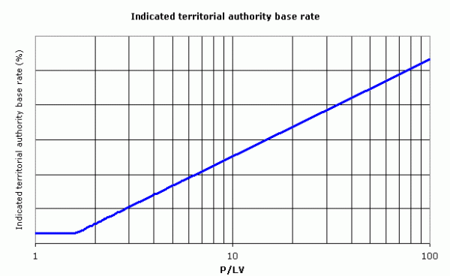  The Transport Agency calculated the base rate indicator annually as at August using the current year’s block road maintenance allocation and the latest available net equalised rateable land values.  This gave territorial authorities advance notice of potential changes in their approved base rates.

Other factors in base rate determination | The Transport Agency stressed that the base rate indicator provided only an indication of the level of assistance for a Territorial Authority . To this was added the Agency’s judgement of the circumstances of each territorial authority.  The factors taken into account in deciding on the base rate were:  - base rate indicators calculated for the current and previous two years  - approved base rates for the current and previous two years  - the base rate indicator for the next year  - changes in the road operations, maintenance and renewals programme  - changes in net equalised land value  - the resultant change in local share.

Summary of TA base rate policy | The Transport Agency wished to retain a degree of stability in TA base rates and therefore avoided making minor changes to the base rates.  The TA base rate policy was described in the table below.  If the base rate indicator was … Then …  greater than ±2 percent from the currently approved TA base rate a move was made towards the indicated TA base rate by half the difference, or such as to be within ±2 percent of the indicator, whichever was the lesser adjustment. An exception was where territorial authorities with normally small programmes had introduced work into their programmes that caused a large but temporary change in the appropriate level of assistance. Note: Territorial authorities were generally given the advantage of the odd ½ percent if necessary.  less than or equal to ±2 percent from the currently approved TA base rate no change was made unless the same trend has been shown for two successive years.

Approved TA base rate | The Transport Agency reviewed, and adjusted as necessary, the approved base rate for all Territorial Authorities in August prior to the start of the three-year National Land Transport Programme (NLTP). This allowed maximum notice to be given to territorial authorities before the start of the three-year period over which the new base rates applied. Out of necessity, this meant that the TA base rate for the following three years was determined by the:  - current year’s block road maintenance allocation  - latest available net equalised land values.  The approved TA base rate remained unchanged for the duration of the three year NLTP. Only in exceptional circumstances would the Transport Agency consider a review of TA base rates at other times.  Any additional funds approved at monthly programme reviews was at the funding assistance rate previously set.

Determination of TA construction rate | The TA construction rate was equal to the TA base rate plus 10 percent, for TA base rates up to and including 80 percent. For TA base rates greater than 80 per cent, the TA construction rate was half-way between the TA base rate and 100 percent, rounded up to a whole percent up to a maximum of 94%. This ensured that the assistance rate calculation was consistent with the principle that those who benefit from transport investment should pay.  Note: Once the TA construction rate was set for an individual project, or phase of a project, it remained constant until the project or phase was completed.

