How to stop AR invoices from printing for contract partners
- Go to transaction CAA2
- Enter business partner number of tenant that invoice should not be printed for
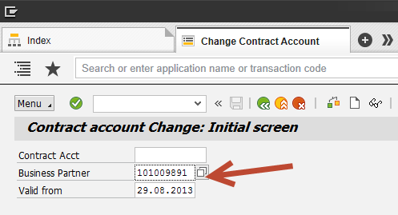

- Go to Dunning/Correspondence Tab and set Lock to ‘A’

