REQUIREMENTS FOR URBAN BUSES (RUB) CHECKSHEET
(Refer to RUB edition amendment no.3 December 2014) NB Not applicable for Section 8 Existing Bus Standards
BUS [insert operator, bus make and model] | DATE [insert date]
Definition of bus | Measurement | Pass/Fail/  Score/  Comment
2.2 Design and performance
Vehicle age < 20 years
2.3 Engine
Acceleration 0-50km/h ≤ 30 seconds
Fuelling range = ≥ 350km or 15 hours
Emissions (current Vehicle Emissions Rule)
Noise (current Vehicle Equipment Rule)
Compartment insulation – Non-flammable material used. Fire to ISO 3795 or FMVSS 302 (US) or equivalent ECE standard
2.4 Transmission
SB fully automatic or electronic shift
LB or LBDD fully automatic or electronic shift plus retarder
2.5 Suspension
SB air suspension
LB/LBDD air suspension ECAS, including self-levelling
LB/LBDD kneeling at front ≥ 60mm drop/lift
Kneel or rise time <8 seconds
LB/LBDD driver controlled in-use indicator/drive off protection
2.6 Stability and steering
LB/LBDD ESC-electronic stability control
2.7 Braking
EBS and ABS
Vehicle movement above 5km/h is inhibited while rear door is open or the kneeling system is activated
3.1 Access
Priority seats - 4 seats preferably off side
Must be available when wheelchair space is occupied by wheelchair passenger or pram
Minimum of two forward facing
3.2 Doors
SB one door >850mm single leaf
LB/LBDD two doors unless specifically for express/limited stop service
Front ≥ 1000mm
Rear ≥ 700mm,
LBDD Rear > 1000mm preferred
3.3 Step height/depths
First step measured from the ground to top of step (not kneeled)
SB < 300mm, may be < 370mm if kneeling to < 300mm fitted
LB and LBDD Front < 370mm
Rear ≤ 370mm
Kneeled: Front 19.5 inch rims ≤ 280mm, 22.5 inch rims < 300mm
For LBDD internal step heights should be of equal height
Maximum of two different heights is permitted
3.4 Floors
Slip-resistant(AS 3696.13) flooring used on floor areas
Front and rear door entry/exit step areas - contrasting colour
Multi-use/Wheelchair area - contrasting colour
Wheelchair wall mounted and flooring insert signage is required
Priority seat area - contrasting colour
SB flat floor at least to rear of priority area
LB/LBDD flat floor to rear edge of rear door or to front of the rear axle if only one door fitted on LB
LB/LBDD stepped access to saloon to the rear of the rear door maximum of 2 steps
LB/LBDD Is transverse ramp slope required to meet < 370mm rear step height
3.5 Aisle width
SB > 780mm in middle of the wheel arch at height of 300mm
LB/LBDD ≥ 800mm through wheel arches and to rear of multi-use/wheelchair space
LB ≥ 440mm to rear of priority seats of saloon
LBDD > 440mm to rear of priority seats in both the lower and upper saloon
3.6 Seating configuration
≥ 60 percent forward facing
≥ 50 percent forward facing in priority area
For LB rear ward facing seats fitted on front wheel arch
For LBDD rear ward facing seat fitted to the front and or the rear wheel arches
Seat spacing between forward-facing seats shall be ≥670mm
The height from the floor to the top of the front of the seat cushion should be ≥400mm and ≤500mm
The height to the top of the seat back excluding any grab handle should be ≥900mm
Are inwards facing flip up seats fitted if so location and number
Leg room > 300mm measured from front edge of seat squab horizontally to seat back or modesty panel in front
3.7 Seating design
Seat width - single seat ≥ 425mm
Seat width - double bench or paired seat ≥ 875mm
Seat width - mother/child ≥ 760mm, location
Seat spacing - Forward facing ≥ 670mm
Seat style, frame or moulded shell
Seat styles, numbers of each - single (S), double (D) or triple (T) bench
Seat fabric, unpadded plastic, vinyl or fabric covered cushion or insert
3.8 Luggage/stroller/prams/mobility devices
Provide space for 2 folded prams/mobility frames and 2 pieces of luggage of ≤25kg with dimensions ≤ 800mm x ≤ 300mm
4.2 Vehicle interior, entrance and exit step and plinth edges
Door entry/exits - slip-resistant material
Sharks tooth design edging has not been used in any area
Step/edges and plinths fitted with yellow high-visibility, slip-resistant/non-trip nosing in a solid band contrasting colour
4.3 Stanchions/handrails
High-visibility yellow contrasting colour
Along length of bus saloon(s) and not impede movement on aisle, spacing at least on alternate seats
Additional handrails in entry and exit locations
LBDD handrail/stanchions at top and bottom and in the stairwell area
Overhead contrasting colour handrails should be no higher than 1900mm from floor level, unless fitted with strap hangers to reach to or below this height
Maximum cross-section dimension 30-35mm
Finger/hand clearance space of 35-45mm between any part of the vehicle, and all part of a handrail
4.4 Grab handles
Yellow contrasting colour if not an integral part of a moulded style seat back
Circular or cross section of 30-35mm
Length of 100mm-120mm
4.5 Lighting
Internal entry and exit doorway ≥ 100 lux, externally downwards and outwards for >300mm
Entry/exit light automatically extinguished on door closure
Fare paying area ≥65 lux
LBDD Overhead lighting above the stairwell > 40 lux
LBDD stairwell sidewall low intensity safety lighting at each step height
General saloon behind driver's modesty panel ≥ 40 lux
4.6 Security and safety
Wiring for CCTV - SB one located forward to the driver to view fare paying and saloon area
LB minimum of three, two internal and one external
LBDD minimum of 5 including two in upper saloon to view into the stairwell and saloon
Number of cameras provided - external, internal lower saloon, upper saloon
For LBDD signage requiring that “passengers must not stand in the stair well whilst the bus is in motion”
LBDD a nearside upper deck mounted tree guard
For LBDD an upper deck electro/optical approaching hazard warning device is optional
4.7 Heating, ventilation and air conditioning
Adequate saloon heating and ventilation eg forced air system with a mix of hopper or sliding side windows and roof vents
For Auckland, Wellington and Christchurch, air conditioning climate control is mandatory
LBDD effective climate control in upper saloon is of great priority
Passenger controlled individual directional vents are optional
4.8 Demisting
If full air conditioning is not fitted, the demisting system must be capable of initial demisting and keeping clear glass panels of front and rear doors and all side windows
Communication
5.2 Bus stopping signals
Fitted with 2 dual-indicator bus stopping signalling and display devices (a mix of upper and lower case) that are easily seen and heard by the driver and the passengers (one rear ward facing and a 2nd forward and rear ward facing repeater located near the rear door or rear axle if only one door fitted)

LBDD Including one in the upper saloon
Easily reached by any person seated in a priority seating area or wheelchair area without having to stand up, eg on side walls or on stanchions
Used by elderly and disabled people with poor hand and finger function or dexterity
Adjacent to and not less than every second row of seats on both sides of the aisle
Fitted to the underside of any fold-up seat fitted in the multi-use/wheelchair space if the other bell push is obscured by the fold-up seat
The dashboard indicator shall have two components: a general signal and a second signal to indicate to the driver that the signal has been made by a passenger occupying a wheelchair or priority seating position
The device shall trigger both an audible and visual indication to the driver and passenger
Finger/thumb/knuckle push buttons on the vertical stanchions at a height of ≥1300mm and ≤1600mm above floor level
Finger/thumb/knuckle push buttons on the bus side panels at a height of ≥850mm and ≤1050mm particularly in the priority seating area or on the undersides of folding seats
Finger/thumb/knuckle push buttons fitted as near as possible to top edge of any fold up seat for use when seat in fold up position if the side wall button obscured
Note: Cordage alone is not acceptable
High contrast and consistent colours should be used ie. a red button on yellow background/mounting
5.3 External destination display
A mix of upper and lower case is preferred for destination information
Front forward-facing three-digit/character route number and destination combination sign ≥1500mm wide located at or above the top of the windscreen
Near side, as close as possible to the front entrance, a route number and destination repeater sign preferably fitted at the top of the first side window
Rear ward-facing three digit/character route-number only sign at a height ≥1500mm and ≤2500mm ( for LBDD < 2900mm) above ground level and central or left of centre, ie toward the nearside of the bus
Front and rear route number characters shall be ≥150mm
Front destination characters shall be ≥125mm
Side destination characters shall be ≥60mm
For LB/LBDD a wide destination sign is desirable
5.4 Internal information
Electronic information displays and announcements - ducting and mounting must be ready for fitment at a later date ( for LBDD includes upper saloon)
5.5 Driver operational communication
For larger urban centres of larger fleets RT radio fitted
Facilities for passengers with impairments
6.2 Priority seating area
Priority seating area well to the forward end of the saloon with at least four preferably all forward facing seats identified for passengers with impairments or extra mobility needs. These seats may be of the folding type in order to facilitate wheelchair access and stowage. Any fold-up seat must be capable of being held in the stowed position and be readily unlocked by simple and obvious mechanism. Non-lever systems are preferred
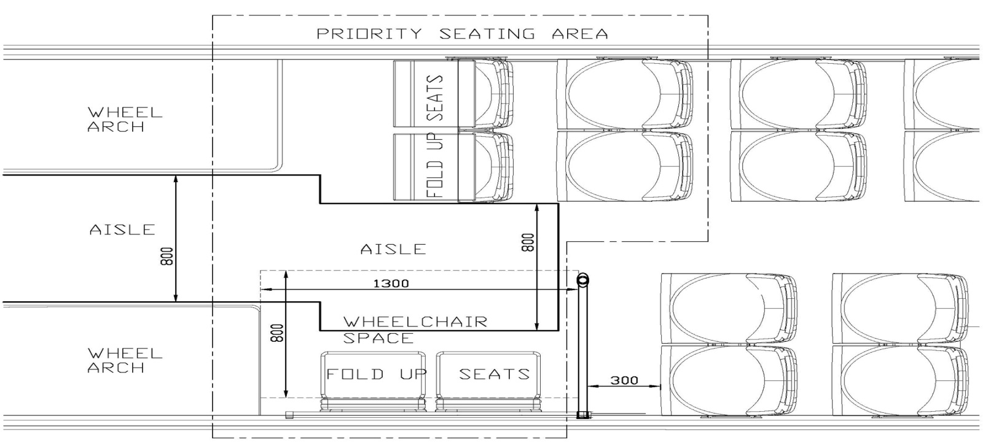
A separate space of dimensions not less than 800mm by 1300mm to cater for a wheelchair and user with a wheelchair footprint of ≤700mm width x ≤1200mm length
Contrasting, easily seen signage to indicate the area and request to vacate seats for use by passengers with disability/mobility needs along the following lines: ‘Priority seating area - Please vacate these seats for elderly or disabled passengers or parents/caregivers with small children’
6.3 Wheelchairs
Footprint to be provided for forward or rearward facing stowage ≤700mm width x ≤1200mm length
If transverse stowed, with handles and foot rest capable of being folded or stowed ≤700mm width x ≤900mm length
SB to carry a minimum of one rearward facing wheelchair, LB/LBDD a minimum of one rearward facing wheelchair (preferably on the nearside)
International wheelchair symbol for accessibility sign must be provided in the flooring material of any wheelchair space
2 x wheelchair symbol signs externally fitted - one on left front of bus and one on side of bus by front door entrance
There should be signage to indicate wheelchair brakes and lap belts should be applied
Any passenger safety/modesty panel & vertical stanchion fitted behind wheelchair/multi-use space should not hinder wheelchair manoeuvrability in to/out of the space
6.4 Boarding and alighting
Shall have a kneeling capability
The following shall be provided on the exterior of the bus adjacent to the front door: A sign stating ‘This bus kneels on request’
6.5 Ramp
A manually-operated flip-over style ramp >800mm width shall be provided at the front door
Ramp hinges & lifting rings/handles countersunk/flush with floor, preferably lifting handle full-hand width
Ramps must comply with section 8.2 of the Passenger Service Vehicles Rule 1999 in terms of any ramp, door brake interlock and driver warning system
High yellow contrast flat ramp edge marker strips are preferred over the raised metal edges
Ramp surface material must be slip-resistant
A wall mounted sign clearly indicating maximum permitted ramp weight and dimension for the wheel chair passenger, 300kg weight and 700mm width
Powered ramp fitted
7. Driver compartment
A fully sprung driver's seat with adjustment for all three planes of driving position
A readily adjustable (tilt and height) steering wheel column and soft style easily cleaned, and dried steering wheel
A footrest for the left foot
Coat/jacket storage, eg hook
Out-of-sight storage for personal belongings such as bag/lunchbox
Ticketing equipment and till stand should be ergonomically located

Barrier protection panel immediately behind the driver to prevent any form of assault from behind, either directly by a passenger or by a thrown object
A revenue collection and holding system so that the driver's cash can be readily and securely locked into a cash box that can be secured to the bus

Approval [insert bus make and model]
Signature
Print name
Organisation
Position
Date

