

LEVEL CROSSING MAINTENANCE

STANDARD TRAFFIC MANAGEMENT PLAN

To get this standard TMP approved as a generic TMP an STMS needs to:
- Follow the instructions shown in red in the standard TMP
- Submit the completed GTMP to the appropriate road controlling authority for approval

Table of Contents

Level Crossing Maintenance for period (add year of operation) 3
Level Crossing Maintenance Procedures 9
1. Monthly inspection and maintenance of barriers, bells and alarms 9
2. Annual inspection and maintenance of barriers, bells and alarms 10
3a Alignment of signal lenses (lights) LED 11
3b Alignment of signal lenses (lights) non-LED 12
4 Replacement of lightweight barrier arms 14
5 Barrier not operating 15
6 Signals not operating 16
7 Barriers and signals not operating 17
Appendix 1: KiwiRail site record 18
Appendix 2: STMS List 19
Appendix 3: Traffic Management Diagrams (TMDs) 19
TMD 1 - General maintenance of barriers and signals 20
TMD 2- Annual inspections & maintenance 21
TMD 3a- Alignment of lenses – LED 22
TMD 3b- Alignment of lenses - Non LED 23
TMD 4 - Replacing barrier 24
TMD 5 - Barrier not working 25
TMD 6 - Signals not working 26
TMD 7 -Signals and barrier not working 27
Appendix 4: List of Crossing Locations 28

Level Crossing Maintenance for period (add year of operation)
Use this form for complex activities. Refer to the NZ Transport Agency’s Traffic control devices manual, part 8 Code of practice for temporary traffic management (CoPTTM), section E, appendix A for a guide on how to complete each field.
Organisations /TMP  reference |  | TMP reference:  Insert reference |  |  |  |  |  |  |  |  | Contractor:  KiwiRail |  |  |  |  |  |  |  |  |  |  |  |  | Principal (Client): New Zealand Railways Corporation
 |  |  |  |  |  |  |  |  |  |  |  |  |  |  |  |  |  |  |  |  |  |  |  | RCA: Add name of the RCA that the TMP is to be submitted to
Location details and road characteristics |  | Road names and suburb |  |  |  |  |  |  |  |  |  |  |  |  |  |  |  |  |  |  |  |  |  | House no./RPs  (from and to) |  |  |  |  |  |  |  |  |  |  |  |  |  |  |  | Road  level |  |  |  | Permanent  speed
 |  | All roads where signalised railway level crossings occur  (list of crossing locations attached see Appendix 4) |  |  |  |  |  |  |  |  |  |  |  |  |  |  |  |  |  |  |  |  |  | ______________________ |  |  |  |  |  |  |  |  |  |  |  |  |  |  |  | Level LV Level 1  Level 2 |  |  |  | Various
Traffic details (main route) |  | AADT |  |  |  |  |  |  |  |  |  |  |  |  |  |  |  |  |  |  |  |  |  | Peak flows
 |  | Various <10,000 vpd |  |  |  |  |  |  |  |  |  |  |  |  |  |  |  |  |  |  |  |  |  | Peak traffic times are to be avoided as detailed below in the planned work programme
Description of work activity
Routine maintenance of railway level crossing alarm and barrier systems
Planned work programme
Start date |  |  |  |  |  |  |  |  |  |  |  |  | Time |  |  |  |  |  | End date |  |  |  |  |  |  |  |  |  |  |  |  |  |  |  |  |  |  |  |  |  | Time
Consider significant stages, for example:  - road closures  - detours  - no activity periods. |  |  |  |  | Planned work to be undertaken:  - during daylight hours  - outside of peak traffic times whenever possible  Callouts for faults will be completed at night and at peak times (if needed)
Alternative dates if activity delayed |  |  |  |  | As this is a generic TMP the work activity is to be carried out on an as required basis within agreed times and dates for a 12-month period. Therefore, alternative dates will not be required.
Road aspects affected (delete either Yes or No to show which aspects are affected)
Pedestrians affected? |  |  |  |  | No |  |  |  |  | Property access affected? |  |  |  |  |  |  |  |  | No |  |  |  |  |  |  |  |  |  | Traffic lanes affected? |  |  |  |  |  |  |  |  |  |  |  |  |  | No
Cyclists affected? |  |  |  |  | No |  |  |  |  | Restricted parking affected? |  |  |  |  |  |  |  |  | No |  |  |  |  |  |  |  |  |  | Delays or queuing likely? |  |  |  |  |  |  |  |  |  |  |  |  |  | No
Proposed traffic management methods
Installation  (includes parking of plant and materials storage) |  |  |  |  |  | When approaching the level crossing the driver of the vehicle will:  - Switch on the vehicles’ amber flashing beacon to indicate the intention to leave the carriageway  - Indicate  - Slow down and move into the shoulder/parking area.  Once outside the live lane the vehicle will be parked at the furthest lateral position from the edgeline.  Amber flashing beacon to remain on and indicator lights in hazard mode, if required, for extra warning.  Added protection behind a roadside barrier to be sought and used whenever available to park the vehicle.
Attended (day) |  |  |  |  |  | A methodology for each activity is provided in the level crossing procedures of this document and in Appendix 3: Traffic management diagrams (TMDS).  Where barriers or alarms are used to stop traffic, queues will be monitored continuously. Where queues extend to the WX1R/L (PW57) sign or 5 minutes has passed, work will cease (if on the lane) and the barriers or alarms will be removed and traffic allowed to clear.
Attended (night) |  |  |  |  |  | A methodology for each activity is provided in the level crossing procedures of this document and in Appendix 3: Traffic management diagrams (TMDS).  Where barriers or alarms are used to stop traffic, queues will be monitored continuously. Where queues extend to the WX1R/L (PW57) sign or 5 minutes has passed, work will cease (if on the lane) and the barriers or alarms will be removed and traffic allowed to clear.
Unattended (day) |  |  |  |  |  | A methodology for each activity is provided in the level crossing procedures of this document and in Appendix 3: Traffic management diagrams (TMDs).
Unattended (night) |  |  |  |  |  | Methodology for each activity is provided in the level crossing procedures of this document and in Appendix 3: Traffic management diagrams (TMDs).
Detour route |  |  |  |  |  | Detours will not be required for this work activity.
Does detour route go into another RCA’s roading network? No (delete either Yes or No)
If Yes, has confirmation of acceptance been requested from that RCA? Yes No (delete either Yes or No)
Note: Confirmation of acceptance from affected RCA must be submitted prior to occupying the site.

Removal |  |  |  |  |  | When leaving the site, the driver will:  - Turn off hazard indicators where used  - Indicate and wait until there is a gap in traffic  - Move into the carriageway and accelerate to the permanent speed limit  - Turn off the indicator and amber flashing beacon.
Proposed TSLs (see TSL decision matrix for guidance)
 | TSL details as required  Approval of Temporary Speed Limits (TSL) are in terms of Section 5 of Land Transport Rule: Setting of Speed Limits 2003, Rule 54001  (List speed, length and location) |  |  |  |  |  |  |  |  |  |  |  |  |  |  |  |  |  |  | Times  (From and to) |  |  |  |  |  |  |  |  |  |  |  | Dates  (Start and finish) |  |  |  |  |  |  |  |  |  | Diagram ref. no.s  (Layout drawings or traffic management diagrams)
Attended day/night | Temporary speed limits will not be required |  |  |  |  |  |  |  |  |  |  |  |  |  |  |  |  |  |  | _____________ |  |  |  |  |  |  |  |  |  |  |  | _____________ |  |  |  |  |  |  |  |  |  | _____________
Unattended day/night | Temporary speed limits will not be required |  |  |  |  |  |  |  |  |  |  |  |  |  |  |  |  |  |  | _____________ |  |  |  |  |  |  |  |  |  |  |  | _____________ |  |  |  |  |  |  |  |  |  | _____________
Positive traffic management measures
Not required

Contingency plans
Generic contingencies for:  - major incidents  - incidents  - pre planed detours.  Remove any options which do not apply to your job |  |  |  |  | Major Incident  A major incident is described as:  - Fatality or serious injury - real or potential  - Significant property damage, or  - Emergency services (police, fire, etc) require access or control of the site. |  |  |  |  |  |  |  |  |  |  |  |  |  |  |  |  |  |  |  | Actions  The STMS/TC must immediately conduct the following:  - stop all activity and traffic movement  - secure the site to prevent (further) injury or damage  - contact the appropriate emergency authorities  - render first aid if competent and able to do so  - notify the RCA representative and / or the engineer  - under the guidance of the ‘officer in charge’ (police or fire) of the site, reduce effects of TTM on the road or remove the activity if safe to do so  - re-establish TTM and traffic movements when advised by officer in charge that it is safe to do so.
 |  |  |  |  | Incident  An incident is described as:  - excessive delays - real or potential  - minor or non-inquiry accident that has the potential to affect traffic flow  - structural failure of the road. |  |  |  |  |  |  |  |  |  |  |  |  |  |  |  |  |  |  |  | Actions  The STMS/TC must immediately conduct the following:  - stop all activity and traffic movement if required  - secure the site to prevent the prospect of injury or further damage  - notify the RCA representative and / or the engineer  - STMS to implement a plan to safely remove TTM and to establish normal traffic flow if safe to do so  - re-establish TTM and traffic movements when it is safe to do so and when traffic volumes have reduced.
 |  |  |  |  | Detour  If because of the on-site activity it will not be possible to remove or reduce the effects of TTM once it is established a detour route must be designed. This is likely for:  - excessive delays when using an alternating flow design for TTM  - redirecting one direction of flow and / or  - total road closure and redirection of traffic until such time that traffic volumes reduce and tailbacks have been cleared.  The risks in the type of work being undertaken, the risks inherent in the detour, the probable duration of closure and availability and suitability of detour routes need to be considered.  The detour and route must be designed including:  - pre- approval form the RCA’s whose roads will be used or affected by the detour route  - ensure that TTM equipment for the detour - signs etc are on site an pre-installed. |  |  |  |  |  |  |  |  |  |  |  |  |  |  |  |  |  |  |  | Actions  When it is necessary to implement the pre-planned detour the STMS must immediately undertake the following:  - Notify the RCA and / or the engineer when the detour is to be established  - Drive through the detour in both directions to check that it is stable and safe  - Remove the detour as soon as it practicable and safe to do so and the traffic volumes have reduced and tailbacks have cleared  - Notify the RCA and / or the engineer when the detour has been disestablished and normal traffic flows have resumed.
Note also the requirements for no interference at an accident scene:
In the event of an accident involving serious harm the STMS/TC must ensure that nothing, including TTM equipment, is removed or disturbed and any wreckage article or thing must not be disturbed or interfered with, except to:
- Save a life of, prevent harm to or relieve the suffering of any person, or
- To maintain the access of the general public to an essential service or utility, or
- To prevent serious damage to or serious loss of property.
Other contingencies to be identified by the applicant  (i.e. steel plates to quickly cover excavations) |  |  |  |  | - High Traffic volume on-site:  Work will not begin until excess traffic has been cleared. Where the work is carried out clear of the carriageway it is unlikely the traffic will be affected. However, at any time when the work activity results in a buildup of traffic, work will cease until traffic has cleared.  - Access for emergency vehicles:  At any time, a crossing is closed to traffic, the crossing will be opened immediately to allow emergency services to pass.  - Inclement Weather:  If visibility is reduced to less than the clear sight distance required for the road user, work will cease until visibility is restored.  - Traffic accidents on site:  These procedures are to be followed in the event of a traffic accident on site:  - A fire extinguisher and First Aid kit are to be carried in each work vehicle  - Emergency services to be contacted when required to attend.
Authorisations
Parking restriction(s) alteration authority |  |  |  | Will controlled street parking be affected? |  |  |  |  |  |  |  |  |  |  |  |  |  | No |  |  |  |  |  |  |  | Has approval been granted? |  |  |  |  |  |  |  |  |  |  |  |  |  |  |  |  |  |  |  |  | _____
 |  |  |  | __________
Authorisation to work at permanent traffic signal sites |  |  |  | Will portable traffic signals be used or permanent traffic signals be changed? |  |  |  |  |  |  |  |  |  |  |  |  |  | No |  |  |  |  |  |  |  | Has approval been granted? |  |  |  |  |  |  |  |  |  |  |  |  |  |  |  |  |  |  |  |  | ______
 |  |  |  | __________
Road closure authorisation(s) |  |  |  | Will full carriageway closure continue for more than 5 minutes (or other RCA stipulated time)? |  |  |  |  |  |  |  |  |  |  |  |  |  | No |  |  |  |  |  |  |  | Has approval been granted? |  |  |  |  |  |  |  |  |  |  |  |  |  |  |  |  |  |  |  |  | _______
 |  |  |  | __________
Bus stop relocation(s) – closure(s) |  |  |  | Will bus stop(s) be obstructed by the activity? |  |  |  |  |  |  |  |  |  |  |  |  |  | No |  |  |  |  |  |  |  | Has approval been granted? |  |  |  |  |  |  |  |  |  |  |  |  |  |  |  |  |  |  |  |  | _______
 |  |  |  | ___________
Authorisation to use portable traffic signals |  |  |  | Make, model and description/number |  |  |  |  |  |  |  | ___________
 |  |  |  | NZTA compliant? |  |  |  |  |  |  |  | Yes (delete either Yes or No)
EED
Is an EED applicable? |  |  |  |  |  |  |  | No |  |  |  | EED attached? |  |  |  |  | No
Delay calculations/trial plan to determine potential extent of delays
Not required
Public notification plan
Not required
Public notification plan attached? |  |  |  |  |  |  |  |  |  | No
On-site monitoring plan
Attended  day |  |  |  |  |  |  | STMS/TC to record details of the worksite onto the KiwiRail daily site record (Appendix 1)
Unattended  (day and/or night) |  |  |  |  |  |  | Temporary warning signs will be checked every 24hrs when barriers and or alarms are not working.
Method for recording daily site TTM activity (e.g. CoPTTM on-site record)
KiwiRail daily site record.
Site safety measures
All personnel on site will wear high visibility garments.
A hazard checklist will be completed and potential traffic hazards identified – site personnel will be briefed on the hazards.
All personnel on site will comply with the requirements of the KiwiRail Site Safety Plan.
Other information
Signals (which include railway bells, lights and barriers) are legal mechanisms for enforcing a compulsory stop of traffic.
In extreme cases where traffic must be stopped (e.g. a broken barrier arm) the signals will be used to stop traffic for no more than 5 minutes.
The following additional information is provided:
- Location and layout of local Level Crossings where this TMP will be implemented.

Site specific layout diagrams
Number |  |  |  |  |  |  |  |  | Title
1 |  |  |  |  |  |  |  |  | General maintenance of barriers and signal
2 |  |  |  |  |  |  |  |  | Annual inspections and maintenance
3a |  |  |  |  |  |  |  |  | Alignment of lights. (LED)
3b |  |  |  |  |  |  |  |  | Alignment of lights (non LED)
4 |  |  |  |  |  |  |  |  | Replacing a barrier arm
5 |  |  |  |  |  |  |  |  | Level crossing barriers not operating
6 |  |  |  |  |  |  |  |  | Level crossing alarms not operating
7 |  |  |  |  |  |  |  |  | Level crossing alarms and barriers not operating
Contact details
 |  |  |  |  | Name |  |  |  |  |  |  |  |  |  |  |  |  |  |  |  |  |  | 24/7 contact  number |  |  |  |  |  |  |  |  |  |  |  | CoPTTM  ID |  |  |  | Qualification |  |  |  |  |  |  | Expiry  date
Principal |  |  |  |  | To be completed for each RCA road network
TMC |  |  |  |  | To be completed for each RCA road network
Engineers’ representative |  |  |  |  | To be completed for each RCA road network where required
Contractor |  |  |  |  | To be completed for each RCA road network
STMS |  |  |  |  | Named on KiwiRail daily site record (Appendix 1)
TC |  |  |  |  | Named on KiwiRail daily site record (Appendix 1)
Others as required |  |  |  |  | _________________________________________ |  |  |  |  |  |  |  |  |  |  |  |  |  |  |  |  |  | ____________ |  |  |  |  |  |  |  |  |  |  |  | _________ |  |  |  | ____________ |  |  |  |  |  |  | ________
TMP preparation
Preparation |  |  | To be added |  |  |  |  |  |  |  |  |  |  |  |  | To be added |  |  |  |  | To be added |  |  |  |  |  |  |  |  |  |  |  |  | To be added |  |  |  | To be added |  |  |  |  |  |  | To be added
 |  |  | Name (STMS qualified) |  |  |  |  |  |  |  |  |  |  |  |  | Date |  |  |  |  | Signature |  |  |  |  |  |  |  |  |  |  |  |  | ID no. |  |  |  | Qualification |  |  |  |  |  |  | Expiry date
This TMP meets CoPTTM requirements Number of diagrams attached |  |  |  |  |  |  |  |  |  |  |  |  |  |  |  |  |  |  |  |  |  |  |  |  |  |  |  |  |  |  |  |  |  |  |  |  |  |  |  |  |  | As per schedule attached
TMP returned for correction
(if required)
 |  |  | Name |  |  |  |  |  |  |  |  |  |  |  |  | Date |  |  |  |  | Signature |  |  |  |  |  |  |  |  |  |  |  | ID no. |  |  |  |  | Qualification |  |  |  |  |  |  | Expiry date
Engineer/TMC to complete following section when approval or acceptance required
Approved by TMC/engineer (delete one)
 |  |  | Name |  |  |  |  |  |  |  |  |  |  |  |  | Date |  |  |  |  |  | Signature |  |  |  |  |  |  |  |  |  |  | ID no. |  |  |  |  | Qualification |  |  |  |  |  |  | Expiry date
Acceptance by TMC (only required if TMP approved by engineer)
 |  |  | Name |  |  |  |  |  |  |  |  |  |  |  |  | Date |  |  |  |  |  | Signature |  |  |  |  |  |  |  |  |  |  | ID no. |  |  |  |  | Qualification |  |  |  |  |  |  | Expiry date
Qualifier for engineer or TMC approval
Approval of this TMP authorises the use of any regulatory signs included in the TMP or attached traffic management diagrams.
This TMP is approved on the following basis:
- To the best of the approving engineer’s/TMC’s judgment this TMP conforms to the requirements of CoPTTM.
- This plan is approved on the basis that the activity, the location and the road environment have been correctly represented by the applicant. Any inaccuracy in the portrayal of this information is the responsibility of the applicant.
- The STMS for the activity is reminded that it is the STMS’s duty to postpone, cancel or modify operations due to the adverse traffic, weather or other conditions that affect the safety of this site.
Notification to TMC prior to occupying worksite/Notification completed
Type of notification to TMC required |  |  |  | As agreed with RCA |  |  |  |  |  |  |  |  |  |  | Notification completed
 |  |  |  |  |  |  |  |  |  |  |  |  |  |  |  |  |  |  |  |  |  |  |  |  |  |  | Date
 |  |  |  |  |  |  |  |  |  |  |  |  |  |  |  |  |  |  |  |  |  |  |  |  |  |  | Time

Level Crossing Maintenance Procedures

Monthly inspection and maintenance of barriers, bells and alarms
Activity | Duration | Location | Effect on traffic | Proposed TM Method | Relevant Diagram(s)
Checking and adjusting the operation of all equipment on site.  - This involves moving between the components of the system and crossing the road to inspect the equipment located on the opposite location.  - May also include activity (3a) or (3b) Alignment of Signal Lenses (lights) LED/NON LED. | 10mins | At mast location on railway reserve. Minimum 1m clear of the carriageway at all times | NIL | Daylight hours only  Inspector will remain clear of the carriageway at all times  Work Vehicle must be parked in a position where it will not obstruct the road users’ view of the crossing alarm lights or existing/temporary road signs | 1, 3a, 3b

Annual inspection and maintenance of barriers, bells and alarms
Activity | Duration | Location | Effect on traffic | Proposed TM Method | Relevant Diagram(s)
Checking and adjusting the operation of all equipment on site.  - This involves moving between the components of the system and crossing the roads to inspect the equipment located on the opposite location.  - Barrier arms may need to be lowered to check operation.  - May also include activity (3a) or (3b) Alignment of Signal Lenses (lights) LED/NON LED | Up to 1 hour | At mast location on railway reserve. Minimum 1m clear of the carriageway at all times | MINOR  Short delay when operation of the barrier arm is tested (approximately 1 minute) | Static Operation,  Not on a live lane,  Daylight hours only  Work Vehicle must be parked in a position where it will not obstruct the road users’ view of the crossing alarm lights or existing/temporary road signs | 2, 3a, 3b

3a Alignment of signal lenses (lights) LED
Activity | Duration | Location | Effect on traffic | Proposed TM Method | Relevant Diagram(s)
Checking the alignment of the signal lights.  - LED lights are non-directional and can be aligned from the supporting mast position. | Up to 10 mins | At mast location on railway reserve. Minimum 1m clear of the carriageway at all times | NIL | Daylight hours only  Inspector will remain clear of the carriageway at all times  Work Vehicle must be parked in a position where it will not obstruct the road users’ view of the crossing alarm lights or existing/temporary road signs | 3a

3b Alignment of signal lenses (lights) non-LED
Activity | Duration | Location | Effect on traffic | Proposed TM Method | Relevant Diagram(s)
Checking the alignment of the signal lights.  - Non-LED lights are directional and must be aligned to focus at a particular location on the approaching traffic lane.  - The inspector (focus checker) is required to check the alignment from a position on the carriageway. This can be achieved by crossing the road at the required point and checking the focus visually as the focus point is reached. | Up to 10 mins  Up to 10 seconds crossing the live traffic lane | At mast location on railway reserve.  On the carriageway  While crossing the road at a point 70m away from the railway crossing | NIL | Daylight hours only  Inspector will only enter the carriageway when there is no approaching traffic.  Clear sight distance for the activity is to be maintained.  Inspector will leave the carriageway on approach of a vehicle.  Where clear sight distance cannot be achieved, or in high traffic areas, a spotter will be deployed to warn the focus checker of approaching traffic.  The worker adjusting the light may act as the spotter for the person checking the focus under the following conditions;  - Clear sight distance is available to approaching road users in the direction of the focus checker  - The spotter is able to communicate easily and immediately with the focus checker. using an RT  Work Vehicle must be parked in a position where it will not obstruct the road users’ view of the crossing alarm lights or existing/temporary road signs | 3b

4 Replacement of lightweight barrier arms
Activity | Duration | Location | Effect on traffic | Proposed TM Method | Relevant Diagram(s)
The barrier arms are raised to the vertical position, pivoted 90º and lowered parallel with the road.  - The damaged arm can be replaced in this position without obstructing the carriageway.  - It may be necessary for the worker to enter the carriageway for up to 2 minutes if the barrier is damaged and it cannot be raised. In this circumstance, the alarms will be operating and traffic will be stopped (Note: to be used if the alarms are also not operating) | Up to 10 mins | At mast location on railway reserve. | MINOR  Short delay while operation of the barrier arm is tested approximately 1 minute  (less than a typical passing train) | Static Operation,  May require access to the carriageway while alarms are in operation  Work Vehicle must be parked in a position where it will not obstruct the road users’ view of the crossing alarm lights or existing/temporary road signs | 4

5 Barrier not operating
Activity | Duration | Location | Effect on traffic | Proposed TM Method | Relevant Diagram(s)
Advance warning to be installed at the site to give warning of barrier arms not operating. | Possibly up to several days | On the approach to the non-operational barrier and below the cross bar at the crossing point. | SAFETY COMPROMISED  Managed with temporary sign | Temporary warning signs (OTHER HAZARD) and (BARRIERS NOT WORKING) below the existing WX1R/L (PW57)  Work Vehicle must be parked in a position where it will not obstruct the road users’ view of the crossing alarm lights or existing/temporary road signs | 5

6 Signals not operating
Activity | Duration | Location | Effect on traffic | Proposed TM Method | Relevant Diagram(s)
Advance warning to be installed at the site to give warning of signals not operating. | Various, possibly up to several days | Across the crossing site.  On the approach to the non-operational signals and below the cross bar at the crossing point. | SAFETY COMPROMISED  Managed with temporary sign | Temporary warning signs (OTHER HAZARD) and (SIGNALS NOT WORKING) below the existing WX1R/L (PW57)  Cover flashing lights at crossing with orange bags  Work Vehicle must be parked in a position where it will not obstruct the road users’ view of the crossing signal lights or existing/temporary road signs | 6

7 Barriers and signals not operating
Activity | Duration | Location | Effect on traffic | Proposed TM Method | Relevant Diagram(s)
Advance warning to be installed at the site to give warning of barriers signals not operating. | Possibly up to several days | Across the crossing site.  On the approach to the non-operational barriers and signals and below the cross bar at the crossing point. | SAFETY COMPROMISED  Managed with temporary sign | Temporary warning signs (OTHER HAZARD), (SIGNALS NOT WORKING) and (BARRIER NOT WORKING) below the existing WX1R/L (PW57) and below the cross bar at the crossing  Cover flashing lights at crossing with orange bags  Work Vehicle must be parked in a position where it will not obstruct the road users’ view of the crossing alarm lights or existing/temporary road signs | 7

Appendix 1: KiwiRail site record

KIWIRAIL SITE RECORD  To be used to confirm site details. Must be retained for 12 months. |  |  |  |  | Date
Person responsible for site | Name |  |  |  | CoTTM ID Number
Person responsible for site | Signature |  |  |  | STMS / TC
Crossing location |  | Arrival time | TMD used | Departure time |  | Initialed

Appendix 2: STMS List
Refer to KiwiRail local office for an updated list of STMS for the area

Appendix 3: Traffic Management Diagrams (TMDs)

1 | General maintenance of barriers and signals
2 | Annual inspections and maintenance
3a | Alignment of lights. (LED)
3b | Alignment of lights (non LED)
4 | Replacing a lightweight barrier arm
5 | Level crossing barriers not operating
6 | Level crossing alarms not operating
7 | Level crossing alarms and barriers not operating

TMD 1 - General maintenance of barriers and signals

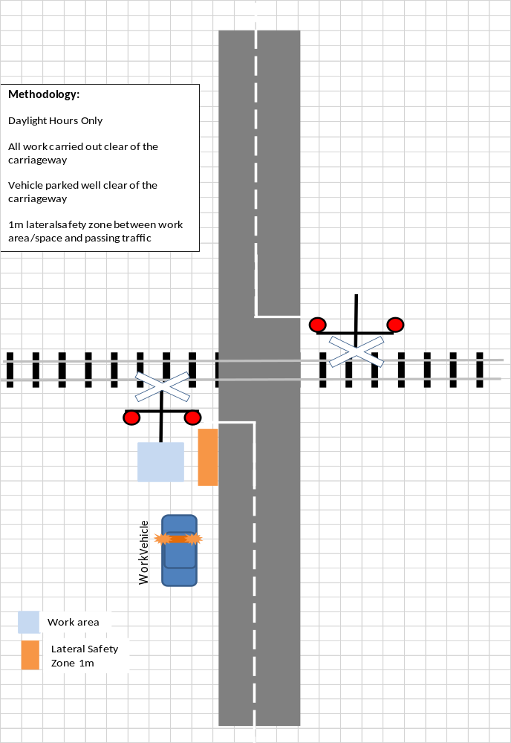

TMD 2- Annual inspections & maintenance
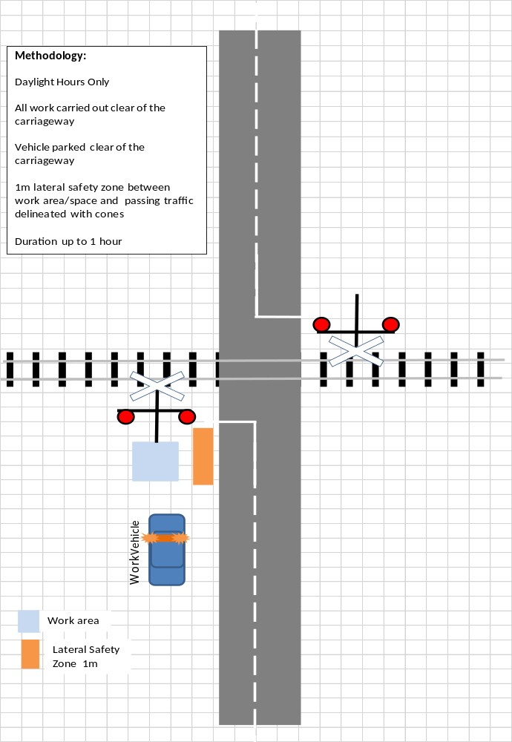

TMD 3a- Alignment of lenses – LED
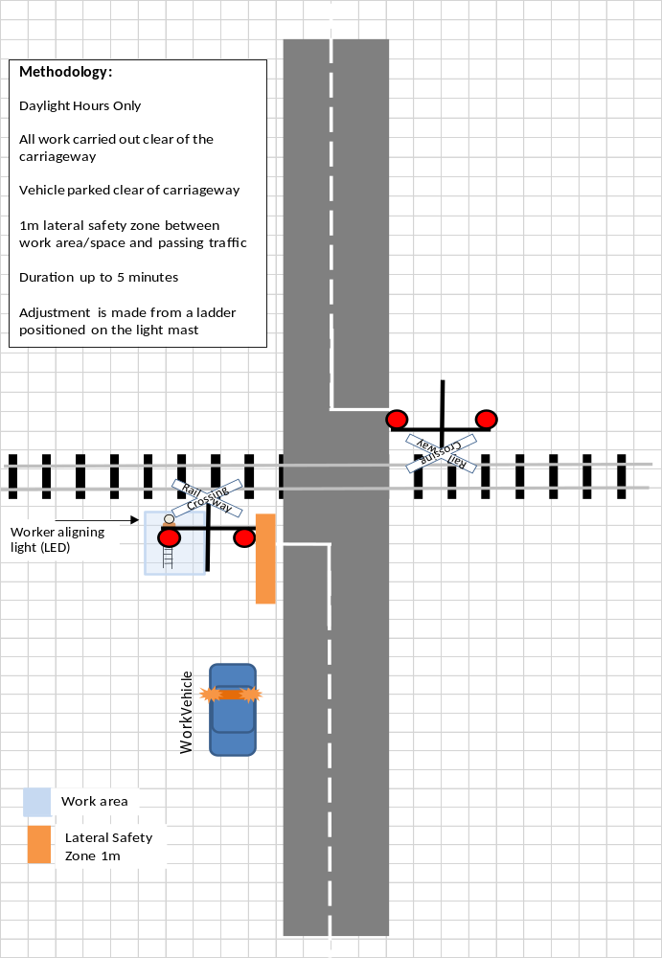

TMD 3b- Alignment of lenses - Non LED
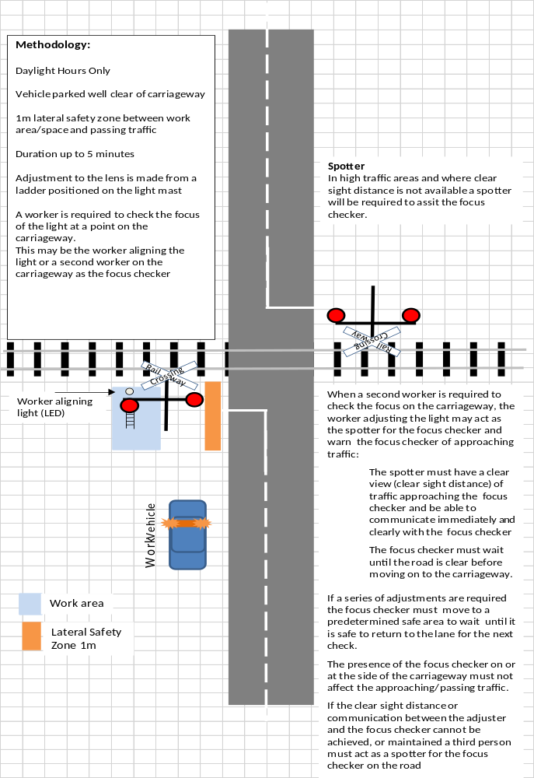

TMD 4 - Replacing barrier
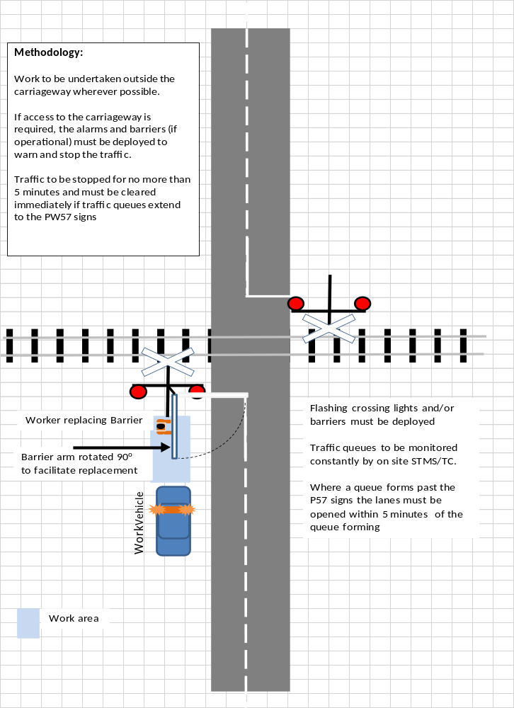

TMD 5 - Barrier not working
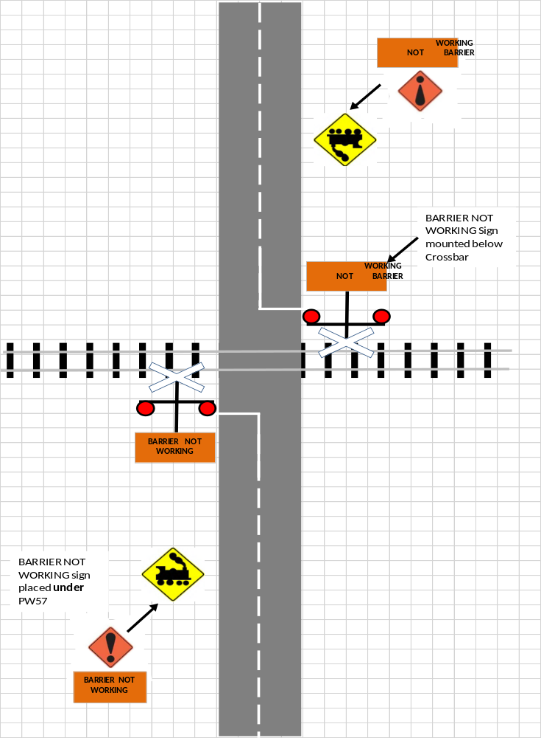

TMD 6 - Signals not working
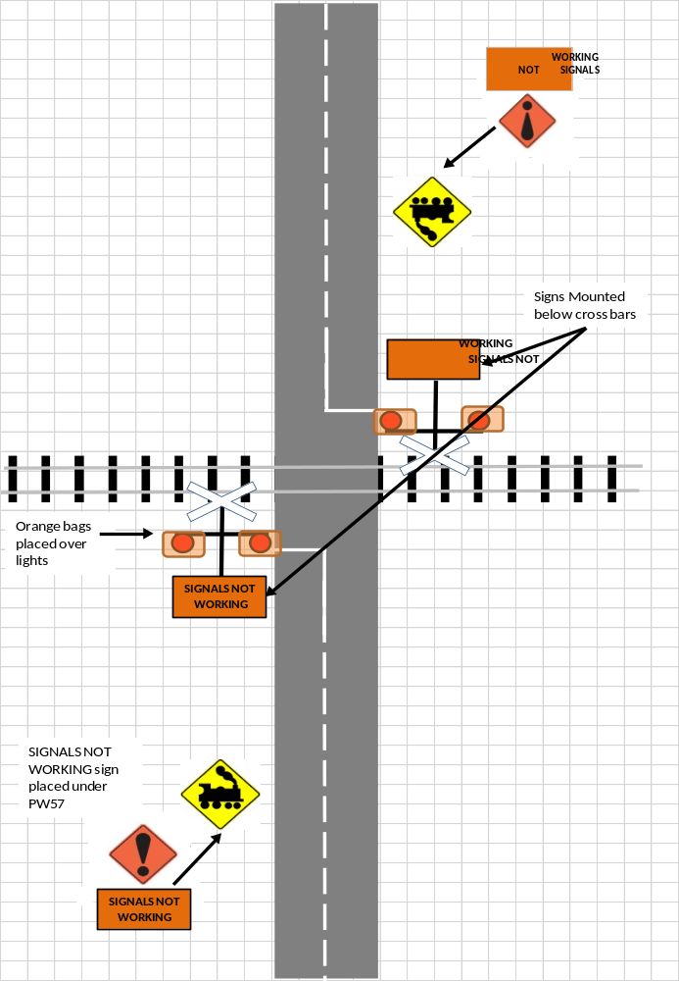

TMD 7 -Signals and barrier not working
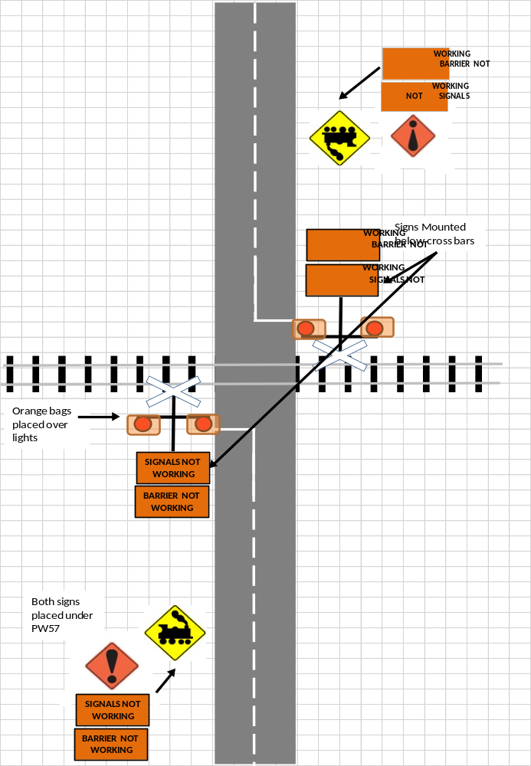

Appendix 4: List of Crossing Locations
Edit the following list so only those crossing locations relevant to the RCA or region are shown.

Name | PR Code | Line Name | Metrage | Type
Ruakura Lane | FLB | ECMT | 4.760000229 | Flashing Lights & Bells
Thompsons Track | FLB | MSL | 68.31999969 | Flashing Lights & Bells
Stanley Road | FLB | MSL | 84.69999695 | Flashing Lights & Bells
Works Road | FLB | MSL | 89.65000153 | Flashing Lights & Bells
Compton Street | FLB | MSL | 97.54000092 | Flashing Lights & Bells
Lagmhor Road | FLB | MSL | 97.94000244 | Flashing Lights & Bells
Winslow Willowby Road | FLB | MSL | 104.1699982 | Flashing Lights & Bells
Swamp Road | FLB | MSL | 110.9700012 | Flashing Lights & Bells
Delamaine Street | FLB | MSL | 113.0800018 | Flashing Lights & Bells
withells Road | FLB | MSL | 126.25 | Flashing Lights & Bells
Elizabeth Avenue | HAB | MSL | 67.56999969 | Half arm Barriers with flashing lights and bells
South Town Belt | HAB | MSL | 67.98000336 | Half arm Barriers with flashing lights and bells
Chertsey Kyle Road | HAB | MSL | 76.31999969 | Half arm Barriers with flashing lights and bells
Fairfield Road | HAB | MSL | 88.58000183 | Half arm Barriers with flashing lights and bells
East Street | HAB | MSL | 93.27999878 | Half arm Barriers with flashing lights and bells
Walnut Avenue | HAB | MSL | 94.23000336 | Half arm Barriers with flashing lights and bells
Havelock Street | HAB | MSL | 95.08000183 | Half arm Barriers with flashing lights and bells
Moore Street | HAB | MSL | 95.44999695 | Half arm Barriers with flashing lights and bells
Maronan Road | HAB | MSL | 98.91999817 | Half arm Barriers with flashing lights and bells
Kingdon Street Ped | FLB | NAL | 8.93999958 | Flashing Lights & Bells
St Georges Road | FLB | NAL | 18.22999954 | Flashing Lights & Bells
ORorke Road | FLB | Onehunga | 0.529999971 | Flashing Lights & Bells
Maurice Road | FLB | Onehunga | 0.970000029 | Flashing Lights & Bells
Captain Springs Road | FLB | Onehunga | 2.069999933 | Flashing Lights & Bells
Church Street | FLB | Onehunga | 2.170000076 | Flashing Lights & Bells
Alfred Street | FLB | Onehunga | 2.710000038 | Flashing Lights & Bells
Victoria Street | FLB | Onehunga | 2.920000076 | Flashing Lights & Bells
Galway Street | FLB | Onehunga | 3.319999933 | Flashing Lights & Bells
Church Street East | HAB | NAL | 1.419999957 | Half arm Barriers with flashing lights and bells
Normanby Road | HAB | NAL | 10.14999962 | Half arm Barriers with flashing lights and bells
Porters Avenue | HAB | NAL | 10.85999966 | Half arm Barriers with flashing lights and bells
George Street | HAB | NAL | 11.36999989 | Half arm Barriers with flashing lights and bells
Morningside Drive | HAB | NAL | 12.80000019 | Half arm Barriers with flashing lights and bells
Asquith Avenue | HAB | NAL | 14.02999973 | Half arm Barriers with flashing lights and bells
Rossgrove Terrace | HAB | NAL | 14.13000011 | Half arm Barriers with flashing lights and bells
Woodward Road | HAB | NAL | 15.80000019 | Half arm Barriers with flashing lights and bells
St Jude Street | HAB | NAL | 17.39999962 | Half arm Barriers with flashing lights and bells
Chalmers Street | HAB | NAL | 17.63999939 | Half arm Barriers with flashing lights and bells
Sarawia Street | HAB | Newmarket | 0.400000006 | Half arm Barriers with flashing lights and bells
Mays Road | HAB | Onehunga | 1.830000043 | Half arm Barriers with flashing lights and bells
Queen Street | HAB | SWL |  | Half arm Barriers with flashing lights and bells
Dalefield Road | FLB | WL | 73.62000275 | Flashing Lights & Bells
Lincoln Road | FLB | WL | 74.80000305 | Flashing Lights & Bells
Brooklyn Road | FLB | WL | 75.29000092 | Flashing Lights & Bells
Victoria Street | FLB | WL | 76.18000031 | Flashing Lights & Bells
Pembroke Street | FLB | WL | 76.44000244 | Flashing Lights & Bells
Belvedere Road | FLB | WL | 76.76999664 | Flashing Lights & Bells
Rhodes Street | FLB | WL | 77.12000275 | Flashing Lights & Bells
Kent Street | FLB | WL | 77.30000305 | Flashing Lights & Bells
Chester Road | FLB | WL | 79.44000244 | Flashing Lights & Bells
Norman Avenue | FLB | WL | 84.79000092 | Flashing Lights & Bells
Norfolk Road | FLB | WL | 85.41999817 | Flashing Lights & Bells
Victoria Street | FLB | PNGL | 115.5400009 | Flashing Lights & Bells
Tamumu Road | FLB | PNGL | 116.1600037 | Flashing Lights & Bells
Racecourse Road | FLB | PNGL | 117.7600021 | Flashing Lights & Bells
Higginson Street | FLB | PNGL | 121.8700027 | Flashing Lights & Bells
Oruawharo Road | HAB | PNGL | 90.11000061 | Half arm Barriers with flashing lights and bells
Fraser Road | HAB | PNGL | 91.47000122 | Half arm Barriers with flashing lights and bells
Amyes Road | FLB | Hornby | 0.589999974 | Flashing Lights & Bells
Halswell Junction Road | FLB | Hornby | 1.769999981 | Flashing Lights & Bells
Wroxton Terrace | FLB | MNL | 2.920000076 | Flashing Lights & Bells
Barnes Road | FLB | MNL | 7.829999924 | Flashing Lights & Bells
Radcliffe Road | FLB | MNL | 9.520000458 | Flashing Lights & Bells
Spencerville Road | FLB | MNL | 13.48999977 | Flashing Lights & Bells
Scruttons Road | FLBS | MSL | 5.199999809 | Flashing L & B with Second Train coming
Chapmans Road | FLBS | MSL | 5.929999828 | Flashing L & B with Second Train coming
Curries Road | FLBS | MSL | 6.75 | Flashing L & B with Second Train coming
Riccarton Road | HAB | MNL | 1.480000019 | Half arm Barriers with flashing lights and bells
Kilmarnock Street | HAB | MNL | 1.720000029 | Half arm Barriers with flashing lights and bells
Fendalton Road | HAB | MNL | 2.49000001 | Half arm Barriers with flashing lights and bells
Glandovey Road | HAB | MNL | 3.190000057 | Half arm Barriers with flashing lights and bells
Wairakei Road | HAB | MNL | 3.640000105 | Half arm Barriers with flashing lights and bells
Blighs Road | HAB | MNL | 4.46999979 | Half arm Barriers with flashing lights and bells
Harewood Road | HAB | MNL | 5.159999847 | Half arm Barriers with flashing lights and bells
Langdons Road | HAB | MNL | 5.480000019 | Half arm Barriers with flashing lights and bells
Sawyers Arms Road | HAB | MNL | 6.099999905 | Half arm Barriers with flashing lights and bells
Northcote Road | HAB | MNL | 6.510000229 | Half arm Barriers with flashing lights and bells
Tuckers Road | HAB | MNL | 7.039999962 | Half arm Barriers with flashing lights and bells
Sturrocks Road | HAB | MNL | 7.559999943 | Half arm Barriers with flashing lights and bells
Belfast Road | HAB | MNL | 10.90999985 | Half arm Barriers with flashing lights and bells
Factory Road | HAB | MNL | 11.61999989 | Half arm Barriers with flashing lights and bells
Marshland Road | HAB | MNL | 13.18999958 | Half arm Barriers with flashing lights and bells
Kainga Road | HAB | MNL | 15.19999981 | Half arm Barriers with flashing lights and bells
Ensors Road | HAB | MSL | 8.659999847 | Half arm Barriers with flashing lights and bells
Wilsons Road | HAB | MSL | 9.279999733 | Half arm Barriers with flashing lights and bells
Gasson Street | HAB | MSL | 10.38000011 | Half arm Barriers with flashing lights and bells
Montreal Street | HAB | MSL | 11.35999966 | Half arm Barriers with flashing lights and bells
Antigua Street | HAB | MSL | 11.57999992 | Half arm Barriers with flashing lights and bells
Selwyn Street | HAB | MSL | 12.06999969 | Half arm Barriers with flashing lights and bells
Grove Road | HAB | MSL | 12.38000011 | Half arm Barriers with flashing lights and bells
Lincoln Road | HAB | MSL | 12.52999973 | Half arm Barriers with flashing lights and bells
Whiteleigh Avenue | HAB | MSL | 13.47000027 | Half arm Barriers with flashing lights and bells
Matipo Street | HAB | MSL | 14.06999969 | Half arm Barriers with flashing lights and bells
Annex Road | HAB | MSL | 15.56999969 | Half arm Barriers with flashing lights and bells
Parker Street | HAB | MSL | 20.69000053 | Half arm Barriers with flashing lights and bells
Halswell Junction Road | HAB | MSL | 21.27000046 | Half arm Barriers with flashing lights and bells
Barters Road | HAB | MSL | 23.23999977 | Half arm Barriers with flashing lights and bells
Kirk Road | HAB | MSL | 24.36000061 | Half arm Barriers with flashing lights and bells
Dawsons Road | HAB | MSL | 25.85000038 | Half arm Barriers with flashing lights and bells
Waihola Place | FLB | MSL | 419.6099854 | Flashing Lights & Bells
Benhar Road | FLB | MSL | 454.7000122 | Flashing Lights & Bells
Baker Street | FLB | MSL | 458.4299927 | Flashing Lights & Bells
High Street | FLB | MSL | 462.5299988 | Flashing Lights & Bells
Waiwera Station Road | FLB | MSL | 486.0400085 | Flashing Lights & Bells
West Otago Road | FLB | MSL | 511.6400146 | Flashing Lights & Bells
Flag Swamp Road | FLB | MSL | 327.1300049 | Flashing Lights & Bells
Inverary Street | FLB | MSL | 329.4899902 | Flashing Lights & Bells
Beach Street | FLB | MSL | 330.4200134 | Flashing Lights & Bells
Coast Road | FLB | MSL | 333.1000061 | Flashing Lights & Bells
Coast Road (Puketeraki) | FLB | MSL | 337.8999939 | Flashing Lights & Bells
Coast Road (Omimi) | FLB | MSL | 344.230011 | Flashing Lights & Bells
Coast Road | FLB | MSL | 345.4899902 | Flashing Lights & Bells
Coast Road | FLB | MSL | 346.5100098 | Flashing Lights & Bells
Bank Road | FLB | MSL | 347.1199951 | Flashing Lights & Bells
Coast Road | FLB | MSL | 347.3699951 | Flashing Lights & Bells
Doctors Point Road | FLB | MSL | 354.1700134 | Flashing Lights & Bells
Coombe Hay Terrace | FLB | MSL | 366.1000061 | Flashing Lights & Bells
Magnet Street | FLB | MSL | 376.9400024 | Flashing Lights & Bells
Wharf Street | FLB | MSL |  | Flashing Lights & Bells
Riccarton Road | FLB | MSL | 395.2200012 | Flashing Lights & Bells
Gladfield Road | FLB | MSL | 397.0299988 | Flashing Lights & Bells
Henley-Berwick Road | FLB | MSL | 412.1300049 | Flashing Lights & Bells
Wickliffe Terrace | FLB | Port Chalmers | 1.289999962 | Flashing Lights & Bells
Gladstone Road | FLB | Taieri | 0.109999999 | Flashing Lights & Bells
Factory Road | FLB | Taieri | 1.5 | Flashing Lights & Bells
Dukes Road | FLB | Taieri | 2.920000076 | Flashing Lights & Bells
Coast Road (Seacliff) | HAB | MSL | 342.6400146 | Half arm Barriers with flashing lights and bells
St Andrews Street | HAB | MSL | 378.3399963 | Half arm Barriers with flashing lights and bells
Heights Road | FLB | Mission Bush | 2 | Flashing Lights & Bells
Patumahoe Road | FLB | Mission Bush | 6.510000229 | Flashing Lights & Bells
Pilgrims Road | FLB | Mission Bush | 10.01000023 | Flashing Lights & Bells
Sommerville Road | FLB | Mission Bush | 10.97000027 | Flashing Lights & Bells
Glenbrook Station Road | FLB | Mission Bush | 11.59000015 | Flashing Lights & Bells
Kellyville Road | HAB | NIMT | 610.5100098 | Half arm Barriers with flashing lights and bells
McDonald Road | HAB | NIMT | 613.2000122 | Half arm Barriers with flashing lights and bells
Harrisville Road | HAB | NIMT | 621.6099854 | Half arm Barriers with flashing lights and bells
Logan Road | HAB | NIMT | 625.6799927 | Half arm Barriers with flashing lights and bells
Crown Road | HAB | NIMT | 633.5700073 | Half arm Barriers with flashing lights and bells
Lytton Road | FLB | PNGL | 387.7399902 | Flashing Lights & Bells
Stanley Road | FLB | PNGL | 388.9500122 | Flashing Lights & Bells
Grey Street | FLB | PNGL | 390.2000122 | Flashing Lights & Bells
Ontario Street | FLB | MSL | 537 | Flashing Lights & Bells
River Street | FLB | MSL | 537.289978 | Flashing Lights & Bells
Mersey Street | FLB | MSL | 537.5800171 | Flashing Lights & Bells
Hyde Street | FLB | MSL | 538.1300049 | Flashing Lights & Bells
Bury Street | FLB | MSL | 538.6199951 | Flashing Lights & Bells
Salford Street | FLB | MSL | 539.2299805 | Flashing Lights & Bells
Selbourne Street | FLB | MSL | 548 | Flashing Lights & Bells
Albion Street | FLB | MSL | 550.2299805 | Flashing Lights & Bells
Rayonier Crossing | FLB | MSL | 553.8200073 | Flashing Lights & Bells
Nelson Street | FLB | Hokitika | 2.779999971 | Flashing Lights & Bells
Weenink Road | FLB | Hokitika | 3.349999905 | Flashing Lights & Bells
Arnold Valley Road | FLB | Midland | 178.4299927 | Flashing Lights & Bells
Blair Road | FLB | Midland | 191.0599976 | Flashing Lights & Bells
Taupo Terrace | FLB | Midland | 202.3000031 | Flashing Lights & Bells
Mawhera Quay | FLB | Midland | 210.8200073 | Flashing Lights & Bells
Albert Street | FLB | Midland | 211.3899994 | Flashing Lights & Bells
Tarapuhi Street | FLB | Midland | 211.5 | Flashing Lights & Bells
Herbert Street | FLB | Midland | 211.6499939 | Flashing Lights & Bells
Tainui Street | HAB | Midland | 211.2700043 | Half arm Barriers with flashing lights and bells
Grey Street | HAB | ECMT | 2.730000019 | Half arm Barriers with flashing lights and bells
Peachgrove Road | HAB | ECMT | 3.700000048 | Half arm Barriers with flashing lights and bells
Killarney Road | HAB | NIMT | 541.4400024 | Half arm Barriers with flashing lights and bells
Te Kowhai Road | HAB | NIMT | 548.0999756 | Half arm Barriers with flashing lights and bells
Ruffell Road | HAB | NIMT | 549.7999878 | Half arm Barriers with flashing lights and bells
Te Aute Trust Road | FLB | PNGL | 134.6000061 | Flashing Lights & Bells
Poukawa Crossing | FLB | PNGL | 141.9600067 | Flashing Lights & Bells
Te Mahunga Road | FLB | PNGL | 145.1900024 | Flashing Lights & Bells
Stock Road | FLB | PNGL | 151.2899933 | Flashing Lights & Bells
Te Aute Road | FLB | PNGL | 152.0099945 | Flashing Lights & Bells
Longlands Road | FLB | PNGL | 155.2899933 | Flashing Lights & Bells
Davis Road | FLB | PNGL | 155.8699951 | Flashing Lights & Bells
Anderson Road | FLB | PNGL |  | Flashing Lights & Bells
Tollemache Road | HAB | PNGL | 157.0299988 | Half arm Barriers with flashing lights and bells
Murdoch Road | HAB | PNGL | 157.6399994 | Half arm Barriers with flashing lights and bells
Lyndon Road | HAB | PNGL | 158.8000031 | Half arm Barriers with flashing lights and bells
Eastbourne Street | HAB | PNGL | 158.9199982 | Half arm Barriers with flashing lights and bells
Queen Street | HAB | PNGL | 159.1600037 | Half arm Barriers with flashing lights and bells
St Aubyn Street | HAB | PNGL | 159.4100037 | Half arm Barriers with flashing lights and bells
Frederick Street | HAB | PNGL | 160.4499969 | Half arm Barriers with flashing lights and bells
Ellwood Road | HAB | PNGL | 162.0700073 | Half arm Barriers with flashing lights and bells
Ruahapia Road | HAB | PNGL | 163.4100037 | Half arm Barriers with flashing lights and bells
Whakatu Road | HAB | PNGL | 164.0599976 | Half arm Barriers with flashing lights and bells
South Manakau Road | FLB | NIMT | 77.55999756 | Flashing Lights & Bells
North Manakau Road | FLB | NIMT | 80.56999969 | Flashing Lights & Bells
Kuku Beach Road | FLB | NIMT | 83.73000336 | Flashing Lights & Bells
McLeavey Road | FLB | NIMT | 87.19999695 | Flashing Lights & Bells
Roslyn Road | FLB | NIMT | 93.18000031 | Flashing Lights & Bells
Heatherlea East Road | FLB | NIMT | 95.41000366 | Flashing Lights & Bells
Tavistock Road | FLB | NIMT | 98.79000092 | Flashing Lights & Bells
Vance Street | FLB | NIMT | 106.4100037 | Flashing Lights & Bells
Okuku Road | FLB | NIMT | 110.0199966 | Flashing Lights & Bells
Mokena Kohere Street | HAB | NIMT | 79.56999969 | Half arm Barriers with flashing lights and bells
Tararua Road | HAB | NIMT | 89.62000275 | Half arm Barriers with flashing lights and bells
Mako Mako Road | HAB | NIMT | 90.63999939 | Half arm Barriers with flashing lights and bells
Bath Street | HAB | NIMT | 91.33000183 | Half arm Barriers with flashing lights and bells
Queen Street | HAB | NIMT | 91.58999634 | Half arm Barriers with flashing lights and bells
Tyne Street | HAB | NIMT | 92.31999969 | Half arm Barriers with flashing lights and bells
Sheehan Street | HAB | NIMT | 106.9100037 | Half arm Barriers with flashing lights and bells
Douglas Road | FLB | MNL | 51.75 | Flashing Lights & Bells
Georges Road | FLB | MNL | 60.29000092 | Flashing Lights & Bells
Johnston Street | FLB | MNL | 63.25 | Flashing Lights & Bells
Church Road | FLB | MNL | 64.12999725 | Flashing Lights & Bells
Scargill Valley Road | HAB | MNL | 86.30000305 | Half arm Barriers with flashing lights and bells
Manor Park Road | HAB | WL | 23.19000053 | Half arm Barriers with flashing lights and bells
Parkside Road | HAO | Gracefield | 1.820000052 | Half arm Barriers Out of use
Hutt Park Road | HAO | Gracefield | 2.319999933 | Half arm Barriers Out of use
Ettrick Street | FLB | Bluff | 0.769999981 | Flashing Lights & Bells
Crinan Street | FLB | Bluff | 1.029999971 | Flashing Lights & Bells
Bond Street | FLB | Bluff | 1.379999995 | Flashing Lights & Bells
Rimu Road | FLB | MSL | 592.5999756 | Flashing Lights & Bells
Mill Road South | FLB | MSL | 594.960022 | Flashing Lights & Bells
Inglewood Road | FLB | MSL | 598.1300049 | Flashing Lights & Bells
Conon Street | FLB | MSL | 600.4000244 | Flashing Lights & Bells
Nith Street | FLB | MSL | 600.6400146 | Flashing Lights & Bells
Heywood Street | FLB | Ohai | 3.150000095 | Flashing Lights & Bells
Renfrew Street | FLB | Ohai | 3.799999952 | Flashing Lights & Bells
Durham Street | FLB | Ohai | 4.079999924 | Flashing Lights & Bells
West Plains Road | FLB | Ohai | 4.760000229 | Flashing Lights & Bells
Moore Road | FLB | Ohai | 5.980000019 | Flashing Lights & Bells
Steel Road | FLB | Ohai |  | Flashing Lights & Bells
Lindisfarne Street | HAB | MSL | 598.9299927 | Half arm Barriers with flashing lights and bells
Elles Road | HAB | MSL | 599.8099976 | Half arm Barriers with flashing lights and bells
Ythan Street | HAB | MSL | 600.1599731 | Half arm Barriers with flashing lights and bells
Liddel Street | HAB | MSL | 601.039978 | Half arm Barriers with flashing lights and bells
Victoria Avenue | HAB | Ohai | 0.699999988 | Half arm Barriers with flashing lights and bells
Bay Road | HAB | Ohai | 2.579999924 | Half arm Barriers with flashing lights and bells
Inland Kaikoura Road | FLB | MNL | 184.2400055 | Flashing Lights & Bells
Oruawharo Road | FLB | NAL | 131.5800018 | Flashing Lights & Bells
Oneriri Road | FLB | NAL | 138.8600006 | Flashing Lights & Bells
Whakapirau Road | FLB | NAL | 149.9299927 | Flashing Lights & Bells
Waterfall Road | FLB | NIMT | 43.61999893 | Flashing Lights & Bells
Hadfield Road | FLB | NIMT | 59.93999863 | Flashing Lights & Bells
School Road | FLB | NIMT | 65.11000061 | Flashing Lights & Bells
Old Hautere Road | FLB | NIMT | 67.55000305 | Flashing Lights & Bells
Rahui Road | FLB | NIMT | 70.79000092 | Flashing Lights & Bells
Beach Road | HAB | NIMT | 38.61999893 | Half arm Barriers with flashing lights and bells
Kapiti Road | HAB | NIMT | 48.38000107 | Half arm Barriers with flashing lights and bells
Otaihanga Road | HAB | NIMT | 51.61000061 | Half arm Barriers with flashing lights and bells
Elizabeth Street | HAB | NIMT | 55.25999832 | Half arm Barriers with flashing lights and bells
Reserve Road | FLB | NIMT | 130.4400024 | Flashing Lights & Bells
Cloverlea Road | FLB | NIMT | 133.4299927 | Flashing Lights & Bells
Roberts Line | FLB | NIMT | 141.5399933 | Flashing Lights & Bells
Clevely Line | FLB | NIMT | 143.8099976 | Flashing Lights & Bells
Makino Road | FLB | NIMT | 156.0599976 | Flashing Lights & Bells
Lethbridge Road | FLB | NIMT | 158.6699982 | Flashing Lights & Bells
Godley Street | FLB | NIMT | 166.6900024 | Flashing Lights & Bells
Kairanga-Bunnythorpe Road | HAB | NIMT | 144.8300018 | Half arm Barriers with flashing lights and bells
Newbury Line | HAB | NIMT | 146.7100067 | Half arm Barriers with flashing lights and bells
Aorangi Works Road | HAB | NIMT | 151.1000061 | Half arm Barriers with flashing lights and bells
East Street | HAB | NIMT | 152.1300049 | Half arm Barriers with flashing lights and bells
Grey Street | HAB | NIMT | 153.5399933 | Half arm Barriers with flashing lights and bells
North Street | HAB | NIMT | 154.5599976 | Half arm Barriers with flashing lights and bells
Monteith Street | HAB | NIMT | 165.5500031 | Half arm Barriers with flashing lights and bells
Stanway Road | HAB | NIMT | 166.0200043 | Half arm Barriers with flashing lights and bells
Homai South Ped | FLB | NIMT | 655.6199951 | Flashing Lights & Bells
Homai North Ped | FLB | NIMT | 655.7700195 | Flashing Lights & Bells
Papatoetoe Up Ped | FLB | NIMT | 660.4400024 | Flashing Lights & Bells
Papatoetoe Down Ped | FLB | NIMT | 660.4500122 | Flashing Lights & Bells
Dalgety Drive | FLO | NIMT |  | Out of use
Alabama Road | FLB | MNL | 316.6199951 | Flashing Lights & Bells
Stuart Street | FLB | MNL | 318.1199951 | Flashing Lights & Bells
Kinross Street | FLB | MNL | 318.5700073 | Flashing Lights & Bells
Horton Street | FLB | MNL | 319.0899963 | Flashing Lights & Bells
Lower Wairau Road | FLB | MNL | 320.8500061 | Flashing Lights & Bells
Aberharts Road | FLB | MNL | 321.1700134 | Flashing Lights & Bells
Fell Street | FLB | MNL | 322.3500061 | Flashing Lights & Bells
Ferry Road | FLB | MNL | 324.7999878 | Flashing Lights & Bells
Hunters Road | FLB | MNL | 328.230011 | Flashing Lights & Bells
Lagoon Road | FLB | MNL |  | Flashing Lights & Bells
Cloudy Bay Drive | HAB | MNL | 312.1600037 | Half arm Barriers with flashing lights and bells
Dillons Point Road | HAB | MNL | 319.3800049 | Half arm Barriers with flashing lights and bells
Budge Street | HAB | MNL | 319.9200134 | Half arm Barriers with flashing lights and bells
Dublin Street | HAB | MNL | 347.3500061 | Half arm Barriers with flashing lights and bells
Judds Road | FLB | WL | 87.84999847 | Flashing Lights & Bells
Hillcrest Street | FLB | WL | 88.36000061 | Flashing Lights & Bells
Cornwall Street | FLB | WL | 88.93000031 | Flashing Lights & Bells
Renall Street | FLB | WL | 89.48999786 | Flashing Lights & Bells
Akura Road | FLB | WL | 91.16000366 | Flashing Lights & Bells
Opaki-Kaiparoro Road | FLB | WL | 98.40000153 | Flashing Lights & Bells
Opaki-Kaiparoro Road | FLB | WL | 101.6800003 | Flashing Lights & Bells
Opaki-Kaiparoro Road | FLB | WL | 106.7600021 | Flashing Lights & Bells
Opaki-Kaiparoro Road | FLB | WL | 111.2099991 | Flashing Lights & Bells
Ngaumutawa Road | HAB | WL | 86.90000153 | Half arm Barriers with flashing lights and bells
Boltons Road | FLB | ECMT | 32.20000076 | Flashing Lights & Bells
Kiwitahi Station Road | FLB | ECMT | 37.97999954 | Flashing Lights & Bells
Hutchinson Road | FLB | ECMT | 43.54999924 | Flashing Lights & Bells
Puketutu Road | FLB | Kinleith | 12.36999989 | Flashing Lights & Bells
Morrinsville-Walton Road | FLO | ECMT |  | Out of use
Avenue Road | HAB | ECMT | 27.70999908 | Half arm Barriers with flashing lights and bells
Lorne Street | HAB | ECMT | 28.62000084 | Half arm Barriers with flashing lights and bells
Kereone Road | HAB | ECMT | 30.55999947 | Half arm Barriers with flashing lights and bells
Hawes Street | HAB | Kinleith | 1.169999957 | Half arm Barriers with flashing lights and bells
Pohlen Road | HAB | Kinleith | 4.539999962 | Half arm Barriers with flashing lights and bells
Tainui Street | HAB | Kinleith | 7.949999809 | Half arm Barriers with flashing lights and bells
Lever Street | FLB | Napier | 1.970000029 | Flashing Lights & Bells
Waghorne Street | FLB | Napier | 3.25999999 | Flashing Lights & Bells
Hastings Street | FLB | PNGL | 177.3000031 | Flashing Lights & Bells
Owen Street | FLB | PNGL | 178.5899963 | Flashing Lights & Bells
Jull Street | FLB | PNGL | 178.8300018 | Flashing Lights & Bells
Severn Street | FLB | PNGL | 180.6999969 | Flashing Lights & Bells
Domain Road | FLB | PNGL | 183.9900055 | Flashing Lights & Bells
Waitangi Road | HAB | PNGL | 171.2400055 | Half arm Barriers with flashing lights and bells
Awatoto Road | HAB | PNGL | 173.4700012 | Half arm Barriers with flashing lights and bells
Sale Street | HAB | PNGL | 177.6900024 | Half arm Barriers with flashing lights and bells
Raffles Street | HAB | PNGL | 177.9900055 | Half arm Barriers with flashing lights and bells
Dickens Street | HAB | PNGL | 178.3999939 | Half arm Barriers with flashing lights and bells
Prebensen Drive | HAB | PNGL | 180.0299988 | Half arm Barriers with flashing lights and bells
Old Mountain Road | FLB | MNPL | 174.0500031 | Flashing Lights & Bells
Surrey Road | FLB | MNPL | 174.3399963 | Flashing Lights & Bells
Norfolk Road | FLB | MNPL | 178.2400055 | Flashing Lights & Bells
Durham Road | FLB | MNPL | 180.3399963 | Flashing Lights & Bells
Dudley Road | FLB | MNPL | 182.5800018 | Flashing Lights & Bells
Standish Street | FLB | MNPL | 183.2400055 | Flashing Lights & Bells
Carrington Street | FLB | MNPL | 183.8099976 | Flashing Lights & Bells
Humphries Street | FLB | MNPL | 184.0700073 | Flashing Lights & Bells
Hursthouse Road | FLB | MNPL | 184.9199982 | Flashing Lights & Bells
Manutahi Road | FLB | MNPL | 194.4299927 | Flashing Lights & Bells
Corbett Road | FLB | MNPL | 199.6600037 | Flashing Lights & Bells
Paraite Road | FLB | MNPL | 201.0899963 | Flashing Lights & Bells
Henwood Road | FLB | MNPL | 202.0099945 | Flashing Lights & Bells
Queens Road | FLB | MNPL | 205.4499969 | Flashing Lights & Bells
Bulkeley Terrace | FLB | MNPL | 209.6300049 | Flashing Lights & Bells
Belt Road | FLB | MNPL | 210.25 | Flashing Lights & Bells
Bayly Road | FLB | MNPL | 211.5299988 | Flashing Lights & Bells
SH 16 | FLB | NAL | 74.62999725 | Flashing Lights & Bells
SH 30 | FLB | ECMT | 177.4199982 | Flashing Lights & Bells
Kawerau Road (SH 34) | FLB | Murupara | 0.310000002 | Flashing Lights & Bells
Hewletts Rd AKZO Nobel | FLO | Mt Maunganui |  | Out of use
SH 30 | FLO | Taneatua | 12.05000019 | Out of use
White Pine Bush Rd (SH 2) | FLO | Whakatane | 0.889999986 | Out of use
SH 2 | HAB | ECMT | 104.4100037 | Half arm Barriers with flashing lights and bells
SH 2 | HAB | ECMT | 127.4100037 | Half arm Barriers with flashing lights and bells
Hewletts Road (SH 29) | HAB | Mt Maunganui | 2.720000029 | Half arm Barriers with flashing lights and bells
Essendon Road (SH 73) | FLB | Midland | 18.84000015 | Flashing Lights & Bells
SH 1 | FLB | MNL | 73.40000153 | Flashing Lights & Bells
SH 1 | FLB | MSL | 74.73999786 | Flashing Lights & Bells
SH 79 | FLB | MSL | 130.8699951 | Flashing Lights & Bells
SH 1 (Winchester) | FLB | MSL | 144.4799957 | Flashing Lights & Bells
Main South Road (SH 73) | HAB | Hornby | 0.379999995 | Half arm Barriers with flashing lights and bells
Lineside Road (SH 71) | HAB | MNL | 26.54000092 | Half arm Barriers with flashing lights and bells
Waipara Flat Road (SH 7) | HAB | MNL | 61.95999908 | Half arm Barriers with flashing lights and bells
SH 1 | HAB | MNL | 77.93000031 | Half arm Barriers with flashing lights and bells
Garlands Road (SH 74A) | HAB | MSL | 7.409999847 | Half arm Barriers with flashing lights and bells
Carmen Road (SH 1) | HAB | MSL | 19.75 | Half arm Barriers with flashing lights and bells
SH 1 (Selwyn) | HAB | MSL | 47.02000046 | Half arm Barriers with flashing lights and bells
Kermode Street (SH 1) | HAB | MSL | 95.56999969 | Half arm Barriers with flashing lights and bells
Awapuni Road (SH 35) | FLB | PNGL | 385.3900146 | Flashing Lights & Bells
Customhouse St (SH 35) | FLB | PNGL | 390.7200012 | Flashing Lights & Bells
Breakwater Road (SH 50) | FLB | Napier |  | Flashing Lights & Bells
SH 2 (Meeanee Quay) | FLB | PNGL | 183.4299927 | Flashing Lights & Bells
Carroll Street (SH 38) | FLB | PNGL | 294.7399902 | Flashing Lights & Bells
Te Uhi Road (SH 2) | FLB | PNGL | 296.75 | Flashing Lights & Bells
Pandora Road (SH 2) | HAB | Napier | 1.029999971 | Half arm Barriers with flashing lights and bells
Bridge Street (SH 50) | HAB | Napier | 2.289999962 | Half arm Barriers with flashing lights and bells
Breakwater Road (SH 50) | HAB | Napier | 3.380000114 | Half arm Barriers with flashing lights and bells
Ruataniwha Street (SH 2) | HAB | PNGL | 108.2300034 | Half arm Barriers with flashing lights and bells
Southampton Street (SH 2) | HAB | PNGL | 158.6699982 | Half arm Barriers with flashing lights and bells
Ellison Street (SH 2) | HAB | PNGL | 176.4100037 | Half arm Barriers with flashing lights and bells
Georges Drive (SH 2) | HAB | PNGL | 179.3300018 | Half arm Barriers with flashing lights and bells
Taradale Road (SH 50) | HAB | PNGL | 179.8500061 | Half arm Barriers with flashing lights and bells
SH 1 (Onslow Street) | FLB | NIMT | 221.9400024 | Flashing Lights & Bells
SH 49 | FLB | NIMT | 299.8800049 | Flashing Lights & Bells
SH 2 | FLB | PNGL | 49.33000183 | Flashing Lights & Bells
McLean Street (SH 2) | FLB | WL | 170.3800049 | Flashing Lights & Bells
Kimberley Road (SH 57) | HAB | NIMT | 87.93000031 | Half arm Barriers with flashing lights and bells
Opiki Road (SH 56) | HAB | NIMT | 111.7699966 | Half arm Barriers with flashing lights and bells
Kimbolton Road (SH 54) | HAB | NIMT | 153.1300049 | Half arm Barriers with flashing lights and bells
SH 1 | HAB | NIMT | 231.2299957 | Half arm Barriers with flashing lights and bells
McLean Street (SH 2) | HAB | PNGL | 26.93000031 | Half arm Barriers with flashing lights and bells
Wairau Road (SH 1) | FLB | MNL | 347.0799866 | Flashing Lights & Bells
Main Street (SH 1) | HAB | MNL | 318.7799988 | Half arm Barriers with flashing lights and bells
SH 1 | FLB | NAL | 243.2100067 | Flashing Lights & Bells
SH 1 | FLB | NAL | 251.8899994 | Flashing Lights & Bells
SH 1 Kamo | HAB | NAL | 218.1300049 | Half arm Barriers with flashing lights and bells
SH 1 | FLB | MSL | 267.8099976 | Flashing Lights & Bells
Beach Street (SH 88) | FLB | Port Chalmers | 1.74000001 | Flashing Lights & Bells
Severn Street (SH 1) | HAB | MSL | 255 | Half arm Barriers with flashing lights and bells
Gordon Road (SH 87) | HAB | MSL | 393.3900146 | Half arm Barriers with flashing lights and bells
Main Road (SH 1) | HAB | MSL | 495.7200012 | Half arm Barriers with flashing lights and bells
SH 1 | FL | Bluff |  | Flashing Lights
SH 1 | FLB | Bluff |  | Flashing Lights & Bells
Bridge Street (SH 93) | FLB | MSL | 549.6699829 | Flashing Lights & Bells
SH 1 | FLB | MSL |  | Flashing Lights & Bells
Clyde Street (SH 1) | HAB | MSL | 600.8800049 | Half arm Barriers with flashing lights and bells
SH 43 (Toko) | FLB | SOL | 9.539999962 | Flashing Lights & Bells
SH 43 (Near Gordons Road) | FLB | SOL | 13.46000004 | Flashing Lights & Bells
SH 43 (Douglas) | FLB | SOL | 17.64999962 | Flashing Lights & Bells
Regan Street (SH 43) | HAB | MNPL | 162.2599945 | Half arm Barriers with flashing lights and bells
Rata Street (SH 3A) | HAB | MNPL | 183.5599976 | Half arm Barriers with flashing lights and bells
SH 26 | FLB | Cambridge | 2.720000029 | Flashing Lights & Bells
SH 26 (Piako Road) | FLB | ECMT | 24.54999924 | Flashing Lights & Bells
Bennydale Road (SH 30) | FLB | NIMT | 449.7399902 | Flashing Lights & Bells
SH 27 | FLB | Waitoa | 7.260000229 | Flashing Lights & Bells
SH 27 | HAB | Kinleith | 2.130000114 | Half arm Barriers with flashing lights and bells
Broadway (SH 24) | HAB | Kinleith | 7.300000191 | Half arm Barriers with flashing lights and bells
Burwood Road (SH 27) | HAB | Kinleith | 9.199999809 | Half arm Barriers with flashing lights and bells
SH 29 | HAB | Kinleith | 15.73999977 | Half arm Barriers with flashing lights and bells
Awakino Road (SH 30) | HAB | NIMT | 475.4500122 | Half arm Barriers with flashing lights and bells
Kahikatea Drive (SH 1) | HAB | NIMT | 540.1199951 | Half arm Barriers with flashing lights and bells
Ellery Street (SH 39) | HAB | NIMT | 558.7399902 | Half arm Barriers with flashing lights and bells
Huntly Bypass (SH 1) | HAB | Rotowaro | 0.07 | Half arm Barriers with flashing lights and bells
McKays Crossing | HAB | NIMT | 41.79000092 | Half arm Barriers with flashing lights and bells
Revans Street (SH 53) | HAB | WL | 56.45999908 | Half arm Barriers with flashing lights and bells
Fitzherbert Street (SH 2) | HAB | WL | 56.52999878 | Half arm Barriers with flashing lights and bells
SH 6 | FLB | Hokitika | 17.45999908 | Flashing Lights & Bells
Aickens (SH 73) | FLB | Midland | 138.1499939 | Flashing Lights & Bells
SH 73 | FLB | Midland | 140.6799927 | Flashing Lights & Bells
SH 6 (Seven Mile Road) | FLB | Rapahoe | 6.380000114 | Flashing Lights & Bells
SH 7 Raupo | FLB | SWL | 25.72999954 | Flashing Lights & Bells
SH 7 (Dudleys) | FLB | SWL | 30.07999992 | Flashing Lights & Bells
SH 7 (Hinau) | FLB | SWL | 48.25999832 | Flashing Lights & Bells
Buller Road (SH 69) | FLB | SWL | 61.06999969 | Flashing Lights & Bells
SH 69 (Landing Bridge) | FLB | SWL | 84.76000214 | Flashing Lights & Bells
SH 69 Oweka | FLB | SWL | 89.79000092 | Flashing Lights & Bells
SH 67 | FLB | SWL | 143.8099976 | Flashing Lights & Bells
SH 67 Granity | FLB | SWL | 160.9900055 | Flashing Lights & Bells
SH 67 | HAB | SWL |  | Half arm Barriers with flashing lights and bells
Kio Kio Station Road | FLB | NIMT | 498.8299866 | Flashing Lights & Bells
Te Kawa Road | HAB | NIMT | 506.6799927 | Half arm Barriers with flashing lights and bells
Tane Road | FLB | NIMT | 120.4100037 | Flashing Lights & Bells
Akers Road | FLB | NIMT | 124.5999985 | Flashing Lights & Bells
James Line | FLB | PNGL | 5.159999847 | Flashing Lights & Bells
Stoney Creek Road | FLB | PNGL | 6.21999979 | Flashing Lights & Bells
Tremaine Avenue | HAB | PNGL | 1.860000014 | Half arm Barriers with flashing lights and bells
Roberts Line | HAB | PNGL | 4.159999847 | Half arm Barriers with flashing lights and bells
Sutton Road | HAB | NIMT | 643.3599854 | Half arm Barriers with flashing lights and bells
Opaheke Road | HAB | NIMT | 644.5999756 | Half arm Barriers with flashing lights and bells
Boundary Road | HAB | NIMT | 645.5300293 | Half arm Barriers with flashing lights and bells
Walters Road | HAB | NIMT | 649.1900024 | Half arm Barriers with flashing lights and bells
Taka Street | HAB | NIMT | 650.3800049 | Half arm Barriers with flashing lights and bells
Manuroa Road | HAB | NIMT | 650.8900146 | Half arm Barriers with flashing lights and bells
Spartan Road | HAB | NIMT | 651.460022 | Half arm Barriers with flashing lights and bells
Pascoe Avenue | HAB | NIMT | 22.88999939 | Half arm Barriers with flashing lights and bells
Steyne Avenue | HAB | NIMT | 24.15999985 | Half arm Barriers with flashing lights and bells
Pukepapa Road | FLB | MNPL | 2.079999924 | Flashing Lights & Bells
Makirikiri Road | FLB | NIMT | 178.2400055 | Flashing Lights & Bells
Station Road | FLB | NIMT | 180.5299988 | Flashing Lights & Bells
Porewa Road | FLB | NIMT | 190.7599945 | Flashing Lights & Bells
Putorino Road | FLB | NIMT | 196.1999969 | Flashing Lights & Bells
Main Street | FLB | NIMT | 204.7599945 | Flashing Lights & Bells
High Street | FLB | NIMT | 205.0500031 | Flashing Lights & Bells
Otara Road | FLB | NIMT | 222.9499969 | Flashing Lights & Bells
Toetoe Road | FLB | NIMT | 241.8300018 | Flashing Lights & Bells
Utiku North Road | FLB | NIMT | 243.9600067 | Flashing Lights & Bells
Gorge Road | FLB | NIMT | 245.6000061 | Flashing Lights & Bells
Rauma Road | FLB | NIMT | 250.3300018 | Flashing Lights & Bells
Ruru Road | FLB | NIMT | 253.0500031 | Flashing Lights & Bells
King Street | HAB | MNPL | 0.170000002 | Half arm Barriers with flashing lights and bells
Matai Street | HAB | NIMT | 180.8600006 | Half arm Barriers with flashing lights and bells
Taupaki Road | FLB | NAL | 39.43000031 | Flashing Lights & Bells
Access Road | FLB | NAL | 44.5 | Flashing Lights & Bells
Waimauku Station Road | FLB | NAL | 50.77000046 | Flashing Lights & Bells
Kanohi Road | FLB | NAL | 77.69000244 | Flashing Lights & Bells
Silver Hill Road | FLB | NAL | 124.6200027 | Flashing Lights & Bells
Maraeroa Road | FLO | Rotorua | 29.23999977 | Out of use
Ngongotaha Road | FLO | Rotorua | 42.04999924 | Out of use
Taui Street | FLO | Rotorua | 42.66999817 | Out of use
Kawaha Point Road | HAO | Rotorua | 46.40999985 | Half arm Barriers Out of use
Fisher Road | FLB | NIMT | 347.2600098 | Flashing Lights & Bells
Oio Road | FLB | NIMT | 371.1400146 | Flashing Lights & Bells
Kawautahi Road | FLB | NIMT | 372.3900146 | Flashing Lights & Bells
Owhango Road | FLB | NIMT | 372.7200012 | Flashing Lights & Bells
Service Road | FLB | NIMT | 381.3699951 | Flashing Lights & Bells
Racecourse Road | FLB | NIMT | 393.75 | Flashing Lights & Bells
Ongarue Back Road | FLB | NIMT | 402.2200012 | Flashing Lights & Bells
Ongarue Back Road | FLB | NIMT | 410.6600037 | Flashing Lights & Bells
Porootarao Road | FLB | NIMT | 434.5599976 | Flashing Lights & Bells
Ngauruhoe Street | HAB | NIMT | 290.6300049 | Half arm Barriers with flashing lights and bells
Raurimu Road | HAB | NIMT | 358.8200073 | Half arm Barriers with flashing lights and bells
Titoki Street | HAB | NIMT | 391.5400085 | Half arm Barriers with flashing lights and bells
Ongarue Village Road | HAB | NIMT | 420.4200134 | Half arm Barriers with flashing lights and bells
Jones Road | FLB | Midland | 0.660000026 | Flashing Lights & Bells
Bealey Road | FLB | Midland | 11.39000034 | Flashing Lights & Bells
Horndon Street | FLB | Midland | 23.53000069 | Flashing Lights & Bells
Mathias Street | FLB | Midland | 24.77000046 | Flashing Lights & Bells
McMillan Street | FLB | Midland | 25.48999977 | Flashing Lights & Bells
North Terrace | FLB | Midland | 26.12000084 | Flashing Lights & Bells
Waimakariri Gorge Road | FLB | Midland | 37.27000046 | Flashing Lights & Bells
Curve Road | FLB | Midland | 38.34000015 | Flashing Lights & Bells
Queen Street | FLB | Midland | 39.36999893 | Flashing Lights & Bells
Aylesbury Road | FLB | MSL | 38.91999817 | Flashing Lights & Bells
Telegraph Road | FLB | MSL | 45.11000061 | Flashing Lights & Bells
Boundary Creek Road | FLB | MSL | 48.84999847 | Flashing Lights & Bells
Browns Road | FLB | MSL | 49.97000122 | Flashing Lights & Bells
Pococks Road | HAB | Midland | 48.74000168 | Half arm Barriers with flashing lights and bells
Curraghs Road | HAB | MSL | 27.17000008 | Half arm Barriers with flashing lights and bells
Weedons Ross Road | HAB | MSL | 30.32999992 | Half arm Barriers with flashing lights and bells
Hoskyns Road | HAB | MSL | 32.43000031 | Half arm Barriers with flashing lights and bells
Mount White Bridge | PB | Midland | 96.08000183 | Level Xing with bells only
Palmer Road | FLB | Kapuni | 8.300000191 | Flashing Lights & Bells
Lower Okotuku Road | FLB | MNPL | 85.62000275 | Flashing Lights & Bells
Oturi Road | FLB | MNPL | 89.73000336 | Flashing Lights & Bells
Mokoia Road | FLB | MNPL | 122.8899994 | Flashing Lights & Bells
Whareroa Road | FLB | MNPL | 129.8999939 | Flashing Lights & Bells
High Street | FLB | MNPL | 132.0299988 | Flashing Lights & Bells
Tawhiti Road | FLB | MNPL | 132.7400055 | Flashing Lights & Bells
Turuturu Road | FLB | MNPL | 134.1499939 | Flashing Lights & Bells
Ohangai Road | FLB | MNPL | 137.0599976 | Flashing Lights & Bells
Egmont Street | FLB | MNPL | 137.9499969 | Flashing Lights & Bells
Austin Road | FLB | MNPL | 140.2899933 | Flashing Lights & Bells
London Street | FLB | MNPL | 151.4600067 | Flashing Lights & Bells
Bridge Street | FLB | MNPL | 151.6199951 | Flashing Lights & Bells
George Street | FLB | MNPL | 152.3000031 | Flashing Lights & Bells
Clifford Road | FLB | MNPL | 152.6600037 | Flashing Lights & Bells
Rangipai Road | FLB | Kinleith | 21.01000023 | Flashing Lights & Bells
Totman Road | FLB | Kinleith | 22.59000015 | Flashing Lights & Bells
Kinloch Road | FLB | Kinleith | 42.65999985 | Flashing Lights & Bells
Vospers Road | FLB | Kinleith | 43.77000046 | Flashing Lights & Bells
Rollett Road | FLB | Kinleith | 54.59000015 | Flashing Lights & Bells
Baird Road | FLB | Kinleith | 56.50999832 | Flashing Lights & Bells
Bridge Street | FLB | Kinleith | 57.34999847 | Flashing Lights & Bells
Balmoral Drive | FLB | Kinleith | 59.20000076 | Flashing Lights & Bells
Campbell Road | FLB | Kinleith | 60.52000046 | Flashing Lights & Bells
Kinleith Road | FLB | Kinleith | 64.59999847 | Flashing Lights & Bells
Okoroire Road | HAB | Kinleith | 26.36000061 | Half arm Barriers with flashing lights and bells
Main Street | HAB | Kinleith | 35.77000046 | Half arm Barriers with flashing lights and bells
Wiltsdown Road | HAB | Kinleith | 46.93000031 | Half arm Barriers with flashing lights and bells
Brandon Street | FLB | WL | 56.24000168 | Flashing Lights & Bells
Fox Street | FLB | WL | 56.68999863 | Flashing Lights & Bells
Bell Street | FLB | WL | 56.91999817 | Flashing Lights & Bells
Woodside Road | FLB | WL | 65.33000183 | Flashing Lights & Bells
Ferry Road | FLB | MSL | 564.3599854 | Flashing Lights & Bells
Dacre-Morton Mains Road | FLB | MSL | 575.4799805 | Flashing Lights & Bells
Flemington Road | FLB | MSL | 583.2299805 | Flashing Lights & Bells
Longbush South Road | FLB | MSL | 587.8200073 | Flashing Lights & Bells
Thornbury Waimatuku Road | FLB | Ohai | 25.67000008 | Flashing Lights & Bells
Main Street | FLB | Ohai | 48.65999985 | Flashing Lights & Bells
George Street | FLB | Ohai | 50.25 | Flashing Lights & Bells
Finnerty Road | FLB | MNPL | 156.3099976 | Flashing Lights & Bells
Climie Road | FLB | MNPL | 157.8099976 | Flashing Lights & Bells
Hills Road | FLB | MNPL | 160.3600006 | Flashing Lights & Bells
Seyton Street | FLB | MNPL | 162.5700073 | Flashing Lights & Bells
Pembroke Road | FLB | MNPL | 162.8500061 | Flashing Lights & Bells
Beaconsfield Road | FLB | MNPL | 167.4499969 | Flashing Lights & Bells
Kent Terrace | FLB | MNPL | 168.0700073 | Flashing Lights & Bells
York Road | FLB | MNPL | 169.4799957 | Flashing Lights & Bells
Bird Road | HAB | MNPL | 159.3600006 | Half arm Barriers with flashing lights and bells
Fenton Street | HAB | MNPL | 161.8800049 | Half arm Barriers with flashing lights and bells
Range Road | FLB | PNGL | 28.20000076 | Flashing Lights & Bells
Law Road | FLB | PNGL | 51.31000137 | Flashing Lights & Bells
Rawhiti Street | FLB | PNGL | 52.29999924 | Flashing Lights & Bells
Allardice Street | FLB | PNGL | 53.72000122 | Flashing Lights & Bells
Cole Street | FLB | PNGL | 54.65000153 | Flashing Lights & Bells
Hospital Street | FLB | PNGL | 55.45999908 | Flashing Lights & Bells
Ruahine Street | FLB | PNGL | 55.81000137 | Flashing Lights & Bells
Makotuku South Crossing | FLB | PNGL | 70.01999664 | Flashing Lights & Bells
Matamau Ormondville Road | FLB | PNGL | 70.65000153 | Flashing Lights & Bells
Norsewood Ormondville Rd | FLB | PNGL | 73.45999908 | Flashing Lights & Bells
Alfredton Road | FLB | WL | 127.0500031 | Flashing Lights & Bells
Haswell Street | FLB | WL | 127.3499985 | Flashing Lights & Bells
Hamua-Hukunui Road | FLB | WL | 137.0599976 | Flashing Lights & Bells
Hall Street | FLB | WL | 154.4299927 | Flashing Lights & Bells
Range Road | FLB | WL | 168.1900024 | Flashing Lights & Bells
Stanley Street | HAB | PNGL | 53.09000015 | Half arm Barriers with flashing lights and bells
Maxwells Road | FLB | ECMT | 96.48000336 | Flashing Lights & Bells
Hamilton Street Ped | FLB | ECMT | 98.15000153 | Flashing Lights & Bells
Maungatawa Quarry Road | FLB | ECMT | 106.6100006 | Flashing Lights & Bells
Kairua Road | FLB | ECMT | 108.8399963 | Flashing Lights & Bells
Totara Street No.3 Sdg | FLB | Mt Maunganui |  | Flashing Lights & Bells
Bureta Road | HAB | ECMT | 95.68000031 | Half arm Barriers with flashing lights and bells
Cross Road | HAB | ECMT |  | Half arm Barriers with flashing lights and bells
Dive Crescent | HAB | ECMT | 98.01000214 | Half arm Barriers with flashing lights and bells
Wharf Street | HAB | ECMT | 98.26999664 | Half arm Barriers with flashing lights and bells
Matapihi Road | HAB | ECMT | 101.9599991 | Half arm Barriers with flashing lights and bells
Matapihi Road | HAB | Mt Maunganui | 0.970000029 | Half arm Barriers with flashing lights and bells
Hull Road | HAB | Mt Maunganui | 4.300000191 | Half arm Barriers with flashing lights and bells
Totara Street | HAB | Mt Maunganui | 5.210000038 | Half arm Barriers with flashing lights and bells
Rise Road | FLB | MSL | 147.0800018 | Flashing Lights & Bells
Springfield Road | FLB | MSL | 150.5 | Flashing Lights & Bells
Richard Pearse Drive | FLB | MSL | 152.1999969 | Flashing Lights & Bells
Domain Avenue | FLB | MSL | 153.1600037 | Flashing Lights & Bells
Arowhenua Station Road | FLB | MSL | 156.3500061 | Flashing Lights & Bells
Dominion Road | FLB | MSL | 158.9100037 | Flashing Lights & Bells
Heaton Street | FLB | MSL |  | Flashing Lights & Bells
Port Loop Rd (North Mole) | FLB | MSL |  | Flashing Lights & Bells
Ritchie Street | FLB | MSL |  | Flashing Lights & Bells
Orari Station Road | HAB | MSL | 140.8500061 | Half arm Barriers with flashing lights and bells
Denmark Street | HAB | MSL | 152.8699951 | Half arm Barriers with flashing lights and bells
Seadown Road | HAB | MSL | 163.75 | Half arm Barriers with flashing lights and bells
Meadows Road | HAB | MSL | 165.75 | Half arm Barriers with flashing lights and bells
Heaton Street | HAB | MSL | 171.3600006 | Half arm Barriers with flashing lights and bells
Pareora Avenue | HAB | MSL | 182.3200073 | Half arm Barriers with flashing lights and bells
Sutherland Avenue | HAB | WL | 28.87999916 | Half arm Barriers with flashing lights and bells
Ward Street | HAB | WL | 31.19000053 | Half arm Barriers with flashing lights and bells
Blenheim Street | HAB | WL | 32.02000046 | Half arm Barriers with flashing lights and bells
Tauwhare Road | FLB | Cambridge | 7.130000114 | Flashing Lights & Bells
Percival Road | FLB | ECMT | 5.949999809 | Flashing Lights & Bells
Telephone Road | FLB | ECMT | 11.07999992 | Flashing Lights & Bells
Waverley Road | FLB | ECMT | 15.43000031 | Flashing Lights & Bells
Island Block Road | FLB | NIMT | 604.2600098 | Flashing Lights & Bells
Horotiu Road | HAB | NIMT | 553.9000244 | Half arm Barriers with flashing lights and bells
Park Road | HAB | NIMT | 555.539978 | Half arm Barriers with flashing lights and bells
Saulbrey Road | HAB | NIMT | 556.5499878 | Half arm Barriers with flashing lights and bells
Havelock Road | HAB | NIMT | 557.6099854 | Half arm Barriers with flashing lights and bells
Princess Street | HAB | NIMT | 559.4099731 | Half arm Barriers with flashing lights and bells
Waingaro Road | HAB | NIMT | 559.6699829 | Half arm Barriers with flashing lights and bells
Old Taupiri Road | HAB | NIMT | 560.0599976 | Half arm Barriers with flashing lights and bells
Kainui Road | HAB | NIMT | 565.1799927 | Half arm Barriers with flashing lights and bells
Tregoweth Lane | HAB | NIMT | 571.8599854 | Half arm Barriers with flashing lights and bells
Bell Crossing | HAB | NIMT | 574.5999756 | Half arm Barriers with flashing lights and bells
Fletcher Street | HAB | NIMT | 576.2399902 | Half arm Barriers with flashing lights and bells
East Mine Road | HAB | NIMT | 577.3900146 | Half arm Barriers with flashing lights and bells
Fisher Road | HAB | NIMT | 578.9299927 | Half arm Barriers with flashing lights and bells
Te Kauwhata Road | HAB | NIMT | 591.4299927 | Half arm Barriers with flashing lights and bells
Oram Road | HAB | NIMT | 606.5999756 | Half arm Barriers with flashing lights and bells
Harris Street | HAB | Rotowaro | 0.829999983 | Half arm Barriers with flashing lights and bells
Peraki Street | FLB | MNL | 19.38999939 | Flashing Lights & Bells
Mulcocks Road | FLB | MNL | 23.34000015 | Flashing Lights & Bells
Fernside Road | FLB | MNL | 24.78000069 | Flashing Lights & Bells
Boys Road | FLB | MNL | 28.10000038 | Flashing Lights & Bells
Northbrook Road | FLB | MNL | 28.88999939 | Flashing Lights & Bells
Wales Street | FLB | MNL | 30.45999908 | Flashing Lights & Bells
Coldstream Road | FLB | MNL | 31.04000092 | Flashing Lights & Bells
High Street | FLB | MNL | 32.97000122 | Flashing Lights & Bells
Toppings Road | FLB | MNL | 39.56999969 | Flashing Lights & Bells
Harleston Road | FLB | MNL | 41.34999847 | Flashing Lights & Bells
Courtenay Drive | HAB | MNL | 18.26000023 | Half arm Barriers with flashing lights and bells
Williams Street | HAB | MNL | 19.07999992 | Half arm Barriers with flashing lights and bells
High Street | HAB | MNL | 29.71999931 | Half arm Barriers with flashing lights and bells
Braddon Street (North) | FLB | MSL | 187.25 | Flashing Lights & Bells
Lucks Road | FLB | MSL | 214.7899933 | Flashing Lights & Bells
Horsenells Road | FLB | MSL | 218.5200043 | Flashing Lights & Bells
Morven Beach Road | FLB | MSL | 220.7400055 | Flashing Lights & Bells
Crowes Road | FLB | MSL | 221.7799988 | Flashing Lights & Bells
White Street | FLB | MSL | 230.8500061 | Flashing Lights & Bells
Foleys Road | HAB | MSL | 210.2899933 | Half arm Barriers with flashing lights and bells
Te Mawhai Road | FLB | NIMT | 513.0900269 | Flashing Lights & Bells
Forkert Road | FLB | NIMT | 527.6500244 | Flashing Lights & Bells
Rukuhia Road | FLB | NIMT | 533.4899902 | Flashing Lights & Bells
Alexandra Street | HAB | NIMT | 517.4500122 | Half arm Barriers with flashing lights and bells
Collins Road | HAB | NIMT | 538.3800049 | Half arm Barriers with flashing lights and bells
Ormond Drive | FLB | PNGL | 335.8500061 | Flashing Lights & Bells
New Lynn Ped | FLB | NAL | 19.48999977 | Flashing Lights & Bells
Corbans Ped | FLB | NAL | 27.13999939 | Flashing Lights & Bells
Oneills Road Ped | FLB | NAL | 31.38999939 | Flashing Lights & Bells
Portage Road | HAB | NAL | 18.87999916 | Half arm Barriers with flashing lights and bells
Veronica Street | HAB | NAL | 19.07999992 | Half arm Barriers with flashing lights and bells
Totara Avenue | HAB | NAL | 19.55999947 | Half arm Barriers with flashing lights and bells
Fruitvale Road | HAB | NAL | 20.94000053 | Half arm Barriers with flashing lights and bells
Glenview Road | HAB | NAL | 22.43000031 | Half arm Barriers with flashing lights and bells
Sherrybrooke Place | HAB | NAL | 24.20000076 | Half arm Barriers with flashing lights and bells
Bruce McLaren Road | HAB | NAL | 25.54999924 | Half arm Barriers with flashing lights and bells
Mt Lebanon Lane | HAB | NAL | 27.37000084 | Half arm Barriers with flashing lights and bells
Metcalfe Road | HAB | NAL | 29.5 | Half arm Barriers with flashing lights and bells
Christian Road | HAB | NAL | 32.36000061 | Half arm Barriers with flashing lights and bells
Robertson Road | FLB | MSL | 238.1300049 | Flashing Lights & Bells
Richmond Road | FLB | MSL | 243.4600067 | Flashing Lights & Bells
Redcastle Road | FLB | MSL | 250.5200043 | Flashing Lights & Bells
Waitaki Avenue | FLB | MSL | 251.2200012 | Flashing Lights & Bells
Caledonian Road | FLB | MSL | 252.0099945 | Flashing Lights & Bells
Weaver Street | FLB | MSL | 252.7299957 | Flashing Lights & Bells
Orwell Street | FLB | MSL | 252.8000031 | Flashing Lights & Bells
Thames Street | FLB | MSL | 254.6199951 | Flashing Lights & Bells
Solway Street | FLB | MSL | 256.3999939 | Flashing Lights & Bells
Thousand Acre Road | FLB | MSL | 259.6300049 | Flashing Lights & Bells
Glencoe Road | FLB | MSL | 277.3500061 | Flashing Lights & Bells
Moeraki Boulders Road | FLB | MSL | 292.6499939 | Flashing Lights & Bells
Moeraki Road | FLB | MSL | 293.8299866 | Flashing Lights & Bells
Goodwood Road | FLB | MSL | 315.3900146 | Flashing Lights & Bells
Works Road | HAB | MSL | 245.7299957 | Half arm Barriers with flashing lights and bells
Regina Lane | HAB | MSL | 251.5299988 | Half arm Barriers with flashing lights and bells
Coquet Street | HAB | MSL | 254.0500031 | Half arm Barriers with flashing lights and bells
Ross Road | HAB | MSL | 276.0799866 | Half arm Barriers with flashing lights and bells
Waimiha Road | FLB | NIMT | 447.1400146 | Flashing Lights & Bells
Te Kumi Station Road | FLB | NIMT | 479.2099915 | Flashing Lights & Bells
Ward Street | HAB | NIMT | 476.2000122 | Half arm Barriers with flashing lights and bells
Rora Street | HAB | NIMT | 476.519989 | Half arm Barriers with flashing lights and bells
Mangarino Road | HAB | NIMT | 485.4400024 | Half arm Barriers with flashing lights and bells
Okoia Road | FLB | MNPL | 35.61000061 | Flashing Lights & Bells
Western Line | FLB | MNPL | 49.97999954 | Flashing Lights & Bells
Kaikokopu Road | FLB | Wanganui | 0.200000003 | Flashing Lights & Bells
Barrack Street | FLB | Wanganui | 0.870000005 | Flashing Lights & Bells
Halswell Street | FLB | Wanganui | 1.350000024 | Flashing Lights & Bells
Pitt Street | FLB | Wanganui | 1.600000024 | Flashing Lights & Bells
Harrison Street | FLB | Wanganui | 1.960000038 | Flashing Lights & Bells
Glasgow Street | FLB | Wanganui | 2.75999999 | Flashing Lights & Bells
Liverpool Street | FLB | Wanganui | 2.99000001 | Flashing Lights & Bells
Purnell Street | FLB | Wanganui | 3.819999933 | Flashing Lights & Bells
Taupo Quay | FLB | Wanganui | 4.679999828 | Flashing Lights & Bells
Heads Road | FLO | Castlecliff | 3.670000076 | Out of use
Holyoake Street | HAB | MNPL | 41.81000137 | Half arm Barriers with flashing lights and bells
Poutini Street | HAB | MNPL | 42.38000107 | Half arm Barriers with flashing lights and bells
Somme Parade | HAB | MNPL | 42.86999893 | Half arm Barriers with flashing lights and bells
Victoria Avenue | HAB | Wanganui | 2.450000048 | Half arm Barriers with flashing lights and bells
College Street | HAB | Wanganui | 3.599999905 | Half arm Barriers with flashing lights and bells
Guyton Street | HAB | Wanganui | 4.150000095 | Half arm Barriers with flashing lights and bells
Simla Crescent | HAB | Johnsonville | 6.829999924 | Half arm Barriers with flashing lights and bells
Station Road | HAB | Johnsonville | 7.940000057 | Half arm Barriers with flashing lights and bells
Fraser Avenue | HAB | Johnsonville | 8.81000042 | Half arm Barriers with flashing lights and bells
Waterloo Quay (South) | HAB | NIMT |  | Half arm Barriers with flashing lights and bells
Waterloo Quay (North) | HAB | NIMT |  | Half arm Barriers with flashing lights and bells
Tawa Street | HAB | NIMT | 13.05000019 | Half arm Barriers with flashing lights and bells
McLellan Street | HAB | NIMT | 14.52000046 | Half arm Barriers with flashing lights and bells
Collins Avenue | HAB | NIMT | 15.09000015 | Half arm Barriers with flashing lights and bells
Paparoa Road | FLB | ECMT | 87.05000305 | Flashing Lights & Bells
Bell Road | FLB | ECMT | 113.0500031 | Flashing Lights & Bells
Kenana Road | FLB | ECMT | 122.2699966 | Flashing Lights & Bells
Pah Road | FLB | ECMT | 123.6900024 | Flashing Lights & Bells
Pongakawa School Road | FLB | ECMT | 134.2700043 | Flashing Lights & Bells
Pongakawa Station Road | FLB | ECMT | 135.2200012 | Flashing Lights & Bells
Maketu Road | HAB | ECMT | 125.8300018 | Half arm Barriers with flashing lights and bells
Park Street | FLB | Hokitika | 37.93000031 | Flashing Lights & Bells
Hampden Street | FLB | Hokitika | 38.16999817 | Flashing Lights & Bells
Otira Settlement Road | HAB | Midland | 130.1300049 | Half arm Barriers with flashing lights and bells
Manawahe Road | FLB | ECMT | 161.5200043 | Flashing Lights & Bells
Simpsons Crossing | FLB | ECMT | 163.7599945 | Flashing Lights & Bells
Western Drain Road | FLO | Taneatua | 9.170000076 | Out of use
Tauraroa Road | FLB | NAL | 187.4100037 | Flashing Lights & Bells
Kioreroa Road | FLB | NAL | 211.75 | Flashing Lights & Bells
Manse Street | FLB | NAL | 215.0899963 | Flashing Lights & Bells
Wrack Street | FLB | NAL | 215.5399933 | Flashing Lights & Bells
Kensington Avenue | FLB | NAL | 215.7799988 | Flashing Lights & Bells
Kamo Road | FLB | NAL | 216.3699951 | Flashing Lights & Bells
Saleyards Road | FLB | NAL | 226.0299988 | Flashing Lights & Bells
Valley Road | FLB | NAL | 232.1000061 | Flashing Lights & Bells

