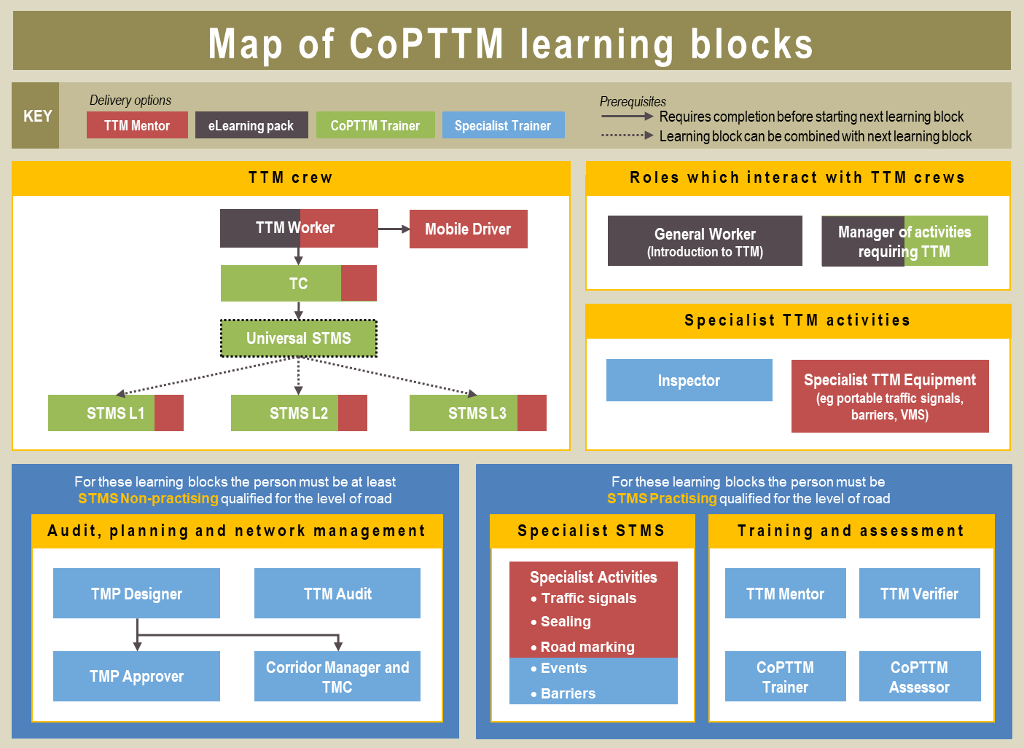
Learning block | Main delivery option | Formal learning time | TTM Mentor coaching at work | TTM Verifier | Assessment by CoPTTM Assessor | Unit Standard | Warrant (NP, P, P<65, P>65)
TTM Crew
TTM Worker | eLearning pack and/or TTM Mentor | 2 hrs | Yes | Yes |  | Yes
Mobile Driver | TTM Mentor | 4 hrs | Yes | Yes |  | Yes
TC | CoPTTM L1 Trainer | 1 day | Yes | Yes | Yes | Yes | NP, P
Universal STMS | CoPTTM L1Trainer | 2 days |  |  |  | Yes
STMS L1 | CoPTTM L1Trainer | 1 day | Yes | Yes | Yes | Yes | NP, P<65, P>65
STMS L2 | CoPTTM L2/3 Trainer | 1 day | Yes | Yes | Yes | Yes | NP, P<65, P>65
STMS L3 | CoPTTM L2/3 Trainer | 1 day | Yes | Yes | Yes | Yes | NP, P
Roles which interact with TTM crews
General Worker | eLearning pack and/or TTM Mentor | 30 mins | Yes | Yes |  | Yes
Manager of activities requiring TTM | CoPTTM Trainer | 2 hours
Specialist TTM activities
Inspector | Specialist Trainer | 1 day |  |  | Yes | Yes | NP, P
Specialist TTM Equipment | TTM Mentor | Various timings | Yes | Yes
Audit, Planning and Network management
TMP Designer | Specialist Trainer | 2 to 3 days | Buddy |  | Yes | Yes | NP, P
TMP Approver | Specialist Trainer | 1 day | Buddy |  | Yes | Yes | NP, P
TTM Audit | Specialist Trainer | 1 day | Buddy |  | Yes | Yes | NP, P
Corridor Manager and TMC | Specialist Trainer | 1 day | Buddy |  | Yes | Yes | NP, P
Specialist STMS
Specialist activities | Specialist Trainer | Various timings |  |  | Yes | Yes
Training and assessment
TTM Mentor | Specialist Trainer | 1 day | Yes |  | Yes | Yes | NP, P (for level of road)
TTM Verifier | Specialist Trainer | 1 day |  | Yes | Yes | Yes | NP, P (for level of road)
CoPTTM Trainer | Specialist Trainer | 3 days |  |  | Yes | Yes | NP, P (for level of road)
CoPTTM Assessor | Specialist Trainer | 1 day |  |  | Yes | Yes | NP, P (for level of road)

