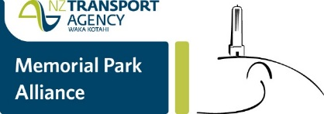
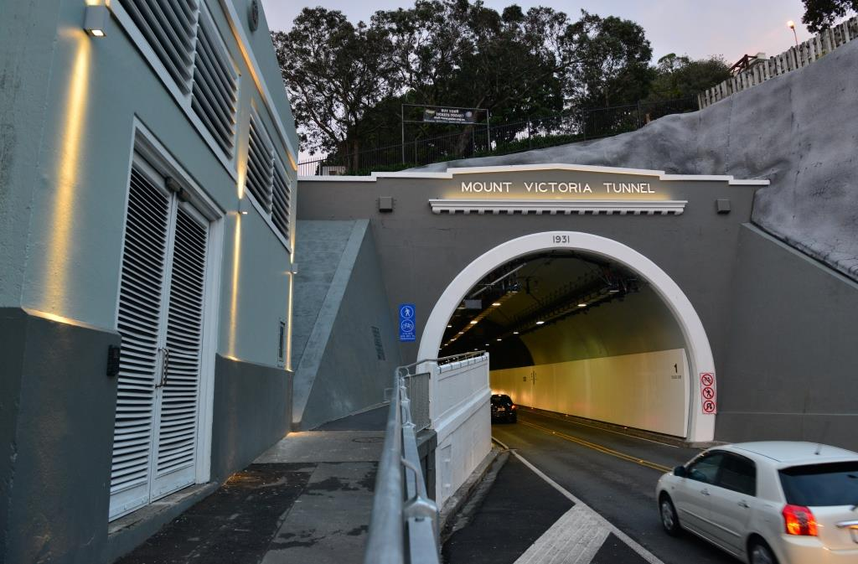
6 July 2016
Temporary break in tunnel radio rebroadcast

A fault in a small component of Mt Victoria Tunnel's radio rebroadcast system has temporarily cut reception.

A replacement part is on its way and, in the not too distant future, you will once more be able to listen to your favourite FM channel on your journey through the tunnel.

Thank you for your patience.

info@memorialpark.co.nz nzta.govt.nz/mvt-upgrade2

