Reshaping Streets – Part 2

Tell us what you think of the changes we want to make to help councils:

- close roads for events

- install pedestrian malls

- install transport shelters

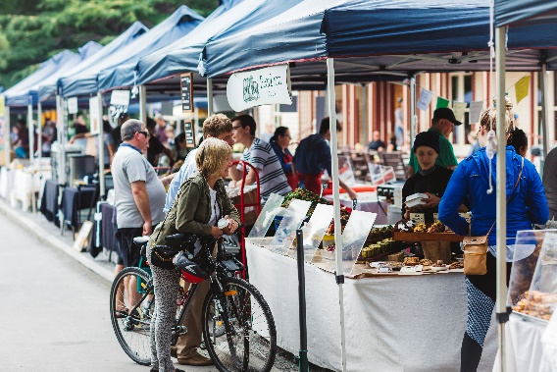
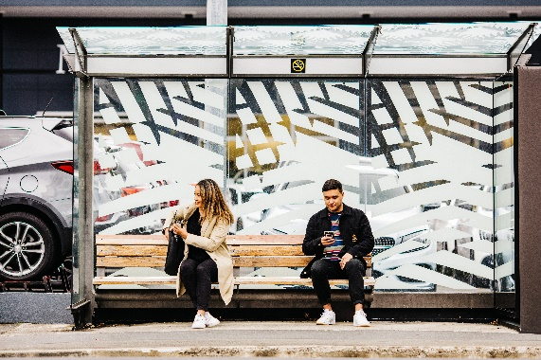

What is in this booklet?

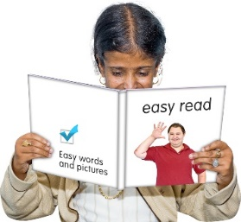
Page:

Before you start……………………. 4

What are we doing?......................... 8

What are the changes we
want to make?............................... 14

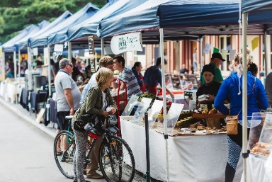
- Closing roads for events…………………………….15

Page:

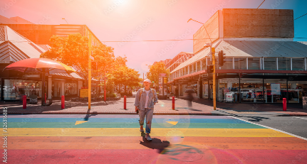
- Pedestrian malls……………...18

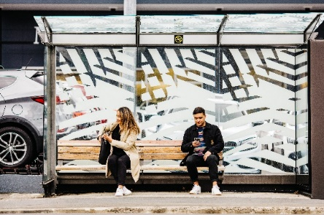
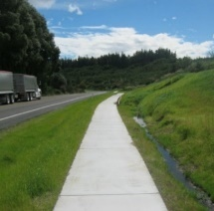

- Transport shelters…………….21

Where to find out more
information about
Reshaping Streets………………25

Before you start

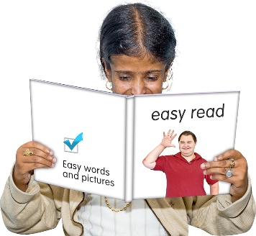
This is an Easy Read booklet about some changes that may be made to help councils make street changes.

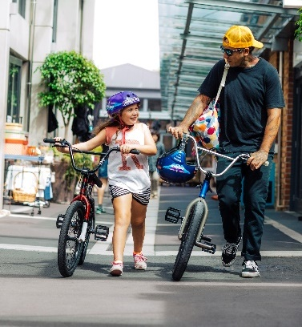
Street changes mean
changes to your street like new pedestrian crossings or bus lanes.

It is an easy read translation of some parts of a longer document called Reshaping Streets.

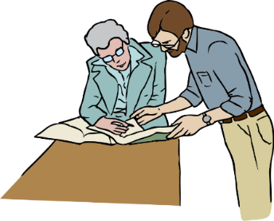
The reshaping streets document has been written by both:

- Te Manatū Waka - The Ministry of Transport

- Waka Kotahi NZ Transport Agency

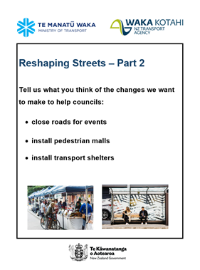
This booklet is called Reshaping Streets: Part 2.

It looks at how councils:

- close roads

- install pedestrian malls

- install transport shelters

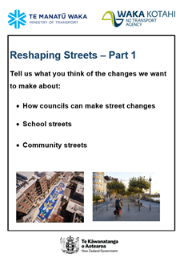
There is also another booklet called Reshaping Streets: Part 1 which looks at:

- How councils can make street changes

- School Streets

- Community Streets

You can find these booklets on the Waka Kotahi New Zealand Transport Agency website:
https://www.nzta.govt.nz/about-us/consultations/reshaping-streets-consultation/accessible-documents/easy-read-documents/

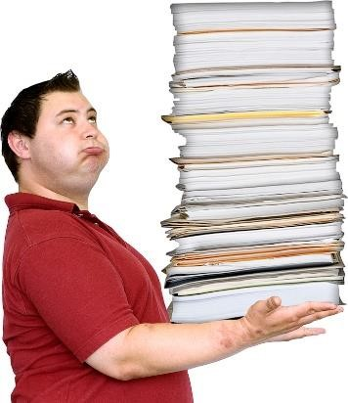

This booklet is a long document.

Some things you can do to make it easier are:

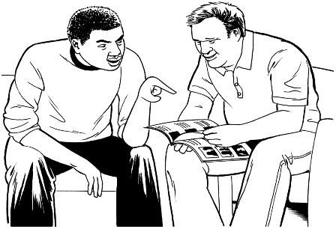
            - read it a few pages at a time

            - ask someone to assist you to understand it

            - ask someone to assist you with filling in the question boxes in the document.

What are we doing?

We want to make some changes to New Zealand Road rules.

We means:

- Te Manatū Waka - The Ministry of Transport

- Waka Kotahi New Zealand Transport Agency

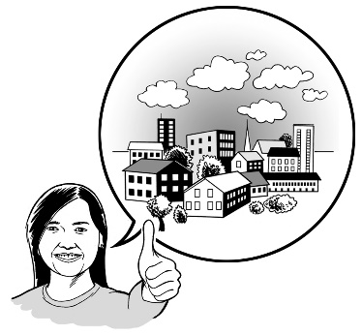
We want to make changes to some of the road rules so it is easier for councils to make street changes.

These changes are part of a group of changes called Reshaping Streets.

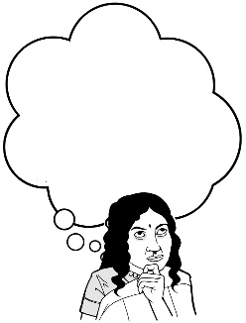
We want you to hear what you think about these changes.

In this booklet we have some questions to assist you to tell us what you think.

You do not have to answer every question.

How to tell us what you think of the changes we want to make to the road rules

You can fill in the question boxes in this booklet then post it to us to read.

You can also tell us what you think by:

- writing us a letter

- sending us an email
- sending us a video message.

You need to make sure you tell us what you think before midnight on Monday 19 September 2022.

You can post in your booklet with answers or letter for free to:

Reshaping Streets 2022
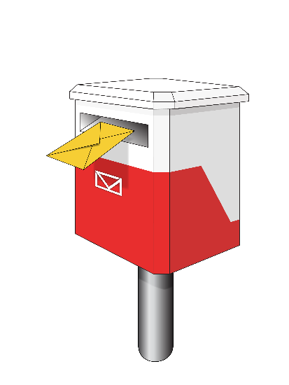
Transport Policy Team

Free Post 65090
Waka Kotahi NZ Transport Agency
Private Bag 6995
Wellington 6141

This is a free post address which means it does not cost you any money to send your letter.

You can send us an email to:

reshaping.streets@nzta.govt.nz

You can send us a video to:

reshaping.streets@nzta.govt.nz

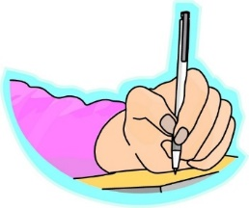
When you tell us what you think please make sure you tell us:

- your name
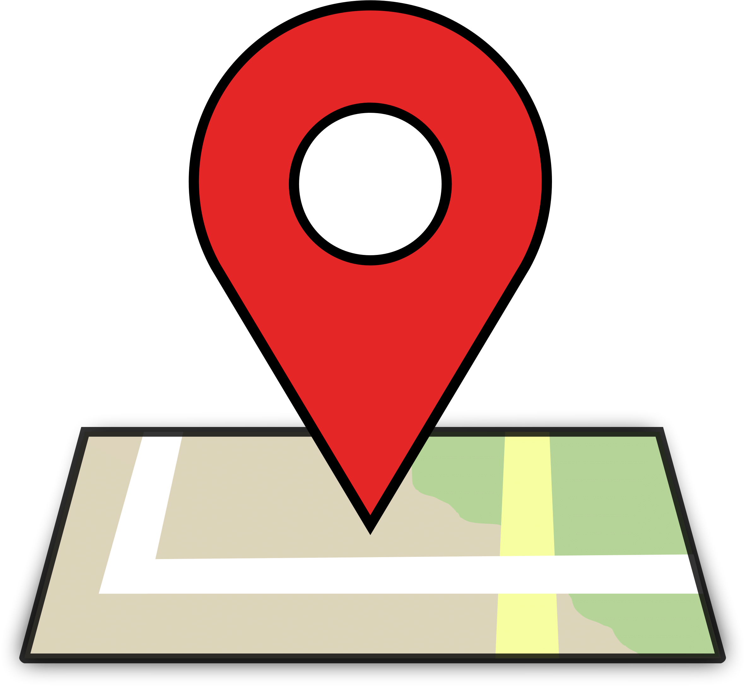
- the name of this booklet - Reshaping Streets

- your address

- your email address if you have one.

What we will do with the ideas you send in
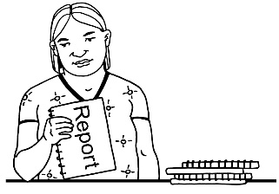
We will write a short report of all the ideas that people send to us.

We will share the short report with everyone.

In that report we might use:
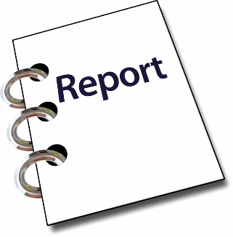
- your name

- information about your ideas.

Please tell us if you do not want your name or your information to be in our short report.

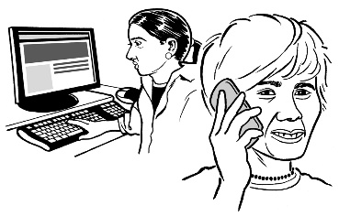
We may call or email you to talk about this.

What are the changes we want to make?

This booklet looks at 3 of the important things we want to change:

          - closing roads for events
          - pedestrian malls

          - transport shelters

1. Closing roads for events

Events mean things like:

- Street markets

- Street festivals

- Fairs

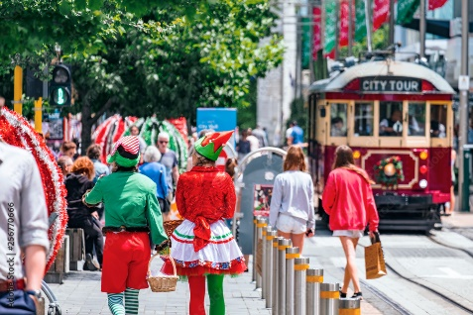

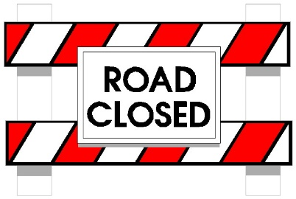
Closing the road for an event means not letting cars or trucks use the street when the event happens.

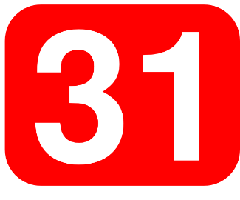

Councils can only close roads for an event 31 days a year.

This can stop councils from:
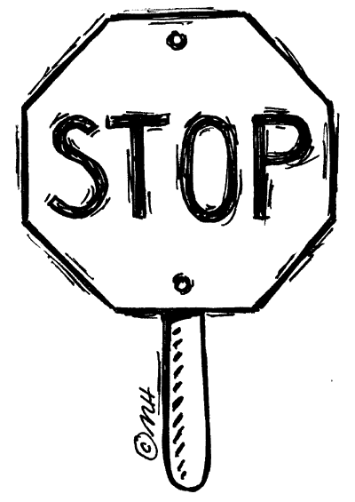
- holding street markets

- closing the road once a week for special events.

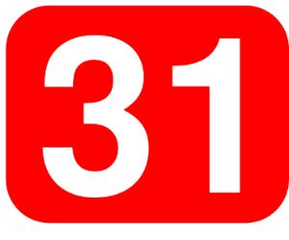
We want to remove the 31 days from road rules.

This means councils will be able to:

- close roads for events more easily.

- hold events once per week or more if they want to.

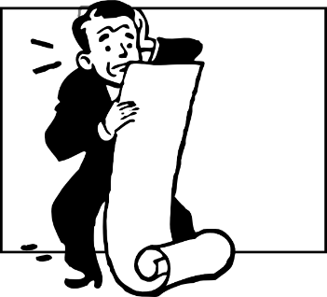
There are different rules that say different things about how councils can close roads to hold an event.

We want rules about closing roads for events to be in one rule.

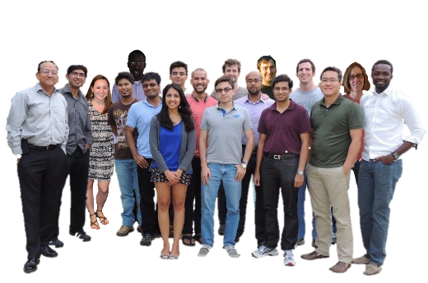

This means the rules for closing roads will be the same for everyone.

Questions
Do you think it is a good idea to:
- Remove the 31 days from rules?
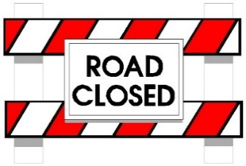
- Put rules about closing roads for events into one rule?
Please put your answer here.

2. Pedestrian malls

Pedestrian means people who are:
- Walking
- Using a wheelchair

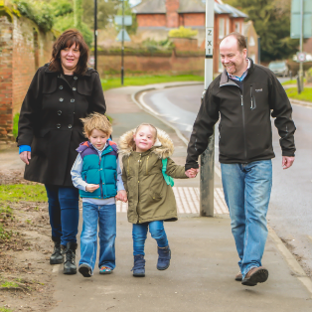

Pedestrian mall means a place that only pedestrians can go.

Cuba Street in Wellington is a pedestrian mall.

City Mall in Christchurch is a pedestrian mall.

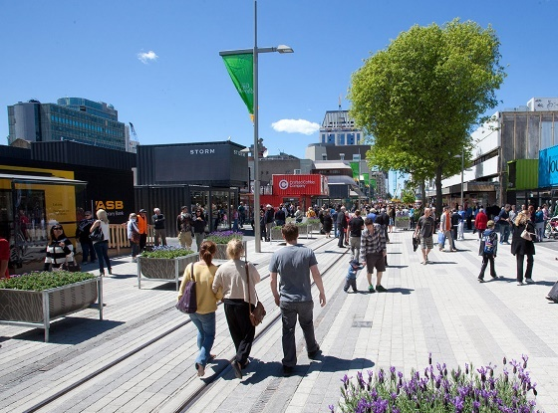

Consult means to talk to you to get your views.

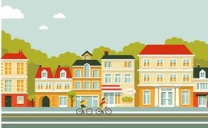
Councils can create pedestrian malls in their towns and cities.

Before creating a pedestrian mall councils need to consult with you.

But rules about how to consult about pedestrian malls are:

- Nearly 50 years old.

- Different from consultation rules about other pedestrian related changes.

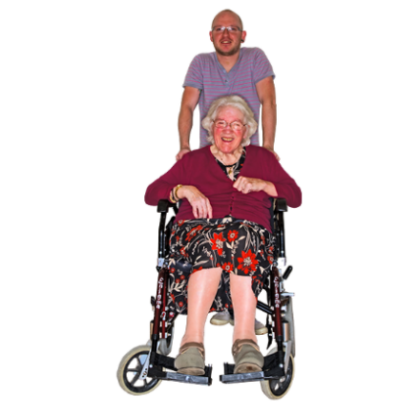
We want to update these rules so:

- Councils can consult with you about pedestrian malls like they do for other streets changes for pedestrians.

Question
Do you think it’s a good idea to let councils consult on pedestrian malls like they do for other pedestrian changes?

Please put your answer here.

3. Transport shelters

Transport shelters are places where people can wait for buses or cars.

Transport shelters help people stay out of the rain.

A bus shelter is a type of transport shelter.

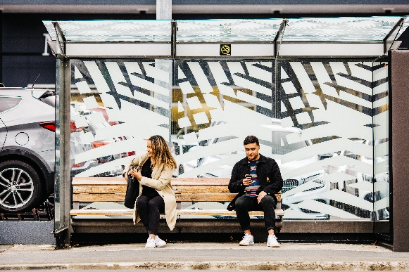

A bus stop is a place where people can wait for the bus.

Not all bus stops have bus shelters.

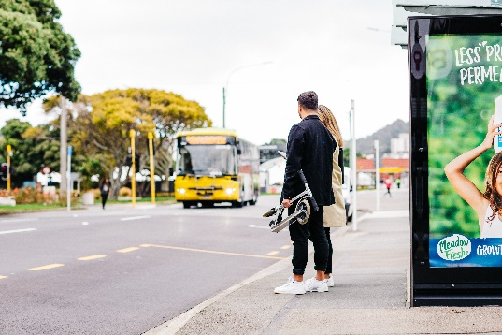

Consult means to talk to you to get your views.

Complaint means saying you do not like something.

Councils consult with people about transport shelters in a way that is different from other Road rules.

For example:
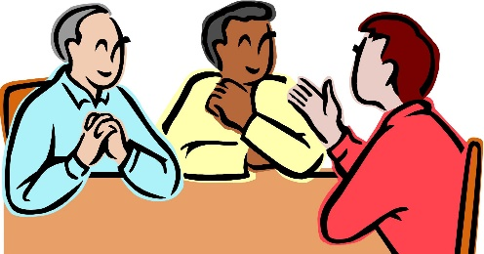
To build a bus stop a council needs to:

- consult with you.

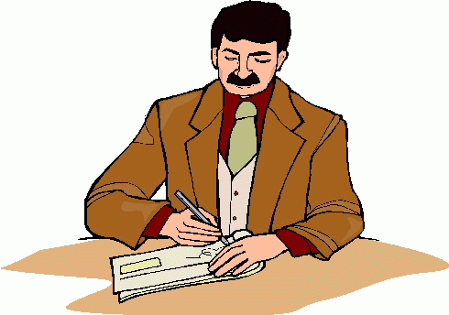
To build a transport shelter a council needs to:

- Write to people who live near the transport shelter.

- Ask them if they want to make a complaint.

- Hear complaints that people want to make.

- make a decision after hearing all complaints.

This means councils need to consult 2 times to build a bus stop with a bus shelter.

We want councils to consult with people about transport shelters like they do for bus stops.

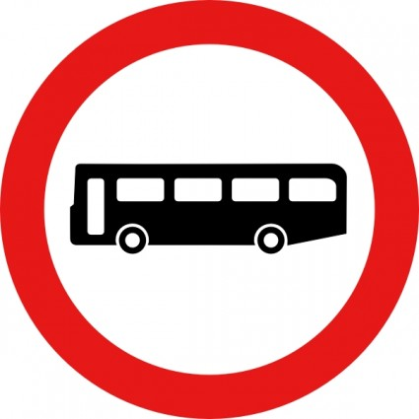
Question:
Do you think it’s a good idea to let councils consult on transport shelters like they do for bus stops?

Please put your answer here.

Where to find out more about Reshaping Streets

You can find more information about Reshaping Streets:

Website:
https://www.nzta.govt.nz/about-us/consultations/reshaping-streets-consultation
Email us at:

reshaping.streets@nzta.govt.nz

Phone us on:

0800 699 000

This is a free call phone number so does not cost you any money to call.

