Reshaping Streets – Part 1

Tell us what you think of the changes we want to make about:

- How councils can make street changes

- School streets
- Community streets

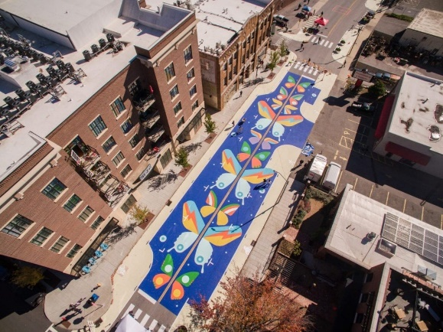
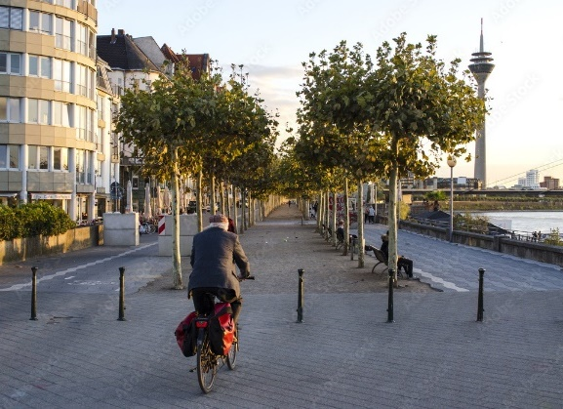

What is in this booklet?

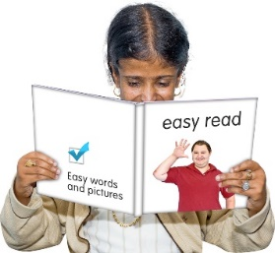
Page:

Before you start……………………. 4

What are we doing?........................ 8

What are the changes we
want to make?...............................14

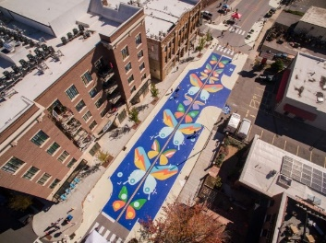
- Street pilots and consultation….15

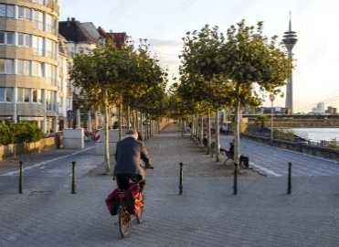
- Restricting traffic………………...20

Page:
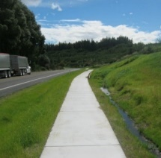

- School Streets……………...….24

- Community Streets……………….………….27

Where to find out more
information about
Reshaping Streets…………………32

Before you start

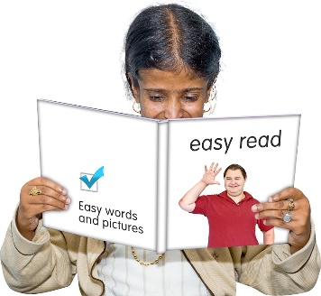

This is an Easy Read booklet about some changes that may be made to help councils make street changes.

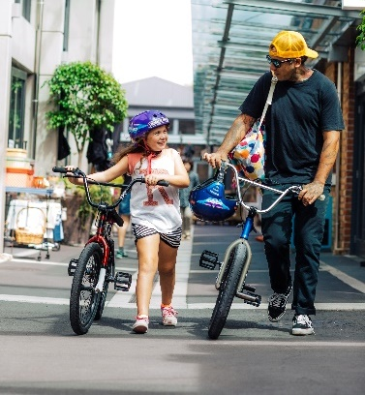
Street changes mean
changes to your street like a new pedestrian crossing or bus lane.

It is an easy read translation of some parts of a longer document called Reshaping Streets.

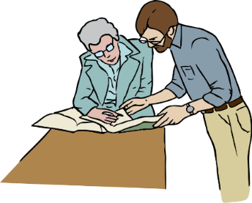
The reshaping streets document has been written by both:
- Te Manatū Waka - The Ministry of Transport
- Waka Kotahi NZ Transport Agency

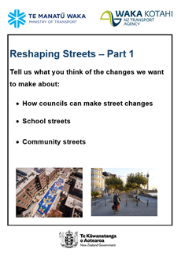
This booklet is called Reshaping Streets: Part 1.

It looks at:

- How councils can make street changes

- School Streets

- Community Streets

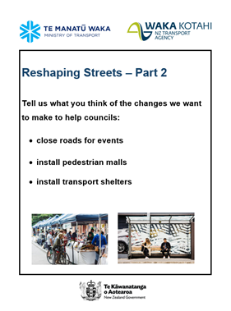
There is also another booklet called Reshaping Streets: Part 2
It looks at how councils:

- Close roads

- Install pedestrian malls

- Install transport shelters

You can find these booklets on the Waka Kotahi New Zealand Transport Agency website:
https://www.nzta.govt.nz/about-us/consultations/reshaping-streets-consultation/accessible-documents/easy-read-documents/

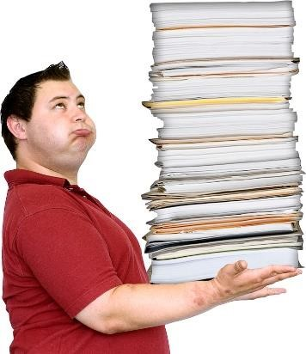
This booklet is a long document.

Some things you can do to make it easier are:

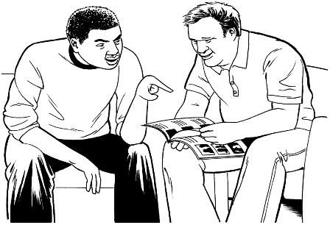
            - read it a few pages at a time

            - ask someone to assist you to understand it

            - ask someone to assist you with filling in the question boxes in the document.

What are we doing?

We want to make some changes to New Zealand Road rules.

We means:

- Te Manatū Waka - The Ministry of Transport

- Waka Kotahi New Zealand Transport Agency

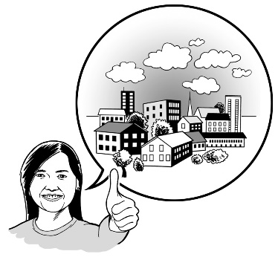
We want to make changes to some of the road rules so that it is easier for councils to make street changes.

These changes are part of a group of changes called Reshaping Streets.

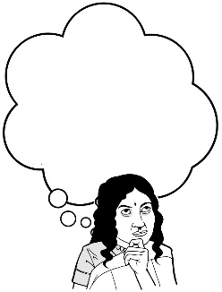
We want you to hear what you think about these changes.

In this booklet we have some questions to assist you to tell us what you think.

You do not have to answer every question.

How to tell us what you think of the changes we want to make to the road rules

You can fill in the question boxes in this booklet then post it to us to read.

You can also tell us what you think by:
- writing us a letter

- sending us an email

- sending us a video message.

You need to make sure you tell us what you think before midnight on Monday 19 September 2022.

You can post in your booklet with answers or letter for free to:

Reshaping Streets 2022
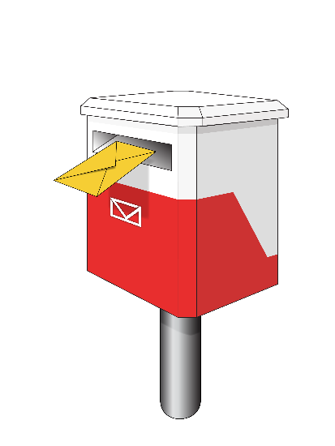
Transport Policy Team

Free Post 65090
Waka Kotahi NZ Transport Agency
Private Bag 6995
Wellington 6141

This is a free post address which means it does not cost you any money to send your letter.

You can send us an email to:

reshaping.streets@nzta.govt.nz

You can send us a video to:

reshaping.streets@nzta.govt.nz

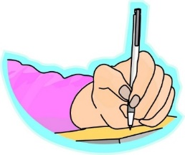
When you tell us what you think please make sure you tell us:

- your name
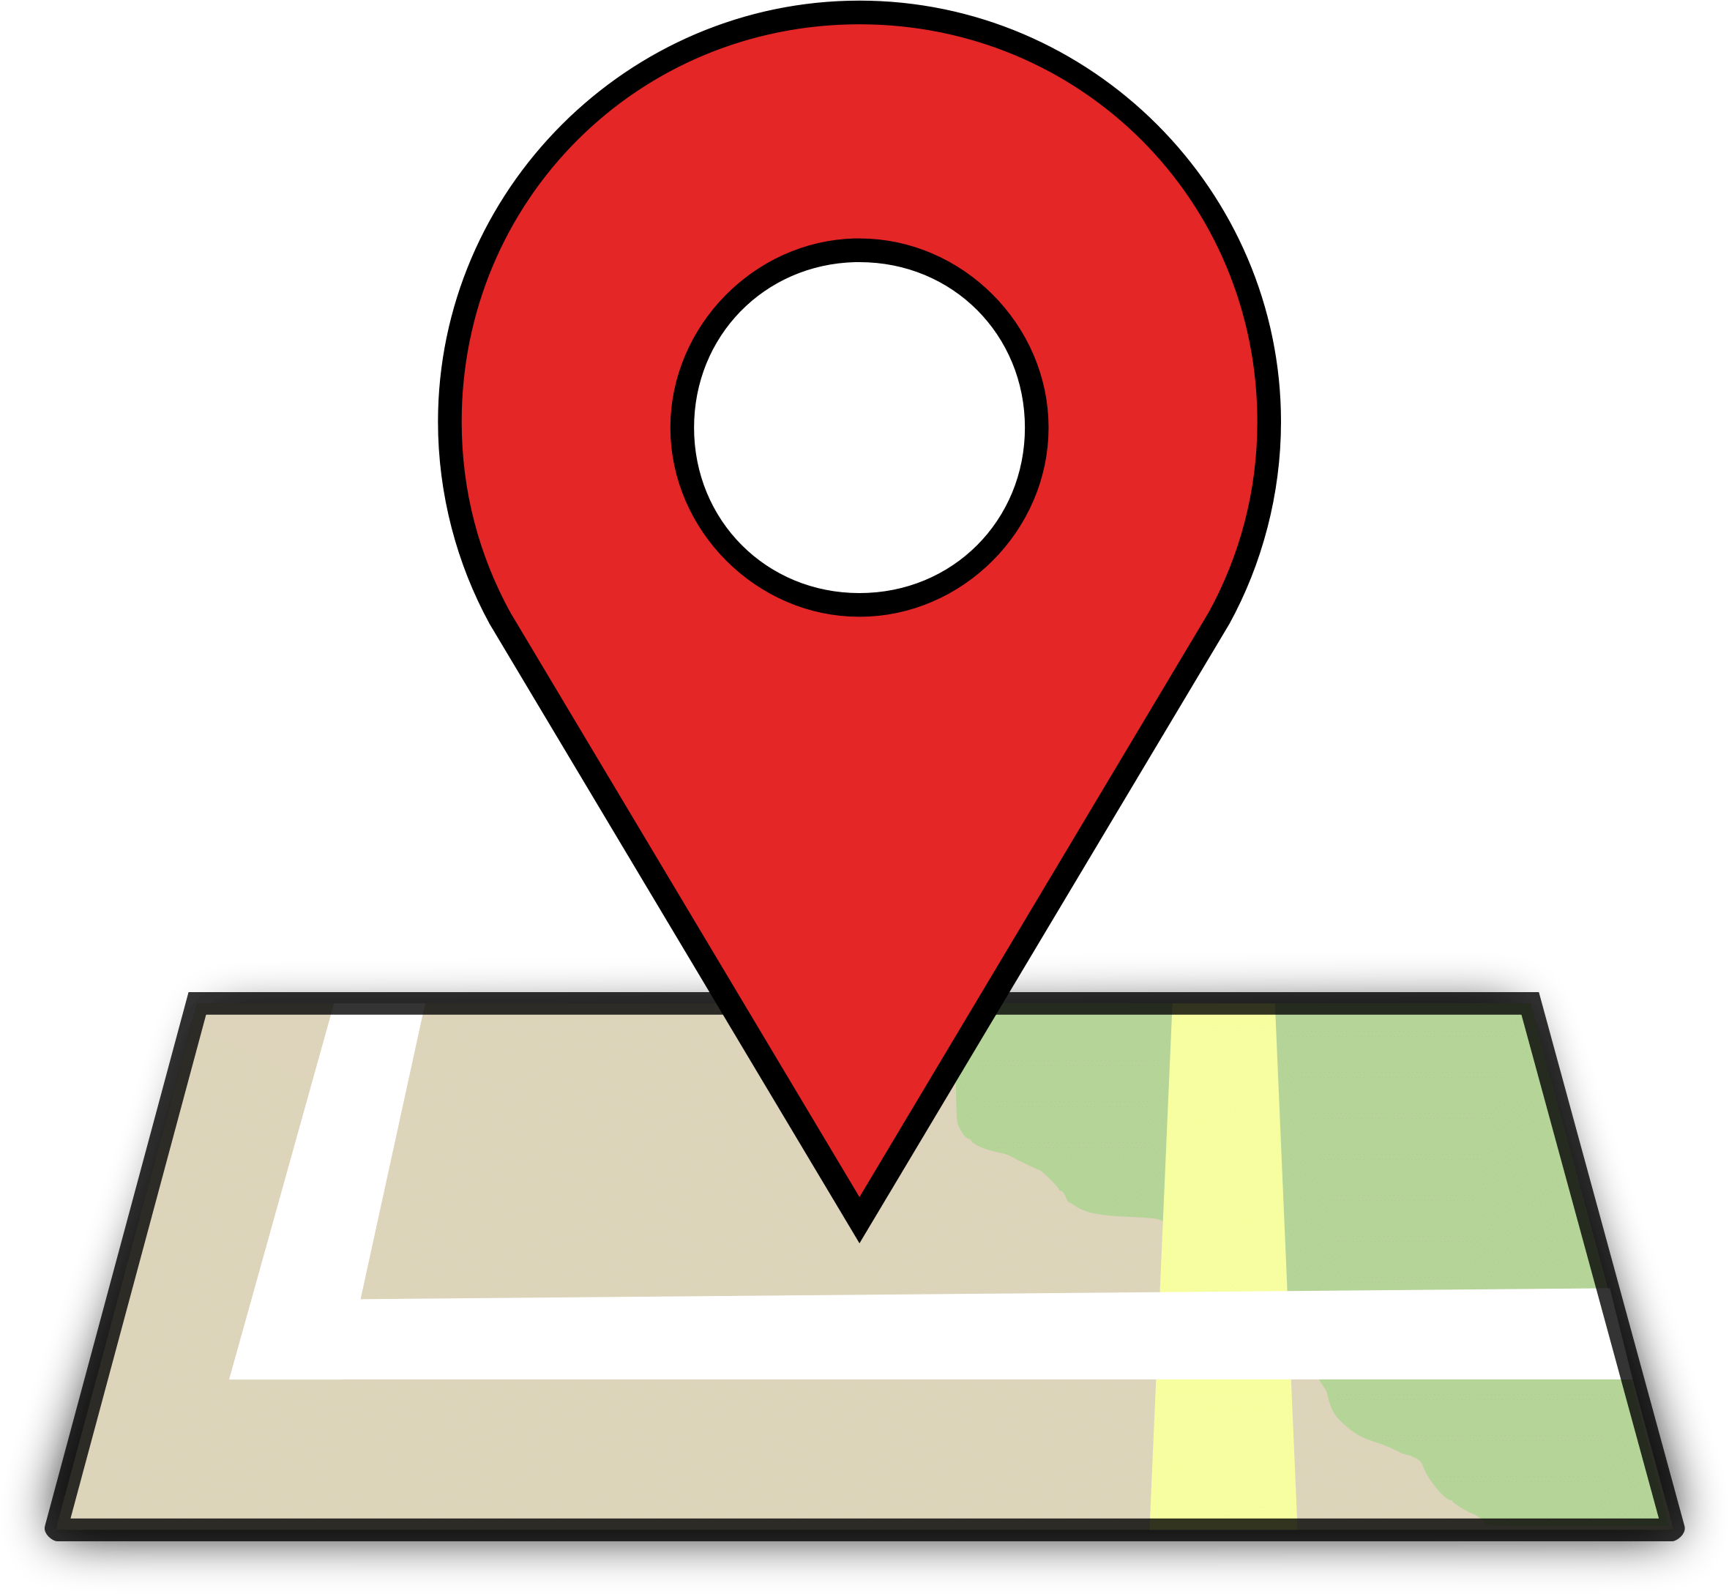
- the name of this booklet - Reshaping Streets

- your address

- your email address if you have one.

What we will do with the ideas you send in
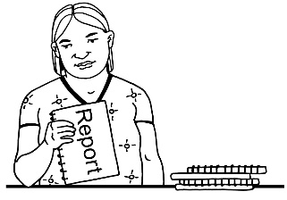
We will write a short report of all the ideas that people send to us.

We will share the short report with everyone.

In that report we might use:
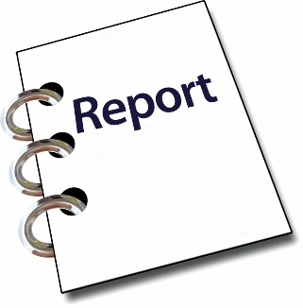
- your name

- information about your ideas.

Please tell us if you do not want your name or your information to be in our short report.

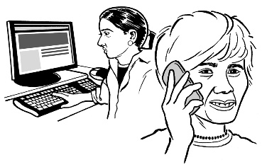
We may call or email you to talk about this.

What are the changes we want to make?

This booklet looks at 4 of the important things we want to change:
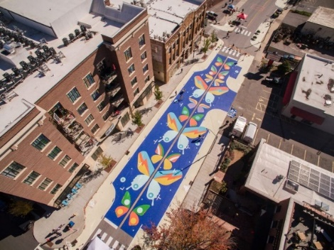

- Street pilots and consultation

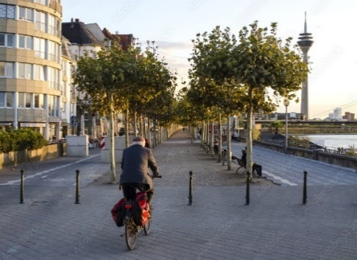

- Restricting traffic

- School streets

- Community streets

1. Street pilots and consultation

Consultation or consult means to talk to you to get your views.

A street pilot means a short-term street change that is used to get your views about a change.

For example:
If a council wanted to make a footpath bigger they could:

- Put road cones on the road to widen the footpath.

- Ask you what you think about this.

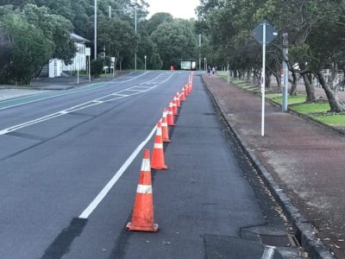

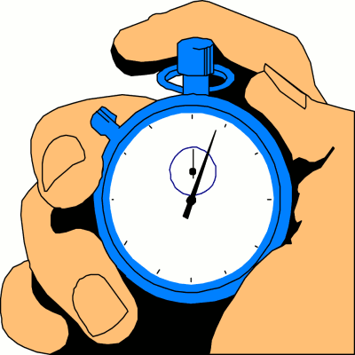
Short-term means something that does not last very long.

Councils can use street pilots now but:

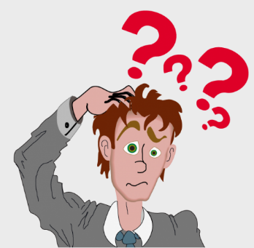
- the rules for making them are confusing

- it is hard to make street pilots permanent if people like them

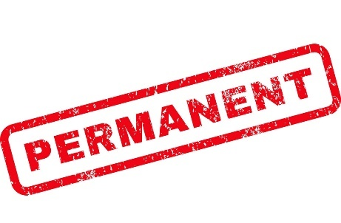
permanent means something that stays for a very long time.

- councils have to talk to you about street pilots many times.

We want to make changes so that there are better rules for councils to make street pilots.

These rules would mean that councils will need to:
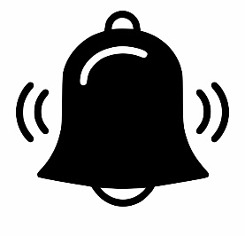
- tell you about a street pilot before it happens
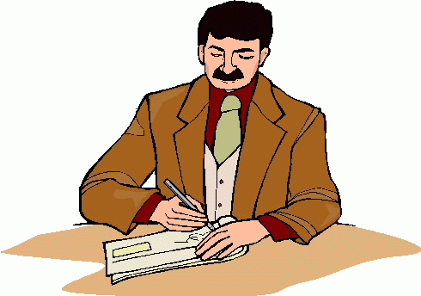

- give you a good way to share your views about the street pilot

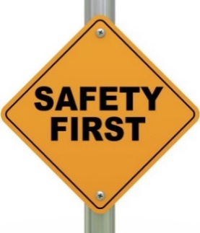
- check the street pilot to make sure it is safe

- change the street pilot if it is unsafe

- change the street pilot if people do not like it.

If people like the street pilot and it is safe the council can make the street pilot permanent.

If people do not like the street pilot and it is not safe the council can remove the street pilot.

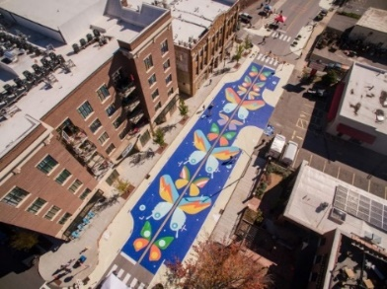
Question:
Do you think it is a good idea to make new rules for street pilots?

Please put your answer here.

2. Restricting traffic

Modal filters are objects that are put on the road to change how the road is used.

For example:

Plants and gardens can be put on the road to make the road thinner.

This helps cars slow down on some streets.

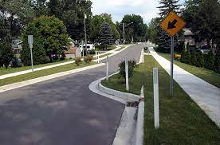

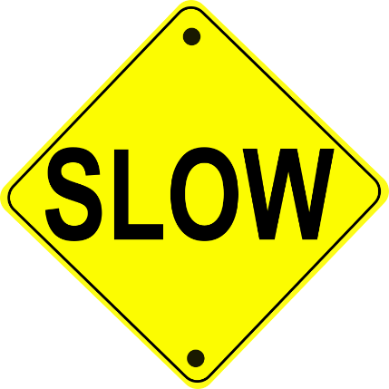

Road rules do not let councils install modal filters.

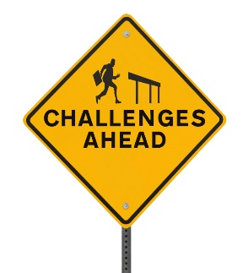
It is also hard for councils to change the way a road is used.

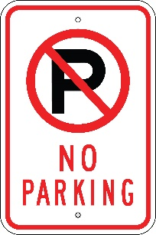
It is hard for councils to:
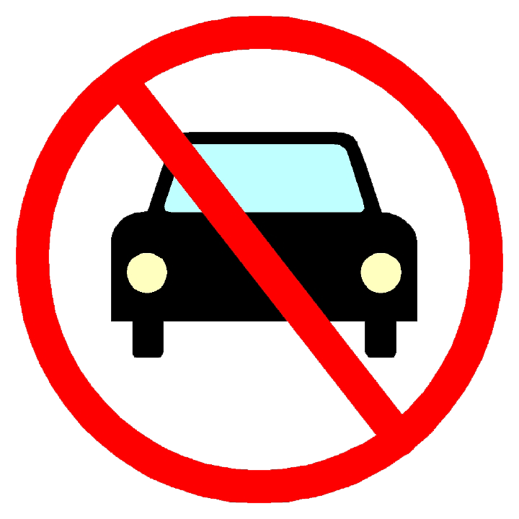
- remove car parks

- stop cars and trucks from using parts of a road.

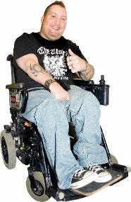
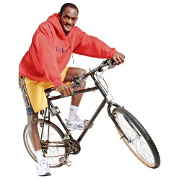
This means it is hard to make more space for people who are:

- Walking

- Riding a bike
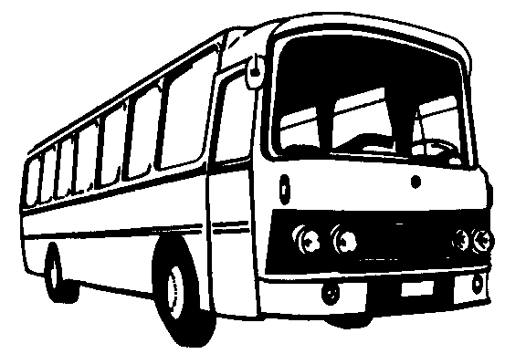

- Taking the bus.

We want to help councils change how the road is used.

Changes to road rules would mean councils can:

- Use modal filters

- Stop cars and trucks from using parts of the road

- Remove car parks.

Councils would need to talk to you about these changes and get your view first.

Question
Do you think it is a good idea to let councils:
- Use modal filters?
- Stop cars and trucks from using parts of the road?
- Remove car parks?
Please put your answer here.

3. School Streets

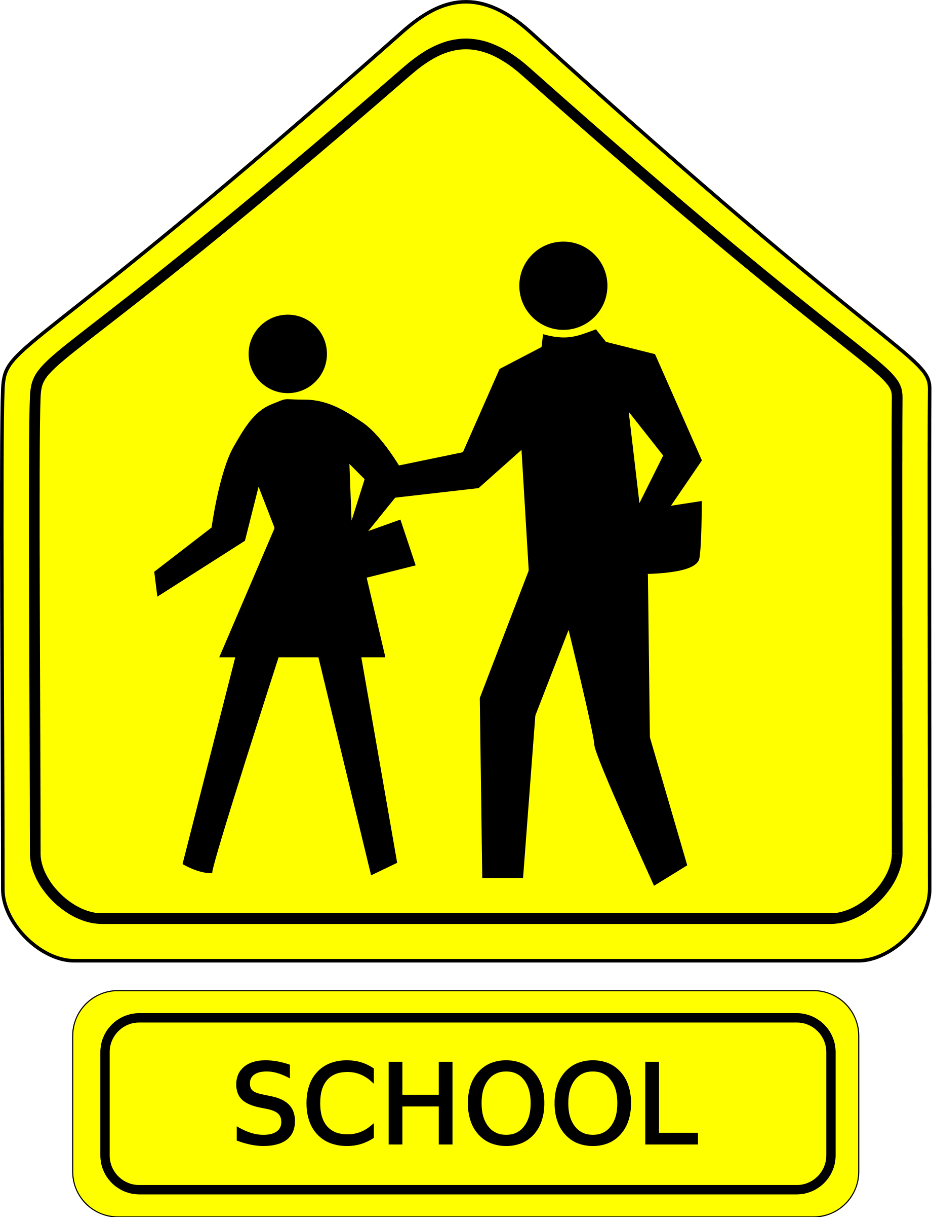
A School Street is a street beside a school that is closed to cars:

- When kids get dropped off at school.

- When kids get picked up from school.

This helps children walk and cycle to school safely.

Cars and trucks can use the School Street when kids:
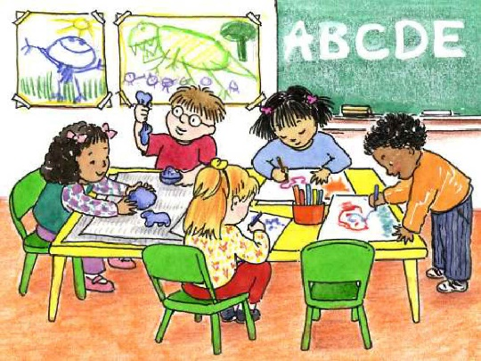
- Are not getting dropped off at school.

- Are not getting picked up from school.

Road rules do not allow for School Streets in New Zealand.

We want to change the rules so that councils can create school streets with support from schools.

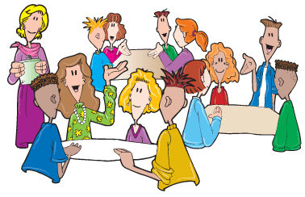

Councils would need to talk to schools and families first.

Councils would need to put up signs to tell people about the school street.

Question:
Do you think it’s a good idea to let councils create school streets with support from schools?

Please put your answer here.

4. Community Streets

Community streets are a type of street event.

The street is closed for 1 to 3 hours to:

- let children play

- let the community to get together.

They are also known as Play Streets.

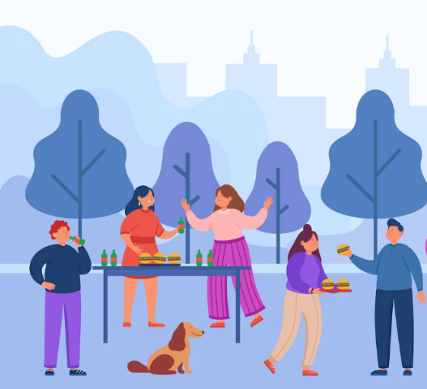

Community Streets are organised by people who live on or around the street.

But road rules only let councils set up community streets.

We want to change the rules so that:
- people can set up Community Streets

- councils can help them to do this.

- there are rules that everyone needs to follow before setting up a community street.

This means that people can ask a council if they can set up a community street.

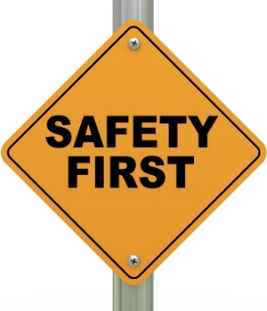

Councils would need to make sure this is safe to do.

If it is safe a council can help people to set up a Community Street.

If it is not safe a council can:

- say no to a Community Street

- or
- set extra rules for the Community Street to keep people safe.

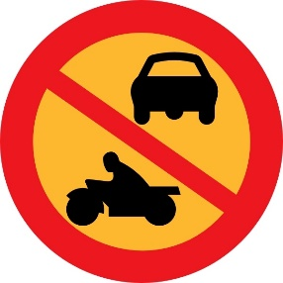
Cars cannot be driven on the road during the Community Street unless:
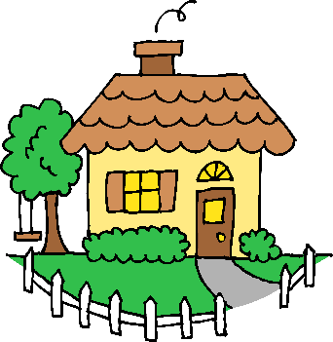

- they need to go to a house on the Community Street.

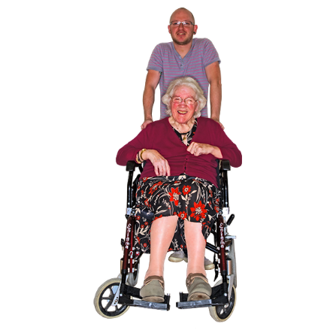

People can still walk or bike or ride a device through the Community Street if they want to.

Everyone would need to give way to people using the Community Street.

To give way means to let someone else go first.

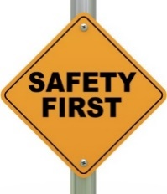
Question
Do you think it’s a good idea to let people organise community streets with help from councils?

Please put your answer here.

Where to find out more about Reshaping Streets

You can find more information about Reshaping Streets:

Website:
https://www.nzta.govt.nz/about-us/consultations/reshaping-streets-consultation
Email us at:

reshaping.streets@nzta.govt.nz

Phone us on:

0800 699 000

This is a free call phone number so does not cost you any money to call.

