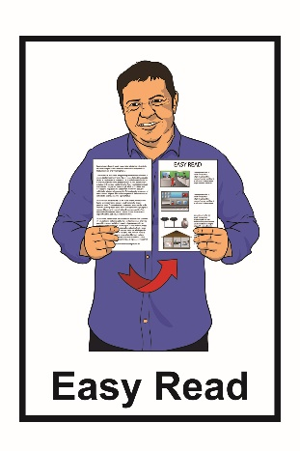

Accessible Streets – Part 2

Tell us what you think of the changes we want to make to the road rules about how we:

- drive on our roads

- give way to others on our roads

- cross on our roads.
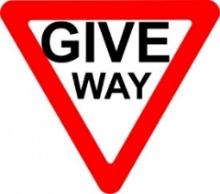
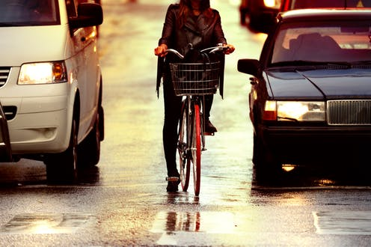

What is in this booklet?

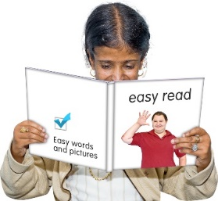
Page:

Before you start……………………..4

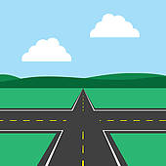

What are we doing?........................8

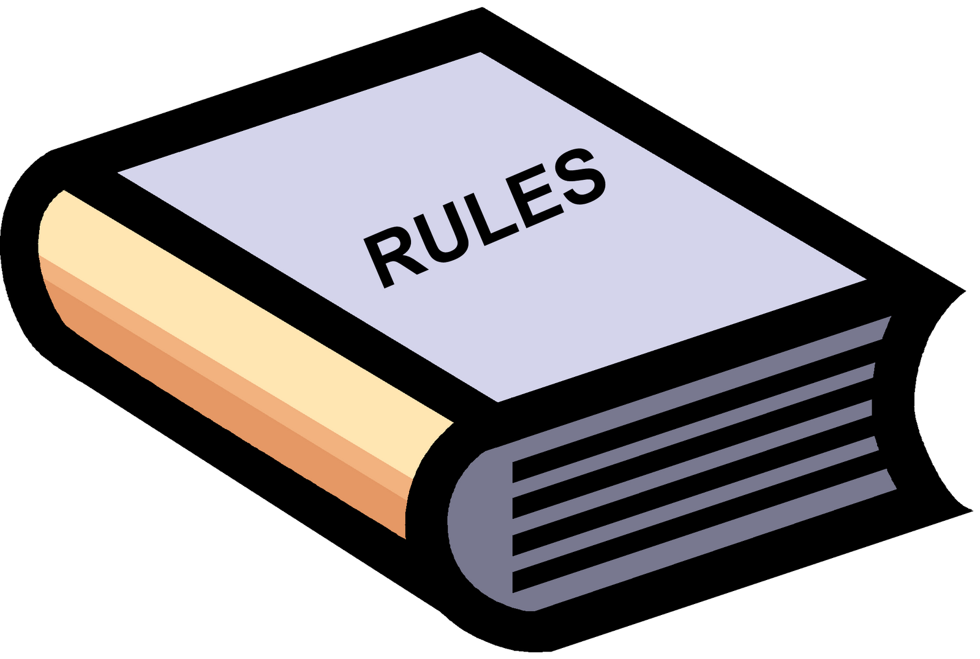
New rules for using the road……..14

What are the changes we
want to make?...............................16

Page:
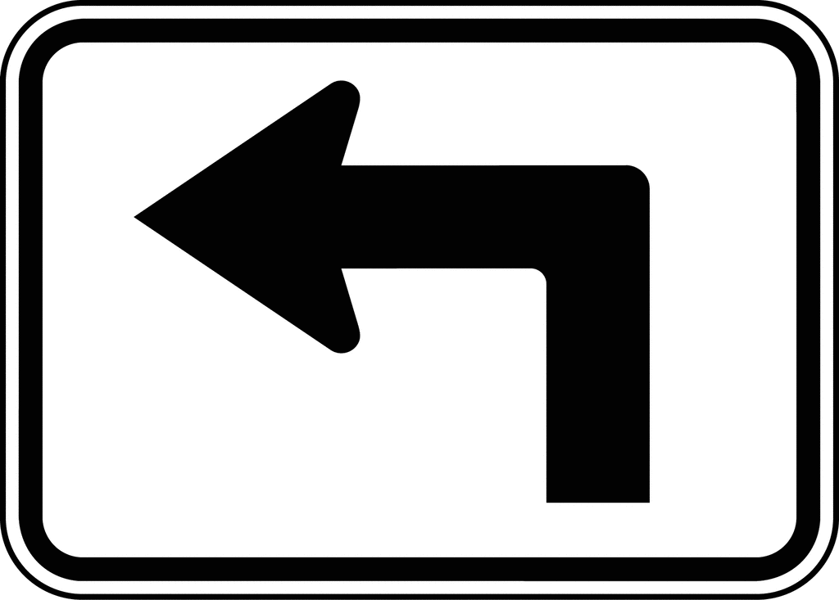
- Bicycles and transport devices on the road in the left turning lane………………….17

- Bicycles and transport devices passing slow motor vehicles
on the road………………………19

- Turning traffic must give way
to people in separated lanes….22

- Traffic must give way to people crossing the road if there are
2 white lines……………..………26

Page:

- Motor vehicles must pass at
a gap of least 1 metre……….…29

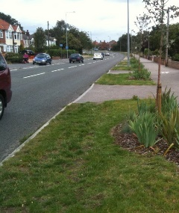

- Parking on berms…………….…32

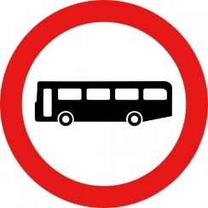
- Give way to buses leaving
bus stops………………………...35

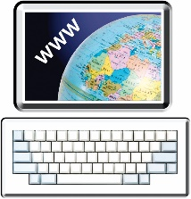
Where to find out more
information about
Accessible Streets…………………38

Before you start

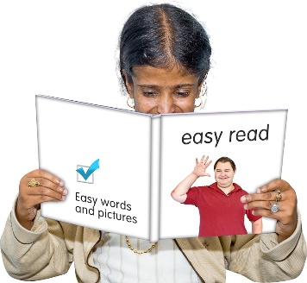
This is an Easy Read booklet about some changes that may be made to make our streets and pathways more:
- accessible

- safe to use.

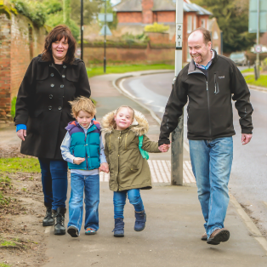
Accessible means making our paths and roads easy for everyone to use.

It is an easy read translation of some parts of a longer document called Accessible Streets.

The Accessible Streets document has been written by both the:
- Ministry of Transport
- Waka Kotahi New Zealand Transport Agency.

This booklet is called Accessible Streets: Part 2.

It looks at how we:

- drive on our roads

- give way to others on our roads

- cross on our roads.

There is also another booklet called Accessible Streets: Part 1 which looks at how we use:

- footpaths

- shared pathways

- bicycle pathways.

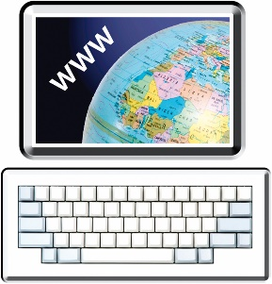
You can find these booklets on the Waka Kotahi New Zealand Transport Agency website:

www.nzta.govt.nz/about-us/ consultations/accessible-streets

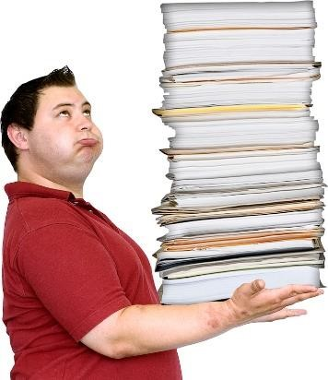
This booklet is a long document.

Some things you can do to make it easier are:
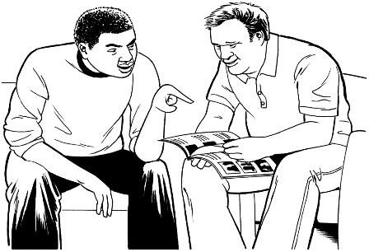
            - read it a few pages at a time

            - ask someone to assist you to understand it
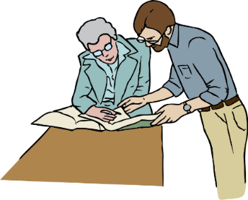
            - ask someone to assist you with filling in the question boxes in the document.

What are we doing?

We want to make some changes to the New Zealand road rules.

We means:

- The Ministry of Transport
- Waka Kotahi New Zealand Transport Agency

Road rules are rules that everyone must follow while using:

- roads

- footpaths

- bicycle pathways.

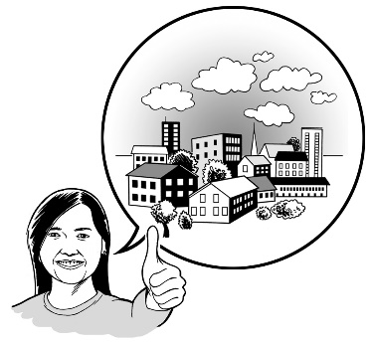
We want to make changes to some of the road rules so that it is easier for everyone to get to where they want to go.

These changes are part of a group of changes called Accessible Streets.

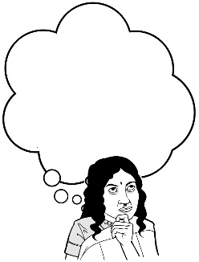
We want you to hear what you think about these changes.

In this booklet we have some questions to assist you to tell us what you think.

You do not have to answer every question.

How to tell us what you think of the changes we want to make to the road rules

You can fill in the question boxes in this booklet then post it to us to read.

You can also tell us what you think by:
- writing us a letter

- sending us an email

- sending us a video message.

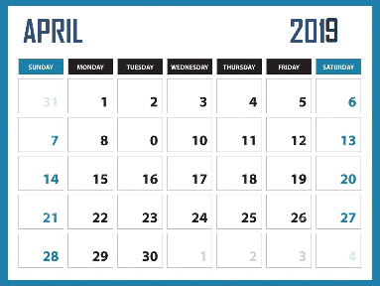
You need to make sure you tell us what you think before 5pm on Wednesday 22 April 2020

You can post in your booklet with answers or letter for free to:

Accessible Streets 2020
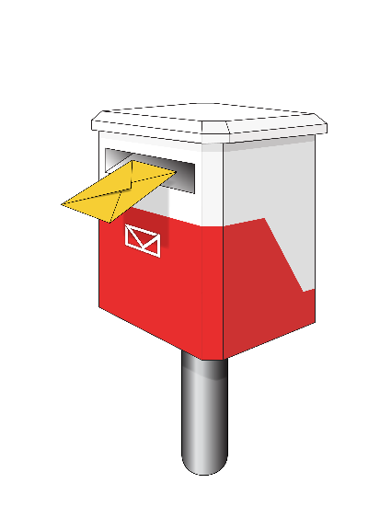
Free Post 65090
Waka Kotahi NZ Transport Agency
Private Bag 6995
Wellington 6141

This is a free post address which means it does not cost you any money to send your letter.

You can send us an email to:

accessible.streets@nzta.govt.nz

You can send us a video to:

accessible.streets@nzta.govt.nz

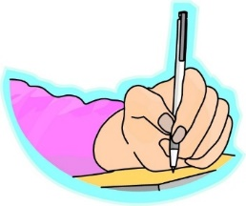
When you tell us what you think please make sure you tell us:

- your name
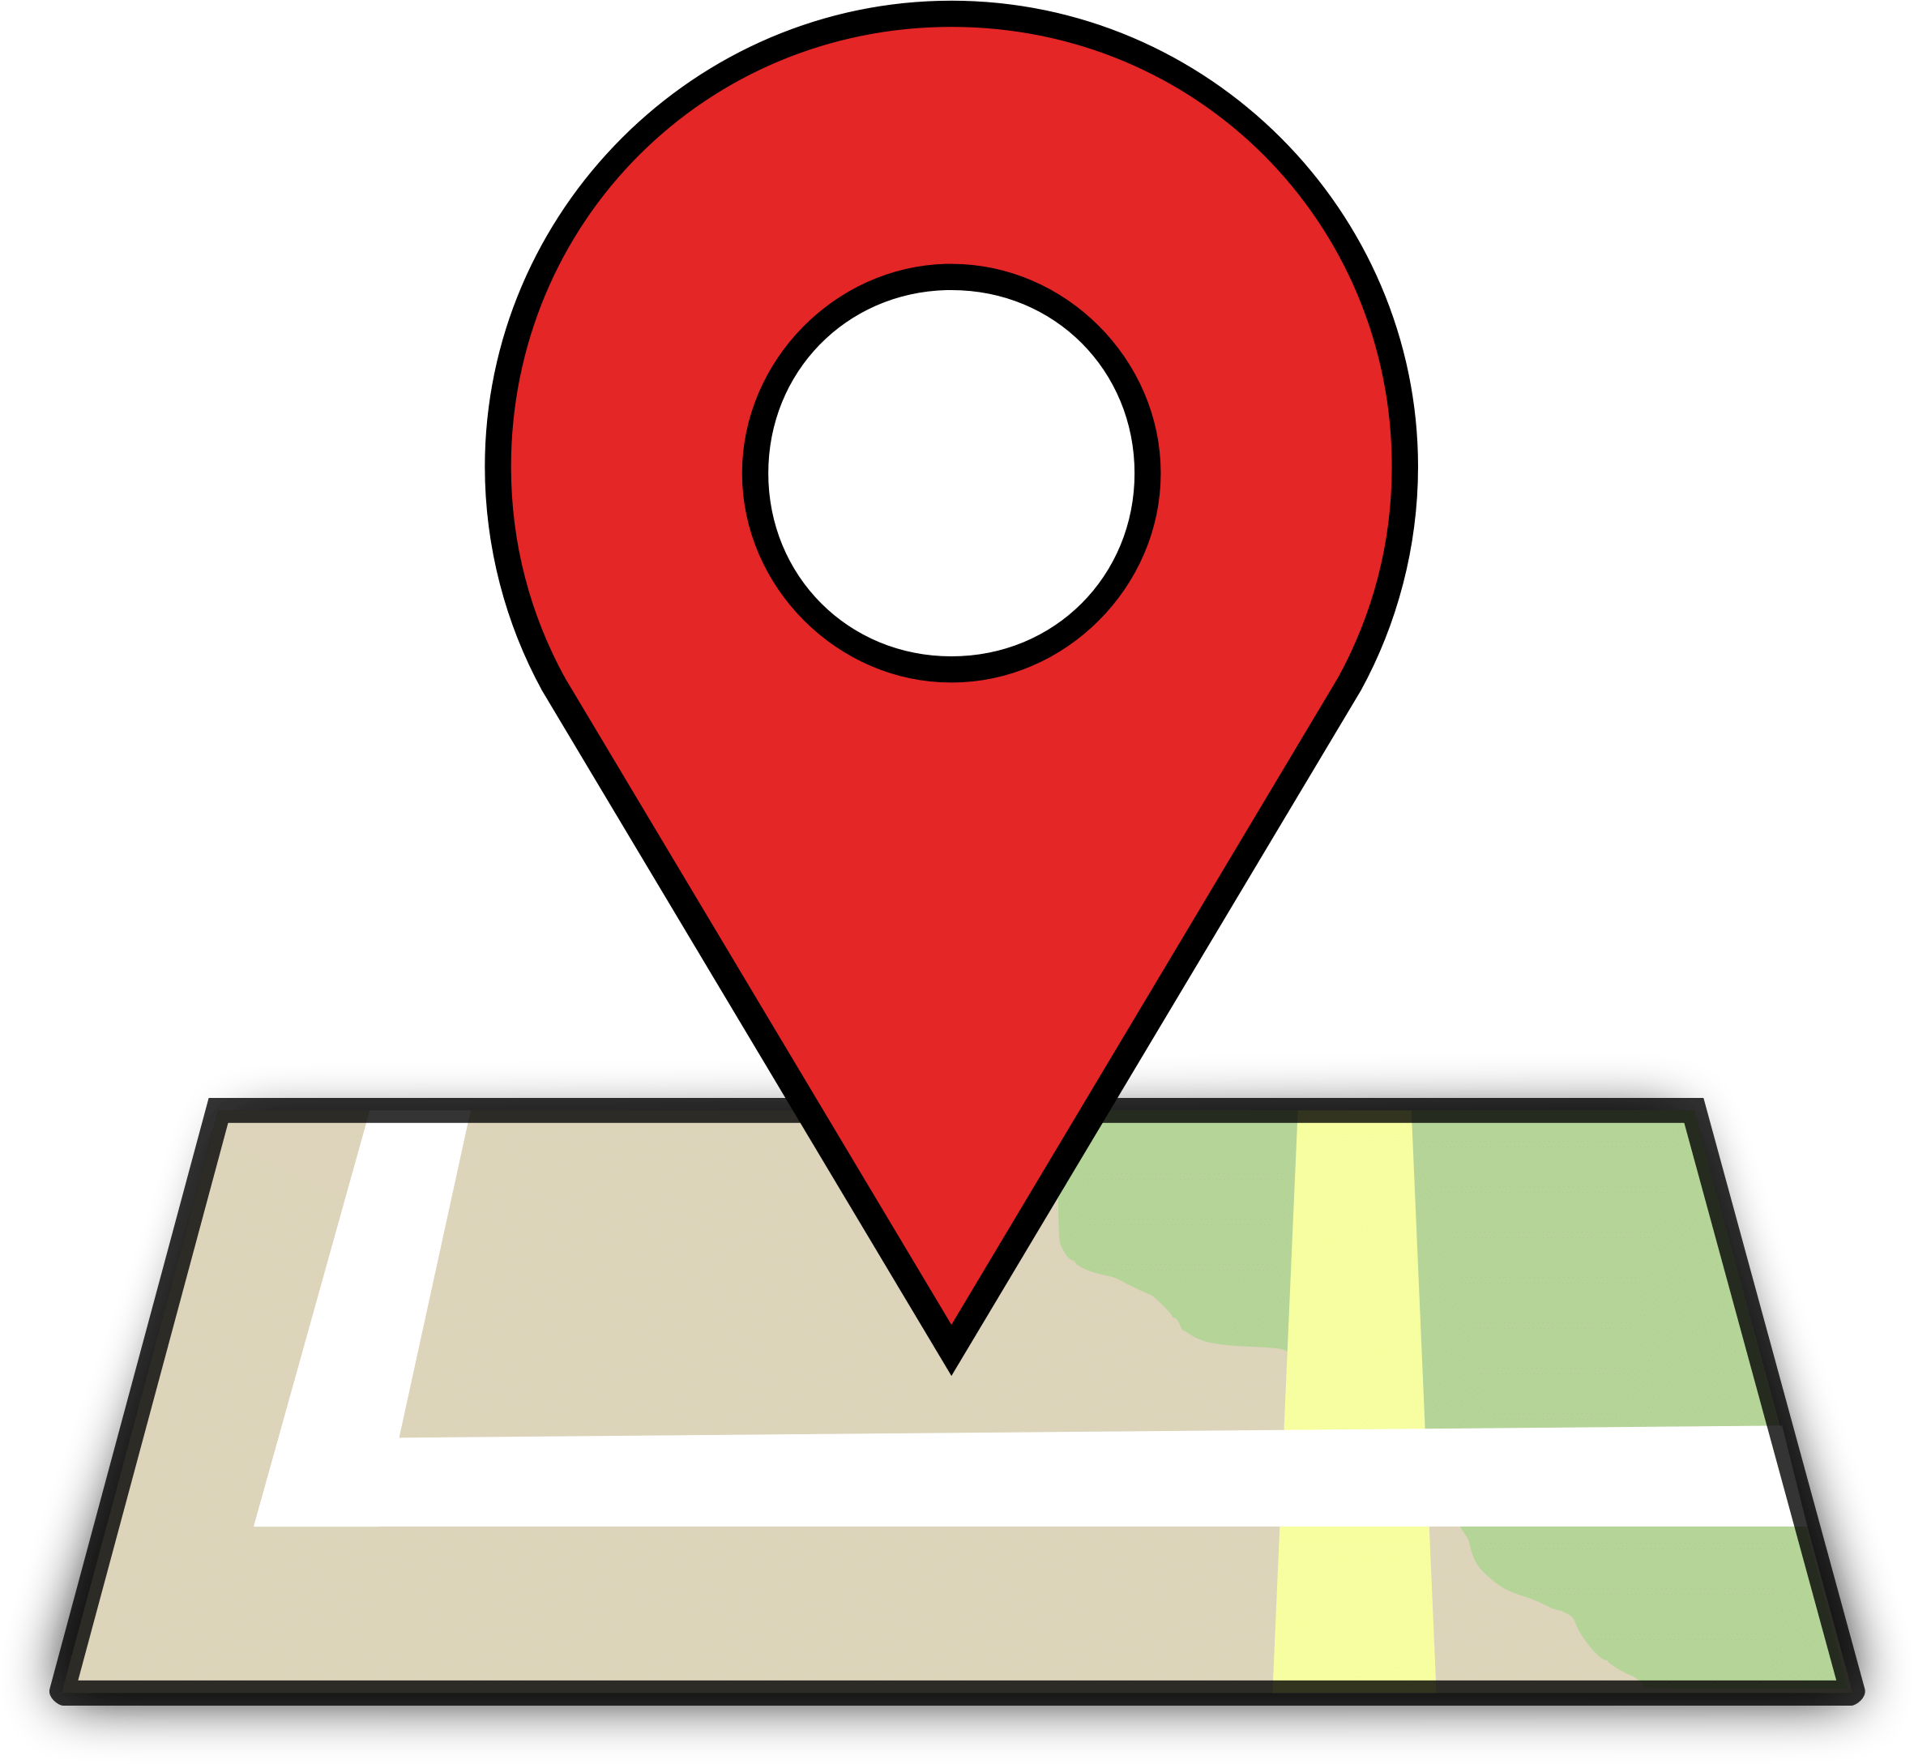
- the name of this booklet - Accessible Streets

- your address

- your email address if you have one.

What we will do with the ideas you send in
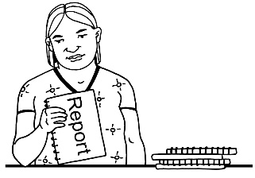
We will write a short report of all the ideas that people send to us.

We will share the short report with everyone.

In that report we might use:
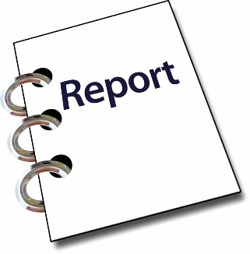
- your name

- information about your ideas.

Please tell us if you do not want your name or your information to be in our short report.

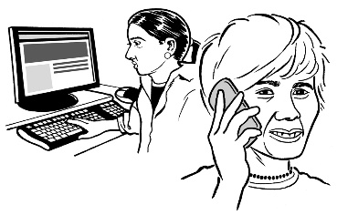
We may call or email you to talk about this.

New rules for using the road

This booklet goes through some of the road rule changes we want to make.

The new road rules will change the way you:

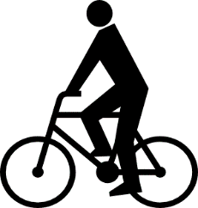
- walk on our roads and pathways

- ride a bicycle on our roads and pathways
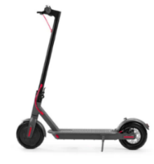
- ride transport devices on our roads and pathways
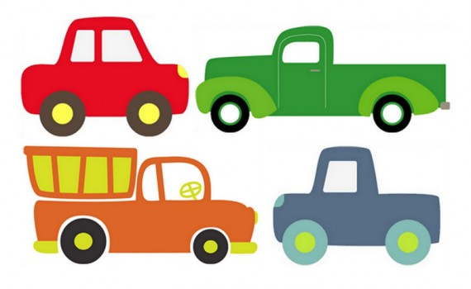
- drive a motor vehicle on our roads.

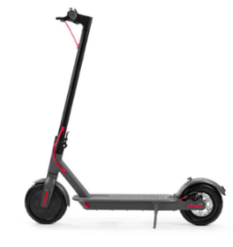
Transport devices are things like:

- push scooters

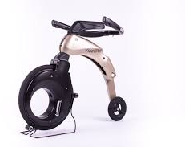
- electric scooters

- yike bikes which is like a small motorbike that can be folded up.

Motor vehicles are things like:

- cars

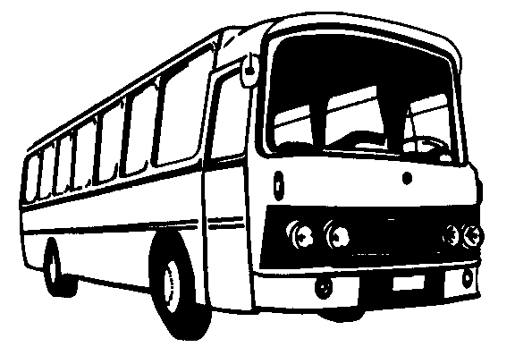
- trucks

- buses.

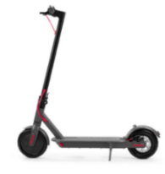
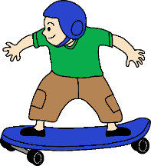
Transport devices are things like:
- powered transport devices

- unpowered transport devices which are things like skateboards and push scooters
What are the changes we want to make?

This booklet looks at 7 of the important things we want to change:
- Bicycles and transport devices on the road in the left turning lane
- Bicycles and transport devices passing slow motor vehicles on the road

- Turning traffic must give way to people in separated lanes

- Traffic must give way to people crossing the road if there are 2 white lines

- Motor vehicles must pass at a gap of least 1 metre

- Parking on berms

- Give way to buses leaving bus stops.
- Bicycles and transport devices on the road
in the left turning lane

The road rule change that we would like to make is:

Let bicycles and transport devices go straight ahead from a left turning lane.

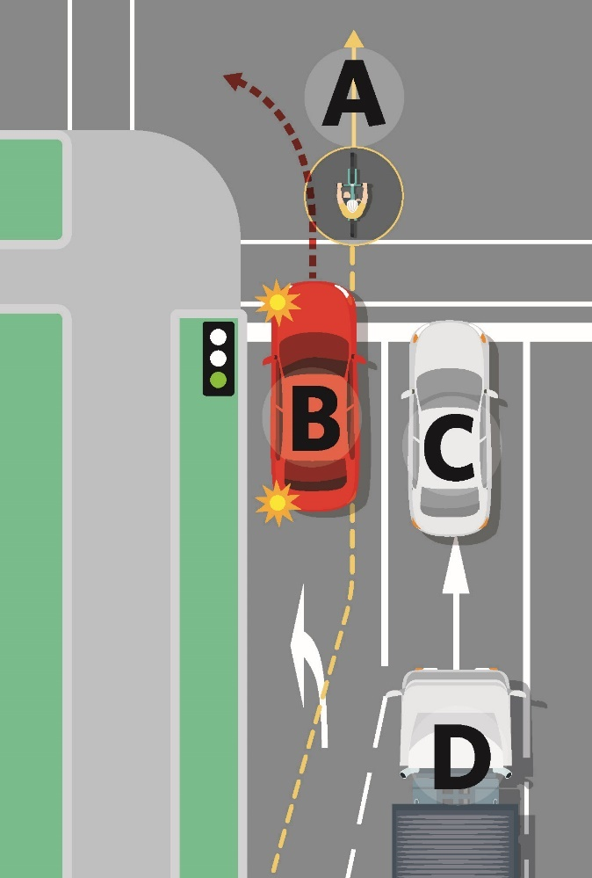
This picture shows what it would look like if we changed this rule.

A: The bicycle is moving straight ahead from a left turning lane.

B: The red car is turning left.

C and D: These cars are going straight ahead.

Question 1
Do you think it is a good idea to let cycles and transport devices go straight ahead from a left turn lane?
Please put your answer here:

- Bicycles and transport devices passing
slow motor vehicles on the road

The road rule change that we would like to make is:

Let bicycles and transport devices pass slow moving traffic on the left.

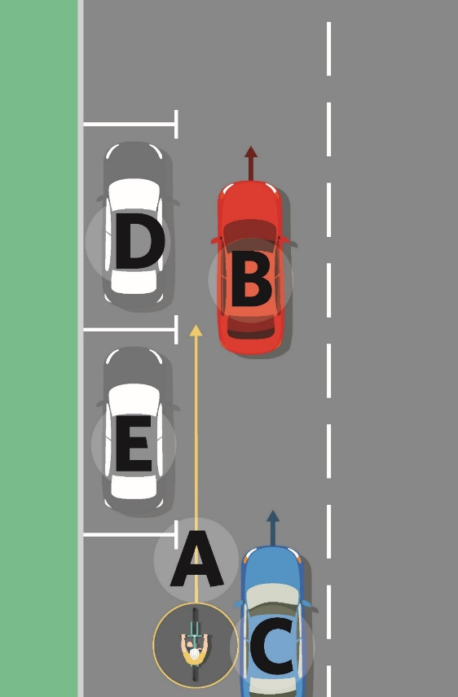
This picture shows what it would look like if we changed this rule.

A: The bicycle is passing the blue car on its left side.

C: The blue car is moving slowly.

B: The red car is going straight ahead.

D and E: cars are parked and not moving at all.
Passing on the left is also called undertaking.

Many people riding bicycles do this already.

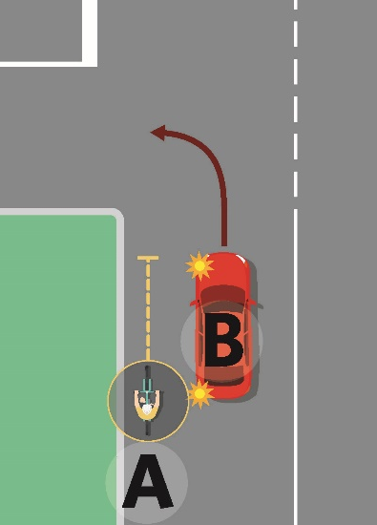
It is important to understand that people riding bicycles or transport devices will not be able to undertake if a car is going to turn left.

Question 2
Do you think it is a good idea to let bicycles and transport devices pass slow moving traffic on the left?

Please put your answer here:

- Turning traffic must give way to people in separated lanes

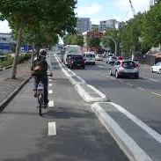
A separated lane is a lane beside the road with barriers to stop motor vehicles from using the lane.

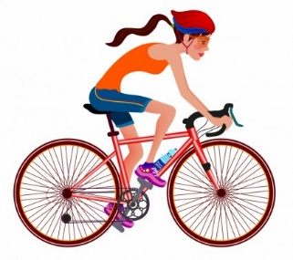
A separated lane can be used by:

- people riding bicycles

- buses

- transport devices.

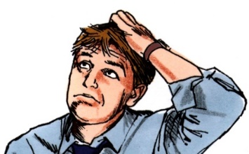
Sometime it is not clear who needs to give way to turning traffic at intersections.

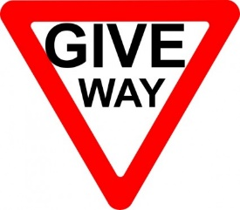
To give way means to let someone else go first.

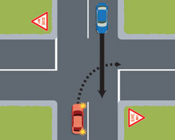
An intersection is an area where different roads meet

The road rule change that we would like to make is:

Turning traffic must wait for people in a separated lane to go first.

This picture shows what it would look like if we changed this rule.
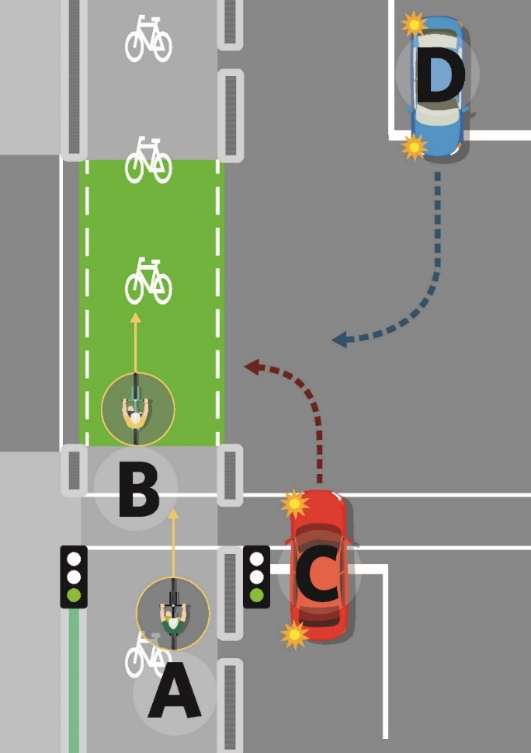

The traffic lights have turned green for go.

A and B: Bicycles in the separated lane can ride through the intersection.

C and D: These cars need to give way to the bicycles that are going through the intersection in the separated lane.

Question 3

Do you think it is a good idea that turning traffic must wait for people in a separated lane to go first?

Please put your answer here:

- Traffic must give way to people crossing the road if there are 2 white lines

At the moment the road rules say people must wait for turning traffic before crossing a side road.

The road rule change that we would like is:

When there are 2 white lines across the road turning traffic must:
- stop

- wait for people crossing the road.

This picture shows what it would look like if we changed this rule.

There are 2 white
lines.

A and B: People walking
straight ahead and crossing the road.

C: A person on a bicycle
going straight ahead.

E: A car that will need to stop
and give way to A B and C.

If there are no white lines people will need to still wait for turning traffic before crossing the side road.

Question 4

Do you think it is a good idea that turning traffic stop and wait for people to cross a side road if there are 2 white lines across the road?

Please write or type your answer here:

Motor vehicles must pass with a gap of

at least 1 metre

We want motor vehicles to drive past others more carefully on the road.

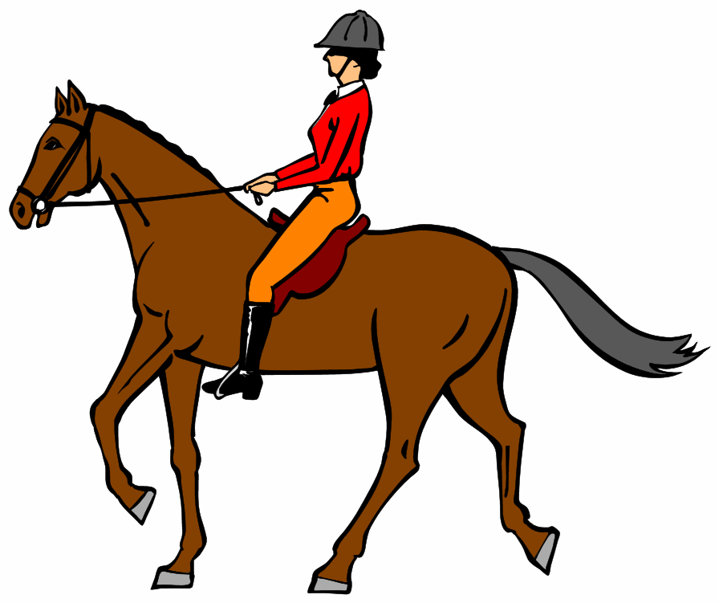
These are rules for when drivers pass:

- people riding bicycles

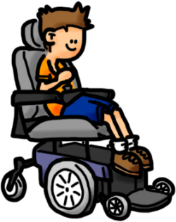
- horse riders

- people walking or running on footpaths or roads

- people using mobility devices like wheelchairs

- people on transport devices.

We want drivers to make sure there is space between them and the person are driving past.

We want to change the road rules so that:

Motor vehicles must pass others at a space of:

- 1 metre or more when the speed limit is 60 kilometres per hour or less

- 1.5 metres or more when the speed limit is over 60 kilometres per hour.

Question 5

Do you think it is a good idea that drivers have more space between them and the person they are driving past?

Please put your answer here:

Parking on berms

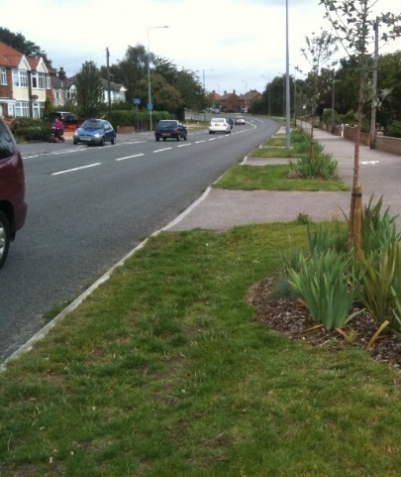
A berm is the land beside the road that can be:

- grass

- dirt

- garden.

Cars and trucks park on berms.

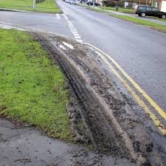
But sometimes this can be dangerous or damage land.

We want to make it easy to stop cars and trucks from parking on berms if it:

- is dangerous
- makes it hard to get past

- could damage the land.

The change we would like to make to the road rules is that:

There does not need to be signs to tell people not to park on a berm.

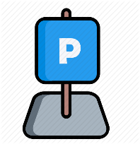
People will go on the internet instead to see if they are allowed to park on a berm.

Question 6
Do you think it is a good idea to stop using signs to tell people not to park on a berm?

Please write or type your answer here:

Give way to buses leaving bus stops

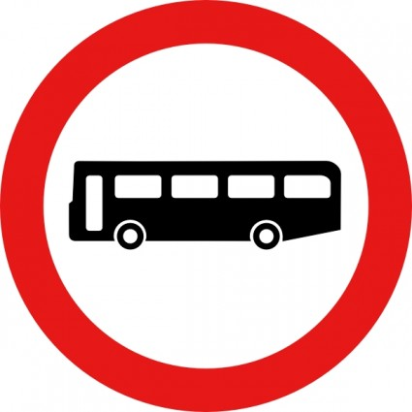
When a bus is leaving a bus stop other people on the road do not have to give way.

To give way means to let someone else go first.

If there is a lot of traffic this can:
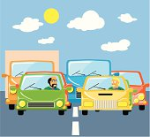
- slow the bus down

- make the people riding the bus late.

The road rule change we would like to make is:

We want traffic to give way to buses when:
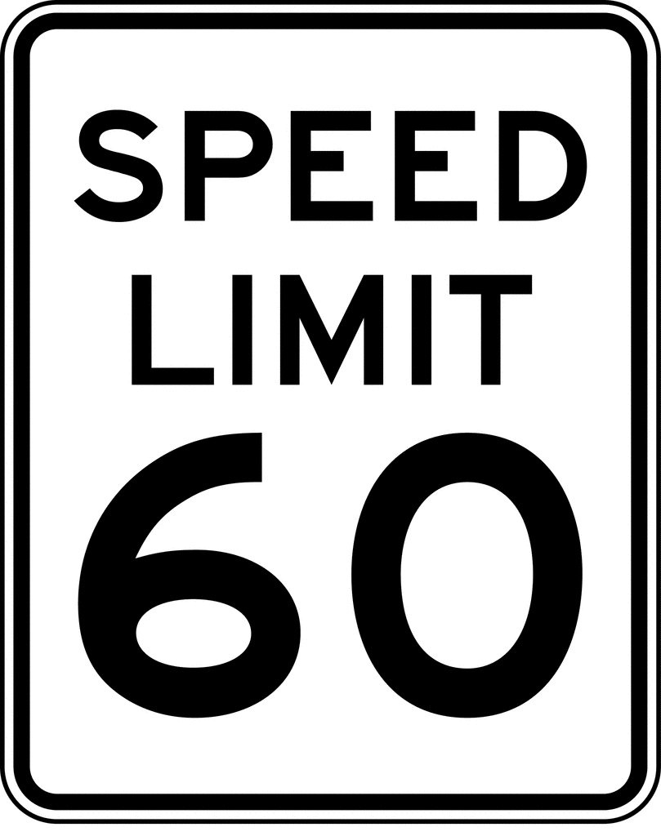
        - the bus is leaving the bus stop

        - the speed limit is 60 kilometres or less.

This rule would only happen on roads where motor vehicles are travelling at 60 kilometres per hour or less.

Question 7

Do you think it is a good idea that we want traffic to give way to buses when:
        - the bus is leaving the bus stop

        - the speed limit is 60 kilometres or less?
Please put your answer here:

Where to find more information about Accessible Streets

You can find more information about Accessible Streets:

Website:

www.nzta.govt.nz/accessible-streets-consultation

Email us at:

accessible.streets@nzta.govt.nz

Phone us on:

0800 699 000

This is a free call phone number so does not cost you any money to call.
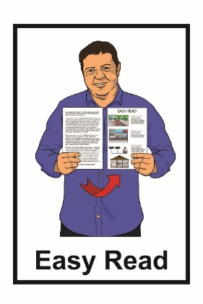
This information has been translated into Easy Read with advice from the Make It Easy service of People First New Zealand Inc Ngā Tāngata Tuatahi.

The ideas in this document are not the ideas of People First New Zealand Ngā Tāngata Tuatahi.
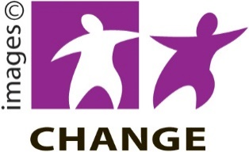

Make It Easy uses images from:

- Changepeople.org.nz

- Photosymbols.com

- Sam Corliss
- Steve Bolton

