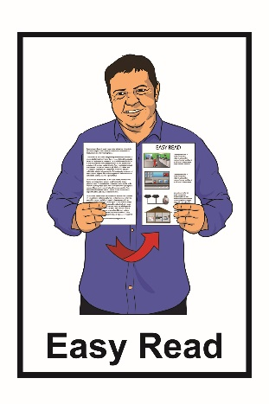

Accessible Streets – Part 1

Tell us what you think of the changes we want to make to the road rules about how we use:

- footpaths

- shared pathways

- bicycle pathways.

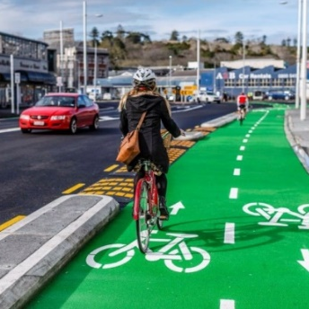
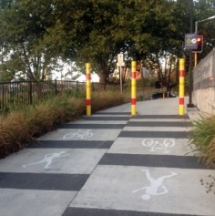
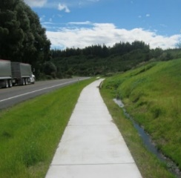

What is in this booklet?

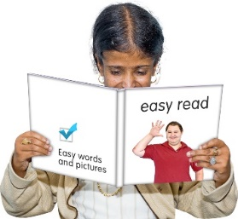
Page:

Before you start……………………..3

What are we doing?........................7

What are the changes we
want to make?...............................13

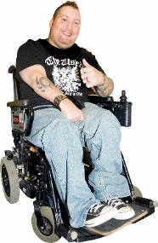

- Pedestrians and wheelchairs…14

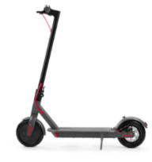

- Powered transport devices…….18

Page:
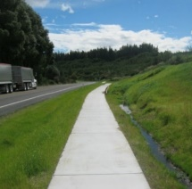

- Footpaths………………………..21

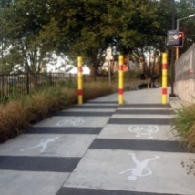
- Shared pathways……………….25

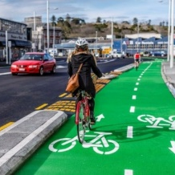
- Cycle lanes and cycle pathways………………….29

- Riding at night time……………..33

Where to find out more
information about
Accessible Streets…………………36

Before you start

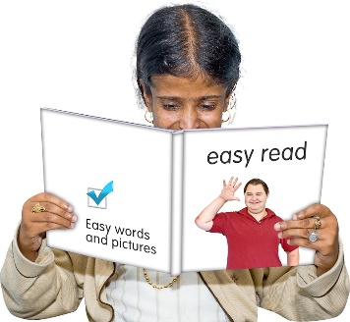
This is an Easy Read booklet about some changes that may be made to make our streets and pathways more:
- accessible

- safe to use.

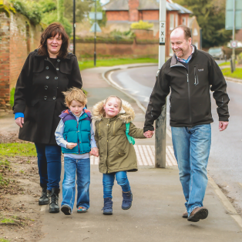
Accessible means making our paths and roads easy for everyone to use.

It is an easy read translation of some parts of a longer document called Accessible Streets.

The Accessible Streets document has been written by both the:
- Ministry of Transport

- Waka Kotahi New Zealand Transport Agency.

This booklet is called Accessible Streets: Part 1.

It looks at how we use

- footpaths

- shared pathways

- bicycle pathways.

There is also another booklet called Accessible Streets: Part 2 which looks at how we:

- drive on our roads

- give way to others on our road

- cross on our roads.

You can find these booklets on the Waka Kotahi New Zealand Transport Agency website:

www.nzta.govt.nz/about-us/ consultations/accessible-streets

This booklet is a long document.

Some things you can do to make it easier are:
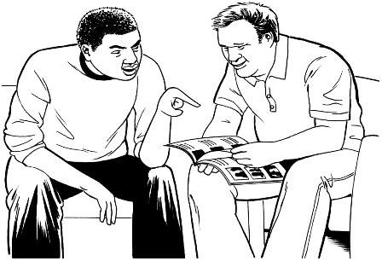
            - read it a few pages at a time

            - ask someone to assist you to understand it
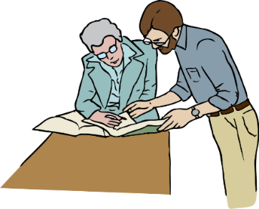
            - ask someone to assist you with filling in the question boxes in the document.

What are we doing?

We want to make some changes to the New Zealand road rules.

We means:

- The Ministry of Transport
- Waka Kotahi New Zealand Transport Agency

Road rules are rules that everyone must follow while using:

- roads

- footpaths

- bicycle pathways.

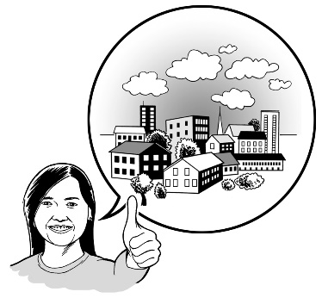
We want to make changes to some of the road rules so that it is easier for everyone to get to where they want to go.

These changes are part of a group of changes called Accessible Streets.

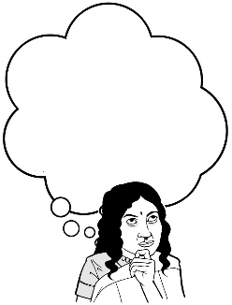
We want you to hear what you think about these changes.

In this booklet we have some questions to assist you to tell us what you think.

You do not have to answer every question.

How to tell us what you think of the changes we want to make to the road rules

You can fill in the question boxes in this booklet then post it to us to read.

You can also tell us what you think by:
- writing us a letter

- sending us an email

- sending us a video message.

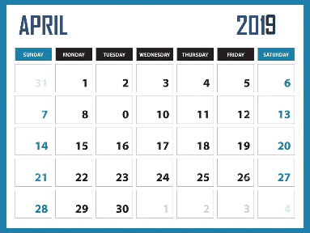
You need to make sure you tell us what you think before 5pm on Wednesday 22 April 2020

You can post in your booklet with answers or letter for free to:

Accessible Streets 2020
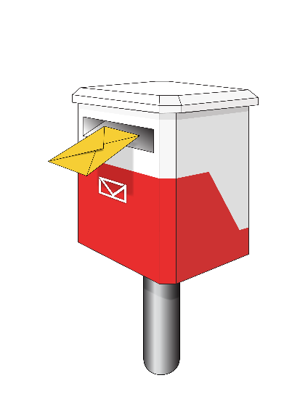
Transport System Policy Team

Free Post 65090
Waka Kotahi NZ Transport Agency
Private Bag 6995
Wellington 6141

This is a free post address which means it does not cost you any money to send your letter.

You can send us an email to:

accessible.streets@nzta.govt.nz

You can send us a video to:

accessible.streets@nzta.govt.nz

When you tell us what you think please make sure you tell us:

- your name
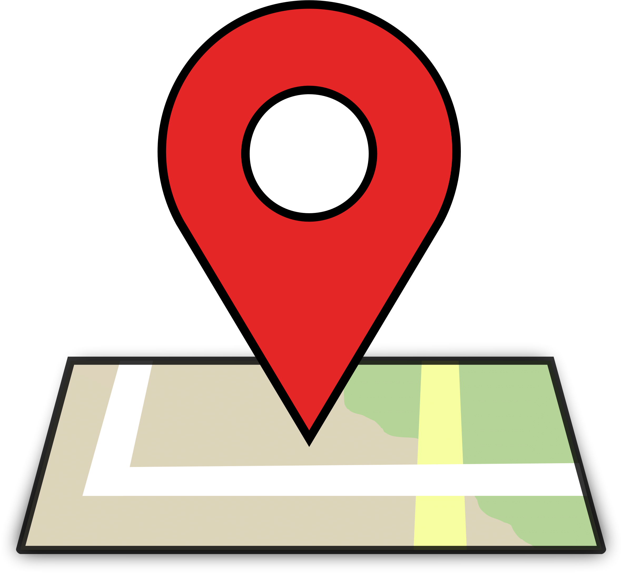
- the name of this booklet - Accessible Streets

- your address

- your email address if you have one.

What we will do with the ideas you send in
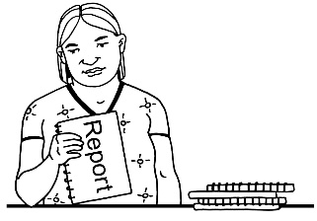
We will write a short report of all the ideas that people send to us.

We will share the short report with everyone.

In that report we might use:
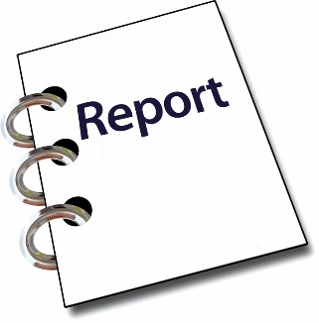
- your name

- information about your ideas.

Please tell us if you do not want your name or your information to be in our short report.

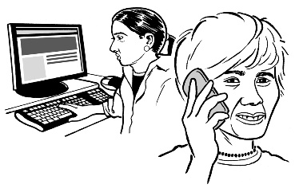
We may call or email you to talk about this.

What are the changes we want to make?

This booklet looks at 6 of the important things we want to change:

- Pedestrians and wheelchairs

- Powered transport devices

- Footpaths

- Shared pathways

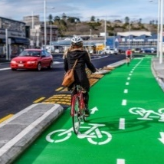
- Cycle lanes and cycle pathways

- Riding at night time.

Pedestrians and wheelchairs

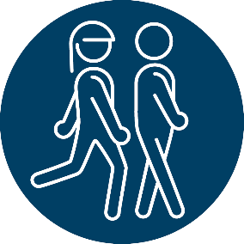
At the moment the road rules say that pedestrians are:

- people walking or running on footpaths or shared pathways
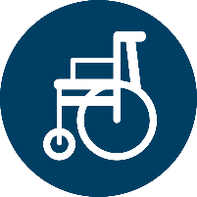
  - people using unpowered wheelchairs on footpaths or shared pathways.

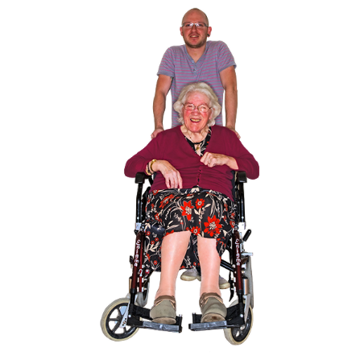
An unpowered wheelchair is a wheelchair that a person:

- has to push along themselves

- have someone push for them.

The road rule change that we would like to make is:

People using powered wheelchairs are also pedestrians.

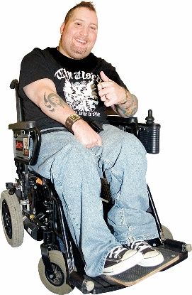
A powered wheelchair is a wheelchair that has by a small motor that makes moves it around.

Powered wheelchairs can move faster than unpowered wheelchairs.

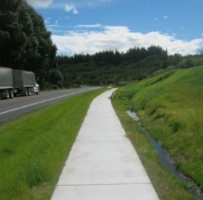
Changing this rule would mean that people using powered wheelchairs could use:
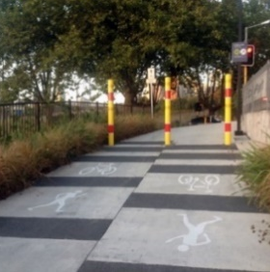
- footpaths

          - shared pathways.

Where there are no footpaths people using powered wheelchairs would also be able to use:

- roads
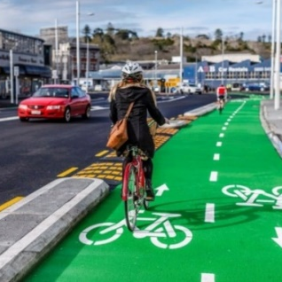
- bike lanes

- bicycle paths.

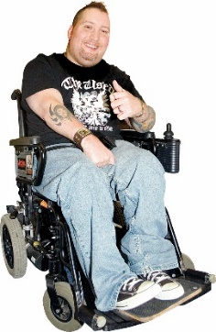
This would mean that other people on the pathway would need to give way to people using powered wheelchairs.

To give way means to let someone else go first.

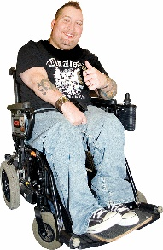
Question 1
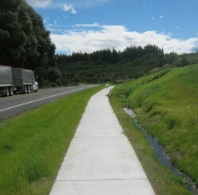
Do you think it is a good idea that people using powered wheelchairs are also pedestrians?

Please put your answer in here:

Powered transport devices

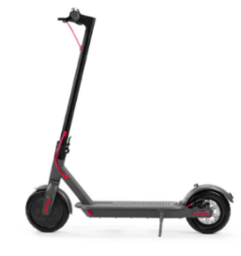
Powered transport devices are devices with small motors to make them move.

2 powered transport devices are:
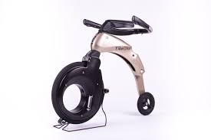
- e-scooters

- yike bikes which is like a small motorbike that can be folded up.

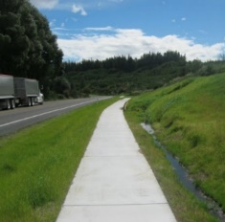
These 2 powered transport devices can be used on:

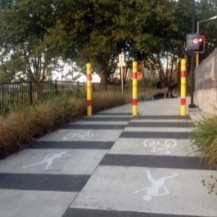
- footpaths

- some shared paths

- roads.

We would like the road rules to say that the following are not powered transport devices:

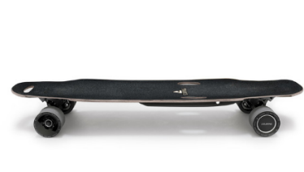
          - e-skateboards
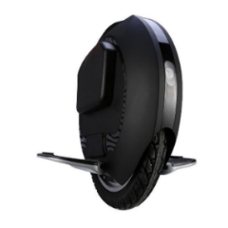
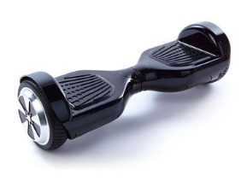
        - hoverboards

        - electric unicycles.

This would mean that those powered transport devices would not be allowed on:

- footpaths
- some shared pathways

- roads.

Question 2

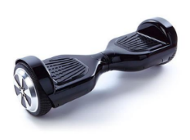
Do you think it is a good idea that these other devices are not seen as powered transport devices?

Please put your answer here:

3. Footpaths

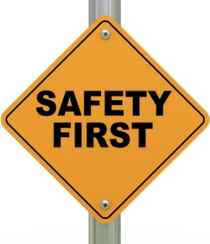
We want to make sure our footpaths are safe for everyone to use.
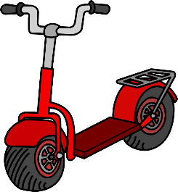
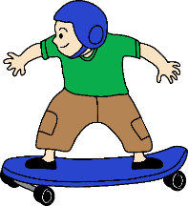
There are a lot more people riding different things on our pathways so we need some clear rules to help make this safe.

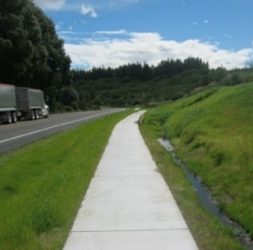
We want to have a national framework for the use of footpaths.

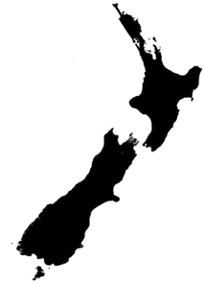
This means we want to have an agreed set of rules across all of New Zealand about how our footpaths are used.

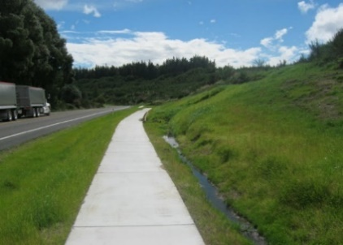
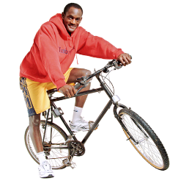
We want to change the rules for people using the footpaths if they are riding things like:

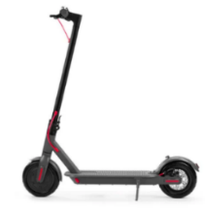
- bicycles

- skateboards
- e-scooters (powered scooter)

- yike bikes.

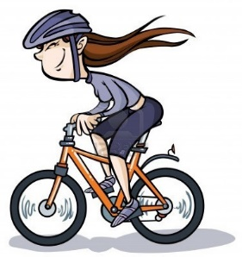
For example at the moment the rules about bicycles on footpaths are:

- small children can ride bicycles on footpaths
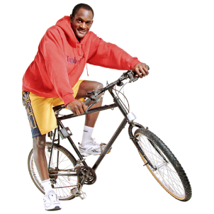
- older children and adults can not ride bicycles on footpaths.

The road rule change we would like to make is:

People can ride on the footpaths if they follow some important rules.

The rules for people riding on footpaths would be:

- ride in a way that is safe for other people
- let people go first if they are:

- walking or running

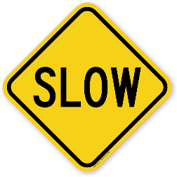
- using a wheelchair

- do not go faster than 15 kilometres per hour

- that the things that people ride on must be less than 75 centimetres wide.
Question 3

Do you think that it is a good idea to let people to ride on the footpath if they follow the rules?

Please put your answer here:

4. Shared pathways

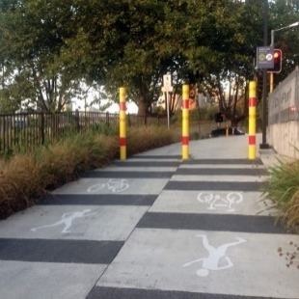
A shared path is a path used by many different people who are:

- walking or running
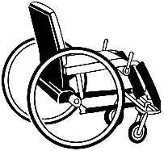
- using a wheelchair

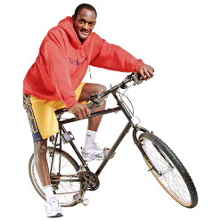
- using a mobility scooter

- riding a bicycle.

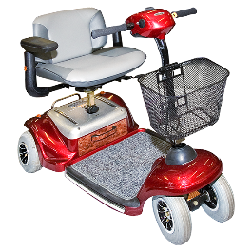
Mobility scooters are powered transport devices used by people who need support to get around in their community.

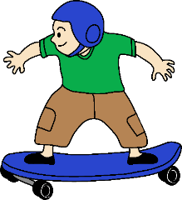
people riding these things are sometimes allowed in shared pathways:

- push scooters

- push skateboards

- e-scooters (powered scooter)

- yike bikes.

The road rule change we would like to make is:

People can ride these things in shared pathways if they follow some important rules.

The rules for people riding in shared pathways would be that they:

- ride in a way that is safe for other people

- let people go first if they are:

- walking or running

- using a wheelchair.

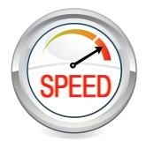
We have been thinking about how fast people can ride in shared pathways.

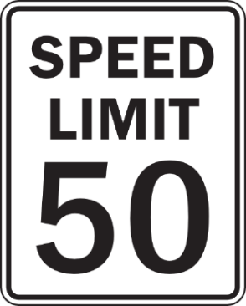
We think people riding in the shared pathways should go no faster than 50 kilometres an hour.

Question 4
Do you think it is a good idea to let people to ride in shared pathways if they follow the rules?

Please put your answer here:

5. Cycle lanes and cycle pathways

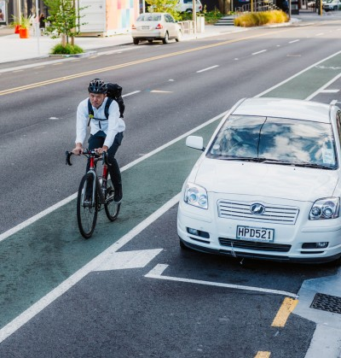
A cycle lane:

- is a part of the road for people to ride bicycles

- is often painted green

- has no barriers to stop cars being in the cycle lane.
No barrier

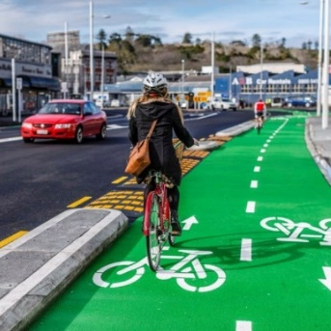
A cycle pathway:

- is a part of the road for people to ride bicycles

- is often painted green
This is the barrier
- does have barriers to stop cars from using the cycle pathway.
At the moment people riding these things are not allowed in cycle lanes and some cycle pathways:

- push scooters

- push skateboards

- e-scooters (powered scooter)

- yike bikes.

The road rule change we would like to make is:

People can ride those things in cycle lanes and cycle pathways if they follow some important rules.

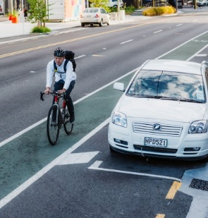
The rules for people riding in cycle lanes and cycle pathways would be that they:

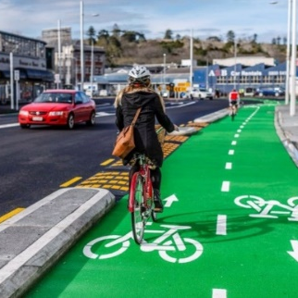
- ride in a way that is safe for other people

- let people go first if they are:

- walking

- running

- using a wheelchair.

We have been thinking about how fast people can ride in cycle lanes and cycle pathways.

We think people riding in cycle lanes and cycle pathways should go no faster than 50 kilometres an hour.

Question 5
Do you think it is a good idea to let more people to ride in cycle lanes and cycle pathways if they follow the rules?

Please put your answer here:

6. Riding at night time

The road rule change we would like to make is:

People who are riding powered transport devices when it is dark at night time must have a:
- headlamp

- position light

- reflectors.

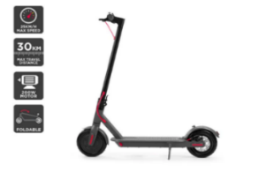
A headlamp is a light on the front of a device.

A position light is at the back of the device.

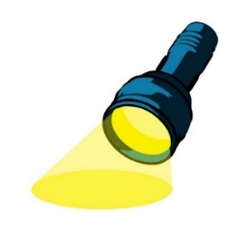
Reflectors work by bouncing light back to where it came from.

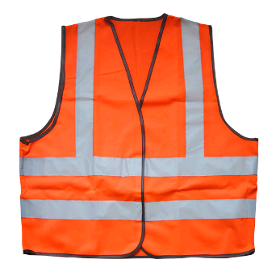
Reflectors can be:
- on the powered transport device

- part of your clothing.

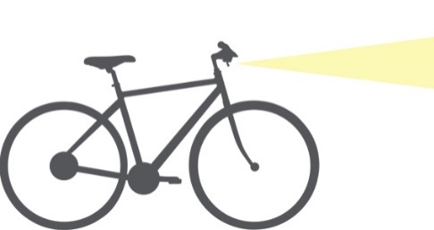
The rules already say that people riding bicycles at night must have these lights on their bicycles.

We want to make sure everyone is safe when they are riding any other devices at night time.

Question 6

Do you think it a good idea that people riding powered transport devices must have lights on at night time?

Please put your answer here:

Where to find more information about Accessible Streets

You can find more information about Accessible Streets:

Website:

www.nzta.govt.nz/accessible-streets-consultation

Email us at:

accessible.streets@nzta.govt.nz

Phone us on:

0800 699 000

This is a free call phone number so does not cost you any money to call.
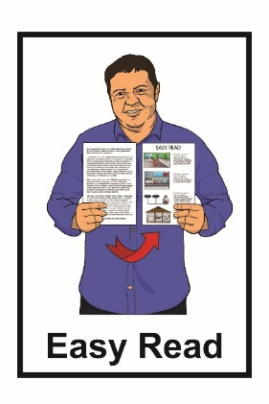
This information has been translated into Easy Read with advice from the Make It Easy service of People First New Zealand Inc. Ngā Tāngata Tuatahi.

The ideas in this document are not the ideas of People First New Zealand Ngā Tāngata Tuatahi.

Make It Easy uses images from:

- Changepeople.org.nz

- Photosymbols.com

- Sam Corliss
- Steve Bolton

