Tenant Balance Instructions

To get a tenant balance, the use the transaction FPO4.

The steps are:

- Type /nFPO4 into the top box
  - A new window appears

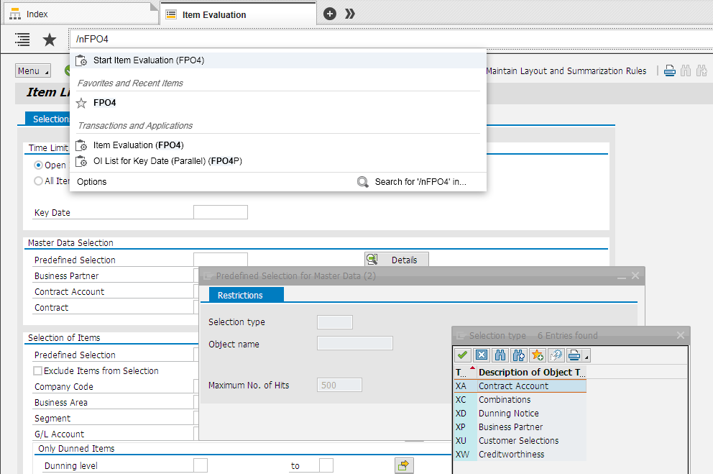

- Go to the Master Data Selection > Predefined Selection box
  - Select XA Contract Account as the Selection Type
  - Enter and find the relevant person or company

- Select the appropriate Colliers or Darroch parameter:
  - Selecting Colliers will give you all debts managed by Colliers staff (not broken down by regions)
  - Selecting Darroch will give you all debts managed by Darroch. This also doubles as the debtos by Auckland/Northland
  - Selecting individual people (ie. Carl Raumati etc..) gives you the debts where this person is nominated as the Clerk Responsible on that tenant/contract partner.

- Variants have been set up. Use: the get variant button:
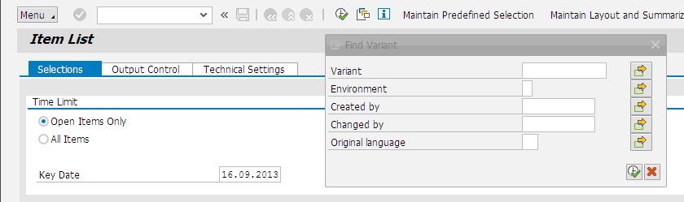
- Then click the execute button and choose the option you want:
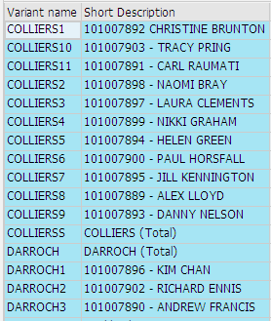
Using the variant means that other options like the 1000 company code are populated automatically.

Note: When entering new Tenants/Contract Partners, please complete the “Clerk Responsible” field as this is the identifier for separating debts by Region

Additional Note: When staff change in the future, change the business partner name from the outgoing person to the new person. This retains all the pre-sets for the role.
Further Options to be aware of are:

Open Items only will give just the unpaid debt. All items will give a payment history.

Key Date would normally set to the current date.

Master Data Predefined selection discussed already

Selection Predefined Selection – not set up
Company code – 1000.

Output Control:
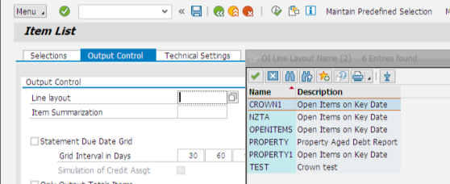

The Line Layout gives choices for property.

Results

The PROPERTY option gives:

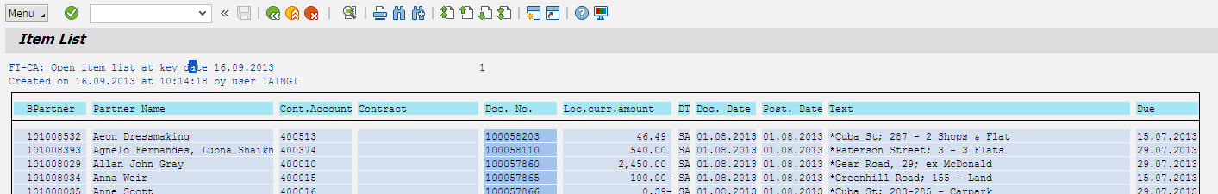

BUT use the ALV selection on the Output screen

This gives a more readable layout and the layout can be changed by using the cube symbol: 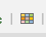

See over:
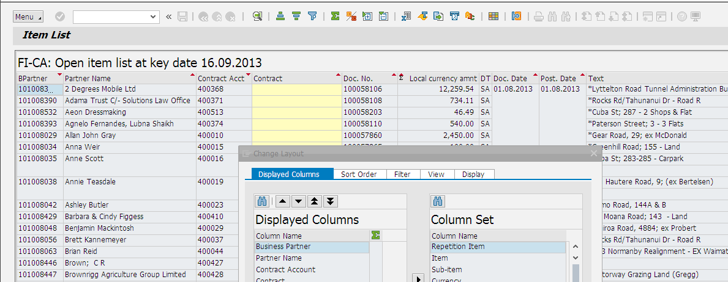

A row can be double clicked to see an individual tenant’s details.

The PROPERTY1 option gives:

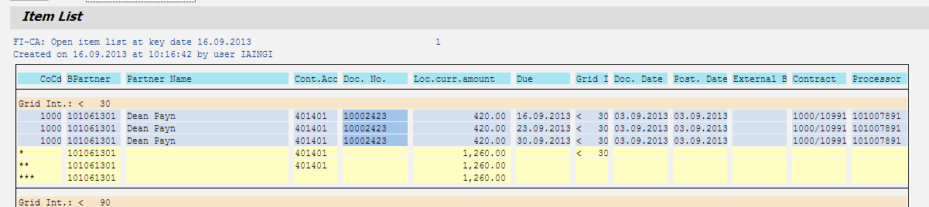

This provides an aged profile of the debt.

Note: Column DT (Document Type) shows you what the payment is
e.g Z2 = incoming payment, Y1 = NZTA property rent, SA = Gen. Debt Position

Double clicking a line in any of the options gives the detail for a tenant:

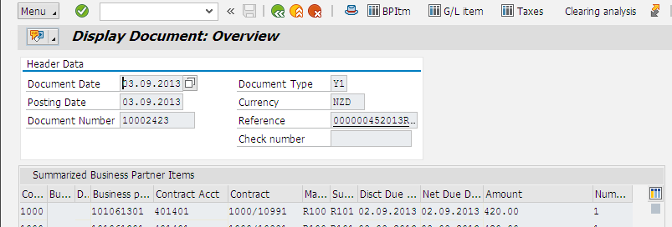

Exporting

Most of the screens can be exported to Excel, use the Excel button.

Follow the instructions from there to save the file.

